IMPACTS OF MARKET UNCERTAINTIES ON lIQUEFIED NATURAL GAS (lng) EXPORTS FROM THE UNITED STATES

Sugandha D. Tuladhar, NERA Economic Consulting, Phone 202 466 9206, E-mail: Sugandha.Tuladhar@nera.com

Reshma Patel, NERA Economic Consulting, Phone 202 466 9212, E-mail: Reshma.Patel@nera.com

Overview
Since 2008, the United States (U.S.) has seen a remarkable increase in natural gas production. Optimism about shale gas resources and accelerated technological advancement in recovery has created a shale gas boom that has propelled the oil and gas industry as a cornerstone for the renaissance of manufacturing growth. According to the Energy Information Agency (EIA), shale gas is projected to account for more than 50% of the total U.S. natural gas production by 2040. The abundance of this resource has generated significant interest in converting current regasification plants to liquefaction plants and even proposals for new liquefaction plants to export liquefied natural gas (LNG) to international markets. Proponents of the export of natural gas argue that the nation as a whole would benefit from natural gas trade while opponents argue that restricting natural gas exports would create lower domestic natural gas prices and hence benefit the economy. These arguments have led to a national energy policy debate on the benefits and costs of restricting exports of LNG and how domestic and international market dynamics would impact the level of LNG exports from the U.S.
This paper evaluates potential levels of LNG exports and their impact on the U.S. economy as result of different domestic and international natural gas market dynamics. We simulate scenarios that take into account uncertainties associated with three different natural gas supply outlooks (pessimistic, reference, and optimistic outlooks) while on the international front we simulate three different conditions of natural gas supply and demand (reference, demand push, and supply pull-back and demand push).

Method
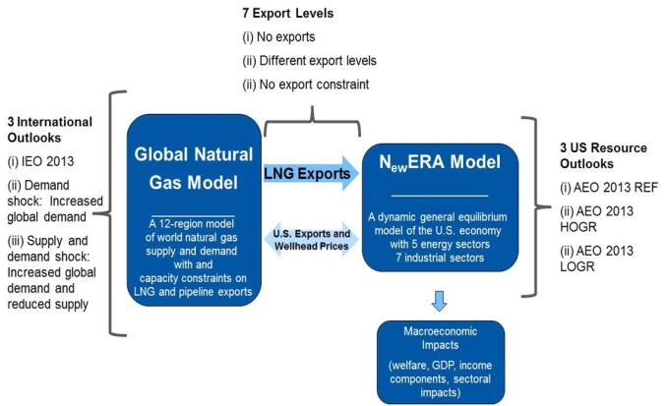
To estimate the net economic impacts of LNG exports from the U.S., we first use our Global Natural Gas Model (GNGM) to determine feasible U.S. LNG export volumes assuming 3 different U.S. natural gas outlooks (reference, high oil and gas resource, and low oil and gas resource), 3 different international supply/demand conditions (reference, demand, and supply-demand shocks), and 7 different U.S. LNG export capacities. We run 63 scenarios to capture the range of uncertainties. GNGM is a partial-equilibrium model of the world natural gas market designed to estimate natural gas production, consumption, and trade between 13 world regions. The N_{ew}ERA model is a fully dynamic computable general equilibrium model of the U.S. economy. The N_{ew}ERA model is built to address key factors affecting future natural gas supply and prices resulting from uncertainty about the availability of shale gas in the U.S. The N_{ew}ERA model’s flexible natural gas supply curves allow it to incorporate uncertainties and analyze subsequent effects they could have on domestic markets. We use the N_{ew}ERA model to estimate economic impacts for a subset of U.S. LNG export levels.

Results
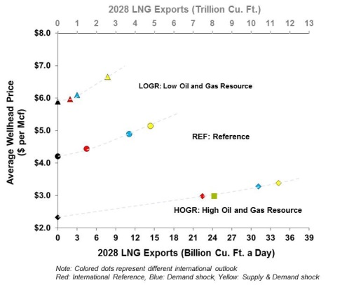
The level of export volumes depends upon uncertainty associated with natural gas market dynamics and resource base outlook: The figure on the left shows the resulting market equilibrium wellhead prices under four different natural gas outlooks for a no-LNG export case (black dot), international demand case (red dot), supply-demand case (blue dot), and unconstrained LNG export levels (yellow dot). We see that at low levels of prices large exports are possible. Under an optimistic natural gas outlook (HOGR case), if the natural gas prices remain at $3/MCF in 2028, the U.S. would export significant volumes (about 11Tcf). However, with a higher natural gas price outlook (LOGR), the market itself will limit the level of U.S. LNG exports. If the prices were between $6 per Mcf to $7 per Mcf, then the U.S. would only export about 1 to 3 Tcf in 2028. If the international natural gas price were based on gas-on-gas competition then there would be less incentive relative to an oil-linked pricing regime for the U.S. to export. The unconstrained level of exports could drop from 12.5 Tcf (yellow diamond) to 8 Tcf (green square) in 2028. The uncertainty associated with the pricing regime alone could swing the export level by 36%. Moreover, the natural gas price results show that the increase is modest and remains within a $1 per Mcf range. This price rise is well within the historical variation the U.S. has witnessed in the last decade.

LNG exports are supported by higher domestic production: A significant amount of LNG exports are supported by an increase in domestic supply of natural gas. The figure on the left shows demand and supply changes for the reference outlook under an international demand shock case in 2028. Our results suggest that there is plenty of natural gas to support the domestic economy as well as LNG exports through increased production of natural gas. More than 80% of LNG exports come from new production of natural gas. We consistently see this pattern in other scenarios as well.

LNG exports lead to increases in welfare and GDP: In all of the scenarios we simulated, our results show that there is an increase in GDP and welfare. In fact, we see GDP monotonically increasing with LNG export volumes. This suggests that our analysis does not see a “sweet spot” lower than the market determined level of LNG exports. Under the reference case scenario with an unconstrained level of exports, GDP in 2038 will increase by about $25 billion compared to the no export case. In terms of the components of GDP, government revenues will increase by over $10 billion, investment income by about $15 billion, resource income by about $10 billion, while labor income will decrease by about $15 billion, all compared to the no export case. Under the most optimistic natural gas outlook (HOGR) and the unconstrained export case scenario, our result show that GDP could increase by about 0.3% by 2038.

Conclusions
We use NERA’s proprietary GNGM and N_{ew}ERA economic model to evaluate economic impacts from U.S. LNG exports. Our study concludes that U.S. LNG exports are beneficial to the U.S. economy at large. Our analyses show that U.S. LNG exports will not cause runaway increases in the natural gas prices. These modest natural gas price increases lead to slowing the growth of the manufacturing sector only marginally and are unlikely to harm its long term growth in any significant way that would derail the manufacturing renaissance. We also show that economic benefits are distributed broadly between different components of the GDP. Although economy-wide labor income decreases, we see that both net GDP and consumer wellbeing increase.

The results in this paper are based on: (i) “Updated Macroeconomic Impacts of LNG Exports from the United States,” Robert Baron, Dr. Paul Bernstein, Dr. W. David Montgomery, and Dr. Sugandha D. Tuladhar, NERA Economic Consulting. 20 February, 2014. http://www.nera.com/67_8081.htm; and (ii) Prepared Testimony of W. David Montgomery, Ph.D. submitted to the Committee on Energy and Natural Resources, “United States Senate Importing Energy, Exporting Jobs: Can It Be Reversed?” 25 March, 2014.

