Overview

Co-optimized Planning of Electricity Transmission and Generation Resources

Jonathan L. Ho, The Johns Hopkins University, (413) 687-1329, jho19@jhu.edu
Venkat Krishnan, Iowa State University, vkrish@iastate.edu
Benjamin H. Hobbs, The Johns Hopkins University, bhobbs@jhu.edu
James D. McCalley, Iowa State University, jdm@iastate.edu
Traditional models for planning transmission expansion, such as Integrated Resource Planning models, apply only to vertically integrated utilities (e.g., Hobbs, 1995). In deregulated electric systems, generation and transmission expansion planning is done separately, but at a potential cost of loss of coordination. Conflicting objectives and incomplete information in the planning process limit the integration of renewables and increase the cost of building and operating the systems. Modeling transmission expansion using co-optimization, which is the simultaneous identification of two or more classes of investment decisions within one optimization strategy, would provide a powerful planning tool, addressing shortcomings of previous approaches, reducing system costs and supporting the integration of renewable generation (Liu et al., 2013).

Using detailed co-optimization models in planning has become more practical, due to developments in computer processing power and mature commercial and non-commercial MILP solver packages. Co-optimization can be used in two different institutional settings. In a vertically integrated utility, co-optimization identifies transmission-generation expansions plans that together lower costs, compared with planning transmission and generation separately. Traditionally, utilities have instead planned transmission given an assumed spatial distribution of generation investment; since transmission access costs are a large proportion of the total expense of developing remote yet productive renewable resources, the assumption that generation patterns can be determined independent of transmission costs is increasingly unrealistic. Co-optimization may also be used in restructured markets, where the generation and transmission are planned by different entities. In this context co-optimization planning allows transmission planners to expand their network anticipating that generation planners respond to the expanded network optimally. This accounts for the fact that transmission access affects both interconnection costs and energy prices (locational marginal prices) for generation, and thereby impacts the relative attractiveness of generation investment in different places. Consequently, where transmission is placed is likely to affect the location of future generation.

Methods
We examine the benefits of co-optimization in transmission planning using two different co-optimization models: NETPLAN (a multi-sector simultaneous multi-period linear program that projects generation additions by region and interregional transmission additions for the entire nation) and the JHU model (an electric sector mixed-integer linear program), applied to a 13 zone network reduction of the United States. The models are dynamic, in that transmission and generation investments decisions are made in each of several decades, and generation dispatch and transmission flow decisions are simulated for a number of hours within each decade, representing the ranges of load and renewable generation.

Results
In both models, we found that the co-optimization approach yielded significant savings in the present worth of capital and fuel costs of generation and transmission. In particular, cost decreases up to 11% were achieved, compared to traditional planning in which generation expansion is planned followed by a separate optimization for transmission expansion. In traditional planning, generation and transmission planners make decisions with incomplete information about each other’s costs and benefits, resulting in suboptimal decisions. For instance, co-optimization finds that interconnections between Texas and the rest of the US would result in fuller exploitation of the Texan wind resource, with much of it being exported from the state, and allowing Texas to rely more on imported generation to back-up the variability of wind (Fig. 1). This cost-reducing plan is not uncovered by traditional planning, in which a scenario of generation siting is first defined, followed by expanding the grid to accommodate that generation scenario.
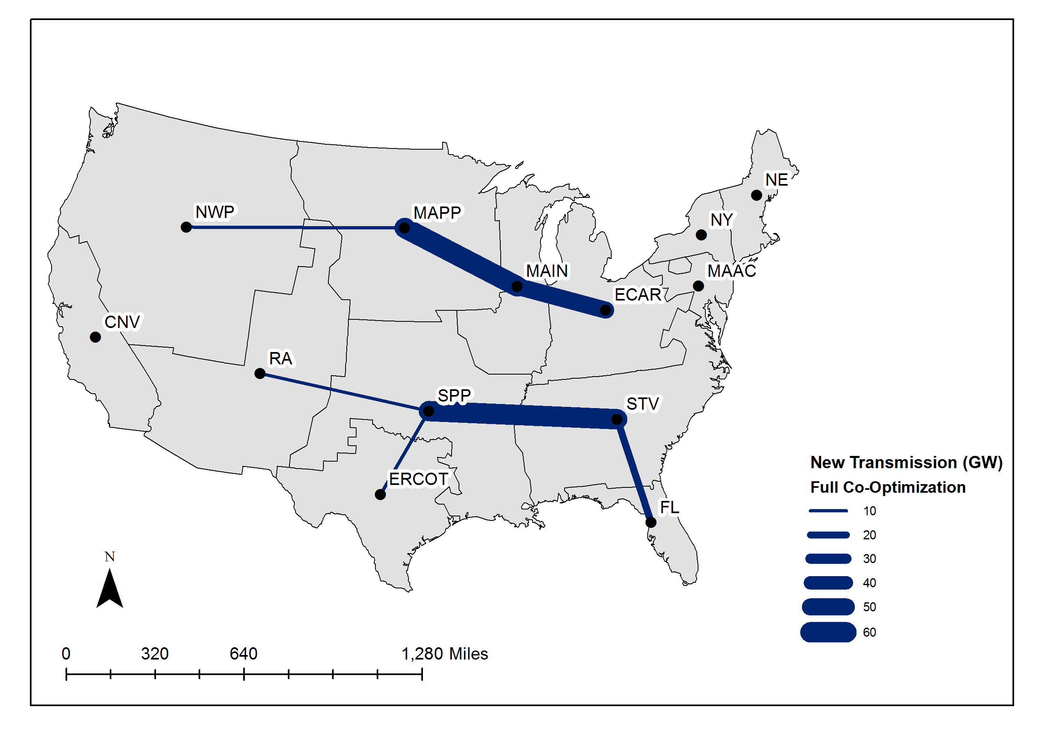
Figure 1 Transmission network investment results under full co-optimization using the JHU model.

Iterating between generation and transmission planning models (in which one type of investment is optimized subject to a fixed scenario of the other, and then the reverse model is solved, and so on) improved solutions, and is one practical way to implement co-optimization. This approach was able to achieve 80% of the cost reductions (compared to traditional planning) that full simultaneous co-optimization yields. Thus, co-optimization by iteration does not generally converge to the overall optimal generation-transmission solution (Fig. 2).

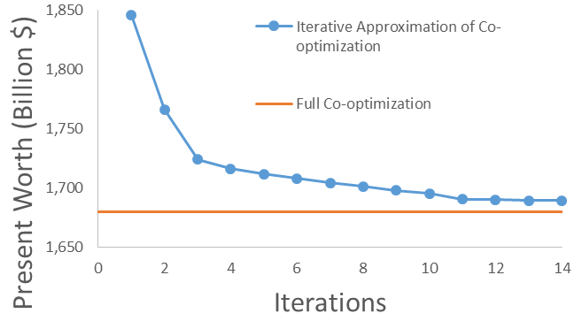
Figure 2 Comparison of an iterated approximation of co-optimization with full co-optimization.

Conclusions

Co-optimization offers significant economic benefits over separate and imperfectly coordinated transmission and generation expansion planning approaches. Savings in generation investment due to improved siting and mixes were captured by a co-optimized planning model. The benefits of co-optimization were confirmed through a comparison of two different planning models.. While approximations of co-optimization are an improvement over tranditional planning approaches, they do not capture the full benefits of co-optimization.

References
B.F. Hobbs, “Models for Integrated Resource Planning by Electric Utilities, Invited Review,” European Journal of Operational Research, 83(1), May 1995, 1-20.
A. Liu, B.F. Hobbs, J. Ho, J. McCalley, V. Krishnan, M. Shahidehpour, and Q. Zheng, Co-optimization of Transmission and Other Supply Resources, Prepared for the Eastern Interconnection States’ Planning Council and National Association of Regulatory Utility Commissioners, Washington, DC, 20 Dec. 2013. Available: naruc.org/Grants/Documents/Co-optimization-White-paper_Final_rv1.pdf

