a pragmatic approach to energy development
and climate strategy

Donald A. Hanson, Argonne National Laboratory, 630-252-5061, dhanson@anl.gov
Deena M. Patel, Argonne National Laboratory, deena@dmpatel.net
David K. Schmalzer, Argonne National Laboratory, schmalzer@anl.gov

Overview
Climate change and ocean acidification are huge issues, too big to be approached from a single direction. Climate scientists and atmospheric modelers need to assume alternative spatial/temporal patterns of greenhouse gas (GHG) emissions as inputs to their models. Oceanographers need to understand the natural and anthropogenic processes that affect the global carbon cycle. Policy analysts, engineers, and economists need to understand technology, human behavior, and economic systems relevant to both mitigation and adaptation. In this paper, we approach the subject from the position of the policy analyst and economist seeking effective but sensible approaches to reducing GHG emissions.

A few observations may be self-evident but are not necessarily widely accepted. First, technologies, production sectors, and institutions are diverse and a “one-size-fits-all” approach will not work. The electric power sector emits 40% of the CO₂ emissions; transportation emits 33%; industry 16%; and residential/commercial 10%. A $25 per tonne CO₂ emissions charge is enough to shut down much of the existing fleet of pulverized coal power plants and replace them with gas; whereas $25/tonne would add less than a quarter per gallon to the price of gasoline. So a pure cap-and trade or uniform price on emission allowances would have uneven and unacceptable impacts across activities.

So we end up with a bundle of hopefully well-designed and often targeted policies, programs, and regulations. Second, the pursuit of any given measure likely has diminishing effectiveness at some point, and sometimes increasingly severe undesirable consequences. (We recall early runs of the M.I.T. climate policy model yielding a carbon tax of $10,000 per tonne as the efficient solution!) Third, the consequences of multiple, interacting measures is generally to reduce the impact of a single measure independently. Forth, the overall effects need to be totaled to determine if goals are being met and if investment outlays and other costs/impacts are manageable.

In this paper we summarize our proposed methodology, which is to assemble a set of consistent models with considerable sector detail which can represent interaction effects, account for sector-specific consequences, aggregate costs and real resources deployed, and estimate progress toward climate and other goals. The model set that we use at Argonne for these purposes is the All-Modular Integrated Growth Assessment (AMIGA) system [1]. The AMIGA model is part of the international Integrated Assessment Modeling Consortium (IAMC). Developing, commercializing, and accumulating new energy-related technology takes time, so it is important to represent the steps in market penetration in the models. Models based on unconstrained least-cost may replace existing, less efficient capital stocks in one period, e.g., the existing fleet of coal plants [2].

Methods
The AMIGA model includes multiple sectors, interindustry flows, and calculates an equilibrium solution under various policy sets. The AMIGA model represents an individual sector’s structure as a hierarchy which can construct energy services of various types, material usage, capital and labor. For specific energy efficiency measures, the model can calculate consistent factor substitutions for energy. AMIGA also serves as an integrating framework for connecting detailed sector models:
- Vehicles & Transportation Energy Consumption (VTEC)

Vehicles & Transportation Energy Consumption (VTEC)
Macro Analysis of Refining Systems (MARS) Model
Electricity Supply and Investment Model (ESIM)
Alternative Outlooks for Gas Supply (ALOGS) Model
- Macro Analysis of Refining Systems (MARS) Model
- Electricity Supply and Investment Model (ESIM) [3,4]
- Alternative Outlooks for Gas Supply (ALOGS) Model
All of the models have a flexible structure. VTEC can accommodate a wide range of transportation technologies. The fuels processing model, MARS, has 25 process steps which can be arranged in different configurations. ESIM currently has 30 technology types which are dispatched against a load duration function. ALOGS provides the ability to run sensitivity cases, solving for gas prices and quantities consistent with alternative supply and demand conditions.

Results
One of the most interesting results is the expenditure path (fuel, operating and maintenance, and capital outlays) needed to achieve a given CO₂ reduction, as shown in the figure. The second figure shows capital expenditures by electric power technology type. Lots of investment in renewables is partly due to their low capacity utilizations rates.

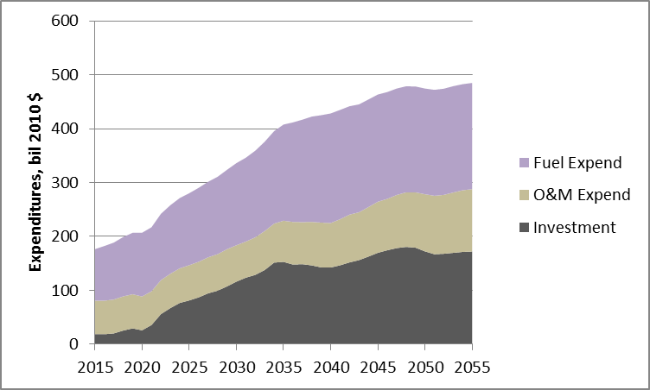

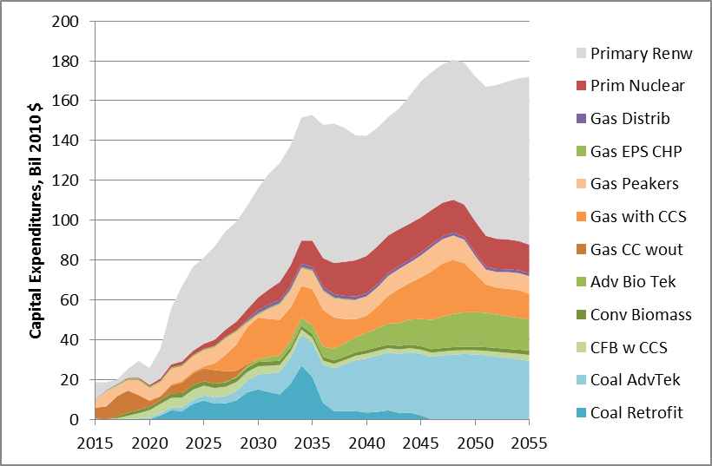

Conclusions
Based on levelized expenditures, electricity prices appear to be affordable while achieving low CO₂ emissions. It is important for a number of reasons to keep carbon prices relatively low (e.g., competitiveness, controlling capital turnover rates, avoiding huge transfer payments, fairness of regressive tax, macroeconomic adjustment costs). Additional measures can be combined with price incentives to reduce GHGs. CO₂ capture credits can incentivize the construction and dispatch of carbon capture and storage. Diversity and balance are part of a least-cost solution (due to rising marginal costs of any one measure) and provide risk avoidance.

References
- See: http://amiga.dis.anl.gov/
- Paltsev S., Reilly J.M., Jacoby H.D., and Morris J.F. The Cost of Climate Policy in the United States. MIT Joint Program on the Science and Policy of Global Change. 173 (2009).
- Shelby M.G., A.A. Fawcett, O.E. Smith, D.A. Hanson, and R.D. Sands, 2008, “Representing Technology in CGE Models: A Comparison of SGM and AMIGA for Electricity Sector CO₂ Mitigation,” Int.J. Energy Technology and Policy, Vol.6, No. 4.
- Hanson D.A., and Schmalzer D.K. “An Adoption Scenario for Carbon Capture in Pulverized Coal Power Plants in the USA,” Greenhouse Gases Science and Technology, 3:1-6 (2013) John Wiley and Sons.

