Overview

An Integrated Simulation/Optimization Approach to the Modeling and Analysis of the Decentralized Turkish Market
Kemal Sarica, Boğaziçi University, Phone: +902123597072, saricake@boun.edu.tr
İlhan Or, Boğaziçi University, Phone: +902123596772, or@boun.edu.tr
Gürkan Kumbaroğlu, Boğaziçi University, Phone: +902123597079, gurkank@boun.edu.tr
The scope of the study is to develop an agent-based simulation model of the Turkish electric power market. An integrated simulation/optimization approach will be used to the modeling and analysis of the decentralized electricity market. It is aimed to investigate market restructuring and deregulation and understand the implications of a competitive Turkish power market (under transmission line capacity and production technology based constraints) on electricity prices, availability and supply security. The agent based optimization/simulation model will be designed such that it can be used for investment planning as well, being capable to identify the most appropriate electricity production technology, size and region. CO₂ emissions resulting from power generation will be accounted for, featuring a scenario-based analysis of energy-environment interactions.
Power Transmission Operator, Power Transmitter Agents, Power User Agents, Independent Power Producers Agents, Power Generator Agents and System Operator (SO) will be included in the simulation model. Collective behavior and interaction of these agents is expected to generate the market behavior of Turkish electricity market. These agents shall interact under various scenarios and varying parameters such as bidding arrangements, demand forecasting, subsidy schemes, learning algorithms, market structure, primary resource prices and availability, and demand patterns.
The design of the system operator agent creates an optimization problem in which from which producer in which region should I get power to satisfy the demand from each consumer in different region with minimum cost while keeping the stable. This optimization problem is important in the sense that each power producer agent will react to the decisions made by the central planner and change their investment planning and horizons accordingly.

Methods
The interactions within an electricity market constitute a repeated game, whereby a process of experimentation and learning changes the behavior of the firms in the market (Roth and Erev 1995). A computational technique that can reflect these learning processes and model the structure and market clearing mechanism (with a high level of detail) appears to be useful for understanding market behavior. A most promising technique at this point in time is agent-based simulation (Batten, 2000).

Agent-based simulation provides a flexible framework to explore the influence that the repetitive interaction of participants exerts on the evolution of wholesale electricity markets. Static models neglect the fact that agents base their decisions on the historic information accumulated through the daily operation of market mechanisms. Market players have good memories and learn from past experiences (and mistakes) to improve their decision-making and can adapt to changes in several environments (economic, physical institutional and natural). This suggests that adaptive agent-based simulation techniques can shed light on features of liberalized electricity markets that static equilibrium models ignore.

Results
Currently all agents that represents the market actors are developed and implemented for a 30 bus network with 9 generators, 21 power user and 41 transmission line. Three type new algorithms imitating peak demand power, market share and price setting power of the generators. Sensitivty analysis has been completed and final touch-ups are being made to algorithms to implement at full scale. Interesting dynamic price formations have been observed under different scenario formations. The following price dynamics is one of the interesting dynamics that can be seen form Figure 1.
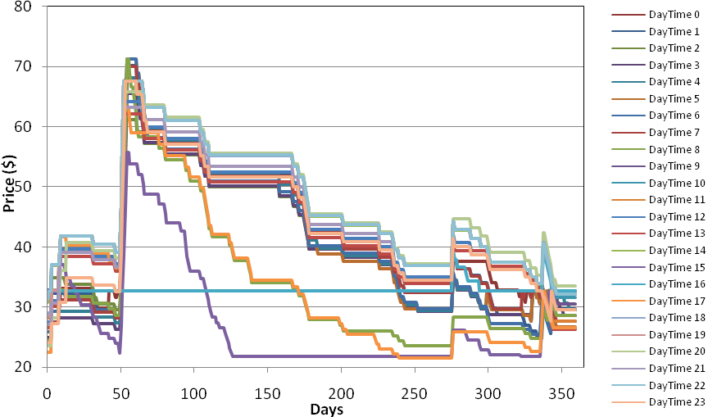
Figure 1 Hourly price formation at simulation year for base case
Above case shows a case where a generator is needed only for a single hour of the day throughout the year, showing how such a case may change the price dynamics. Figure 2 is the graph constructed such that timeline is converted to mode 24 mathematically. Figure 1 shows the spikes and settlement of the prices to the marginal costs for different day times. Model results shows that the if the disturbances generally increases the delays for the settlement of prices while prices gap to the marginal cost is a good indicator of the price levels at the spikes. Also transmission line constraint effects, demand dynamics, real and reactive power demand characteristics, technical constraints of generators effects on market dynamics has been observed and very interesting results have been identified.

Conclusions
The above results reveal that the effects mentioned above have substantial effects on market dynamics such that frequency of firm needed throughout the year may result huge price spikes far higher than its marginal costs, while transmission effects increases the variability of prices. Besides lack of information on transmission line usage rates during a transmission bottleneck, cuts down such variability on price spikes significantly Also the possibility to see the effect of renewable on price formation is under investigation with other parameters of the market structure. Thus for the case of Turkey and literature, valuable policy design contributions for liberalized electricity market design will be suggested in later case.

References
Bower, J. and D.W. Bunn (2000) A model-based comparison of pool and bilateral market mechanisms for electricity trading. The Energy Journal 21(3): 1-29.
Bunn, D. W. and F. S. Oliveira (2001) Agent-based simulation: an application to new electricity trading arrangements of England and Wales. IEEE Transactions on Evolutionary Computation 5(5): 493-503.
Bunn, D.W. and F. S. Oliveira (2003) Evaluating individual market power in electricity markets via agent-based simulation. Annals of Operations Research 121: 57-77.
Batten, D.F. (2000) Discovering Artificial Economics: How Agents Learn and Economies Evolve. New York: Westview Press.
Roth, A.E. and I. Erev (1995) Learning in extensive form games: experimental data and simple dynamic models in the intermediate term. Games and Economic Behavior 8:164-212.

