RENEWABLE ENERGY SUPPLY FOR ELECTRIC VEHICLE OPERATIONS IN CALIFORNIA

Anthony Papavasiliou, IEOR Department UC Berkeley, Phone +1 415 728 7532, tonypap@berkeley.edu
Shmuel Oren, IEOR Department UC Berkeley, +1 510 642 1836, oren@ieor.berkeley.edu
Ikhlaq Sidhu, IEOR Department UC Berkeley, +1 510 642 8790 , sidhu@berkeley.edu
Phil Kaminsky, IEOR Department UC Berkeley, +1 510 642 4927, kaminsky@ieor.berkeley.edu

Overview
Electric vehicles are emerging as a potentially significant class of consumers in the California power system [1], at the same time that the state is pioneering efforts for large scale renewable energy integration [2], [3]. Hence, although electric vehicles could cause a large increase in California electric power consumption, they also represent an ideal fit for unpredictable and uncontrollable renewable energy sources like wind and solar power [4] due to their inherently flexible charging patterns [5]. Using renewable energy to power the transportation sector can bring about a radical shift in the fuel mix of our energy supply, a fact which will have major technological, economic and environmental implications. In this paper we focus on identifying the correlation of California wind and solar power supply patterns with electric vehicle consumption patterns and we analyze a least-cost portfolio of supply contracts for satisfying these loads subject to the constraint of offsetting the carbon emissions resulting from powering these vehicles. We conclude that wind generation supply contracts are cost competitive with fossil fuel energy contracts for supplying electric vehicles, whereas solar power supply does not appear to be an economically viable option. We also find that careful charging strategies can lead to significant cost savings.

Methods
In our analysis we consider the task of a service provider such as the local utility or an independent profit-maximizing entity which has the objective of cost effectively and reliably supplying electricity to battery electric vehicles (BEVs). We assume that the BEV service provider operates under the constraint of offsetting the emissions of BEV energy supply , either by directly supplying solar or wind power, or by purchasing the appropriate quantity of renewable energy credits (RECs) to neutralize nonrenewable energy supply to BEVs. We assume that the BEV service provider can select from a mix of wind, solar, and fossil fuel contracts with the objective of minimizing its operational costs. Wind and solar power supply offer the advantage of contributing to the commitment of the BEV service provider for satisfying its demand with renewable energy sources. On the other hand, these resources are unreliable, and if faced with a shortage, the BEV service provider must purchase energy from the electricity spot market. Fossil fuel generators, in contrast, are more reliable and cheaper; however, their emissions must be offset by the purchase of RECs. According to the baseline scenario of the paper, the service provider serves 100,000 vehicles and follows a charging strategy which guarantees that all vehicles are fully charged at 6 am and 4 pm every day. Detailed assumptions regarding our analysis are based on are presented at [3].

Results
In order to assess the extent to which renewable generation can satisfy BEV demand, the supply of 100,000 vehicles with varying
Solar (MW) | 0 | 60 | 120 | 180
Wind (MW)
0 | 0.0 | 25.0 | 43.7 | 50.0
30 | 17.4 | 42.2 | 56.4 | 62.0
60 | 34.6 | 57.6 | 68.4 | 72.7
90 | 48.9 | 68.4 | 76.8 | 80.2
120 | 59.0 | 75.1 | 81.8 | 84.7
150 | 65.9 | 79.6 | 85.3 | 87.7
180 | 70.9 | 82.8 | 87.7 | 89.8
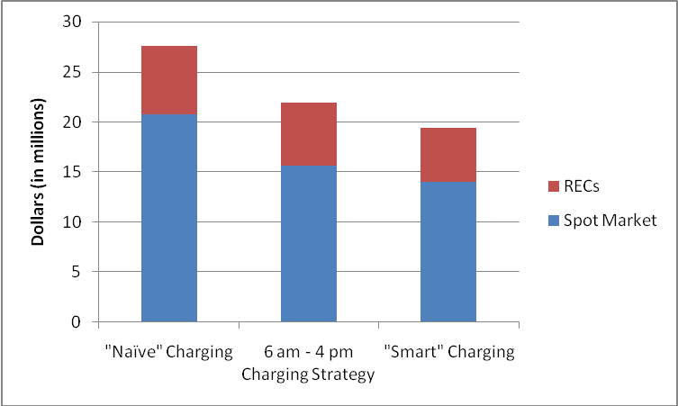
Figure 1: Annual cost savings from increasingly refined charging. strategies.
Table 1: Percentage of BEV energy demand satisfied by renewable energy sources (100,000 cars).

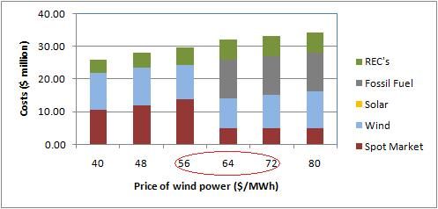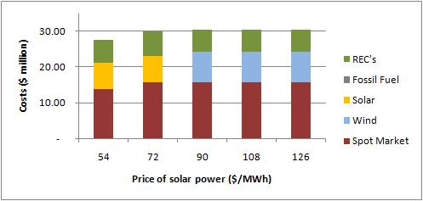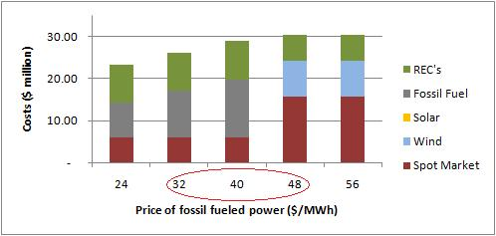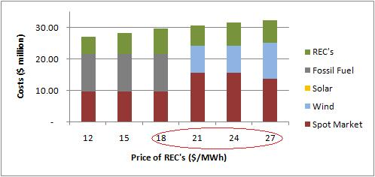
Figure 2: Sensitivity analysis on annual cost breakdown.

amounts of renewable capacity was simulated. The results are presented in Table 1. The beneficial impact of sophisticated vehicle charging strategies is confirmed in Figure 2. The first strategy is a naïve approach whereby customers are served immediately as they plug their cars into the grid. The second is the aforementioned baseline strategy whereby cars are fully charged at 6 a.m. and 4 p.m. and the third is an improved charging strategy whereby cars are charged at 75% of their full capacity at 6 a.m. and 4 p.m. due to the ability of the service provider to customize charging to individual driving habits. In figure 2 we have determined the optimal supply portfolio of the service provider for various combinations of price parameters and we have broken down the operational costs of the service provider.

Conclusions
Solar and wind power are complementary energy sources in California and can satisfy a significant proportion of electric vehicle energy demand. According to baseline assumptions, the best choice for supplying electricity to 100,000 BEVs is contracting for 60 MW of wind power. This is a conservative choice, whereby wind almost never exceeds BEV demand, but only covers 31.2% of vehicle energy demand, with the resulting deficits purchased in the spot market. Solar power becomes an economical option only below $72/MWh, which is significantly below the cost of most existing solar technologies. In contrast, wind power is cost competitive with fossil fuel generators at a reasonable range of wind power, fossil fuel power and REC prices. Careful charging strategies can increase the amount of wind energy that is economically absorbed by BEVs, and can result in $8 million of annual cost savings.

References
[1] D. M. Lemoine, D. M. Kammen, and A. E. Farrell, An innovation and policy agenda for commercially competitive plug-in hybrid electrical vehicles Environ. Res. Lett. 3, 2008.
[2] C. Loutan, and D. Hawkins, “Integration of Renewable Resources”, California Independent System Operator, CA, Nov. 2007.
[3] U.S. DoE Energy Efficiency and Renewable Energy “20% Wind Energy by 2030”, May 2008.
[4] F. van Hulle, "Large Scale Integration of Wind Energy in the European Power Supply: Analysis, Recommendations and Issues",European Wind Energy Association, Brussels, 2005.
[5] A. Papavasiliou, S. S. Oren Coupling Wind Generators with Deferrable Loads, IEEE Energy 2030, Atlanta, Georgia, 17-18 November 2008.
[6] A. Papavasiliou, A. Lee, P. Kaminsky, I. Sidhu, B. Tenderich, S. S. Oren, Electric Power Supply and Distribution for Electric Vehicle Operations, Electric Vehicle Summit, Berkeley, California, 21 November 2008. Available online at http://cet.berkeley.edu/ dl/ EV2Grid_Final.pdf.

On average, vehicles are in motion two hours every day, whereas it takes only 6-7 hours for empty batteries to be fully charged [6].

