[Energy Strategies in Norht-East Asia: ESPO- and Altay-Pipelines]

[Vladislav V. Savin, ERIRAS, +7 499 123 08 11, vsavin@eriras.ru, w11bsavi@mail.ru]
[Tatiana A. Mitrova, ERIRAS, +7 499 137 60 30, mitrovat@rambler.ru]
[Vladimir N. Sidorenko, MSU, +7 495 939 2676, v_sidorenko@mail.ru, vladimir@econ.msu.ru]
[Alexander A. Zaitsev, alex_zaytsev@bk.ru]

Overview
In March 2006 during his visit in China the President of the Russian Federation Vladimir Putin proposed to build the NG pipeline – “Altay”-pipeline – from Russia to China that could transport yearly up to 40 billion m³ of natural gas and be about 6700 km long (2700 km on Russia’s and 4000 km on China’s territory). In July 2008 the vice-speaker of Russian Duma, and simultaneously the President of the Russian Gas Society, Valery Yazev told on the video-conference “Moscow-Beijing” about Russian plans to enlarge the Russia’s gas export to the “East” and to build new capacities for transporting in 2020 up to 10% of Russian gas exports (~70 billion m³) to Asian-Pacific Region. So, it seemed that a new vision for a gas pipeline network going from Russia to China emerged.
However this was only the beginning of the story. Afterwards the world economy crisis came to Russia and deteriorated the Gazprom investments capabilities. This developments, together with environmental questions raised by Greenpeace, made the construction of Altay-pipeline highly implausible. As the result, this pipeline is for now not the part of the Gazprom general scheme for development of gas pipelines in Russian Federation till 2030.
In this paper authors try to show what kind of rationalizing could lead first to the discussing the Altay-pipeline and then to giving it up.

Methods
As a method of the analysis the formal approach of the game theory was used. We analyzed the game in extensive form (with perfect information) between three players: Russia, China, and USA, who could be interested in the one or in the other way in constructing “Altay”-pipeline. In the framework of the game two “lobbying” activities were introduced (one for USA and one for China): the lobbying for building the pipeline coming from China, and the support of ecological-environmental activities coming from USA (see Figure 1 below). The payoffs for players were developed using different assumptions for valuations of China’s receiving/non-receiving of Russian natural gas. The formulas according to which payoffs were calculated each year are:
$$U_{\text{Ru}}=P_{\text{Ch}}⋅Q_{\text{Ch}}−C_{\text{Ru}}+L_{\text{Ch}}+α_{\text{Ru}}{\text{EcSp}}_{\text{Us}}$$ | (1)
$U_{\text{Ch}}={\text{EnEf}}_{\text{Ch}}⋅Q_{\text{Ch}}−P_{\text{Ch}}⋅Q_{\text{Ch}}−С_{\text{Сh}}−L_{\text{Ch}}$ | (2)
$$U_{\text{Us}}=−{\text{EcSp}}_{\text{Us}}+k_{\text{Us}}⋅(−Δ_{Q_{\text{Ch}}})$$ | (3)

, – where U_{Ru}, U_{Ch}, and U_{Us} – are Russia’s, China’s, and USA’s payoffs, P_{Ch} is the price for natural gas delivered to China, Q_{Ch} is the quantity of natural gas delivered to China (in billion m³ of NG), EnEf_{Ch} is energy efficiency (in terms of billion GDP dollars for billion cubic metres of natural gas), C_{Ru}, and C_{Ch} are construction costs on Russian and Chinese side, L_{Ch} is lobbying “fees” that China transfers to Russia, EcSp_{US} is the support that environmental movements enjoy from USA, Δ_{QCh} is the reduction of Russia’s gas deliveries to China because of ecological protests supported by USA, k_{Us} is a the “gloating”-coefficient (for USA in billion of GDP dollars per billion cubic metres of China’s natural gas consumption diminishment).

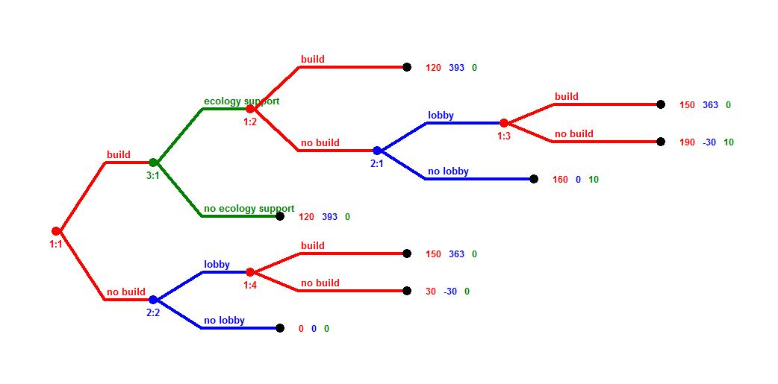
Figure 1: The game tree for the game regarding Altay-gas-pipeline
(Russia decides to build, China – to lobby, USA to support ecology)

Results
We have shown (with Zermelo-Kuhn-algorythm of searching for subgame perfect equilibria) that if the payoffs are calculated for 20 years beginning 2011 till 2030 for 40 billion m³ natural gas exported from Russia to China every year (and with interest rate equal to 10%, and in accordance to some assumptions regarding prices, quantities, construction costs, energy efficiency, lobbying, and ecological support), then it could be seen that USA have well understood interest of support the Greanpeace and other ecological movements for making the “Altay”-pipeline not to be build.
The authors didn’t want to say that exactly this scenario was realized between 2006 and 2009 which lead to non-construction of the “Altay”-pipeline. A lot of other facts have simultaneously played their roles. Also the third player not necessary USA could be taken into account (it could also be EU, or Japan, or Saudi Arabia etc.). The result shows that with certain assumptions about the payoffs the strategically important decisions that for decades could influence the pipeline landscape between Russia and China could be successfully influenced by any third party.

Conclusions
In this paper we have shown what kind of reasoning besides the world economy crisis could lie behind the facts that the “Altay”-pipeline could first be proposed and then later given up by the Russian government. So, through our analyzes we showed that quite any third party not interested in the construction of th pipeline could with success intervene in the situation and with using certain kind of strategies quasi “prohibit” the building of the pipeline.

References
1. Generalscheme of gas industry development till 2030. Gazprom. 2008. [Генеральная схема развития газовой отрасли на период до 2030 года. Газпром. 2008].
2. Osborne M. An introduction to game theory. Oxford University Press, 2006.

The question about Russian oil pipelines (ESPO or VSTO-1- and ESPO or VSTO-2-pipelines) going in North-East-Asia from West-Siberia oil fields to Chinese Daqing and/or Russian Nakhodka received a detailed answer in the following paper written by the Russian-Taiwan workgroup in 2008: Savin V. et al. “Russia’s global energy strategy - mapping trans-Asian pipelines (Intermediary Report 2008), http://www.eriras.ru/papers/2009/savin_taiwan_09.pdf.

