Overview

issues over energy decomposition Methodologies: Laspeyres or Lmdi?

Jihyo Kim, Seoul National University, +82-2-880-8284, frogpri1@snu.ac.kr
Hwa-Young Sin (Kim), Seoul National University, +82-2-880-8284, lovesin7@snu.ac.kr
Eunnyeong Heo, Seoul National University, +82-2-880-8323, heoe@snu.ac.kr
Energy index decomposition analysis is a methodology that decomposes the change of energy consumption level into production effect, structure effect, and intensity effect. It could be applied to energy demand and gas emission related to the use of energy, and many others. This analytic method has been used to conduct energy consumption analysis on manufacturing and industrial sectors to establish and evaluate the energy policies.
Energy index decomposition methodologies could be divided into “the Laspeyres family” and “the LMDI(log mean Divisia index) family”. There have been numerous studies and discussions surrounding these two index families. In an IAEA (International Atomic Energy Agency) publication, the IAEA recommended the use of IEA (International Energy Agency) model, which is constructed based on the Laspeyres index concept. Ang (2007) asserted that LMDI methods are preferable because of the interpretation of residual term. LMDI methods give perfect decompositions that do not leave a residual term contrary to Laspeyres index methods. However, perfect decomposition methods do not reflect a specific situation at a given time and it merely distributes the residual effect by allocating it to production, structural, and intensity effects. The decision for which decomposition concept should be selected as the international standard must be rooted in sound theoretical foundation and decided only after ample empirical studies. Our study starts from this question: can we say perfect decomposition methods are really superior to imperfect decomposition methods?
This study decomposed the change of energy consumption level in Korean manufacturing sector from 1986 to 2007 applying five decomposition methods: LMDI Ⅰ, LMDI Ⅱ, Laspeyres index, Paasche index, and Fisher index. LMDI I and LMDI Ⅱ belong to “the LMDI family”. Laspeyres, Paasche, and Fisher indices belong to “the Laspeyres family”. We tested whether these methods satisfy the robust conditions based on the index theory and compared the results from each of the five methods.

Methods
Index decomposition method: LMDI Ⅰ, LMDI Ⅱ, Laspeyres, Paasche, Fisher (multiplicative method)

Results
1) Analyses using the five decomposition methods yielded similar production, structural, and intensity effects. The results are shown in figures below. On average, total Korean manufacturing energy consumption increased 8.16% annually. There was a direct relationship between the production effect and the increase in energy consumption with the exception of the 1998 Korean financial crisis; however, structural and intensity effects did not show consistent relationships in terms of change in energy consumption level in Korea. The results indicate that on average, changes in production effect resulted in energy consumption increase of 8.36% annually. Changes in the structure effect resulted in a decrease of energy consumption by an average of 1.11 – 1.17% annually. Changes in the intensity effect caused an increase of 1.11 – 1.17% in energy consumption annually, on average.

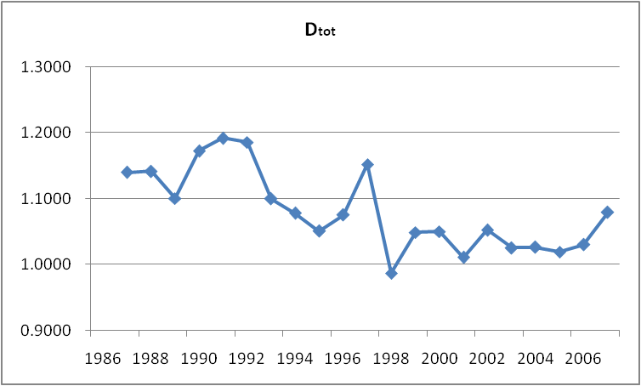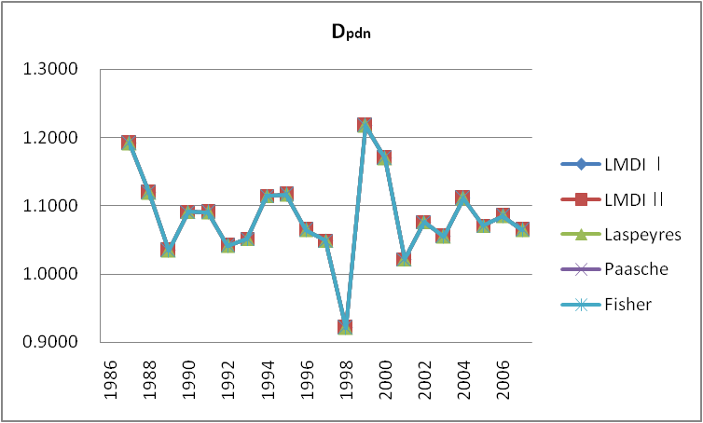
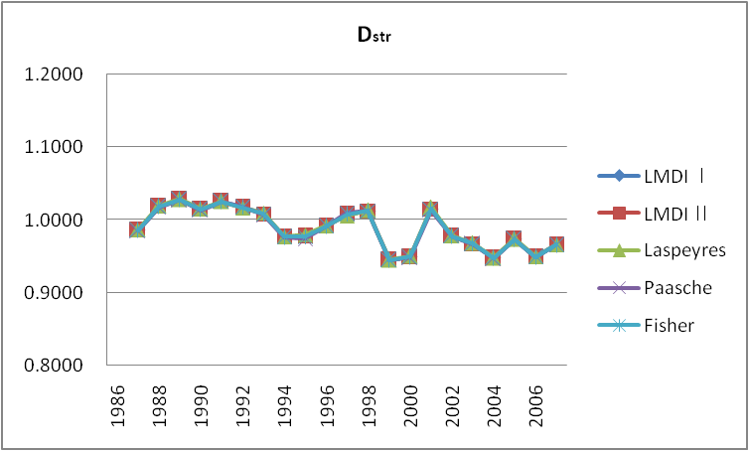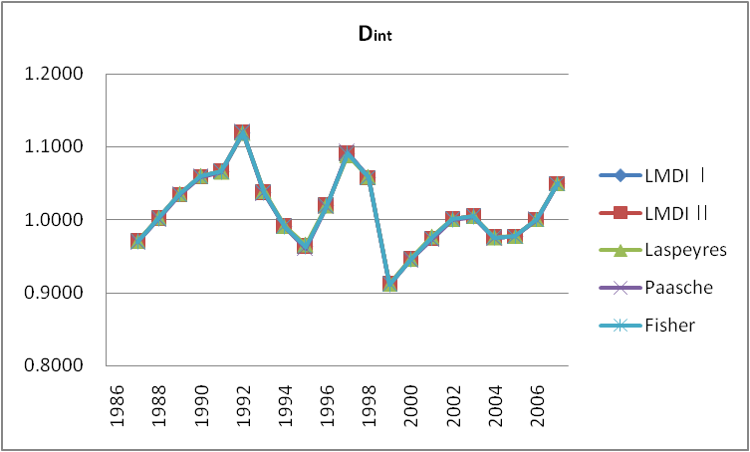

2) Perfect decomposition methods, LMDI Ⅰ, LMDI Ⅱ and Fisher index have no residual term; however, Laspeyres and Paasche index methods do. This distinguishing feature can be clearly observed in our analysis during the latter half of the 1990s – during the Korean financial crisis. The following figure shows the residual terms of five decomposition methods.
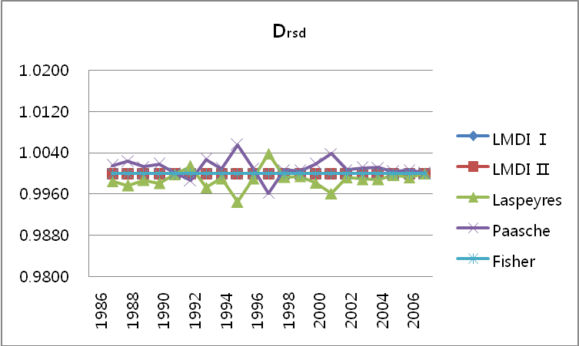

Conclusions
In this study, we found that there is little difference in the results of five decomposition methods; however, during the time of Korean financial crisis, we observed Laspeyres and Paasche index decomposition methods produced comparatively significant residual effects. This implies that imperfect decomposition methods such as Laspeyres and Paasche index of “the Laspeyres family” shows and could explain other factors affecting energy consumption change – such as economic shock and instability (in the case of 1998 Korean financial crisis) – that cannot be explained by production, structural, and intensity effects. Moreover, perfect decomposition methods, such as LMDI I, LMDI II, and Fisher index, are no more than formulas that distribute residual terms over the production, structural, and intensity effects using proper weight. Therefore, although these perfect decomposition methods seem to provide accurate overall results, they do not take into account special circumstances that could affect overall energy consumption.
The existing studies about decomposition methodologies suggested that perfect decomposition methods which do not leave a residual term are more desirable. Our study showed decomposition methods yield similar production, structural, and intensity effects whether these methods leave a residual term or not. It also showed interpretation of residual terms allow for a deeper understanding of the implications behind the numbers, which leads to understanding of energy consumption in more realistic terms and ultimately to better energy policies.

References
Ang, B. W. and N. Liu (2007): “Energy decomposition analysis: IEA model versus other methods,” Energy Policy, Vol. 35, pp. 1426-1432.

Ang, B. W. and F. L. Liu (2001): “A new energy decomposition methods: perfect in decomposition and consistent in aggregation,” Energy, Vol. 26, pp. 537-548.

Ang, B. W. and K. H. Choi (1997): “Decomposition of aggregate energy and gas emission intensities for industry: a refined Divisia index method,” Energy Journal, Vol. 18, No. 3, pp. 59-75.

Ang, B. W., F. L. Liu and H. S. Chung (2004): “A generalized Fisher index approach to energy decomposition analysis,” Energy Economics, Vol. 26, pp. 757-763

