Productivity in exploration drilling
Petter Osmundsen*, Kristin Helen Roll** and Ragnar Tveterås**
* University of Stavanger /Norwegian School of Economics and Bus. Adm.
** University of Stavanger / International Research Institute of Stavanger

Brief overview
Recently, we have seen falling oil prices combined with sticky costs at a high level in the petroleum industry. This cause cost cuts and project postponements, thus challenging reserve replacement of oil companies and security of supply for consumers. Costs are particularly high for drilling. High rig rates are obviously important. In new contracts for high-spec semi rigs on the Norwegian Continental Shelf (NCS), e.g., the day rate has increased from 147,500 USD per day in July 2004 to 530,820 USD in September 2008, i.e., an increase of 260 per cent in four years. In addition we experience a dramatic fall in drilling productivity (Figure 1).

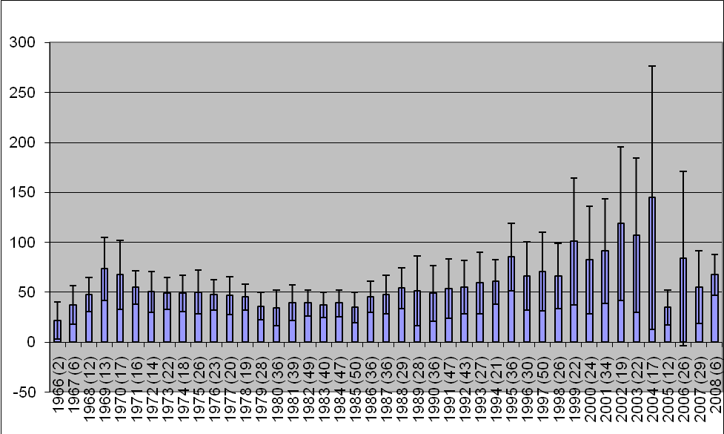

Figure 1: Average meters drilled per day. Exploration wells on the NCS, from 1966 to 2008. Annual number of wells in parenthesis. Black vertical lines indicate standard deviation. Data source: Norwegian Petroleum Directorate.

This paper analyses the development in drilling productivity in exploration wells at the Norwegian continental shelf. We analyse a complete panel data set from the Norwegian Petroleum Directorate (NPD) with detailed information on all exploration wells drilled on the NCS from 1966 to 2008. The article also draws on a number of meetings, presentations and conversations with key specialists in the NPD, oil companies, rig contractors and oil service enterprises.

Method
Relevant explanatory factor for variations in drilling productivity are examined by means of econometric productivity analyses, which allow us to account for several covariates simultaneously. The unique dataset from the NPD - covering all exploration wells on the NCS - allows us to apply econometric analyses to ascertain the vital explanatory factors for variation in drilling productivity over time and between different wells.
As dependent variable in the econometric analyses we use meter per day, which is the industry standard for measuring drilling efficiency. Our production function is specified as a translog in continuous variables. We implement both (1) variables that represent physical characteristics associated with the exploration well and (2) variables that are proxies for supply and demand conditions in the drilling market, such as the oil price and total number of wells drilled on the NCS, which may influence productivity.

We also test for differences in productivity between drilling facilities and oil companies by estimating fixed effects model. Our results indicate significant differences in productivity both between drilling facilities and between oil companies.

Results
Our findings largely correspond with our a priori expectations. We find that the following explanatory factors are significant in explaining drilling efficiency: (1) Wildcats are more productive than appraisal wells. (2) The Barents Sea wells are the least productive, North Sea wells are most productive, and Norwegian Sea wells are in between. (3) Wells with discovery are less productive than dry wells. (4) Water depth has a negative effect on productivity. (5) Drilling productivity slows down when oil prices increase. (6) Drilling productivity is lower in years when many wells are drilled on the NCS. (7) We can trace a positive effect on productivity from technological changes.

Conclusions
The combination of falling drilling efficiency and increased rig rates have led to a dramatic increase in costs. Helge Lund, CEO of the major player at the NCS - StatoilHydro - has referred to this as a ‘cost tsunami’. The oil companies could cope with the dramatic cost increase when the oil price was above 100 USD per barrel, but the present cost structure is seriously challenging the development of new reserves at current oil prices well below the 100 USD level.
This article analyses one of the major drivers of the cost inflation in the oil industry - the decrease in drilling efficiency. The output of our analyses can be useful, in two ways: 1) by identifying the underlying factors that influence drilling efficiency, we provide a basis for making forecasts of future drilling efficiency levels. For instance, what is the likely effect on drilling efficiency of the current oil price fall? 2) By identifying the major explanatory factors for variations in drilling efficiency over time we can give advice on where the oil industry has the largest potential for improvement. - Is it in a careful management of drilling capacity versus drilling tasks, or is it primarily in better handling of deep-water drilling?

References
Corts, K S and J Singh (2004), ‘The Effect of Repeated Interaction on Contract Choice: Evidence from Offshore Drilling’, Journal of Law, Economics, and Organization 20 (1), 2004, 230-260.
Kellog, R (2007), “Learning by Drilling: Inter-Firm Learning and Relationship Persistence in the Texas Oilpatch”, Unpublished mimeo, Department of Agricultural and Resource Economics at UC Berkeley, and University of California Energy Institute (UCEI).
Mohn, K and P Osmundsen (2008), ‘Exploration economics in a regulated petroleum province: The case of the Norwegian continental shelf’, Energy Economics 30,2,303-320.
Moomjian, C A (1999), ‘Contractual insurance and risk allocation in the offshore drilling industry’, Drilling Contractor, January/February, 19-21.
Osmundsen, P, A Toft and K A Dragvik (2006), ‘Design of Drilling Contracts - Economic Incentives and Safety Issues’, Energy Policy 34, 2324-2329.
Osmundsen, P., T. Sørenes, and A. Toft (2008), ’Drilling Contracts and Incentives’, Energy Policy 36, 8, 3138-3144.

