EvalUATING AN NGCC PROJECT: TECHNICAL OPTIMISATION VERSUS REAL OPTIONS
Alain Galli, Cerna Mines-Paristech, +33 1 40519314, alain.galli@mines-paristech.fr
Salaheddine Belkas, Mines-Paristech, belkas_salaheddine@yahoo.fr
Margaret Armstrong, Cerna Mines-Paristech, +33 1 40519313, margaret.armstrong@mines-paristech.fr

Overview
The design of new power plants is complex because many technical options can be used to increase efficiency or to decrease emissions. The deregulation of the energy sector has made it even more difficult to evaluate the long-term profitability of power plants because of uncertainties on electricity prices and fuel costs. The standard approach in real options is by modelling the spark spread (See for example, Hsu, 1998; Deng et al 1999, Eyleland & Geman, 1999;Nasakkala & Fleten, 2005; Maribu, Galli & Armstrong, 2007). While interesting this approach has two weak points because it does not take account of technical costs. Some more recent papers (e.g. Tseng & Barz, 2002; Deng & Oren, 2002) show the importance of taking account of such costs. This paper shows how to incorporate
- the technical problems (and costs) of ramping the plant up and down each time it has to start generating and
- the possibility of using financial derivatives to hedge the production.
into the evaluation procedure in order to get more realistic estimates.

Methods
On the electrical engineering side, Li (2006) developed an interesting approach to multi-objective optimisation for integrated energy systems for power and/or cogeneration in the CO₂ abatement context. By considering the specific investment cost and the CO₂ emission rate as two objectives, he was able to typify the performance of NGCC plants available on the market for power and/or cogeneration. One disadvantage of Li’s approach is that he fixed the prices for gas, electricity and CO₂ emissions. Our work extends this methodology by allowing for the fluctuations in the electricity and gas prices. We assumed that the ordering relation between the projects found by Li (2006) would be the same if more flexibility was introduced. The mean-reverting model with stochastic volatility proposed by Maribu et al (2007) was used to model the joint evolution of electricity and gas prices. CO₂ emission prices were assumed to be constant because the markets up to 2007 give little information on future emission prices.

The NGCC plant we consider is designed to operate during peak load periods on the French market (that is, during the 12 hour period from 9H to 20H on weekdays). The cost of ramping up the plant depends on whether it was working or not in the preceding period. That is, a cold start is more expensive than a hot start. The external temperature was also considered because it affects plant efficiency - in our case by up to14%.

Several hedging strategies were considered ranging from “fixed margin” strategies where forward prices are used for both gas and electricity, through to pure spot strategies where the owner of the plant decides every day whether to produce electricity the next day or to buy it on the market. Two more interesting strategies are also considered: the first is a tolling agreement and the other is an arbitrage between calendar futures for electricity and gas, and day-ahead prices. The economic values of these strategies are compared with each other and with the results obtained by Li.

We computed the values, firstly within the framework of our price model, and then used data from the French market for the period 2006 to November 2008 to check whether they turned out to be true in reality. It could happen that the strategy appears excellent when tested within a model but that it loses money in the real world.

Results
The figure below presents histograms of the project NPVs for the four strategies. The arbitrage strategy between long term and short term futures (yellow) and the tolling agreement strategy (light blue) are clearly more interesting.

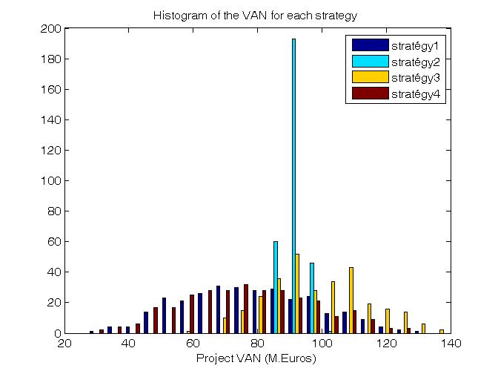
Tolling Agreement
Arbitrage long term short term

Figure: Comparing the histograms of the project NPVs for the four strategies, with the first two strategies in red and dark blue. The NPV for the tolling agreement in shown in light blue while the arbitrage between long term futures for gas and electricity & short term day-ahead prices is shown in yellow

Conclusions
Flexibility clearly adds value to a power plant. This increase in value is accentuated by the lack of symmetry between high and low values for electricity prices. It also depends on the volatility of the electricity prices, and to a large extent, on the correlation between electricity and gas prices. It is interesting to note that the best strategy on average (long term versus short term arbitrage) is only possible by the interaction between the physical market and the financial one. Only the owner of a plant could carry out such a strategy. The tests on historical data confirm the pertinence of this strategy.

References
Deng S., B. Johnson & A. Sogomonian (1999) Spark spread options and the valuation of electricity generation assets, IEEE System Sciences, HIC SS-32, Proceedings of the 32nd Annual Hawaii International Conference
Deng S.,Oren S. (2002) Incorporating Operational characteristics and startup costs in Option based valuation of Power Plant generation Capacity. PEIS 17 (2) pp155-181.
Deng S. Xia Z. (2006) A Real Option Approach for Pricing Electricity Tolling Agreements. International Journal of Information Technology & Decision Making, Vol 5 No3 pp 421-436.
Eyleland A. & H. Geman, (1999). Fundamentals of Electricity Derivatives. in Energy Modelling and Management of Uncertainty. Risk Books.
Hsu, M. (1998) Spark spread options are hot, The Electricity Journal, Vol 11, N° 2, pp 28-39
Li, H. (2006) Environomic Modelling and Multi-Objective Optimisation of Integrated Energy Systems for power & Cogeneration, Thèse EPFL, N° 3657
Maribu K.M., A. Galli & M. Armstrong (2007) Valuation of Spark-Spread Options with Mean Reversion and Stochastic Volatility, International Journal of Electronic Business Management, Vol 5, N° 3, pp173-181
Nasakkala E. & S.E. Fleten, (2005) flexibility and technology choice in gas fired power plant investments, review of Financial Economics, Vol 14, N° 3-4, pp 371-393
Tseng CL & G Barz, (2002) Short-Term Generation Asset Valuation: A Real Option Approach Operations Research Vol 50,No 2, March-April 2002, pp 297-310

