Concentrating on the Future: The Benefits of Large-Scale Solar Electric Technologies

Lori Smith Schell, Ph.D.
President, Empowered Energy

LSchell@EmpoweredEnergy.com

Phone: (970) 247-8181
Fax: (970) 246-3761

Overview

Large areas of the globe are blessed with a bountiful and renewable solar resource, the use of which is environmentally sustainable and does not contribute to global warming. Electricity generated by large-scale solar power (“LSSP”) technologies reduces reliance on fossil fuels (typically natural gas), reduces emissions, provides health benefits, and creates local and regional jobs. Certain LSSP technologies may include integrated thermal energy storage (“TES”) that extends the solar-only hours of generation and allows for limited dispatch of the solar-generated electricity. Hybridization of LSSP technologies with natural gas-fired generators allows both complete use of the solar resource and complete dispatchability of the hybridized system, though avoided emissions and related health benefits are reduced. Even countries that export fossil fuels can benefit from indigenous solar power generation in that domestically generated solar electricity frees up more of a country’s fossil fuel reserves for export.

The purpose of this paper is to demonstrate to policy makers that LSSP technologies (operating with TES where applicable) provide quantifiable value in a number of important categories. This knowledge may encourage policy makers to support ratepayer-funded incentives that will lead to increased rates of market penetration and subsequent cost reductions over time. Increased rates of LSSP market penetration in the State of California can make a significant contribution to California’s greenhouse gas reduction goals.

Methods

This paper presents the results of a detailed examination of the aggregate value proposition to California of six different LSSP technologies, operating with TES where applicable: (i) Parabolic troughs; (ii) dish/engine systems; (iii) solar power towers; (iv) compact linear Fresnel systems; (v) concentrating photovoltaics (“PV”); and (vi) non-concentrating PV. Separate value propositions are derived based on avoiding two different types of in-state natural gas-fired electricity generators, i.e., a peaker or a combined cycle plant. Value components are quantified for: (i) Avoided capacity-related costs; (ii) avoided fuel costs and related price hedging value; (iii) avoided water use; (iv) avoided emissions (by type) and related health benefits; and, (v) net job creation potential. In cases where the LSSP plant is located on-site or at distribution system voltages, value components for applicable avoided transmission and/or distribution costs are also calculated.

The basic operating characteristics for each of the six LSSP technologies will be introduced, including a discussion of global developments related to each technology. A more-detailed discussion will follow, describing the quantification of each of the major value components. Quantification of value components is based on third-party research, market prices, and extrapolation of other results found in the literature.

Results

Figure 1 illustrates the value proposition of LSSP technologies in California when the avoided generator is a natural gas-fired peaker; the paper also presents the value proposition of LSSP technologies in California when the avoided generator is a natural gas-fired combined cycle plant.

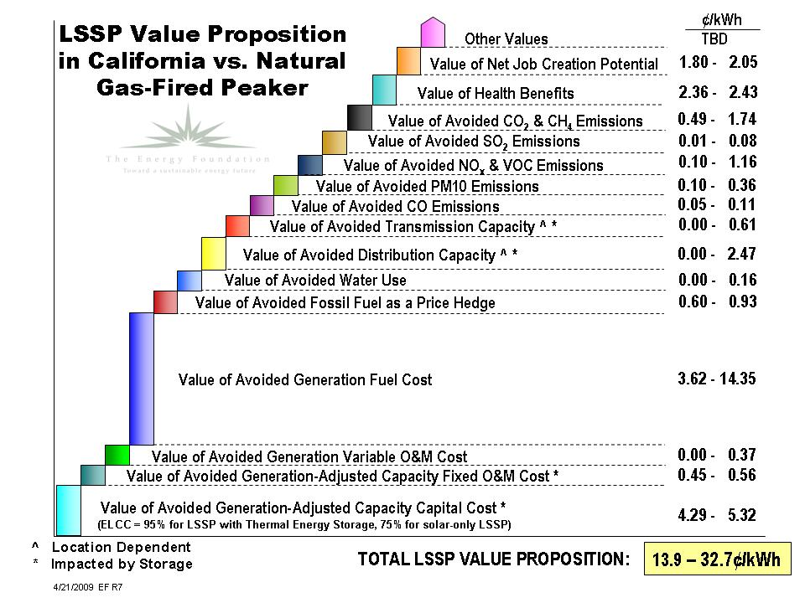

Figure 1. LSSP Value Proposition in California vs. Natural-Gas Fired Peaker

Conclusions

Large-scale solar power technologies can provide significant benefits to the ratepayers of California. Among the most important benefits are the value of avoided natural gas use by central station generators, the value of avoided emissions, the value of health benefits, and the value of net job creation. If the paper’s projected 10,000 MW of LSSP installed capacity in California is achieved by 2020, these LSSP technologies could result in between 12.3-16.7 million metric tons of carbon dioxide emissions reductions, or between 7-10% of California’s targeted goal of 172 million metric tons in total carbon dioxide reductions.

References

Energy and Environmental Economics, Inc., 2008, “2008 Market Price Reference Model,” Final Public Version. http://www.ethree.com/downloads/MPR/2008%20MPR%20Model%20E4214%20Final%20Public.xls

National Renewable Energy Laboratory, undated, Job and Economic Development Impact Models, “JEDI Solar Model, CSP Trough Model rel. CSP1.08.02a.” http://www.nrel.gov/analysis/jedi

U.S. Department of Energy, June 2008, “Assumptions to the Annual Energy Outlook 2008, with Assumptions for 2030,” Energy Information Administration, DOE/EIA-0554(2008). http://www.eia.doe.gov/oiaf/aeo/assumption/pdf/0554(2008).pdf

