Estimation of Capacity Payments in Hydro Dominated Systems

Rafael Campo, Independent Consultant, +1(561)901-0646, rcml1@attglobal.net]

Overview
Adding capacity payments to the energy prices resulting from the spot and long term electric markets has been controversial, not being clear the benefit that consumers obtain in exchange for these payments. Some markets base capacity payments on the annualized fixed cost of a peaking unit. More recently, auctions have been introduced in several markets to establish the payments. This paper discusses a rationale for capacity payments, for mainly hydro systems, that suggests the utilization of a mathematical model to estimate them, based on Kholodnyi’s Non Markovian methodology [1]. The model will be presented, as well as results from a case study, using data from an actual electric power market.

Methods

Review of existing practices and their evolution in time for several Central and South American markets; use of auctions to estimate capacity payments; formulation of Non Markovian model as proposed in [1], adapted to the problem at hand; justification of its use for estimating capacity payments in mainly hydro systems; use of simulation, statistical analysis and stochastic models to estimate its parameters; application to a mainly hydro electric power market.

Results

A case study will be presented for the Colombian power market. Model results will be shown to be close to capacity payments. A link will be established between unitary capacity compensation and rationing costs, allowing the establishment of consistency between both values. Use of the model to establish proper auction parameters will be illustrated.

Two states are identified in the Colombian power market, depending on the occurrence of an “El Niño” event, spot prices being considerably higher during such events, due to draughts in the main watersheds, as can be appreciated in Figure 1:

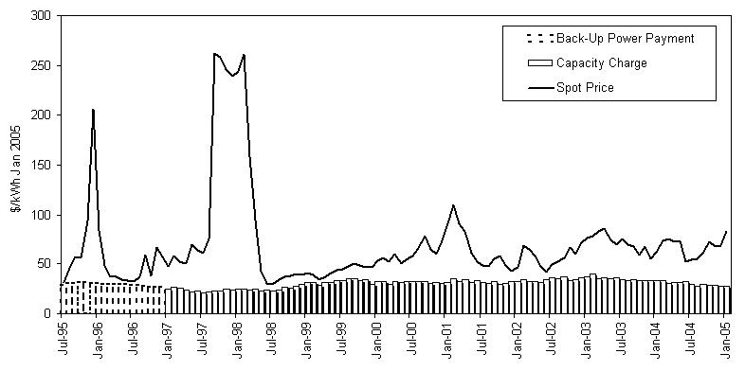
Figure 1

Monthly Spot Prices (Col $/kWh)

A modification of the methodology in [1] is proposed based on simulation results. Parameters are estimated on the basis of historical values, as follows:

- Transition probabilities between spike (i.e. El Niño) and regular states are estimated using historical inflow data;
- A mean reverting geometric Brownian process is used to model spot prices;
- Using simulation and Kholodnyi’s formulation, values are obtained for the capacity charge that closely agree with those used by the Regulator and the results of recent auctions.
- A link is established between these market driven values and rationing costs.
- An application of the model to the estimation of model parameters will be provided.

Conclusions

Experience in mainly hydro systems proves the importance of capacity compensation to ensure adequate supply;
(2) Recent practices highlight the need to obtain good market based estimates previous to establishing its value either by administrative means or by using auctions;
(3) Kholodnyi’s Non Markovian model provides the basis for developing models for obtaining these estimates;

References
[1] “A non-Markov Method” V. Kholodnyi, EPRM Electricity March 2001

[2] Mejía, Patricia “Time Series Simulation accounting for El Niño” (In Spanish) M.Sc Thesis, Universidad de Los Andes, Bogotá (Colombia). 1995

[3] Ross, Sheldon “An Elementary Introduction to Mathematical Finance” Cambridge University Press 2003

[4] “Study of Colombian Capacity Charge – Final Report” (in Spanish), Universidad Pontificia Comillas, Madrid, May 10 2000.

[5] “A market approach to long-term security of supply “ Vásquez et al (2002), IEEE Transactions on Power Systems Vol 17, No 2 pp 349-357.

