Overview
Modeling price effects of the Russian-Ukrainian gas conflict in the European gas market
Stefan Lochner
Institute of Energy Economics at the University of Cologne (EWI)
Albertus-Magnus-Platz, 50923 Cologne, Germany
Tel. +49-221-1709 1818 Email: Stefan.Lochner @uni-koeln.de
With a total market share of 25 percent, Russia is the single largest supplier of natural gas to the European Union. As there does not yet exist a direct transportation route from Russia into the EU (with the exception of pipelines to Finland and the Baltic states), the majority of the gas volumes has to be transported via (non-EU) transit countries. These are mainly Belarus and Ukraine, with the latter one transiting 65 percent of total Russian exports to the EU. Ukraine, itself a large importer of gas from or via Russia, has frequently been in negotiations with Russia about the price it is paying for natural gas, transit fees and outstanding debt for past gas imports from Russia. These negotiations became severe conflicts in the winters of 2006 and 2009, which led to prolonged interruptions of gas transits through Ukraine to Europe. This caused severe disruptions of gas supply in some Eastern European countries, especially in 2009. In central and western Europe, however, storage inventories and natural gas from other sources were sufficient to meet demand. At the time, the characteristics of the European gas infrastructure system limited western and central European countries in shipping gas to the east. Furthermore, adequate price signals to consumers were not sent as liquid natural gas trading does not take place in any of the eastern European countries. In central and western continental Europe, where some more or less liquid gas hubs exist, significant price spikes were not observed. This surprised even industry insiders, politicians and regulators as it suggested that the system coped much better with the supply shortfall than most had expected.
In this paper, we simulate short-run marginal costs for representative locations in each EU country before and during the crisis and compare them with actual prices. This allows us to analyse how gas flows were changed to meet demand during the crisis, whether the gas supply infrastructure was utilized as efficiently as it could have been, why price effects were much smaller than expected and what price signals should have been sent to consumers in the various countries without liquid gas trading. In a second step, we show how further interconnection of the European grid – by merely enhancing compressors to allow reverse flows if necessary on most pipelines – would have altered the supply and price effects for the different European countries.

Methods
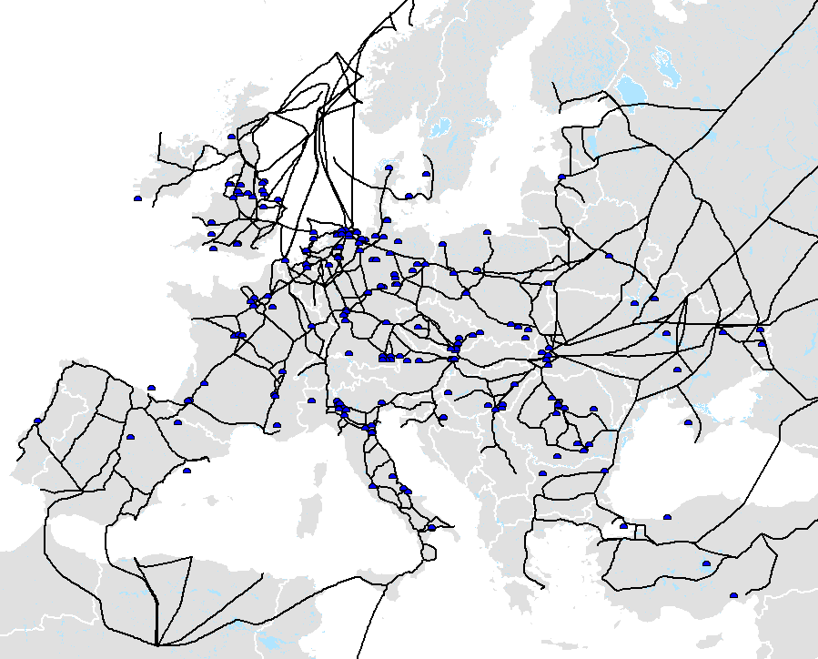
We apply an advanced version of the TIGER natural gas infrastructure and dispatch model, which was developed to analyse gas infrastructure projects, security of supply considerations and capacity bottlenecks in the context of the whole European gas infrastructure. With a high temporal granularity and the incorporation of capacity data on all major transmission pipelines, gas storages, LNG import terminals (see Figure 1) as well as regionalized gas supply and demand, the linear optimization model allows a detailed simulation of the optimal gas dispatch taking those parameters as given. Apart from the utilization of the aforementioned infrastructure assets, the model enables the determination of the locational short-run marginal costs of gas supply at each point in the network (along the lines of Cremer and Laffont (2002) who derive nodal prices in a theoretical model). In theory, these locational marginal costs should equal prices in a competitive market in the short-run.
Figure 1: TIGER infrastructure model
We parameterize the model for the 2008 / 2009 winter with actual infrastructure availability and (estimated) demand and supply data and calculate physical gas flows and the short-run marginal gas supply costs to the different European gas hubs. This enables the comparison of the gas price estimator to the actually observed prices before and during the crisis and, thus, allows a validation of the estimator and the performance of the market during the shortages. In a second simulation, we assume a further market interconnection as envisaged by the European Commission to increase security of supply. Therefore, we allow the model to use pipelines for gas flows in the reverse direction if necessary during a crisis. This implies that further market integration takes place by upgrading compressor stations but without new pipeline constructions. Hence, this simulates a relatively low cost solution for additional market integration.

Results
As a result of our model-based simulations with the European natural gas infrastructure model TIGER, we find that the countries which experienced shortages would also have experienced them under a more market-orientated and liberalized market structure. For the central and western European countries, our simulation also tracks actual price developments fairly well (see Table). This implies that even in a competitive market, price spikes in Eastern Europe would not have impacted central and Western Europe significantly as bottlenecks within the European gas infrastructure would have prevented price arbitrage across the continent.
Table: Modeled and actual impacts | Figure 2: Supply and price effects of increased market integration  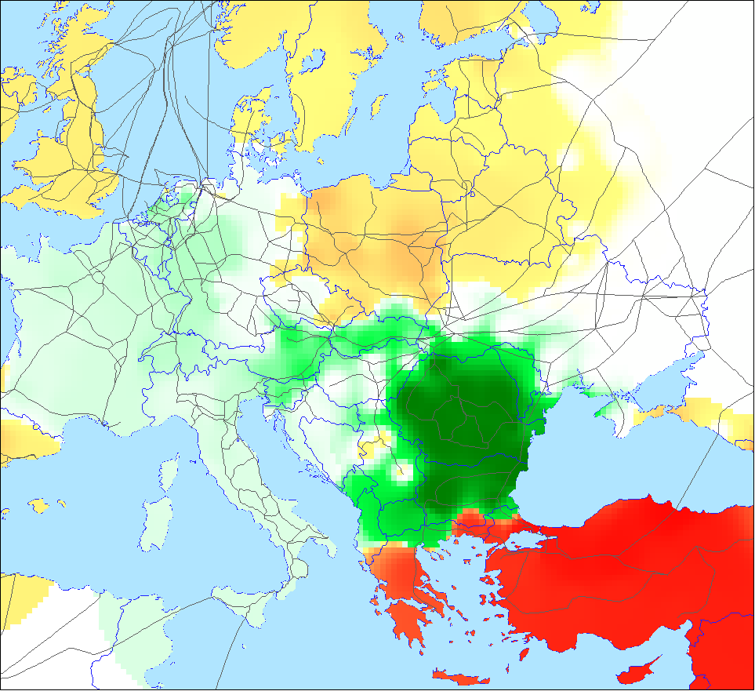
This, unsurprisingly, changes in a market with further interconnection (see Figure 2). In this case, the switching off of consumers in some Eastern European countries, namely Romania and Bulgaria, would not have been necessary, and price increases in other countries would have been smaller. However, falling prices in those countries also mean increasing prices in other parts of Europe implying that some consumers would have been worse off had a physically more integrated market already been implemented. Interestingly, this effect would be greatest for those countries with a high dependency on Russian gas – but which escaped the severity of the 2009 crisis, namely Turkey, Greece, Poland and the Czech Republic. During the 2009 Ukrainian-Russian gas conflict, these countries had the opportunity to fall back on natural gas from other supply sources or via other transport routes. With increased interconnection and liquid gas trading in Eastern Europe, these group of countries would have to “share” the alternative gas supply as price arbitrage would ensure that some of these volumes flow to the more heavily affected countries.

Conclusions
During the 2009 Russian-Ukrainian gas crisis, the European gas market behaved almost as efficiently as the infrastructure allowed it to. Observed price impacts on western European trading points matched those predicted by the model. Relatively small improvements regarding increased connectivity of the different national networks would have allowed a reduction of the supply shortages in some, but not all, of the eastern European countries which experienced them. The results further suggest that interconnection within western and central Europe is already relatively advanced, which explains why most countries were much less affected by the crisis than expected. Especially in Eastern Europe, however, markets are not integrated enough. This caused some of the countries in the region to escape the crisis without much harm while others experienced severe shortages. In the short-term, the former group of countries would thus lose, the latter one profit from higher physical market integration.
The policy implication of the crisis and this analysis is, that large-parts of Europe were much better equipped to handle the disruptions when many observes had thought. Further market integration, however, will also improve the situation for the more exposed countries and, thus, significantly reduce the dependence of European consumers on single transit or supply countries.

References
Cremer, H., and J.J. Laffont. 2002. Competition in Gas Markets. European Economic Review 46: 928-935.
Lochner, S., and D. Bothe. 2007. From Russia With Love – An analysis of the Nord Stream pipeline’s impact on the European transmission system with the TIGER model. EWI Working Paper 07/2, Cologne/Germany.
Pirani, S.; J. Stern & K. Yafimava. 2009. The Russo-Ukrainian gas dispute of January 2009: a comprehensive assessment. Oxford Institute for Energy Studies, February 2009, NG 27.
Stern, J. 2006. The Russian-Ukrainian gas crisis of January 2006. Oxford Institute for Energy Studies. Downloadable: http://www. oxfordenergy.org/pdfs/comment_0106.pdf (15 Jan 2009).

For a detailed elaboration on the economic (and potentially political) background on the two crises, see Stern (2006) and Pirani et al. (2009).
“Transport Infrastructure for Gas with Enhanced Resolution”-Model, see Lochner and Bothe (2007) for a detailed description.

