Table of figures

HUBBERT OIL PEAK AND HOTELLING RENT REVISITED BY A SIMULATION MODEL
Pierre-Noël Giraud, CERNA Mines ParisTech, Phone: +33 (0)1 40 51 92 06, E-mail: pierre-noel.giraud@ensmp.fr
Timothée Denis, EDF-R&D, Phone: +33 (0)1 47 65 40 44, E-mail: timothee.denis@edf.fr
Aline Sutter, EDF-R&D, Phone: +33 (0)1 47 65 16 61, E-mail: aline.sutter@edf.fr
Figure 1: Oilfields production profiles 3
Figure 2: Exploration and production diagram 3
Figure 3: Simulator working diagram 4
Figure 4: Pattern of the relative error (coefficient of variation) on total oil volume 4
Figure 5: Exploration heuristic curves 6
Figure 6: Classical Hotelling rent 7
Figure 7: Estimated depletion date by agent 8
Figure 8: Pattern of the relative standard deviation (coefficient of variation) on total oil volume (and depletion date) 8
Figure 9: CAPM return (discounting factor) / risk (relative standard deviation) curve 8
Figure 10: Model structure 9
Figure 11: Exploration levels per region 10
Figure 12: Duopoly interaction 11
Figure 13: Distribution of oilfields by category volume 12
Figure 14: Simulation outputs – single agent exploring one global area – uncapped exploration - 1 scenario 13
Figure 15: Simulation outputs – single agent exploring one global area – exploration capped - 1 scenario 14
Figure 16: Simulation outputs – single agent exploring one global area – exploration capped - 100 scenarios 15
Figure 17: Distribution of oilfields by category volume per area 16
Figure 18: Simulation outputs – single agent exploring two areas – exploration uncapped - 1 scenario 17
Figure 19: Simulation outputs – single agent exploring two areas – exploration uncapped - 100 scenarios 18
Figure 20: Simulation outputs – single agent exploring two areas – exploration capped in zone 1 - 1 scenario 19
Figure 21: Simulation outputs – single agent exploring two areas – exploration capped in zone 1 – 100 scenarios 20
Figure 22: Simulation outputs – Stackelberg duopoly – exploration uncapped– 1 scenario 21
Figure 23: Marginal cost evolution in single agent and duopoly cases 22

Introduction
As conventional oil reserves are declining, oil economics has become a burning issue: Hubbert oil production peak, relevancy of a scarcity Hotelling rent, oligopolistic behaviour and optimal strategy of OPEC.
On the basis of these classical approaches and using an exploration and production simulation model, we revisit the long-term oil market fundamental driving forces. The simulation is based on rational representative agents with limited but improving information.
The aim is to get a grasp on the long-term dynamics of oil price setting, by accounting for:
- reserves depletion;
- different production cost ranges;
- technical constraints (exploration and production);
- uncertainty on oilfields size and production cost.
The model allows to investigate three major directions:
- a single agent exploring a global area;
- a single agent exploring two areas with different geological characteristics;
- two agents acting as a Stackelberg duopoly (OPEC and a competitive fringe) exploring a global area.

Overview
Debates on the 2050 oil price level are focusing on two issues. On the one hand, the reasons why and the moment when a “peak oil” should happen, that is the crude oil market price should stabilize at the level which allows for the profitable production of substitute fuels from gas, coal and biomass. On the other hand, the oilfields owners should rationally anticipate this event, and this should lead to a Hotelling scarcity rent within the oil market prices.
We propose to tackle the two issues above using an oil price model which replicates the behaviour of a rational representative agent, with both represent the oil exploring and producing firms and the oilfields owners. He acts rationally, but the information at his disposal is incomplete and changes through time. The model is based on an iterative simulation method, and the agent makes a decision at each time step having a certain amount of information. His decision will then improve the information for the next time step.
The main outcomes from the model are the following:
- we show an oil peak at the world level only if exploration expenses are being constrained;
- nevertheless, we account (without exploration constraints) for a regional oil peak (e.g. as has been successfully predicted by Hubbert for the United States) based on the existence of different oil regions, with distinct geological characteristics which are unveiled only progressively to exploring firms.
We then take into account political constraints which curb the level of exploration within the most endowed regions. This changes the shape of the oil pea, but without leaving it out.
- When we consider a monopoly power on oil production within the least endowed regions, we notice that the leader firm is taking the greatest (profitable) possible market share and that the market power exerted by the leader increases prices, but postpones the depletion date.
- The scarcity rent has an impact on oil market price only when the depletion date becomes much less uncertain.

The first part of this article describe the characteristics of the simulation model.
The first section of the second part shows that a Hubbert oil production peak can happen at a world level only when a strong constraint curbs the exploring expenses.
The second section of the second part deals with the case of two production regions with different oilfields sizes and production cost characteristics. However, this is not known from the agent at the beginning, and they gradually realize it while exploring both of them. We show that the progressive exploration of a much better endowed region alters the shape of the production curve.
The third section of the second part deals with the case of a single region, where most of low production cost oilfields are, subjected to a monopolistic restriction on the oilfields access. In other words, we simulate a monopoly power on the cheap fields of the Middle East.

Methods

- Core of the model (heuristics)

We consider an oil inelastic demand, which can be satisfied by different oil types.
To begin with, we need to account for the initial heterogeneous distribution of oilfields on Earth. We differentiate them in two ways: their size and their production cost, which allows us to simulate many different distributions. We chose one of them, and we then define a scenario as a certain order in which the oilfields will be discovered by the exploring firms. We are therefore able to simulate a great number of scenarios from this unique initial distribution. We chose to consider five different oil types (from conventional cheap oil to unconventional more expensive oil.), according to their production cost, and three different sizes (small, medium and giant oilfields). This gives us potentially 15 different categories of different oilfields to be discovered.
We assume the presence of an infinitely and immediately available backstop technology, which replaces regular oil when supply is not sufficient to meet demand (in particular when oil is fully depleted at the end of the model time horizon).
Additionally, we suppose that oil is produced according to a simplified profile, which stands for a representative oil well production curve. The profile we use is based on an oilfield containing a reserve volume R, yielding a constant rate of production during τ years. We shall see in the third part of the article that this constraint has significant consequences on the results.
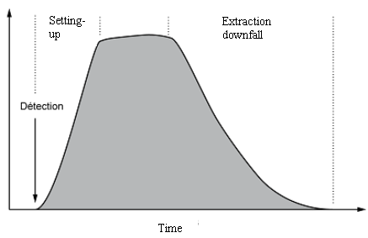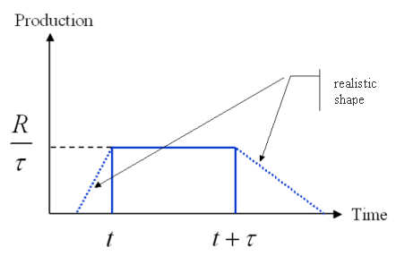
Realistic production profile
Simplified production profile

Figure 1: Oilfields production profiles

Before being able to produce oil, the representative agent first has to discover oilfields by investing in exploration. We consider a constant and unique exploration cost whatever the explored field, but its size and future production cost are unknown. This is the way we represent uncertainty within the model, which is then twofold. First, the expected size of the oilfield will impact the exploration decision (hence the production decisions and the price) in the future time steps and secondly, the cost of the discovered oilfield will modify the portfolio merit order. Therefore the production decisions and the price will here again be influenced.

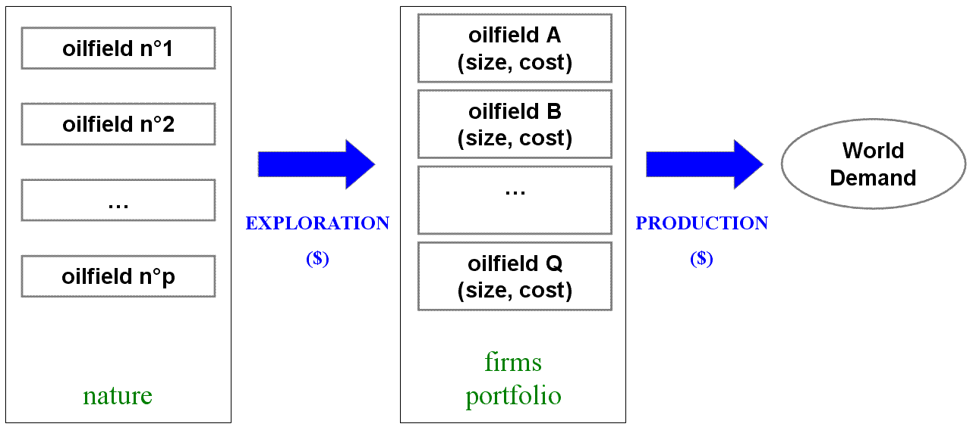

Figure 2: Exploration and production diagram

Here we introduce the model heuristics, which decides on the agent best level of exploration investment for each time step (given by the number of oilfields he will explore) in order to meet demand for the following time step at a minimum cost (note that there is no inter temporal optimisation here). The heuristics is powered by a simulator, described below.

The agent chooses the amount of exploration at each time step so that the expected costs (discovery and extraction) is less than or equal to his marginal cost of production if he does not find cheaper oil.
The general outline of the simulator is as follows:
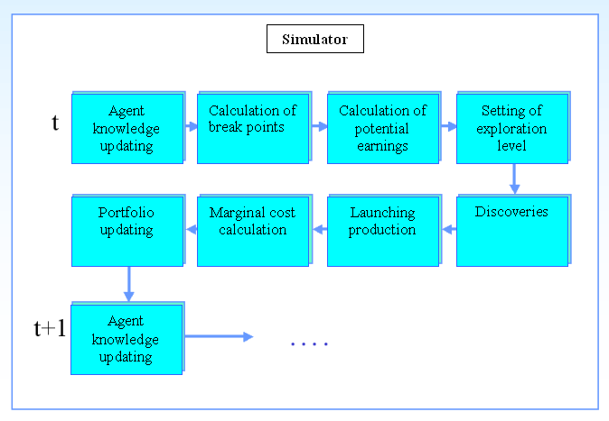
Figure 3: Simulator working diagram

The different stages of the simulator are described below.

Agent knowledge updating
It is assumed that the actor has no clear prior idea of the oilfields distribution by size and operating costs. However, he is given access to the information below, assumed to be shared by all market participants ("common knowledge"):
- the total number of deposits to be discovered (may correspond to the number of sedimentary basins containing oil);
- the pattern of the relative error of estimating the volume of oil on earth, which reduces hyperbolically as exploration goes on
.
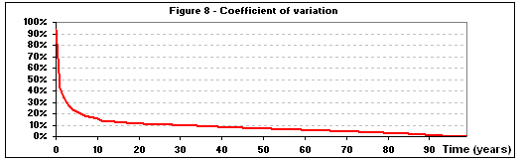
Figure 4: Pattern of the relative error (coefficient of variation) on total oil volume
(average on 100 scenarios)

As he is gradually exploring more and more, the actor relies on what he found so far to refine his idea of the distribution of deposits by size and cost.
For simplicity, we suppose in the calculation below that there are 3 oilfields size categories : small, medium and giant.
We note:
- $i$, the index corresponding to the size of the deposit (we have $i∈\left\{1,2,3\right\}$)
- $n_{i}$, the number of deposits belonging to size category $i$
- $q_{i}$, the size (Gb) of the deposit of the class $i$
- $j$, the index for the cost of extraction of the deposit
- $c_{j}$, the cost of extraction (in $ / b) for deposit of category $j$
- $S$, the total volume of oil in the ground (in Gb)
- $ν$, the number of exploration campaigns conducted by the actor
- $N$, the total deposits in the ground (after $N$ exploration campaigns, the actor knows exactly what total oil volume was)
We hence have :
$\sum_{i=1}^{3}{n_{i}=N}$ and $\sum_{i=1}^{3}{n_{i}q_{i}=S}$
We assume that the actor is given the value $N$ at time $t=0$ (he could know the number of sedimentary basins containing oil).
We call $X$ the random variable associated with the hazard of discovery (vector of size $ν$ representing the different possible discovery paths) and $x$ the realization of hazard $X$.
For example, if $ν=\text{10}$, we could have $x=(3;\text{14};5;\text{11};2;\text{15};\text{13};4;4;\text{10})$.

For $ν$ between 1 and $N$, we define the following:
- $\tilde{n}(x,ν,i,j)$ is the number of $(i,j)$ category deposits in the world, estimated by the actor, after the $ν^{\text{th}}$ exploration, for realization $x$ of hazard $X$
- $n_{\text{sample}}(x,ν,i,j)$ is the number of in the exploration sample after the $ν^{\text{th}}$ exploration, for realization $x$ of hazard $X$
Given that, the actor updates its estimate for the oilfields left in each category after the exploration outcome in the following manner:
$$\tilde{n}(x,ν,i,j)=\frac{N}{ν}n_{\text{sample}}(x,ν,i,j)$$
Therefore, the probability of discovery used by the actor for his heuristic exploration is:
$$P(x,ν,i,j)=\frac{\tilde{n}(x,ν,i,j)}{N}$$
with:
- $P(x,ν,i,j)$, the probability of discovering a $(i,j)$ category deposit, as estimated by the actor, after the $ν^{\text{th}}$ exploration
He then considers the total volume of reserves (from which he derives an estimate of the depletion date) as follows:
$$\hat{R}(x,ν)=\frac{N}{ν}\sum_{i=1}^{3}{q_{i}}n_{\text{sample}}(x,ν,i,j)$$
The expectation and variance of this estimator on the discovery scenarios $x$ are, for every $ν$:
$E_{x}(\hat{R}(x,ν))=S$ and $V(\hat{R}(x,ν))=E_{x}\left[{\left(\hat{R}(x,ν)−S\right)}^{2}\right]$
We consider the uncertainty on the volume in the ground via the relative standard deviation (or coefficient of variation) given by:
$$σ_{R}(\hat{R}(x,ν))=\frac{\sqrt{E_{x}\left[{\left(\hat{R}(x,ν)−S\right)}^{2}\right]}}{S}$$
We then give the actor access to this value, for each time step, which allows him to calculate Hotelling scarcity rent (see below).

Calculation of break points
For its heuristic exploration, the actor begins by determining, for each oil cost category $j$, which volume ${\text{Vp}}_{j}$ should be discovered so as to meet demand only by using oil from cost category $j$ or cheaper.
Since oil is put into production by increasing cost, the cheaper the cost category, the more exploring is needed to be able to meet demand only by using oil from cost category $j$ or cheaper.
Then it calculates, again for each oil cost category $j$, the (expected) discovered volume ${\text{Ve}}_{j}$ when the number of explored oilfields is equal to one:
$${\text{Ve}}_{j}=\sum_{c≤j}{V_{c}⋅P_{c}(t)}$$
with:
- $j$, the oil cost category;
- $V_{c}$, the estimated remaining volume of oil from $c$ cost category
- $P_{c}(t)$, the probability of discovering oil from $c$ cost category, discounted at time step $t$
One can thus calculate the number of deposits corresponding to the break point ${\text{PR}}_{j}$for each cost category $j$:
$${\text{PR}}_{j}=\frac{{\text{Vp}}_{j}}{{\text{Ve}}_{j}}$$
By definition, these 5 break points correspond to the number of deposits to be discovered so as to put into production (in expectation) only the deposits with oil from cost category $j$ or cheaper.
Note: this number is not an integer but a real number.
The main interest of those break points is that we know that the minimum total cost of exploration and production for a given time step is reached in one of them. Indeed, given the assumptions, the total cost is piecewise linear and follows the breaking points defined above.
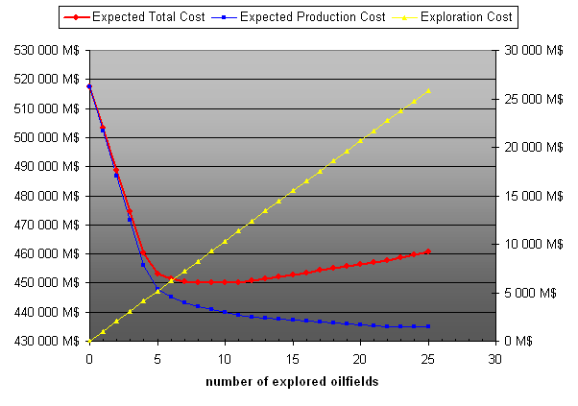
Figure 5: Exploration heuristic curves

If we consider a given time step, this chart highlights the following key elements:
- the cost of exploration (right axis) is deterministic and increases linearly with the number of exploration campaigns;
- the expected cost of production shows a hyperbolic profile: it first decreases sharply, then less and less and finally reaches a line of slightly negative slope when the number of campaigns increases significantly;
- the sum of these 2 functions admits a minimum due to the fact that reducing the expected cost of production becomes less and less interesting with the number of oilfields explored (whereas the exploration fee remains the same).
We here define the exploration earning (or gain) as the money saved (in expectation) by the exploration decision with respect to its total cost without exploration.
Finally, for the same reasons, the gain function is also piecewise linear and follows the same break points as defined above.
We now need to compute the 5 values taken by the gains at the breaking points to find the optimum number of fields to explore.

Calculation of potential earnings
The agent then assesses, for each calculated break point, the money saved (in expectation) by the exploration decision with respect to its total cost without exploration.

Setting of exploration level
Finally, to determine its level of exploration, the agent takes the break point of cost category which allows him to achieve a maximum gain (within his exploration investment limit).
Discoveries
Once this level of exploration is determined, the agent explores the corresponding number of deposits (which is a real number as outlined above), and he is confronted to the discovery hazard.

Launching production
He can then bring into production its reserves by increasing cost, in order to meet demand.

Marginal cost calculation
He also computes the marginal cost of production in order to determine the oil price (defined as the sum of marginal cost and the updated Hotelling rent). We suppose here that exploration cost are covered by Ricardian rents.

Agent knowledge updating
Finally, he updates his portfolio taking into account the reserves, the discoveries and what has just been put into production.

The calculation of the Hotelling rent can be done the classical way or by accounting for the uncertainty on the depletion date.

In the model, the classical Hotelling scarcity rent is computed the following way:
$$H(t)=(C_{s}−C_{m}(t))\text{exp}(−r(T−t))$$
with:
- $C_{s}$, the backstop technology production cost;
- $C_{m}(t)$, the marginal production cost;
- $r$, the discounting factor;
- $T$, the depletion date (defined as the moment when the backstop technology is put into production without discontinuity), which we suppose we know at the beginning of the time period.

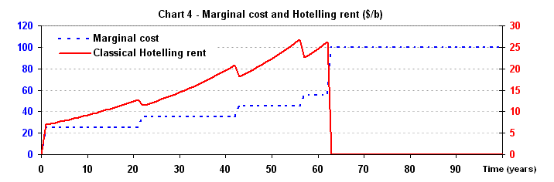
Figure 6: Classical Hotelling rent

The uncertainty then modifies two parameters within the Hotelling formula :
- the depletion date $T$;
- the discounting factor $r$.

a. Regarding the depletion date, we allow the agent to update it at each time step according to the discoveries he has made and the new information he gets from them.
The progressive refining of its knowledge allows the agent to update its estimate of the total volume in the ground at each time step.
The method is implemented as follows:
- the actor does not have any initial knowledge of what he can find, in terms of size of deposits and production cost;
- he begins to explore and gradually builds his vision for the future, in accordance with the growing sample available from his previous discoveries;
- this leads to the volume left gradually converging towards a vision very close to the actual distribution of oilfields, until the two eventually meet when there is no oil left to be discovered.
Thus, the estimated date of depletion of the actor varies over time, as he is increasing his knowledge and adjusting the depletion date to it:
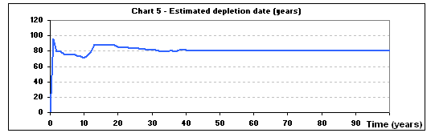
Figure 7: Estimated depletion date by agent

b. Regarding the discounting factor, we want to account for the hazard arising from the uncertainty on the depletion date, and we then assume that:
- the relative standard deviation (or coefficient of variation) of the depletion date is the same as the relative standard deviation of the remaining volume in the ground. This relative standard deviation decreases rapidly as exploration goes on, as shows the figure below:
Figure 8: Pattern of the relative standard deviation (coefficient of variation) on total oil volume (and depletion date)
(average on 100 scenarios)

- the risky assets of the market can be represented (using CAPM theory) with the return / risk curve below:
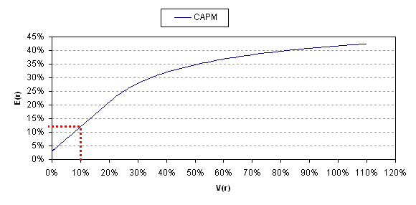
Figure 9: CAPM return (discounting factor) / risk (relative standard deviation) curve

The above curve gives us the return that an agent can expect from taking a given risk, using a non-arbitrage reasoning on the whole of risky assets on the market.
Indeed, we consider that a rational economical agent only cares about risk and return and should therefore make no difference between owning risky assets and oil.
For example, if at a given time step, the relative standard deviation is equal to 10 % (e.g. year 34), one can read that the expected return should be around 12% (see red dotted line on the above figure). The same applies for every time step and gives us a new value for the discounting factor $r$ within the Hotelling formula.

Once the agent owns oil in his portfolio, demand is met by putting new reserves into production, in the ascending cost order. As indicated above, we then compute the market price of oil as the sum of the marginal well production cost and the Hotelling scarcity rent.

The model core and its structure are summarized in the figure below.
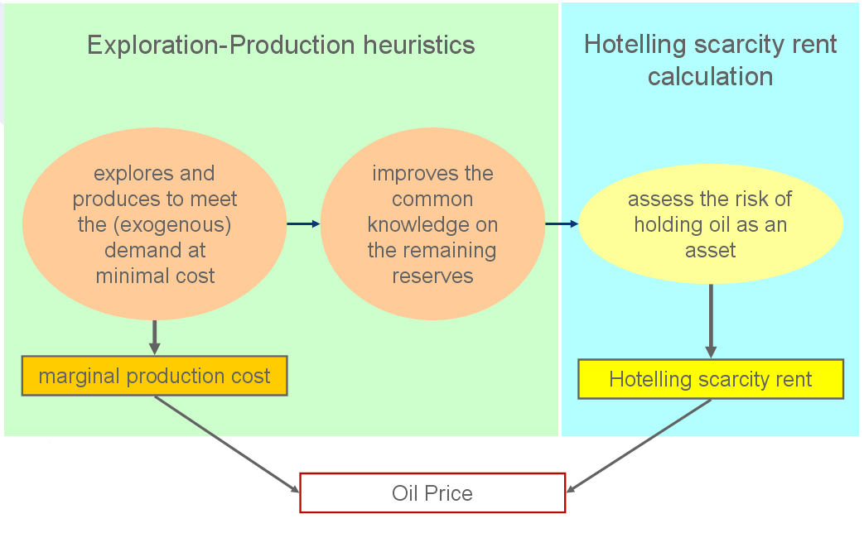
Figure 10: Model structure

- Single agent exploring one global area

In the first case, we consider a single agent standing for all actors of a competitive market and exploring one global area.
Based on the methodology described above, we let the agent make his decisions according to the heuristics and the hazard realization.
The data set and the results we obtain are described in the second part of the article.

- Single agent exploring two areas with opposite characteristics

The difference with the first case is that we consider here two areas endowed with oilfields unevenly distributed in terms of extraction cost and sizes. In practice, there is a region where oil is abundant (many big-sized oilfields) and cheap, and the other where it is scarce (many small-sized oilfields) and expensive. However, this is unknown by the agent in the beginning. The agent goal is still to satisfy demand, but he can split the exploration process between the two areas.
To represent two different exploration regions from the simulation scheme defined in the first part. We then need to:
- duplicate a number of quantities (characteristics of deposits and reserves, knowledge of the actor, random discovery ...);
- amend heuristic exploration of the actor to enable him to choose which region to explore based on its knowledge;
- develop a strategy for production of the reserves discovered in each zone.

The two-zone simulator is described below.

Agent knowledge updating
All data characterizing the zones are duplicated, as well as the process of updating the knowledge described in the first part (actual number of deposits by type, estimated number of deposits by type...).

Calculation of break points
It is necessary to calculate the amount of exploration chosen by the agent in both areas. To do this, we first assume that the actor calculates the amount of exploration in each area in order to meet total demand.
For the calculation of break points per oil cost category, the actor uses:
- the volume of oil ${\text{Vp}}_{j}$(overall for both areas) to find to so as to add as new production only oil from cost category $j$ or cheaper;
- the expected volume discovered (when exploring one deposit) from a cost category $j$ or cheaper (zone by zone).
These values, updated as the actor gradually explores, allows him to refine its exploration heuristic based on its knowledge of each area.

Calculation of potential earnings
As has been described in the first section of the first part, the actor will derive break points for each region, as well as the gains by area, which he will use to calculate the optimal levels of exploration per region. In a first step, the calculation of these levels of exploration area is then conducted so that the exploration in each area allows to meet total demand (which is twice too much).

Setting of exploration level
It is therefore essential to allocate the levels of exploration computed above between the two areas, because using them in each area would yield twice the total demand overall.
For this, we divide the mean value of exploration levels decided by the player in each region, in proportion to the maximum earnings per area, as is shown is the formulas below:
$$e_{1}=\frac{1}{2}\frac{e_{\text{opt},1}+e_{\text{opt},2}}{2}\frac{G_{\text{max,}1}}{G_{\text{max,}1}+G_{\text{max,}2}}$$
$$e_{2}=\frac{1}{2}\frac{e_{\text{opt},1}+e_{\text{opt},2}}{2}\frac{G_{\text{max,}2}}{G_{\text{max,}1}+G_{\text{max,}2}}$$
with
- $e_{i}$, the exploration level in region $i$
- $e_{\text{opt},i}$, the exploration level which would optimally meet total demand in region $i$
- $G_{\text{max,}i}$, the maximum earning in region $i$ coming from meeting total demand in region $i$
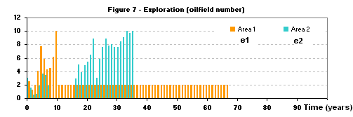
Figure 11: Exploration levels per region

Discoveries
Once these exploration levels are defined for both regions, the agent explores each area and faces discovery hazard.

Launching production
Then we must define a strategy for production of reserves in each zone. The oil cost categories lower than the marginal cost are all put into production in each area.
For oil belonging to the marginal cost category, we need to define a rule for allocating the production of this category of oil per area. The main idea is to share in total production, either in proportion to the reserves not yet in production in each area, or in proportion to the amounts found in each zone, within the capacity limits of each area so that the sum of production put in each area meet total demand.

Marginal cost calculation
The marginal cost of production allows for the price (defined as the sum of marginal cost and the Hotelling rent).

Portfolio updating
Finally, the agent updates its portfolio (in a comprehensive manner, but also by distinguishing the deposits on their geographical origin), taking into account its reserves, its discoveries and what has been put into production.

- Two agents acting as a Stackelberg oligopoly exploring a global area

Thirdly, we study the interaction between two agents of a Stackelberg oligopoly. This market structure is composed of:
- the heart (leader firm representing OPEC);
- the competitive fringe (all other agents).
In the Stackelberg equilibrium, the leader firm sets its output and then the follower firms of the competitive fringe are free to choose their optimal quantities given their knowledge of the leader's output.
We assume that the heart owns a huge amount of conventional cheap oil and has perfect information on its reserves portfolio. The competitive fringe, on the contrary, has to explore the global area to discover oilfields (from conventional cheap oil to unconventional more expensive oil), and aims at satisfying residual demand (once the heart has decided its production level) at minimum cost.

The competitive fringe is behaving as the agent described in the first section of this part.
The way we represent the interaction between the heart and the fringe of the duopoly is the following:
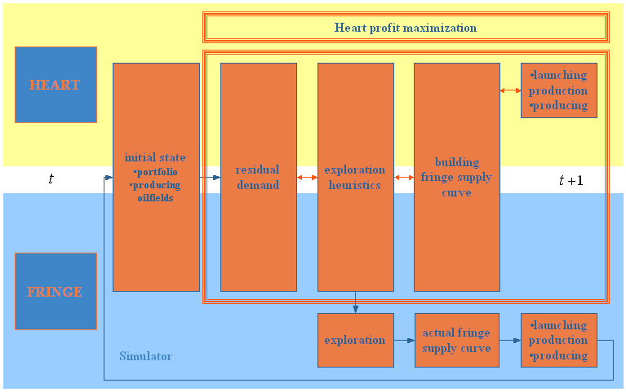
Figure 12: Duopoly interaction

The way we implement it is by using a optimisation heuristics. For each time step, we discretize the demand the heart will leave to the fringe in order to determine the maximum value of the heart profit. When the value is found, we just have to apply the methodology described in the first section of this part to get the reaction of the fringe.

Results

- Single agent exploring one global area

2.a Data

We define a world of 330 oilfields, with following size and cost distribution:

Table 1: oilfields size and cost distributions
$$i$$ | $q_{i}$(Gb) | $$n_{i}$$ | $n_{i}q_{i}$(Gb)
1 | 2 | 230 | 565
2 | 12 | 92 | 1070
3 | 58 | 8 | 465
Total oil volume: |  |  | 2000
Figure 13: Distribution of oilfields by category volume

Moreover, we assume a correlation between oilfields costs and sizes:
- small oilfields are divided equally between 35, 45 and 55 $/b cost categories,
- medium-sized oilfields are divided between 25, 35 and 45 $/b cost categories,
- big oilfields are divided between 15 and 25 $/b.

Finally, we end up with 8 different oilfield types:

Table 1: Number of oilfields per type in the database
Volume (Gb)/ Extraction cost ($/b) | 15 | 25 | 35 | 45 | 55
2 | 0 | 0 | 77 | 77 | 76
12 | 0 | 32 | 30 | 30 | 0
58 | 4 | 4 | 0 | 0 | 0
The profile we use is based on oilfields yielding a constant rate of production during 20 years. We take a risk-free rate of return of 3 % and a linearly increasing oil demand.

2.b Simulation outcomes

This section aims at analysing the model outcomes, especially the shape of global production curve and the impact of uncertainty on Hotelling rent of one single agent exploring one global area. On all charts, the abscissa axis stands for time. We define exhaustion date as the first time step when the backstop technology is put into production and does not disappear anymore.

The main simulation results we obtain with one exploration outcome scenario are represented on the following charts:

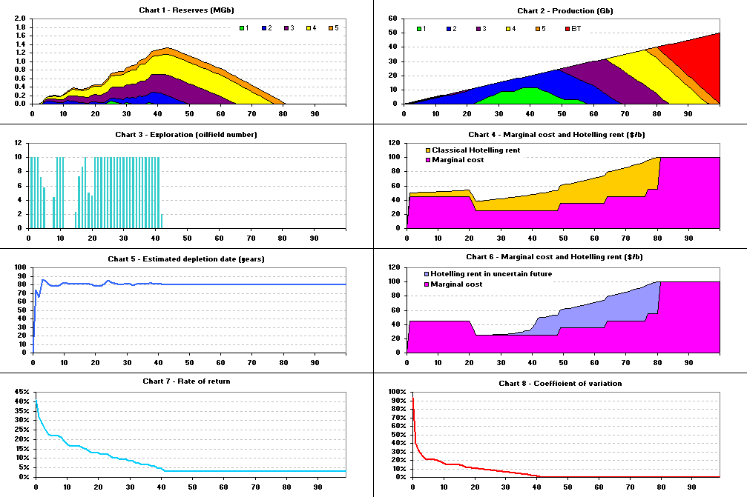
Figure 14: Simulation outputs – single agent exploring one global area – uncapped exploration - 1 scenario

On the first chart, we observe the evolution of the actor’s reserves, from conventional cheap oil (green) to unconventional more expensive oil (orange). During the first 43 time steps, the amount of discovered, but not producing oilfields increases in a quite chaotic way, due to exploration random results. After time step 43, all the oilfields are discovered, as can be seen on chart 3, and reserves decline more evenly. Chart 2 shows the cumulated productions of the 5 different oilfield types, exploited in the ascending cost order to satisfy the steadily increasing demand, until time step 80, when the backstop technology becomes necessary to meet demand (red area).

Chart 3 presents the results of the exploration heuristics described in part 1 (core of the model): at each time step, we can see how many oilfields the actor decides to explore. It should be noticed that the exploration level is limited to 10 oilfields by time steps, for budget, technical and human ressources.

Charts 4 and 6 give an idea of the marginal cost evolution, defined as the exploitation cost of the more expensive producing oilfield at the considered time step. For example, at time step 1, a very expensive oilfield costing 45 $/b (yellow) has to be put into production to meet demand. Due to oil wells production constraint, this expensive oilfield will produce during 20 years, and the marginal cost will be 45 $/b during 20 years, even if cheaper oilfields are discovered in between and put into production during this period (blue).
We notice that the global U-shape evolution of this marginal cost is the following: during the first time steps, the marginal cost is highly dependant on first exploration campaigns results (and has an inertia to decrease of 20 years), because the actor’s portfolio is empty. After a period of 20 years, it tends to decline because the actor discovers cheaper oil. And then, in a third phase, it increases because the actor has to put more and more expensive oil in exploitation to meet demand. Finally, when it begins to lack, the marginal cost reaches the backstop technology price.

What is more, Chart 4 and 6 allow comparing the classical Hotelling rent evolution to the Hotelling rent in uncertain future, implemented with the methodology described above (first section of first part). To compute the Hotelling rent in uncertain future, the actor uses his estimation of depletion date, varying along his successive discoveries (chart 5). To update the rate of return at each time step, he uses the market "common knowledge" curve of the depletion date coefficient of variation (chart 8), and the CAPM (Figure 9: CAPM return (discounting factor) / risk (relative standard deviation) curve). The difference between classical Hotelling rent and Hotelling rent in uncertain future meets the eye: during the first time steps, the Hotelling rent in uncertain future is totally neglectable. Indeed, the rate of return used to calculate it is very high (starting from 40 %), because there is a huge uncertainty about the depletion date. Then, along the actor's discoveries, uncertainty decreases and the Hotelling rent becomes significant at time step 25, when the rate of return is less than 10 %.
This corresponds to the moment when the discoveries sample is big enough to give a reliable estimation of depletion date. When all oilfields are explored (time step 43), the actor knows exactly the depletion date and he uses the risk-free rate of return of 3 %. The Hotelling rent in uncertain future equals consequently the classical Hotelling rent.

One aim of this section was to study the impact of exogenous restrictions on exploration capacities on the shape of the global production profile. On chart 2, it is obvious that the cumulated production curve is not a Hubbert peak: the quick linear decrease of production after exhaustion date is only due to production constraints. Another simulation is realized with exploration capped to 3 oilfields from time step 12. The exploration outcome scenario is the same than in the previously simulated case:

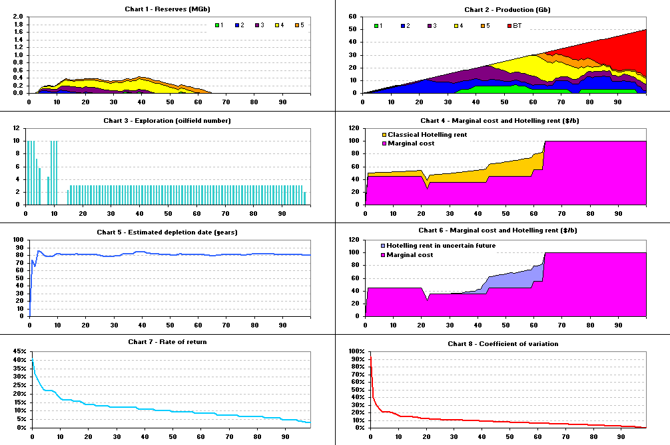
Figure 15: Simulation outputs – single agent exploring one global area – exploration capped - 1 scenario

We can deduce from this second simulation that strong exogenous exploration capacity limitations induce a global Hubbert peak, as it is noticeable on chart 2. The cumulated production curve decreases very slowly after exhaustion date. The oil peak seems symmetrical. Furthermore, we observe that, because of these exploration restrictions, the actor’s portfolio is smaller than in case 1, and his uncertainty remains high over a longer period (the rate of return, on chart 7, remains significant until the backstop technology appearance). These exploration limitations have therefore an impact on the Hotelling rent, which is much lower than in case 1. The main reason for the symmetrical Hubbert peak and the lower Hotelling rent is the exploration exogenous restrictions, which induce a much longer period of exploration and uncertainty. Exploration even goes on after exhaustion date, which occurs about 15 years earlier than in the case with no limitation on investment capacities.

Thirdly, we need to check that these results are not dependant on the simulated exploration outcome scenario. Therefore, we simulate 100 exploration outcome scenarios and analyse the mean results.

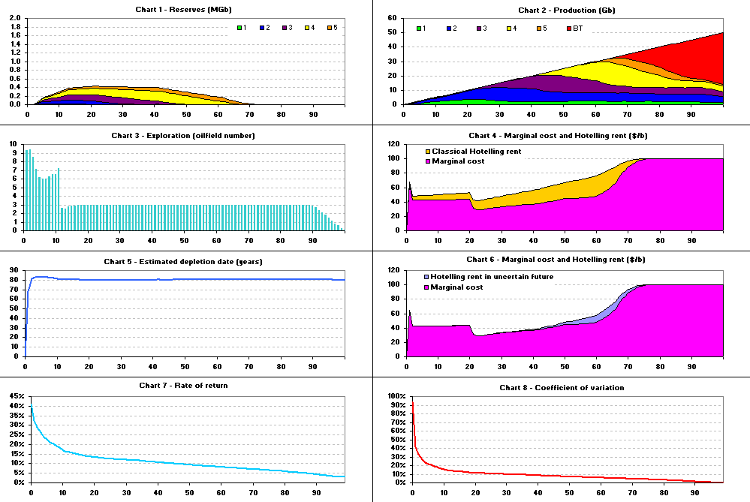
Figure 16: Simulation outputs – single agent exploring one global area – exploration capped - 100 scenarios

Obviously, the results are much smoother and less sensitive to exploration random results. Our first conclusions drawn from the 1 scenario case are confirmed by theses outcomes. The cumulated production curve declines gradually after earlier backstop technology emergence, showing a symmetrical Hubbert peak.

During the first 20 time steps, the mean marginal cost is rather high and constant during 20 years. The U-shape curve is conserved in the mean results over 100 scenarios, what proves that this previously observed phenomenon was not linked to the specific scenario. After 20 years, the marginal cost is likely to decrease because the actor discovers cheaper oil. In a third phase, it raises because the actor is compelled to put expensive oil into production to satisfy the growing demand.

With regard to the Hotelling rent in uncertain future, its mean value over the 100 scenarios follows the formerly observed trend: it is much lower than classical Hotelling rent, because of the high uncertainty on depletion date, which make the belonging of oilfields very risky.

As a conclusion, these 3 simulations suggest that:
- there is no reason for a global symmetrical oil peak unless exploration is restrained by exogenous factors;
- the Hotelling rent is significant only when uncertainty regarding the depletion date becomes small, i.e. when the major part of the oilfields are discovered and exploration limitations maintain uncertainty over a longer period;
- backstop technology emergence occurs earlier when exploration is limited.

- Single agent exploring two areas with opposite characteristic

2.a Data

In this case, the 330 oilfields are divided between area 1 and area 2 (165 oilfields in each zone), according to following cost and size distributions:

Table 2: Oilfields characteristics in area 1
Area 1
Volume (Gb)/ Extraction cost ($/b) | 15 | 25 | 35 | 45 | 55
2 | 0 | 0 | 64 | 16 | 0
12 | 0 | 26 | 22 | 30 | 0
58 | 4 | 3 | 0 | 0 | 0

Table 3: Oilfields characteristics in area 2
Area 2
Volume (Gb)/ Extraction cost ($/b) | 15 | 25 | 35 | 45 | 55
2 | 0 | 0 | 13 | 61 | 76
12 | 0 | 6 | 8 | 0 | 0
58 | 0 | 1 | 0 | 0 | 0

Figure 17: Distribution of oilfields by category volume per area

Total volume is about 1500 Gb in area 1, and 500 Gb in area 2.

2.b Simulation outcomes

Here, we model two areas endowed with oilfields differing in terms of extraction costs and sizes. In area 1, standing for OPEC countries, there are more cheap and big-sized oilfields than in area 2, where oil sources are more expensive to extract, and are present in a smaller amount, as it can be observed in the previous part, describing the simulation data. But this is unknown by the agent in the beginning. The agent goal is still to satisfy demand, but he can split the exploration process between the two areas, according to the heuristics described in the second section of the first part.

The results obtained without any exploration capacity restrictions (except for the budget limitation of 10 explored oilfields per time step) in zone 1 (the better off area) are exposed below:

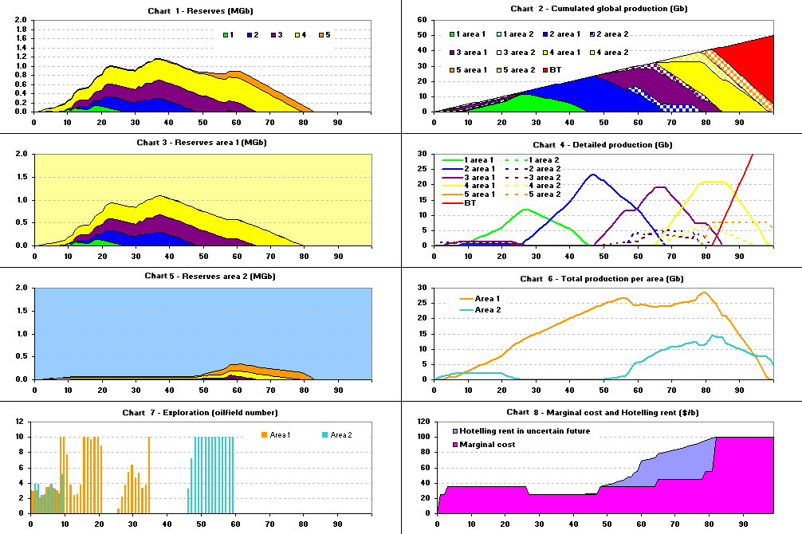
Figure 18: Simulation outputs – single agent exploring two areas – exploration uncapped - 1 scenario

On chart 1, we can see the actor’s portfolio of discovered, but not producing oilfields. Chart 3 and 5 display the fractions of these reserves coming from area 1 and area 2. We observe that, due to the splitting of exploration efforts between the two areas, the reserves during the 45 first time steps consist mainly of cheaper oilfields, because the actor is more likely to explore in area 1. From time step 46, as reserves from area 1 start to decline, the actor has no choice but to explore area 2, and his portfolio is made of more expensive types of oilfields. Chart 7 illustrates well the actor’s exploration strategy: during the first 8 time steps, he does not know well the areas’ opposite characteristics. Therefore, he explores equally each of them. From time step 9, his discovery sample starts to be large enough to give him a significant idea of the most interesting zone. Consequently, he progressively abandons area 2 and concentrates his exploration investments on area 1, until this zone is completely exhausted. Then, as demand increases, he comes back to area 2 and explores it very intensively.
On chart 2, the cumulated productions are displayed, distinguishing area 1 from area 2. We observe no global Hubbert peak (the decrease of total production after backstop technology appearance is only due to the technical production constraint of 20 years).
Chart 4 illustrates the different oil wells production curves. On chart 6, we show the total production curves per area. We notice that production in area 1 has a plateau during about 20 years, and that two production peaks are occurring in area 2 (one small paek at the beginning of the studied period, and one bigger at the end). Indeed, at the beginning, as the actor as no idea of the respective attractiveness of each zone, he explore both of them and has to put into production oilfields coming from each area in order to meet demand. Then, as soon as he identifies area 1 as the most interesting zone, he stops producing oil from area 2, inducing a first small Hubbert peak, and he only exploits area 1. From time step 55, all the most profitable oilfields from area 1 are exhausted, the actor comes back to area 2, which becomes as interesting for him as area 1, and this leads to the production plateau seen in zone 1. The area 2 production is then necessary to satisfy the part of growing demand that can not be met anymore by area 1, generating a third Hubbert peak.

Last but not least, chart 8 represents the marginal cost and Hotelling rent in uncertain future. The evolution of marginal cost over the whole time period is similar to the first case (single agent exploring one global area). Nevertheless, the marginal cost at the beginning is lower, because the actor splits his exploration effort between two zones, and one of them is cheaper to exploit than the other, which improves the actor’s probability to discover cheaper oil during the first time steps.

These results are confirmed by the run done over 100 exploration outcome scenarios:

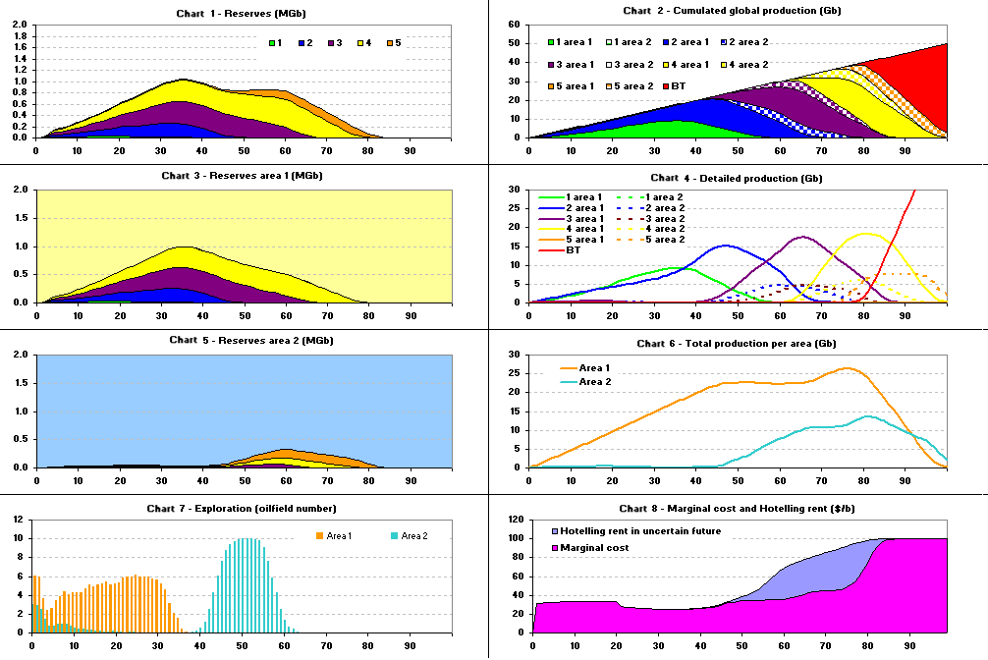
Figure 19: Simulation outputs – single agent exploring two areas – exploration uncapped - 100 scenarios

A third run shows the impact of a strong cap on exploration in zone 1, standing for political constraints in OPEC countries, preventing the single actor from investing in this area:

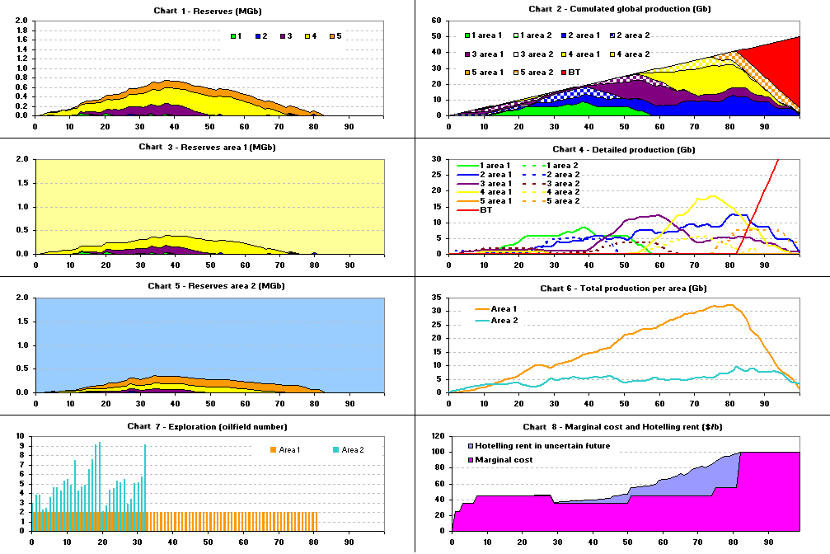
Figure 20: Simulation outputs – single agent exploring two areas – exploration capped in zone 1 - 1 scenario

Obviously, the actor’s portfolio of discovered, but not producing oilfields (chart 1) is smaller than in the case without exploration limitations. The fraction of reserves coming from area 1 is much less important, and area 2 is massively explored during the first phase, because though the actor would prefer to invest in zone 1, he is limited by exogenous factors. Consequently, he has to explore area 2 even if he judges this area as less profitable than area 1. The marginal cost is of course higher during the first time steps than in the first case.

On diagram 2, where cumulated productions are displayed, we can see that no global Hubbert peak occurs. In contrast, the cumulated production curves per area (chart 6) show one Hubbert peak in area 2, the least interesting zone, standing for non OPEC countries (the curve even levels off during a very long phase before falling again) and another Hubbert peak in area 1.
The marginal cost and Hotelling rent in uncertain future (chart 8) evolution are impacted by exploration limitations too: at the beginning, the marginal cost is higher, because the actor cannot split his exploration effort between the two zones as he would like to, he is forced to explore the least profitable area.

Lastly, we simulate 100 exploration outcome scenarios in order to get an idea of the mean results:

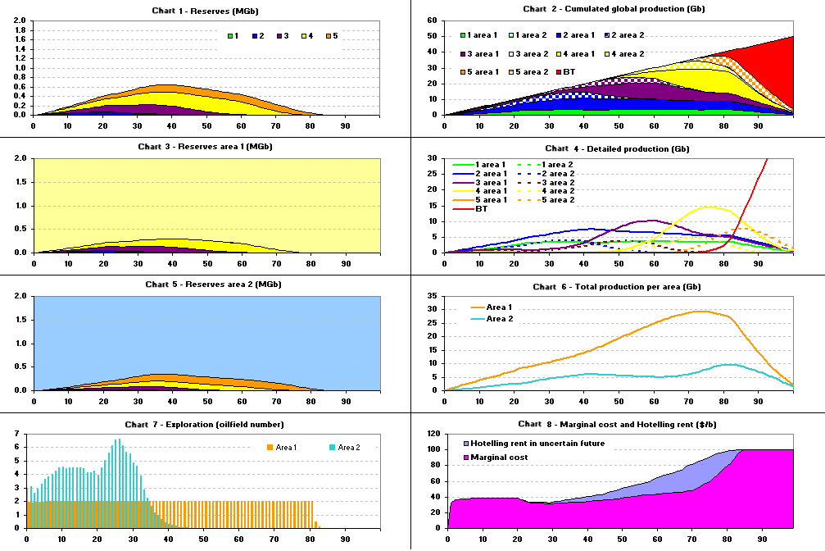

Figure 21: Simulation outputs – single agent exploring two areas – exploration capped in zone 1 – 100 scenarios

The former conclusions are confirmed by this run: no global Hubbert peak occurs. On the contrary, the cumulated production curves per area (chart 6) illustrate a Hubbert peak in area 2, the less attractive region, standing for non OPEC countries, and a non symmetrical Hubbert peak in the most rentable region, standing for OPEC countries.

- Two agents acting as a Stackelberg oligopoly exploring a global area (still work in progress)

In this third case, we represent the action of a leader firm, modelling a Stackelberg duopoly market structure.
The aim of this part is to study the leader firm strategy to maximise its profit (balance between produced quantities and price), and the oligopoly impact on price.

2.a Data

For these simulations, we consider that the oilfields to be discovered by the competitive fringe follow the same cost and size distributions than in the single agent exploring one global area case, but the duopoly heart owns 33 % of the total oil volume (and its exploitation cost is 15 $/b).

2.b Simulation outcomes

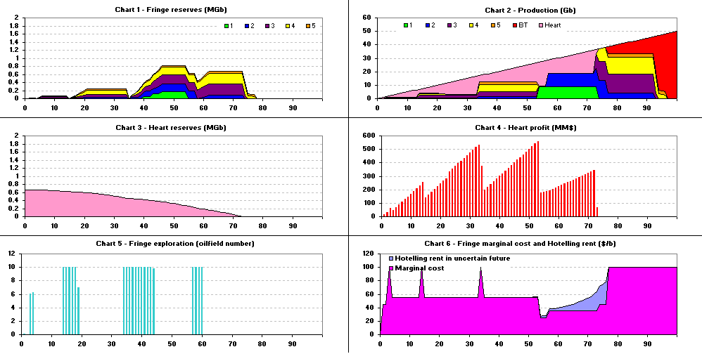
Figure 22: Simulation outputs – Stackelberg duopoly – exploration uncapped– 1 scenario

In the duopoly case, the reserves and exploration levels are much more fluctuating than in the single agent case. During the first time steps, the OPEC only leaves a very small market share to the competitive fringe, and its portfolio is therefore very small compared to previous cases. Chart 2 illustrates well the OPEC profit maximization strategy: the heart manages to maintain the fringe marginal cost at the most expensive exploitation cost, 55 $/b (yellow) during a period of about 50 years. The oligopoly sometimes even forces the competitive fringe to put a tiny amount of backstop technology into production, which induces cyclic price spikes. The OPEC profit strategy seems to follow a very interesting periodic scheme: firstly, it chooses its market share so that the fringe is compelled to explore and to exploit a small quantity of very expensive oil to meet demand. Then, during a phase of 20 years, the marginal cost is steady, and the heart can raise its market share to maximise its profit (that follows a cyclic evolution, as chart 4 shows). The fringe does not explore during this time. This situation goes on until the moment when the production of the very expensive oilfield comes to an end. This corresponds to a phase of linear heart profit increase. Then, the heart has to diminish its market share again to maximise the fringe marginal cost, because the fringe has cheaper oil in its portfolio, and can put it into production to replace the production of the previous very expensive oilfield.
The Hotelling rent is neglectable during the first period when OPEC maintains a very high marginal cost. Indeed, because of its tiny market share, the competitive fringe is not encouraged to explore. Therefore, the uncertainty on depletion date remains very high.
Lastly, we compare the mean evolution of marginal cost in the single agent case and with the duopoly market structure:
Figure 23: Marginal cost evolution in single agent and duopoly cases

These results are consistent with the economics theory: the presence of duopoly heart induces a higher price, but postpones the depletion date (saving natural resources for a longer time).

Conclusions
By building a simulation model, tacking into account the uncertainty linked to oil exploration, technico-economic production constraints and exhaustible resources price theory we manage to understand better some burning issues linked to oil markets, in three market configurations.
In the single agent case, capping exploration is necessary to obtain a global symmetrical Hubbert peak. The depletion date variability introduced in the Hotelling model makes the rent negligible during the first time steps (the Hotelling rent becomes significant only close to depletion). Furthermore, the depletion date is delayed compared to the case without any exploration limitations.
If two areas with opposite characteristics are represented, no Hubbert peak can be observed at global scale. In the least profitable area, two Hubbert peaks are noticeable if exploration is not capped in the more profitable zone and one very flat Hubbert peak occurs if exploration is capped by exogenous factors in the attractive area. In the most attractive zone, we observe an asymmetrical Hubbert peak.
Finally, in the Stackelberg oligopoly case, we show that the leader firm succeeds in taking the greatest market share possible, ensuring that the competitive fringe has to produce (a tiny amount) at a high marginal cost, and that the presence of the duopoly heart induces a higher price and price fluctuations, but postpones the depletion date.

Table 4: Results summary
Case | Constraints on exploration | Production curve characteristics | Hotelling rent in uncertain future
Single agent exploring one global area | Budget constraints | No global Hubbert peak | Equals classical Hotelling rent from time step 45
Single agent exploring one global area | Other exogenous constraints | Global symmetrical Hubbert peak | Much lower than classical Hotelling rent over the whole period, noticeable only close to depletion
Single agent exploring two different areas | Budget constraints in area 1 and 2 | No global Hubbert peak  Area 1: One asymmetrical Hubbert peak  Area 2: Two symmetrical Hubbert peaks | Equals classical Hotelling rent from time step 60
Single agent exploring two different areas | Other exogenous constraints in area 1 (most interesting zone)  Budget constraints in area 2 | No global Hubbert peak  Area 1: One asymmetrical Hubbert peak  Area 2: One very flat Hubbert peak | Lower than classical Hotelling rent over the whole period
Stackelberg duopoly | Budget constraints | One asymmetrical Hubbert peak | Equals classical Hotelling rent from time step 60

The next steps of our work are to consolidate these first results, to refine our database with more realistic inputs, and to analyse our model’s results parallel to oil history (for example, Hubbert peak in the United States, oil price evolution without any measurable Hotelling rent, OPEC behaviour…).

References
Hotelling H. (1931): « The Economics of Exhaustible Resources » in Journal of Political Economy, April, 39, pp 137-175
Rehrl T., Friedrich R. (2005): « Modelling long-term oil price and extraction with a Hubbert approach: The LOPEX model », IER University of Stuttgart, Hessbruehlstr. 49a, D-70565 Stuttgart, Germany
Pakravan K. (1981) « Exhaustible Resource Models and Predictions of Crude Oil Prices. Some Preliminary Results » in Energy Economics, July pp 169-177
Pindyck F. (1978): « The Optimal Exploration and Production of Non-Renewable Resource » in The Journal of Political Economy 86(5), October, pp 841-861
Fishelson G. (1983): « Hotelling Rule, Economic Response and Oil Prices » in Energy Economics, July, pp 153-156

