A Method for Modelling of hydro storage power plants in power plant dispatch Models with rolling horizon Approach
Hasan Ümitcan Yilmaz, Chair of Energy Economics, Karlsruhe Institute of Technology, +49 721 60844503, hasan.yilmaz@kit.edu
Joris Dehler-Holland, Chair of Energy Economics, Karlsruhe Institute of Technology, +49 721 60844579, joris.dehler@kit.edu
Thorsten Kreutzer, NEW Niederrhein Energie und Wasser GmbH, +49 2182 6990826, tkreutzer@gmail.com
Dogan Keles, Chair of Energy Economics, Karlsruhe Institute of Technology, +49 721 60844566, dogan.keles@kit.edu

Overview
The demands of system integration of renewable energies rises the challenges for system modellers by increasing the necessary temporal resolution. To reduce the execution time of energy system optimization problems, the problem is sometimes decomposed into many sub-problems with shorter time intervals [1]. The sub-problems are then solved successively and individually. In this way, parameters from future time intervals are not considered in previous sub-problems and computing becomes more efficient. This makes it possible to solve the whole problem in a reasonable execution time.
There are different approaches for time decomposition [1]. In the rolling horizon approach, the decomposed sub-problems overlap in time, and variables are passed on as fixed values to the next sub-problem. In this way, the next sub-problem has the necessary information due to the fixed values at the beginning of its time horizon.
The rolling horizon approach is widely used in power plant dispatch models and is either motivated by including uncertainty or the reduction of computation time. In these models, the power plants are scheduled based on their variable costs. Therefore, no information on the broad future is necessary. The short time horizon of the sub-problems is sufficient for the decision on power plant dispatch. However, the dispatch decision of seasonal storage must take into account long time horizons, since the use in the present can prevent or restrict the use in the future. This is why the short time horizon of the sub-problems in rolling horizon approach is not sufficient for hydro storage power plants, as seasonal storage is overly dispatched in the first sub-problems and leads to shortages later on. The problem has been acknowledged and addressed differently. [2] presolve a perfect foresight model covering the whole time horizon aggregating production units to reduce computational burden. [3] apply a non-linear control model and test different time horizons of the rolling horizon.
In this study we focus on this problem and develop a 3-step approach for the modeling of storage power plants in power plant dispatch models with rolling horizon.

Methods
In our approach, we take into account the dispatch of the power plants over the whole year and then decide on the water allocation for each suboptimization problem of a rolling horizon model. Therefore, we first run the optimization problem with lower time resolutions and use the results of these optimizations as input for the further optimization steps (See Figure 1).
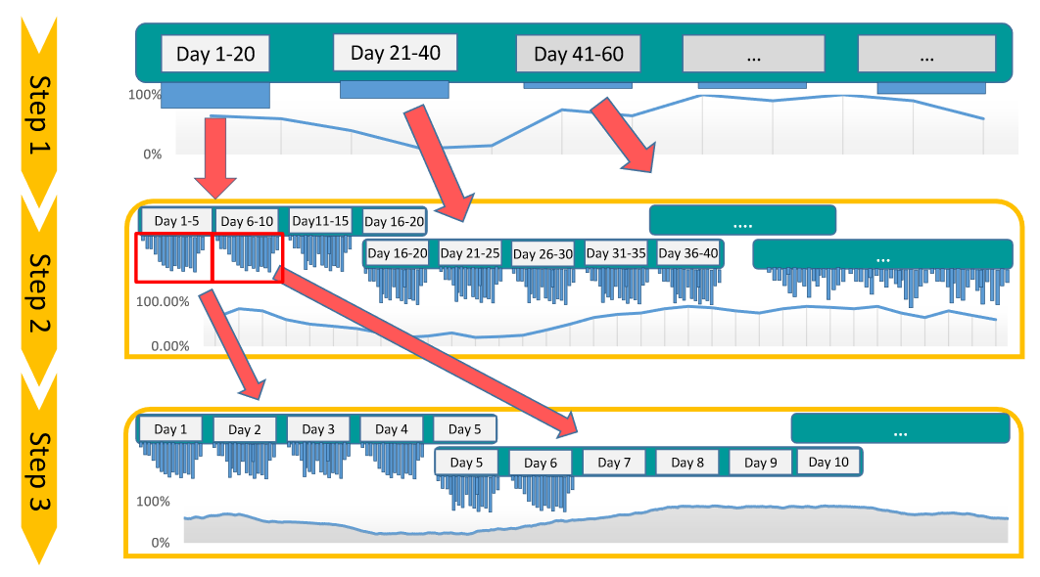
Figure 1: Optimization Steps
We develop a modeling approach consisting of three different optimization steps. In step 1, the model is executed over 365 model time slices (each day aggregated to one time slot) without using time decomposition. In step 2, the results of step 1 are used as input and rolling horizon planning is performed over 20 days, where five days are aggregated into 1 “model day”. Finally, in step 3, a rolling planning over 5 days is optimized with the inputs from step 2.
Step 1 is crucial as it allows the distribution of the water quantities throughout the year. In step 2, information on the course of the days are added and allows a finer distribution of the water quantities. Step 3 is the finest optimization step, where the final model results are created.
In each optimization step, the modelling constraints are also adapted. Many restrictions and the dispatch of pumped storage power plants, which use the fluctuations within the hours of the days, are irrelevant on an aggregated level. Consequently, those technologies and constraints only enter the modelling in the second and third step.
Seasonal storage is also implemented less detailed in optimization step 1. An important parameter for the hydro storage power plants are the minimum water flow levels. In European countries there are regulations which guarantee a minimum water flow for safety, transport or environmental reasons. In the optimization step 1, the minimum flows are calculated different from the other optimization steps. Since hourly production is not relevant, the 0.05 quantiles of the flow levels are used as minimum flow levels of storage power plants to determine the daily minimum flow levels. In Step 2 and 3, the 0.01 quantile of the hourly values over a period of 30 days are used. In this way, seasonal minimum flow levels are taken into account and the flexibility of power plant planning is not unduly restricted.

Results
For the evaluation of the presented method, we use the PERSEUS-EU [4] power system model. Figure 2 shows the comparison of reservoir levels between historical values and model results in Norway. Norway has a high share of storage power plants and provides one of the best model results. From the results it can be seen that the seasonal changes in reservoir levels are very well met in the model results.
Table 1: Correlations between the historical reservoir levels and model results
Norway | 0.9962
Sweden | 0.9977
Austria | 0.9401
Romania | 0.9657
Spain | 0.9196
Portugal | 0.9258
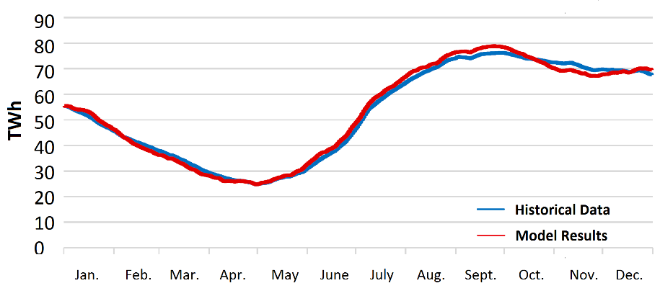
Figure 2: Comparison of historical reservoir levels and model results
Table 1 presents the correlation results between historical data and model results different countries. In general, the correlations are very high. The reservoir level curve of the Norwegian storage power plants shows a correlation degree of 0.9962 with the historical curve of 2015. The results for Sweden differ slightly from the Norwegian results.
In the case of Austria, the correlation values compared to countries with large storage volumes such as Sweden and Norway is lower. In contrast to Norway and Sweden, Austria lies in the middle of Europe and is therefore also used as an electricity transit country. With the neighbouring country Germany, there is also a high level of interconnection capacity. The Austrian storage power plants are used to balance the fluctuating electricity generation from renewable energies. In addition, Austria's storage volume is relatively low compared to its electricity demand, which leads to strong fluctuations in storage levels when the flexibility potential is exploited.

Conclusions
The application of the presented method allows the modelling of storage power plants in power plant dispatch models with rolling horizon. A big advantage of the method is that only a few new model restrictions have to be added and no major changes to the basic energy system model have to be made. The method can therefore be transferred relatively easily to other energy system models. However, an analysis with further data from other years is necessary to determine values for the minimum flow levels.

References
[1] Haas, J., Cebulla, F., Cao, K., Nowak, W., Palma-Behnke, R., Rahmann, C., Mancarella, P. (2017). Challenges and trends of energy storage expansion planning for flexibility provision in low-carbon power systems – a review, Renewable and Sustainable Energy Reviews, Vol. 80, 603–619, doi: 10.1016/j.rser.2017.05.201.
[2] Breithaupt, T., Leveringhaus, T., Hofmann, L. (2019). Heuristic solution of a joint electric control reserve and wholesale market model, International Journal of Modeling, Simulation, and Scientific Computing, Vol. 10, No. 02, 1940001, doi: 10.1142/S1793962319400014.
[3] Erichsen, G., Zimmermann, T., Kather, A. (2019). Effect of Different Interval Lengths in a Rolling Horizon MILP Unit Commitment with Non-Linear Control Model for a Small Energy System, Energies, Vol. 12, No. 6, 1003, doi: 10.3390/en12061003.
[4] Heinrichs, H.U. (2013). Analyse der langfristigen Auswirkungen von Elektromobilität auf das deutsche Energiesystem im europäischen Energieverbund, KIT Scientific Publishing, doi: 10.5445/KSP/1000037111.

