Economic Conditions for hydrogen markets: a scenario analysis
Lennard Rekker, University of Groningen, +31(06)30077768 l.r.rekker@rug.nl
Machiel Mulder, University of Groningen, machiel.mulder@rug.nl
Peter Perey, University of Groningen, p.l.perey@rug.nl

Overview

This paper studies the economic conditions that affect the development of hydrogen markets by an explorative scenario analysis (Mulder et al., 2018, 2019). Explorative scenario analysis examines the possible future states of an economy, based on current economic conditions affecting the decisions of market players (consumers, firms and governments). Applying this type of analysis to hydrogen markets, this paper focuses on the economic conditions for several types of hydrogen production and end-use applications in the Dutch hydrogen market, determining total hydrogen supply and demand. A particular focus is put on the interaction between, and the structure of, different energy markets – the natural gas, electricity and carbon market – to find how prices on these markets are determined and affect eachother.
For the supply side, methods of hydrogen production that currently dominate hydrogen markets include Steam Methane Reforming (SMR) and electrolysis using natural gas and electricity as inputs, respectively. The three types of hydrogen that are considered include hydrogen produced using SMR with and without carbon capture and storage (CCS) producing blue and grey hydrogen, and by renewably sourced electrolysis producing green hydrogen. Therefore, economic conditions affecting hydrogen markets mainly include factors such as natural gas, electricity and carbon prices. Other factors include the regulation of network access and tariffs, the liquidity of hydrogen markets, the functioning of certificate schemes, and the characteristics of hydrogen technologies at the plant-level (e.g. costs, efficiency). As opposed to techno-economic analyses, this researchs aims to provide a broader economic analaysis by paying attention to energy market developments and interactions.
For the demand side, we estimate the growth in volume of hydrogen based on specific assumptions on relative end-user prices (including energy taxes) and technology efficiencies for different end-user sectors (industry, households and transport), as the demand for hydrogen in future markets depends on the relative competitiveness of hydrogen technologies in different end-use applications (Mulder et al., 2019).
This paper extends the explorative analysis with assessment of the competitive position of alternative technologies in end-use applications, and therefore analyzes for each scenario the economic conditions in the Dutch hydrogen market using the top-down and bottom-up approach. The top-down approach estimates the costs of competing technologies for different end-use applications and sectors (the target costs), whereas the bottom-up approach estimates the levelized costs of hydrogen (LCOH) at the point of end-use considering the whole hydrogen value chain. Instead of assuming exogenous energy prices (as in Tlili, 2019), this paper includes energy prices that are endogenously determined by the assumptions for each scenario, which in turn affect the target costs of competing fuels and the delivered hydrogen over time.

Methods

The method for performing the explorative scenario analysis is based on the analysis of the key drivers behind hydrogen market development: the prices for natural gas, electricity and carbon. Each scenario focuses on the developments and structure of natural gas markets determining the natural gas price, and the carbon price that is determined by climate policy: the market for emission allowances (e.g. in the EU ETS) and the level of (national) carbon taxes. The natural gas market is either tight or loose, and climate policy is either stringent or lenient. As the electricity price is set by the marginal electricity producer (often depending on the marginal costs of natural gas technologies), this price is mainly endogenously determined by the level of the natural gas price. However, this endogenous relationship with natural gas price disappears when renewable electricity generating technologies are price setting, which is more likely when the share of renewable energy in the energy system is high. Another factor affecting the electricity price level is the functioning of certificate schemes, and the premium that end-users are willing to pay for certificates of renewably sourced electricity. The analysis also includes the impact of other economic factors on the development of electricity markets, such as the effect of renewable energy policy (e.g. subsidies and feed-in tariffs) on the share of renewable energy in the energy system, instead of assuming the electricity price. Refering to Mulder et al. (2019), we assume that infrastructure costs do not reflect in relative energy prices, as these costs are comparable for different energy carriers and likely to be socialized.

Results

For each given scenario, the energy use for different end-use applications and sectors (the residential heating, industry, and road transport sector). In the ‘Blue hydrogen economy’ scenario, total hydrogen demand increases most strongly. The dominant method of hydrogen production (green, blue and grey) also differs per scenario. To provide an illustrative example, Figure 1 shows the energy use for ‘heating by households’ per type of energy carrier (natural gas, hydrogen, district heating, and electricfication) for each scenario.

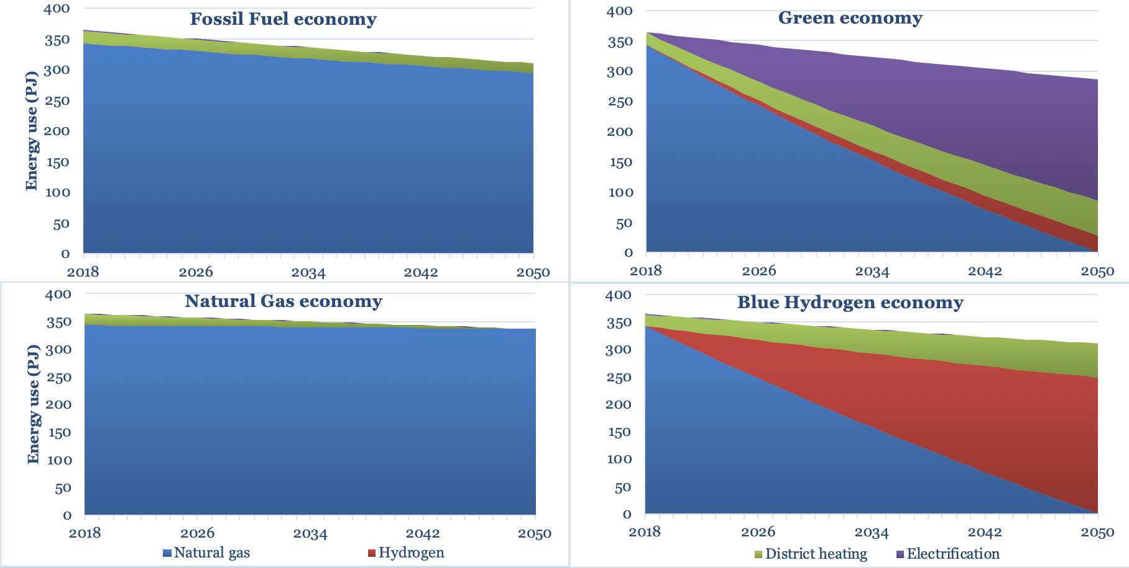
Figure 1. Energy use for heating by households per type of energy carrier, per scenario, 2018-2050. Source: Mulder et al. (2019).

Conclusions

We conclude that the natural gas and carbon price are the two key factors that drive the future development of a Dutch hydrogen market, with both prices being determined by the tightness of the (international) natural gas market and the stringency of (inter)national climate policy. Favourable conditions for the development of green hydrogen depend on low electricity prices and high prices for carbon, which occur in a scenario with tight natural gas markets, stringent climate policy and a relatively high share of renewable energy generation. The development of blue hydrogen is facilitated by low gas prices and high carbon prices, which occur in a scenario when natural gas markets are loose and climate policy is stringent. In the scenario’s with a lenient climate policy (resulting in low carbon prices) the conditions for grey hydrogen production are favourable, and hydrogen demand remains small in both tight and loose natural gas markets.

References

Moraga González José, Moraga González, José and Mulder, Machiel (2018) Electrification of heating and transport:a scenario analysis up to 2050. Centre for Energy Economics Research, University of Groningen.

Mulder, M., Mulder, Machiel, Perey, Peter L and Moraga , José L (2019), Outlook for a Dutch hydrogen market: economic conditions and scenarios. Centre for Energy Economics Research, University of Groningen.

Tlili, O., Mansilla, C., Frimat, D. and Perez, Y. (2019) “Hydrogen Market Penetration Feasibility Assessment: Mobility and Natural Gas Markets in the Us, Europe, China and Japan,” International Journal of Hydrogen Energy, 44(31), pp. 16048–16068.

