Local Flexibility Markets in Smart Cities: Interactions between Positive Energy Blocks

Stian Backe, Norwegian University of Science and Technology, stian.backe@ntnu.no
Pedro Crespo del Granado, Norwegian University of Science and Technology, pedro@ntnu.no
Güray Kara, Norwegian University of Science and Technology, guray.kara@ntnu.no

Overview
Adoption of solar PV and other distributed generation sources are becoming widespread and affordable across Europe. Local onsite energy production raises the chance to manage surplus energy (especially for variable renewable sources, solar or wind) and exploiting possible local flexibility sources (e.g. storage, load shifting, and others). These local energy system features has translated into the rise of positive energy buildings which form a cluster labeled as the Positive Energy Block (PEB). In this paper and as part of the H2020 project +CityXChange, we investigate the creation of local flexibility markets for PEBs. We look into the electricity trading within the block and the exchange of flexibility locally to create added value and incentives for the consumer to generate energy products and services. As local flexibility markets carry different definitions and connotations in the literature, we propose a local market design methodology. We define a framework to tailor local electricity markets based on the value they provide, such as: 1) smoothing and balancing locally solar PV surplus, 2) defer distribution grid investmens and 3) utilizing local energy products.

Methods
We implement a linear programming model to assess specific local electricity market design alternatives. We follow local market designs based on the seminal papers Lüth et al. (2018) and Zepter et al. (2019), but we extended to the PEB concept. That is, a smart grid interconnected positive energy blocks that are allowed to trade through the DSO.

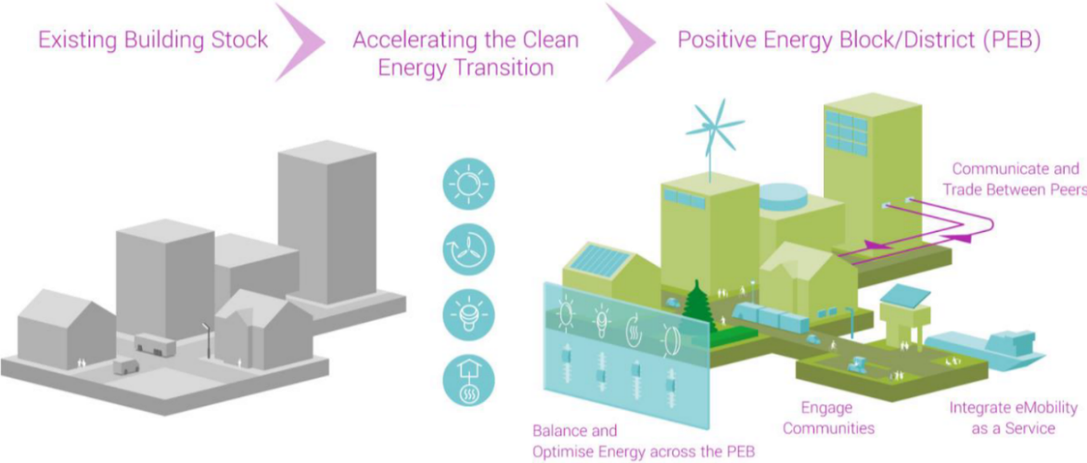
Figure 1: Positive Energy Block concept in the +CityxChange
Source: +CityxChange (Positive City ExChange) https://cityxchange.eu/

Preliminary Results and Conclusions
We show preliminary results for three interconnects PEBs applied for the City of Trondheim, Norway. We also showcase the concept of a framework to formulate local electricity markets which is used for the PEBs in Trondheim.

References

Lüth, A., Zepter, J.M., Crespo del Granado, P. & Egging, R. (2018). Local electricity market designs for peer-to-peer trading: The role of battery flexibility. Applied Energy, 229, pp. 1233–1243.
Zepter, J.M., Lüth, A., Crespo del Granado, P. & Egging, R. (2019). Prosumer integration in wholesale electricity markets: Synergies of peer-to-peer trade and residential storage. Energy and Buildings, 184, pp. 163–176.

https://cityxchange.eu/

