Net Billing Tariff Assessment in the Kingdom of Saudi Arabia for a Feasible Integration of Distributed On-Grid Residential Roof-Tops Solar PV

Abdul Hafiz Al Hariri, Mechanical Engineering Department, King Fahd University of Petroleum & Minerals, g202110370@Kfupm.edu.sa
Fahad Al Sulaiman, Interdisciplinary Research Center for Renewable Energy and Power Systems & Center of Energy Efficiency KFUPM, fahadas@kfupm.edu.sa
Nasser Al Kaabi, Saudi Iron and Steel Company HADEED-SABIC Jubail, alkaabin@hadeed.sabic.com
Shafiq Rehman, Interdisciplinary Research Center for Renewable Energy and Power systems (IRC-REPS), KFUPM, srehman@kfupm.edu.sa

Overview
The Saudi Arabian 2030 vision aims at accelerating the energy transition to achieve national sustainability in accordance with Saudi ambition of achieving net-zero emissions by 2060. Achieving sustainability requires investment in Renewable Energy Resources (RES) such as solar PV systems. Saudi Arabia is moving forward to achieve its sustainable vision, hence, authorities are investing in Mega-Scale solar PV Projects, such as the projects in the Red Sea coast and Neom. Furthermore, legislation is put to accelerate the integration of Distributed Solar PV panels as a priority for Saudi residents. For this reason, cooperation between the Saudi Electricity Company (SEC) and Water and Electricity Regulatory Authority (WERA), which was also referred to as Electricity & Cogeneration Regulatory Authority (ECRA), resulted in the Shamsi program to manage the installation of small capacity solar PV systems. The WERA framework is set to organize the sizing capacity, the pricing policy and the required legislation procedures for the installation of such residential roof-top solarsystems. In this work, a techno-economic analysis of the integration of solar photovoltaic (PV) systems based on the current energy valuation policies set by the authorities has been performed for private residential unit located near the touristic islands on the red seacoast between Ummluj and Al Wajh cities, the latitude and longitude of the chosen area are 25.34°N and 36.75°E respectively. The study found that it is not feasible to invest in an on-grid solar PV system based on the current pricing policies. Therefore, a new energy policy has been proposed, which is an increase in the imported and exported power tariff rates. The simulation results revealed that increasing the tariffs for peak load time (10 Am to 4 PM) makes the investment in an on-grid PV system feasible for an increased imported tariff of 0.092 $/kWh for the selected location. The proposed policy aims and encourages the residents to invest in solar PV systems which will result in the reduction of carbon emissions by 2030. Additionally, it will help in managing and shaving the peak load demand which is a cost burden on any utility electric company. The current proposal has been assessed for different cities around the kingdom representing different climate zones. The hourly simulation is performed using HOMER software and the economic analysis is based on the Net Present Cost (NPC) and the Levelized Cost of Energy in USD/killowatt-Hour (COE in $/kWh).

Methods
In this research study, a solar PV system has been technically sized based on WERA regulations for a real electrical load that has been provided by the SEC. The studied residential unit has an average daily electrical consumption of 170 kWh and a peak of 16 KW in the summer resulting in a 32 KW solar system after taking into consideration the power generating factor, the derating factor, and the effect of the temperature on the efficiency. The research has been divided into two main parts. The first part consists of an economical assessment of the cost of energy based on the current pricing policies, for both grid-only and grid-connected solar PV. The second part consists of increasing the buy and sell-back tariffs for different cities in the Kingdom. For consistency, the analysis is based on the NPC (USD) and COE ($/kWh). In both cases, an hourly simulation has been performed using Homer software based on an hourly basis. The solar PV has been designed to provide the electric load as per the WERA framework taking into consideration the Net-Billing policy, in which the value of the financial exported electricity to the grid could not exceed the financial value of the energy imported from the grid. After the technical design, the cost estimation and the mathematical model have been provided for an accurate simulation. The simulation Model has been built using the selected software, the technical and economic results have been extracted for the analysis of both actual and proposed scenarios. For generalization, the simulation has been performed for different energy costs and for different cities with different climate zones to achieve a policy that could be applied all around the kingdom. The strength of this study comes from achieving the same NPC for a resident implementing a solar PV equal to the NPC in the subsidized grid-only scenario. This result has been concluded when analyzing different policies, one is increasing the energy imported tariff from the grid to the residential unit and the second is when increasing the energy exported tariff from the solar system to the grid.

Results
Technically, a total yearly of 62,050 KWh was purchased from the grid for the grid-only scenario. For the case of grid-connected solar PV, a reduction in the yearly energy purchased from the grid by 45% with a provision of 30,297 KWh additional energy exported to the grid resulting in an increase in the renewable energy share and a decrease in the energy required from the conventional power plants.
Economically, and based on the pricing policies set by WERA, it is found that for the grid for the grid-only scenario the NPC over a 25 years lifecycle is 68,481 USD and a Cost of Energy (COE) of 0.0531 $/KWH for a total yearly of 62,050 KWh purchased from the grid. On the other hand, the economic results found an increase in the NPC by 31 % to a value of 90,258 USD than applying the current actual policy owing to the low subsidized electric cost in the Kingdom and to the reduced energy exported tariff that is applied, which makes investing in On-grid Solar PV still not an economic choice.
The proposed pricing policy, is an increase in the energy imported tariff in peak times (10 Am to 4 PM). It is found that for a value of 0.092 $/kWh (the breakeven point in Figure 1 with the grid-only scenario for the increased tariff in peak time) could be a feasible solution with an NPC of around 92,200 $ for the selected location when the energy exported tariff is still the same as policy (0.02 $/kWh). This could be considered just an increase in the cost, for this reason increasing the energy exported tariff to 0.06 $/kWh resulted in NPC decrease from 90,457 $ to 69,271 $, which is the same cost as the subsidized grid-only actual case.
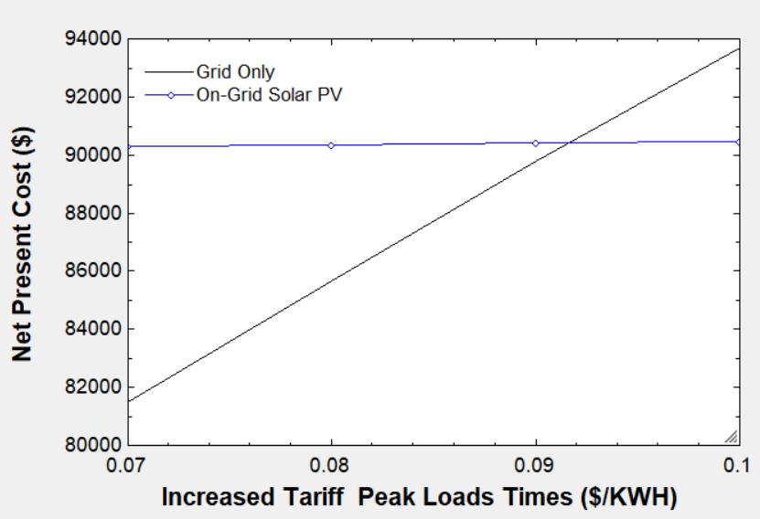
The analysis in Figure 1 presents the minimum increased buy-tariff in peak loads for different Saudi cities. It is found that for higher solar intensity a lower increased tariff is required. It may be accounted for more electricity production from solar PV Panels, which makes the integration more feasible.
Figure 2 Minimum Increased Tariff for Different Saudi Cities
Figure 1 The Variation of NPC with respect to Different Values of Proposed Increased Tariffs in Peak Time for the Selected Location

Conclusions
The change in the energy imported and exported valuation during peak hours in the Kingdom of Saudi Arabia can change the game of the integrated solar PV market for residential applications. More importantly, the proposed policy shows that this can significantly help to shave the energy demand in peak hours which can lead to a reduction of SEC operation and maintenance costs. The Kingdom is investing in utility-scale projects but with just a small change in the peak tariff to 0.115 $/kWh for the whole kingdom could encourage consumers to contribute to the Saudi Green Initiative by utilizing rooftops distributed solar PV power systems.

