current State and perspectives of Pumped Hydro storage in the electricity system

Marlene SAYER, Reinhard HAAS, Amela AJANOVIC
Energy Economics Group, Vienna University of Technology, E-mail: sayer@eeg.tuwien.ac.at

Overview
Power systems around the world are facing the major challenge of transitioning from a largely fossil-based system to a renewable one. In Europe in particular, with the “Clean energy for all Europeans package” concrete targets with a high share of renewables were set, implying that wind and solar will shape the European power system. This development can already be seen, as electricity generation in the EU-28 from intermittent sources such as wind and solar (excluding hydro) has already increased dramatically, from about 20 TWh in 1990 to over 400 TWh in 2019. This trend will continue and therefore measures to balance supply and demand in the integration of a large share of variable renewables are needed. In this view storage could play a crucial role. Storage expansion has been the subject of intense debate, particularly in Germany. According to a study by Schill et al. (2015), no significant expansion of electricity storage is needed in the short term, provided that other flexibility options are used. In the long term however when 100% of the electricity is to be generate from renewables, they will play a significant role, as it is for example Austria’s target by 2020 (nationally/balanced).
To date pumped hydro storage (PHS), with a share of 97% of all electricity storage in the EU in 2019, an efficiency of more than 80% and very fast response times, is the main storage solution. In Fig. 1 all European countries are displayed according to their installed PHS capacity. Only in recent years also other storage technologies like electrochemical or chemical storage systems are starting to play a role in the electricity system. The production costs and revenues of PHS are largely depending on the annual full-load hours, as shown in Fig. 2 taking the storage losses into account. The possible profit is defined as the difference between revenues and costs and is calculated based on the arbitrage profit for market-based storage and decreases substantially in the case that a grid fee of 1.5 cent/kWh is introduced. This reduction can be seen through the yellow rectangles in Fig.2.
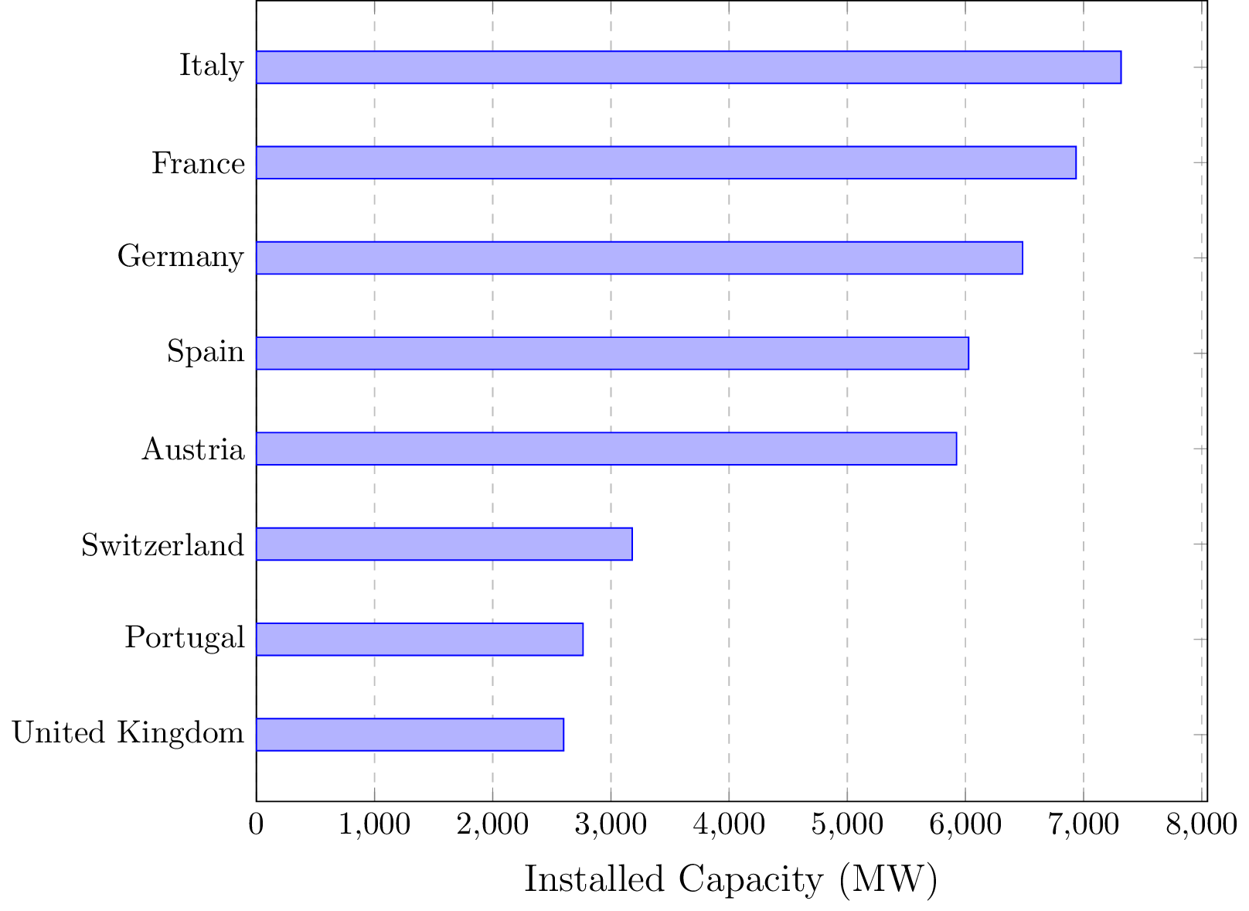 | 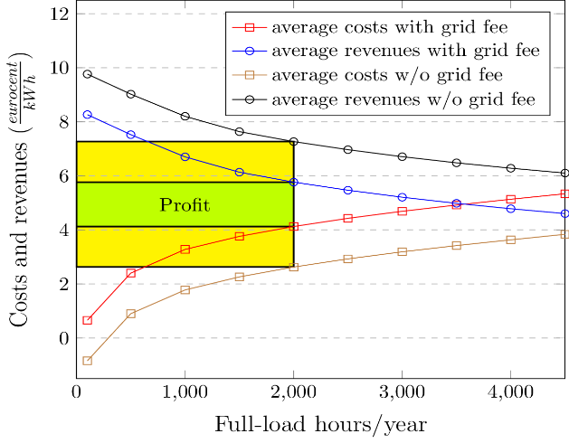
Fig. 1. Installed turbine PHS capacity of European countries with a capacity over 2 GW (Schoenberg 2020) | Fig. 2. Productions costs and revenues of PHS depending on the full-load hours per year and the result on the profit of the introduction of a grid free

Methods
Our approach is based on: (i) an extensive literature review to present the current status of PHS plants, with a focus on Europe; (ii) a comparison of planned and actually installed PHS plants between the years 2009 and 2019 based on the work of Deane et al. (2010) as well as an further estimation up to 2029; (iii) an economic discussion regarding the profit of pumped storage in view of decreasing full-load hours, lower arbitrage opportunities and grid fees; (iv) a comparison of the investment cost development of different storage solutions based on the technological learning approach.

Results
With over 42 GW of installed capacity in the EU-27 (53 GW including UK, Switzerland and Norway), PHS is essentially the only large-scale energy storage system that reached full maturity, but its potential is limited by the availability of sites. As most of the topographic optimal sites are already taken the cost decrease induced by possible technological learning is offset by higher construction costs of PHS plants and more complex permission processes. Extending already existing powerplants to increase production capacity usually requires lower investment costs than new developments (Steffen 2012). Another option that is being discussed is the use of exhaust coal/lignite open or underground mines as water reservoirs for PHS installations, especially for countries without natural difference in altitude. This would allow to build new storage capacities with little environmental implications. The first PHS of this kind were planned by the University of Duisburg-Essen and the Ruhr University Bochum for the Prosper-Haniel mine in Germany, however without any new developments so far due to proclaimed high costs (Brücker und Preuße 2020).
In Fig. 3 the economic performance of different storage technologies is displayed modelled by the technological learning approach using experience curves. For the calculations learning rates of 20% were considered except for PHS, for the reasons mentioned above and that the components already have been optimized to a large extent. It can be clearly seen that alternative solutions will become economically more attractive in the future, whilst the investment costs of PHS might even increase. Nevertheless, there are 9100 MW and 16 projects of additional PHS planned for the upcoming years or currently under construction, see Fig. 4 (Platts 2019). In the period from 2009-2018, 6487 MW and 16 plants were commissioned in the EU, mainly in Austria and Portugal (DOE 2021). This is only slightly less than the estimated 7500 MW by Deane et al. (2010). Nevertheless, the above-mentioned planned installations should be viewed with caution as also proposed projects were included.
There are different reasons why pumped storage power plants are becoming less attractive. First, each additional capacity installed reduces the total full-load hours, unless renewable fluctuating generation capacities are added to the same extent. According to the same principle, the possible arbitrage profits are also reduced, since with each additional installed storage capacity the required peak load is reduced and thus also the price differences. Another issue is the grid fees that every electricity producer and consumer that feeds into or consumes from the high-voltage grid has to pay. As shown in Fig. 2, the profit of the storage operator is thereby reduced significantly. According to an EU survey, fees for pumped storage power plants are levied at the transmission level in 8 countries. However, there has been a recent change in the grid tariff principles and these include an exemption or reduction from the network tariff for offtake and injection, under certain conditions (European Commission 2020).
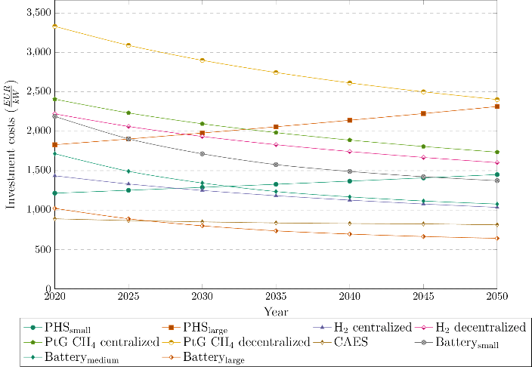 | 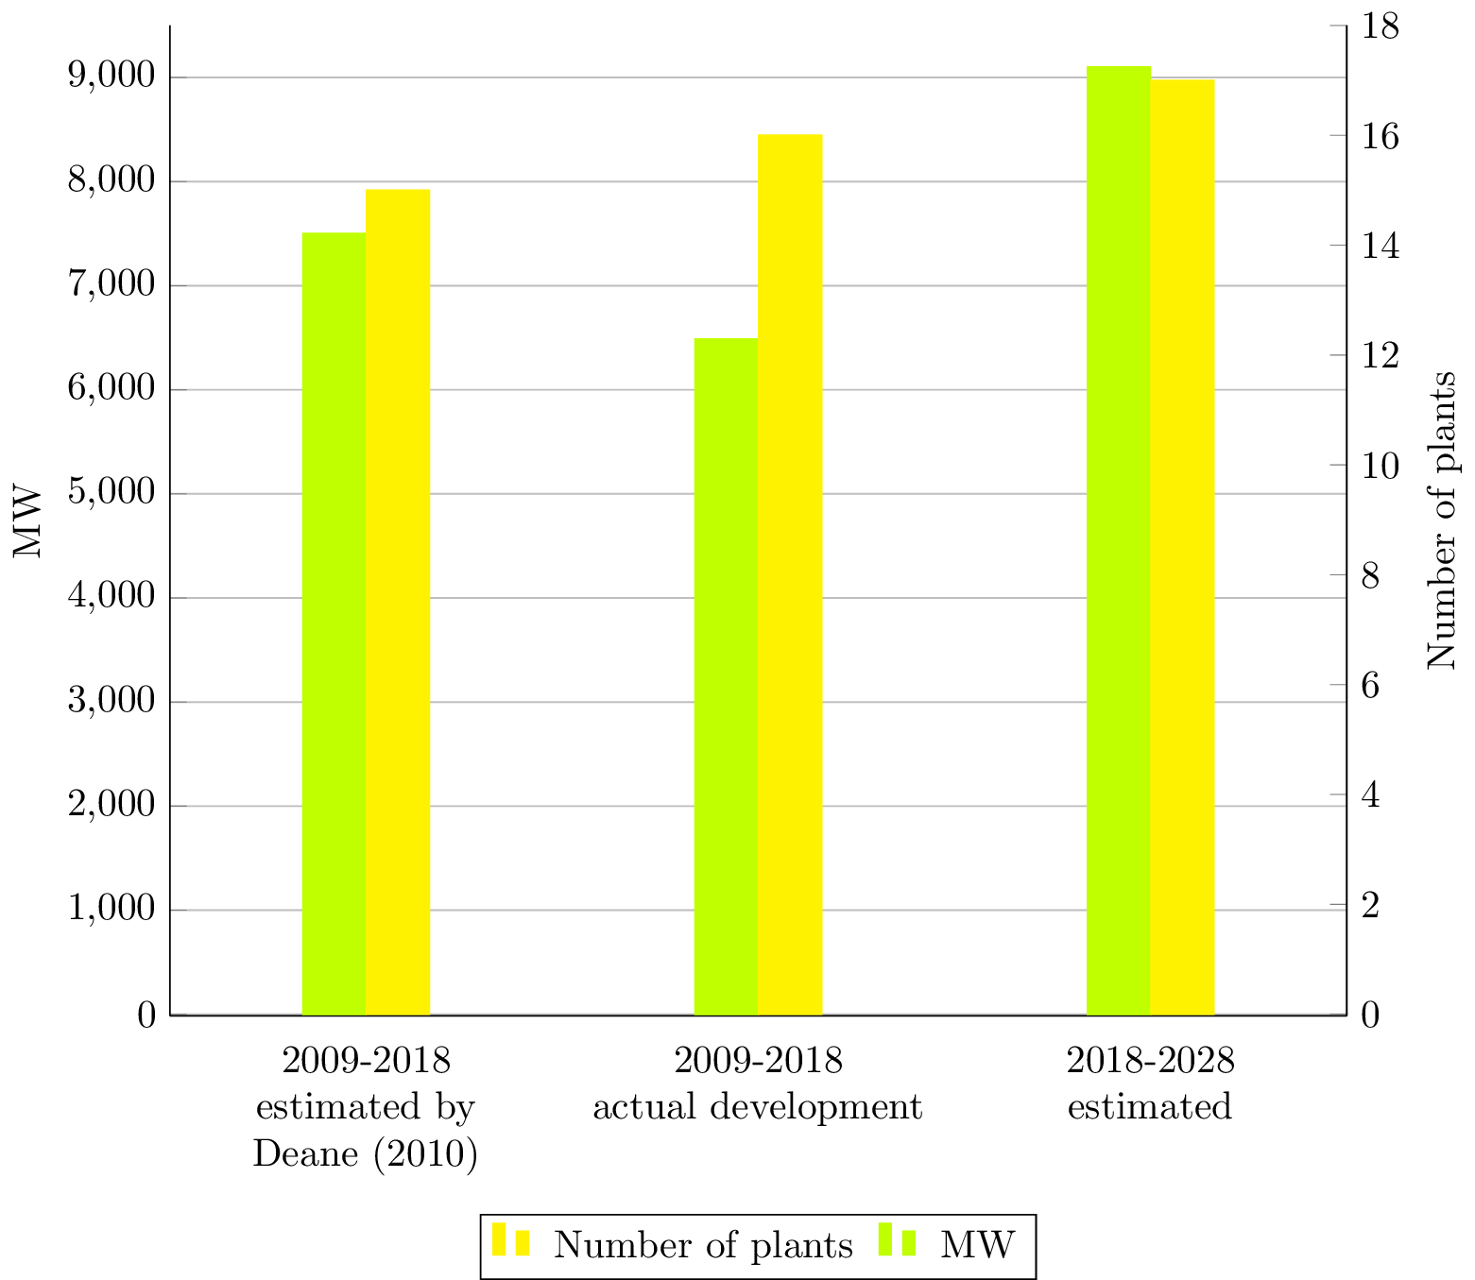
Fig. 3. Development of the investment costs of different storage types according to the technological learning concept and learning rates of 20% (except PHS) | Fig. 4. Installed and planned PHS projects in Europe in comparison to the estimated capacity by Deane et al. (2010),

Conclusions
The main conclusions are that
- PHS is still and will be the main storage technolgy in Europe due to its maturity, efficiency and fast response times. However, the estimated additional capacities are expected to be lower.
- No further learning effects are expected for PHS.
- The final conclusion is that if additional pumped storage power plants are desired, the problem of grid fees must be discussed and dealt with. If this double taxation is present, the potential profit will be lower, also in view of decreasing full-load hours and arbitrage, hence less new capacity will be built.

References

Brücker, Carolina; Preuße, Axel (2020): The future of underground spatial planning and the resulting potential risks from the point of view of mining subsidence engineering. In: International Journal of Mining Science and Technology 30 (1), S. 93–98. DOI: 10.1016/j.ijmst.2019.12.013.
Deane, J. P.; Ó Gallachóir, B. P.; McKeogh, E. J. (2010): Techno-economic review of existing and new pumped hydro energy storage plant. In: Renewable and Sustainable Energy Reviews 14 (4), S. 1293–1302. DOI: 10.1016/j.rser.2009.11.015.
DOE (2021): Global Energy Storage Database. Sandia National Laboratories. https://www.sandia.gov/ess-ssl/global-energy-storage-database-home/.
European Commission (2020): Study on energy storage - Contribution to the security of the electricity supply in Europe.
Platts (2019): PiE’s new power plant project tracker – April 2019 Issue 796.
Schill, Wolf-Peter; Diekmann, Jochen; Zerrahn, Alexander (2015): Power storage: An important option for the German energy transition. In: DIW Economic Bulletin 5 (10), 137-146UR - https://www.econstor.eu/handle/10419/108856.
Schoenberg, Martin (2020): Hydropower in Europe: Facts and Figures. In: Eurelectric.
Steffen, Bjarne (2012): Prospects for pumped-hydro storage in Germany. In: Energy Policy 45, S. 420–429. DOI: 10.1016/j.enpol.2012.02.052.

