Activitypatterns in the Australian Green Certificate Market: Lessons LEarnt After More than 15 years of operation
Regina Betz, ZHAW, and CEEM/UNSW Australia r.betz@unsw.edu.au
Johanna Cludius, ZHAW, Switzerland, clud@zhaw.ch
Beatrice, Petrovich, University of St. Gallen, beatrice.petrovich@unisg.ch
Iain MacGill, CEEM/UNSW Australia i.macgill@unsw.edu.au

Overview
Australia implemented the world’s first national green certificate trading scheme, called the Mandatory Renewable Energy Target (MRET) in 2001. The scheme, now termed the RET, has evolved over time but remains in operation. The principle behind green certificate trading rests on the idea that liable entities have to surrender a number of certificates (corresponding to their individual target under the overall scheme target) in a given year. Under the RET, liable entities are all wholesale purchasers of electricity (mainly electricity retailers and some large load) – an approach with parallels in renewable portfolio standards widely used in the US. Green certificates – called renewable energy certificates (RECs) in Australia - are created and sold by eligible renewable power plants and provide the additional revenue stream, beyond energy market returns, that makes renewable energy projects viable. Economic theory generally assumes that such market-based instruments are highly efficient and create correct signals for investment in additional renewable energy capacity, thanks to the possibility to trade certificates between different players. In particular, under this market mechanism, liable entities are always free to choose between a) long-term securing clean electricity on their own (e.g. by means of a long power purchase agreement with a renewable energy producer or by investing by investing in “their own” renewable power plant), or b) buying certificates on the market, from other players who produce renewable energy and compete to sell the corresponding certificates. A rational choice between a) and b) should result in demand for the most cost-effective solution for the generation of clean energy: those players with an “in-house” cost of renewable generation higher than the market price for RECs should buy on the market. Moreover, active REC trading enhances the formation of certificate prices which should send a signal for investment in renewable capacity.
The Australian green certificate scheme has been in place for more than 15 years and its’ target and rules have changed over time. The first target of the MRET was set at 9,500 GWh by 2010 (equivalent to an additional two per cent of renewable energy in the electricity mix). This was comfortably achieved, particularly through additional wind deployment. In 2009-10, the target was increased to 45,000 GWh by 2020 (equivalent to at least 20 per cent of electricity from renewable sources). In 2011, the RET was split into two separate mechanisms, the Large-Scale Renewable Energy Target (LRET) covering utility scale renewable projects, and the Small-Scale Renewable Energy Scheme (SRES), which has no predefined target, covering residential solar and other smaller scale renewable projects. After a change in government and a relatively lengthy review process lasting 18 months, in June 2015, the LRET target for 2020 was reduced significantly from 41,000 to 33, 000 GWh. Despite this reduction, the certainty this provided that the scheme would continue saw large-scale generation certificate spot prices increase from $33 at the beginning of 2015 to just over $72 by the end of that year. Given that large-scale generation certificate holdings are concentrated in relatively few hands and the liquidity in the market is low, the Clean Energy Regulator expects that liable entities may not rely on the spot market in the future to meet their future obligations.
Along with a range of consulting reports, there have been a number of academic studies; on the short-run impact of the RET on wholesale electricity prices (Forrest and MacGill 2013) and associated effects on retail prices and distribution of costs and benefits (Cludius et al. 2014) as well as on the policy design (Buckman and Diesendorf 2010) and the efficiency of the market (Nelson et al., 2013). However, there is little public research into the operation of the certificate market itself and in particular on the different roles of REC market participants. This paper aims to address that gap by first identifying, who are the players involved in the market for Australian large-scale green certificates, second, whether all of them are actively trading certificates, and most importantly, if we can observe different trading behaviours between well-defined subset of players. In particular, this paper uses a cluster analysis as an explorative tool in order to identify interesting market participant behaviours worthy of further investigation.

Methods
Cluster analysis is an explorative multivariate technique used for identifying patterns in large data sets. Large data sets can be split into clusters on the basis of information contained in these data sets on the objects and their relationship to each other (Hair et al. 2006). The aim is that those clusters exhibit high internal homogeneity and high external heterogeneity. In this context, a trade-off between a small number of clusters and high within-cluster homogeneity exists.
In order to perform the cluster analysis, we use data from the REC registry which makes information available of the history of each REC. The history of a certificate is composed of different actions, which include its creation, registration, (potentially) transfer of ownership and its eventual surrender. The REC Registry displays information relating to the action itself (i.e. the type of the action, the date of the action, the account responsible for the action), and to the certificate or block of certificates that is involved in the action (e.g. the status of the certificate, generation year, generation state, the technology). In order to perform our analysis, we created a database using data downloaded from the REC Registry that concern over 30 million actions on RECs carried out between 18 May 2001 and 9 November 2016.
In the context of the REC Registry Database, accounts in one cluster should share similar properties regarding the activity related the creation, trade and surrender of RECs, while they are significantly different in this regard from accounts grouped into other clusters. In order to generate meaningful clusters, the properties along which accounts are to be clustered, so-called ‘cluster variables’ have to be identified (Hair et al. 2006). In this paper, we identify a total of 6 cluster variables. As each of these variables describes an important aspect related to the activity on the market for RECs, in combination they should be able to identify patterns that are shared by a number of accounts while they differ from the rest of accounts. Using characteristics of the accounts (e.g. liable or non-liable, sectors) each cluster composition is explained.

Results
We find that 615 different accounts performed at least one action which is relevant to our analysis, meaning that they either registered, bought, sold, surrendered or voluntary surrendered at least one (large-scale) REC over the considered period. Only 140 (23%) of these active accounts surrendered certificates mandatorily and hence were a liable entity. Among the remaining non-liable entities, 10% exclusively registered certificates, 30% were “pure traders”, 17% surrendered voluntarily, but not mandatorily; the remaining 43% performed a mixture of these actions (Figure 1).
Similar to previous studies which have identified non-liable entities such as financial players as important participants on the carbon market for European Union Allowances (e.g. Betz and Schmidt 2015; Cludius and Betz 2016) we find similar patterns in the context of the Australian green certificate scheme. In fact, a minority of 20 accounts in the REC Registry Database are linked to financial players. Although few in number, a large share of the transfer activity (almost 20% of total transfers) originates from these accounts.
Figure 1. Information on active accounts
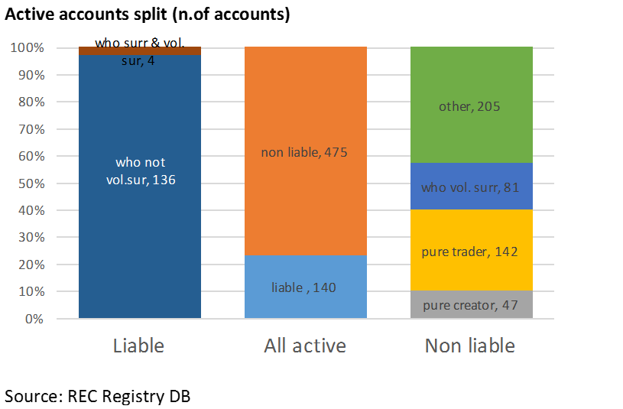

Conclusions
The green certificate scheme did attract - similar to other environmental markets such as the European carbon market - a large number of non-liable entities. Further investigation of the role of such non-liable entities in the green certificate market represents a worthy area for future research. One of the derived research questions would be whether non-liable entities are improving liquidity and support the price signal or holding up certificates and increase the compliance costs for liable entities? Other research could focus on entities involved in voluntary surrendering or compare the efficiency of retailers’ compliance and trading strategies.

References
Betz, Regina; Schmidt, Tobias (2016): Transfer patterns in Phase I of the European Union Emissions Trading System: A first reality check based on cluster analysis. In Climate Policy, pp.
Buckman, Greg; Diesendorf, Mark (2010): Design limitations in Australian renewable electricity policies. In Energy Policy 38 (7), pp. 3365‐3376Buckman, G. & Diesendorf, M., 2010. Desig.
Cludius, Johanna; Betz, Regina (2016): EU Emissions Trading: The Role of Banks and Other Financial Actors - Insights from the EU Transaction Log and Interviews. ZHAW School of Management and Law, SML Working Papers (12), www.sml.zhaw.ch.
Cludius, Johanna; Forrest, Sam; MacGill, Iain (2014): Distributional effects of the Australian Renewable Energy Target (RET) through wholesale and retail electricity price impacts. In Energy Policy 71 (August), pp. 40–51.
Forrest, Sam; MacGill, Iain (2013): Assessing the impact of wind generation on wholesale prices and generator dispatch in the Australian National Electricity Market. In Energy Policy 59, pp. 120–132.
Hair, Joseph. F.; Anderson, Rolph. E.; Tatham, Ronald. L.; Black, William (2006): Multivariate data analysis. 5th ed. Prentice-Hall International. Upper Saddle River, NJ.
Nelson, Tim; Nelson, James; Ariyaratnam, Jude; Camroux, Simon (2013): An analysis of Australia’s large scale renewable energy target: Restoring market confidence. In Energy Policy 62, pp. 386–400.

