THE TRANSITION TO LOW-CARBON HYDROGEN:
BENEFITS AND CHALLENGES FOR THE ELECTRICITY SYSTEM BY 2030-2035
Mathilde Françon, RTE (Réseau de Transport d’Électricité), +33 (0)6 61 19 19 25, mathilde.francon@rte-france.com
Olivier Houvenagel, RTE (Réseau de Transport d’Électricité), +33 (0)1 41 02 10 31, olivier.houvenagel@rte-france.com
Marc Le Du, RTE (Réseau de Transport d’Électricité), +33 (0)1 39 24 39 98, marc.le-du@rte-france.com
Alberto Tejeda, RTE (Réseau de Transport d’Électricité), +33 (0)1 39 24 40 13, alberto.tejeda@rte-france.com

Overview
Low-carbon hydrogen could be an important brick for the energy transition. In the medium term, it offers a solution for reducing emissions from the industrial sector by replacing a hydrogen produced today from fossil fuels; it also creates opportunities to reduce emissions in the transport sector or gas networks. In the long term, developing the production and storage of hydrogen produced by low-carbon electricity can offer a complementary solution of flexibility to the power system, particularly in the perspective of scenarios with a significant share of renewables in the elecitricity mix. The massive development of electrolysis in France will be based on the growth of decarbonated electricity production and will result in additional electricity consumption. The study presents how hydrogen will not have the same consequences, nor will it offer the same opportunities, depending on how the electrolysers operate in practice. The technical modalities, the emission reduction performance, the cost of production and the economic balance largely depend on it. The analyses are conducted on the 2030-2035 horizon in a welfare analysis framework, using a large-scale model of the European electricity system.

Methods
The assumptions for the evolution of the electricity mix used for the analysis are based on the ambitions indicated by the French National Climate and Energy Plan (NCEP). In particular, they include an acceleration in the development of renewable energies, the closure of coal-fired power plants in the medium term and the absence of new fossil-fuel power plant projects, a decommissioning of fourteen reactors by 2035, the development of electric mobility, involving several million of electric vehicles, a globally stable final electricity consumption over the next years, the development of hydrogen production by electrolysis and sustained development of interconnections. This study focuses on how electrolysis works and its challenges for the power system. The Antares power system simulator [1] minimises the expected operating cost of the European transmission-generation system for interconnected power grids at an hourly resolution, for a large number of chronicles of contingencies (consumption, wind, solar and hydraulic production, availability of nuclear and fossil-fired power plants, etc.). In order to achieve the same hydrogen production by electrolysis (630,000 tons of hydrogen produced annually), the study explores three scenarios for the development of electrolysis according to three distinct operating modes : 1) a supply on the market during periods of renewable or nuclear margin ; 2) supply on the market in base load, except peak price hours; 3) a coupling of electrolysers with local renewable production such as wind and/or solar (Fig 1). The model provides costs, electricity prices and CO₂ emissions at the scale of the entire system (European electricity system and hydrogen industry).

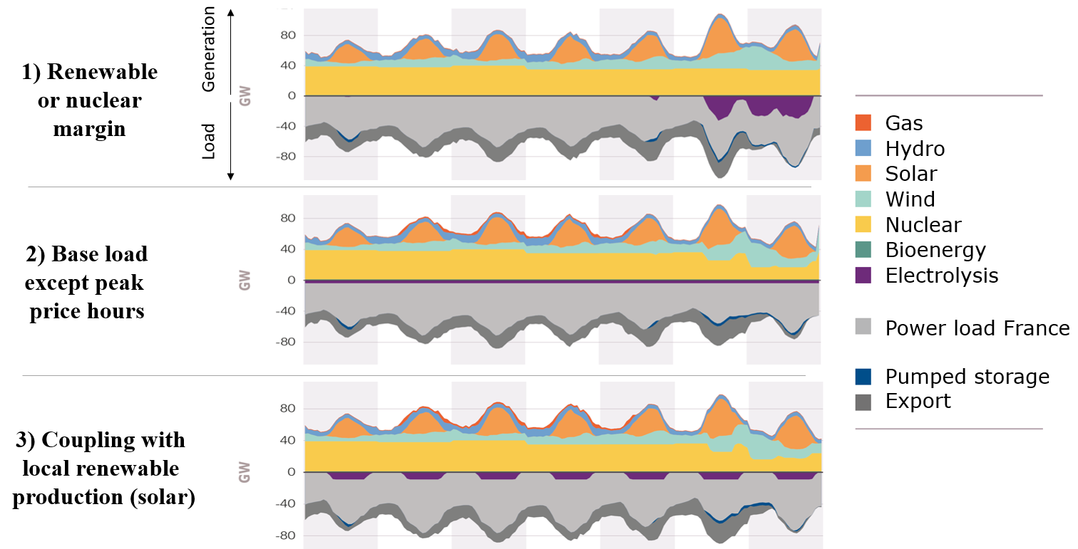

Figure 1 - Illustration of electrolysis operating modes, hourly production and load in France for the week of July 9 to 15, 2035

Results
The investments to be made in the development of electrolysers strongly depend on the operating methods envisaged. Hydrogen production only concentrated during periods of low electricity prices (periods when there is unused renewable or nuclear generation) will have to operate during a reduced number of hours and leads to significant sizing of electrolyzers and therefore to hydrogen production with high fixed costs (high power of the electrolyzers and implementation of dedicated hydrogen storage facilities) and low variable costs (supply during periods of low prices). In total, the production cost is made up of around 80% of the amortisation of electrolyser costs. The coupling mode with photovoltaic self-generation leads to a lower production cost, in particular due to a much lower need for electrolysis power. The base load mode except peak price hours leads to the lowest production cost due to the lower capacity sizing of the electrolysers in relation to their high operating time. In the same way, the operating mode adopted will have a significant influence on the continuity or variability of hydrogen production, and consequently on the need for associated hydrogen storage facilities to cover a stable demand (Fig 2).

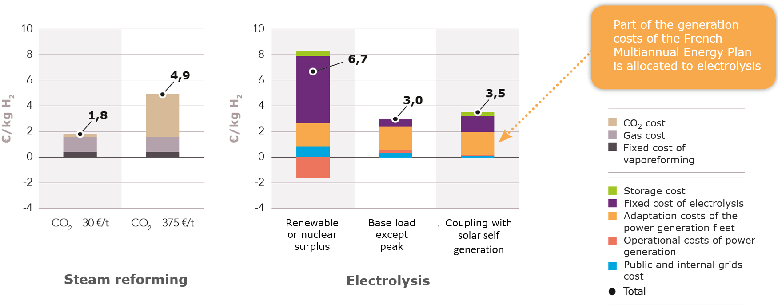
Figure 2 - Comparison of the collective costs of steam reforming and electrolysis
Given that steam methane reforming (SMR) leads to the emission of about 9 kg of CO₂ per kg of hydrogen produced, the transfer of 630,000 tonnes of hydrogen from this production method to electrolysis associated with the adaptation of the decarbonated electricity power generation in France (nuclear and renewables) leads to a reduction in national emissions of nearly 6 million tonnes per year by 2035, i.e. slightly more than 1% of national emissions. This result, which is consistent with the main existing studies on the subject, is due to the nature of the electricity mix in France. When projected on a mix that uses gas and coal as fuels for electricity in large part (Germany) or almost entirely (Poland), the production of hydrogen by electrolysis rather has a negative influence on CO₂ emissions.

Conclusions
The electricity produced in France is already very largely decarbonised (93%) and the announced closure of the last coal-fired power stations will lead to a further improvement in the carbon balance in the coming years. Among the possible technologies for the production of low-carbon hydrogen, priority is being given to the development of electrolysis, in order to limit the use of carbon capture and storage technologies, which still present uncertainties in terms of availability, reliability and acceptability. In the long term, the potential for the development of hydrogen could go far beyond these references. A number of studies identify [2-3], for example, the potential for using hydrogen for other uses, such as the steel industry, which would open up significant development prospects. Hydrogen can also be used as carrier as a substitute for petroleum fuels (for heavy mobility) or fossil gas (via direct injection into the gas network or as a replacement for it gas used in certain processes industry). If these forecasts become a reality, the potential to reduce greenhouse gases emissions will further increase. This study is detailed in a report published by RTE in January 2020 [4].

References
[1] Antares simulator, https://antares-simulator.org/, accessed on 2020-01-22
[2] AIE, 2019, The future of hydrogen
[3] IRENA, 2019, Hydrogen : A renewable energy perspective
[4] RTE, 2019, La transition vers un hydrogène bas carbone : Atouts et enjeux pour le système électrique à l’horizon 2030-2035 (https://www.rte-france.com/sites/default/files/rapport_hydrogene_vf.pdf)

