**TECHNO-ECONOMIC EFFECTS OF DECENTRALISED BATTERY SUPPORTED PHOTOVOLTAIC SYSTEMS CONSIDERING DIFFERENT TYPES OF TARIFFS**

Albert Hiesl, TU Wien, +43158801370371, hiesl@eeg.tuwien.ac.at

Michael Hartner, TU Wien, +43158801370379, hartner@eeg.tuwien.ac.at

Reinhard Haas, TU Wien, +43158801370370352, haas@eeg.tuwien.ac.at

## Overview

The social and economic acceptance of photovoltaics has increased significantly in recent years. Decreasing costs for photovoltaic systems let it become a competitive energy source for decentralized use. In the last years, one can observe increasing self-consumption of photovoltaic electricity. Responsible for this trend is the increasing spread of retail electricity prices and feed-in remuneration. Therefore, the profitability of photovoltaic systems mainly depends on self consumed PV-electricity. Besides this fact another trend arised: Stationary battery systems. Subsidies and technological learning led to decreasing costs and to affordable systems which can increase self consumption and self sufficiency significantly.

This paper focuses on the techno-economic impact of battery supported photovoltaic systems from an household and a system perspective. Therefore, we analyze the effects on the “residual” load of households as well as the economic implications due to battery storage systems. We consider different scenarios for household electricity tariffs and feed-in remunerations and furthermore different operation scenarios of the battery storage.

## Methods

Based on measured data of horizontal irradiation and ambient temperature, the PV-output is calculated following the approach suggested by Huld (Huld et al., 2010). The PV-output can be calculated depending on the direction and installation angle of the PV-modules. The electricity consumption of households are implemented as standardized load profiles but can also be replaced with measured load profiles. In this study, the battery is modeled as lithium battery with a typical loading gauge. The PV-output, the load profile as well as the parameters of the battery are input parameters for the linear optimization model. The optimization model, which is based on the YALMIP toolbox and the GUROBI solver, controls the operation of the battery, decides when to purchase electricity from the electricity grid and when to feed in the PV-surplus, depending on the (time variable) tariff and the operation mode of the battery. The objective function of the model is to minimize the costs of electricity purchase and the calculation is done for 25 years with different PV- and battery capacities. We differentiate between two operation strategies of the battery: Covering mainly peak load and covering total load. With assumptions on the future developement of household electricity prices and feed-in tariffs, the internal rate of return (IRR) is calculated.

The economic calculation is done by

where the cash-flow (Ct) strongly depends on self-consumption, electricity tariffs and feed-in remuneration.

## Results

Battery supported photovoltaic systems can increase self-consumption and self-sufficiency of households significantly. When we look at a standardized household load profile with a consumption of 4000 kWh/a, a 5 kWp PV-system and a 5 kWh battery storage, the rate of self consumption increases from about 31% to 48% and the rate of self sufficiency increases from 42% to 66% considering a battery storage system.

Figure 1 shows two charging strategies of the battery, whereas the left figure displays the results for the total load coverage strategy and the right the peak load coverage strategy. In peak load mode the battery mainly covers a fixed peak load (e.g. 50% of the maximum load [kw]) but is also able to cover total load if battery capacity is left. When we compare these two charging strategies in terms of self consumption and self sufficiency we can observe that there is almost no difference as a result of the optimally use of the batterie’s capacity. This implicates, that there is also no difference in terms of economic parameters when most common electricity tariffs and feed-in remunerations (fixed kilowatthourly based rate) are considered. When we look at time variable tariffs (ToU tariff, Peak load Pricing) there is a difference in the economic parameters.

## 

Figure 1: Charging Strategies of the battery for a standardized household load profile: left: total load coverage, right: peak load coverage

Figure 2 points out the residual load of a household without a PV-System and with PV-System and battery. It can be seen, that there is almost no difference in peak load when we look at the electricity which has to be purchased from the electricity grid (“residual load” if PV is installed). This indicates, that users of PV-Systems and batteries operated in total coverage mode need the same power rate as users without these systems, but pay less network access charges. We thereby anticipate that through a shift of the network access charges from energy-related consumption to capacity, the true costs of individual customer groups can be better reflected and may also change the economic profitability of battery storages significantly.

Not only alternative tariff-options, which influence the operation mode of the battery, but also technological learning has a big impact on the economic profitability of decentralized battery storages. In 2013 a 5 kWh lithium battery storage accounts for about 2560 €/kWh, in 2015 it declined to about 2000 €/kWh and the world wide trend of declining battery costs continues unabated. Even if the economic profitability is not reached yet, a break even point can be reached in the next years and thus can influence an enhanced rollout of these systems with impacts on the whole electricity system.

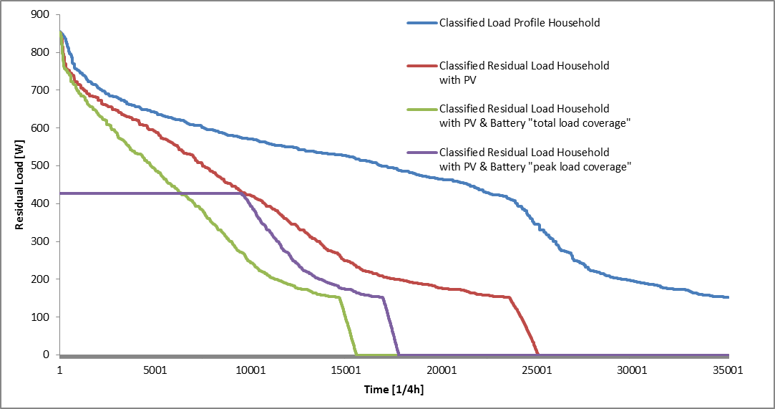

Figure 2: Classified residual load of a standardized household load profile

## Conclusions

Due to technological learning and alternative tariffs, battery storages can become an economic attractive solution for decentralized use. In a future energy system, they can change the load profile of households significantly and they need to react on price signals (charge the battery when electricity prices are low, discharge when prices are high) if time variable tariffs are implemented. Besides their role of increasing self-consumption and self-sufficiency, a “system friendly” operation mode is necessary to be a flexibility option to match electricity demand and suplpy.

## References

Huld, T., Gottschalg, R., Beyer, H.G., and Topič, M. (2010). Mapping the performance of PV modules, effects of module type and data averaging. Sol. Energy *84*, 324–338.