COMPARISON OF CARBON FOOTPRINTS OF DIGITAL CURRENCY (BITCOIN) AND GOLD: DETERMINATION OF THE CRITICAL EXCHANGE RATE
Fehmi Gorkem Uctug (Ph.D), Izmir University of Economics – School of Engineering, +902324888354, gorkem.uctug@ieu.edu.tr
Tayyar Can Unver (M.BA), Enterprise Risk Manager at Kredi Kayit Burosu Inc., +905311613711, canunver@gmail.com

Overview
Over the last two decades the use of digital currency, Bitcoin being the most prominent example, has increased dramatically. In traditional finance, information and data regarding transactions and balances are kept track of by banks digitally. On the other hand, in blockchain-based digital currency systems, the entire memory of transactions is stored digitally in “blocks” that are linked as a chain - hence blockchain - and kept by a network of peers. This system requires a consensus mechanism in which the peers in the network continuously agree on the order of newly added blocks and thus secure the data in a decentralized fashion. In the case of Bitcoin, this task is accomplished via a proof-of-work approach where peers in a network compete in winning the right to add the next block to the chain, a process called “Bitcoin mining” that is performed by “miners” [1]. Bitcoin mining involves solving a puzzle to win the afore-mentioned right to add the next block, and this process requires considerable amounts of computing power; thus, electricity consumption associated with Bitcoin mining is very high, even higher than the annual electricity consumption of some countries. This fact inevitably raised questions about the environmental sustainability of Bitcoin. Consequently, there are studies in the literature, albeit not high in number, concerned with the environmental life cycle impact assessment and/or carbon footprint of Bitcoin mining [1, 2]. However, these studies do not address the following question: Is Bitcoin more environmentally friendly than traditional currency?
In this study, a comparative environmental life cycle assessment of Bitcoin mining and gold production has been realized to calculate their respective carbon footprints. The main aim is to determine the critical exchange rate between Bitcoin and gold at which these two entirely different forms of currency would have identical carbon footprints. To the best of the authors’ knowledge, this is the first study in the literature in which the environmental impacts associated with digital currency and traditional currency have been compared. Hence, we consider this paper to be a novel contribution to the existing literature.

Methods
Carbon footprint of Bitcoin mining was calculated by creating a life cycle model that takes hardware production and end-of-life-treatment as well as electricity consumption stages into account. CCaLCTM software with CML2001 method was used and the relevant processes were obtained from Ecoinvent2 database. The electricity required for the mining of one Bitcoin was obtained as 692.15 kWh from the literature [3]. In order to analyse the effect of mining location on carbon footprint, different countries with distinctly different electricity mix portfolios were chosen. Turkey is one of these countries, not only because this study was conducted in Turkey, but also because Turkey has a rather diverse electricity mix portfolio; with hydroelectricity, natural gas and coal all accounting for more than 15% of the total generation each; and none of the sources in the electricity mix accounting for more than 40% of the total generation. The other countries that were selected are France, Poland, and Denmark, as these countries rely on one specific source to produce at least 50% of their electricity. In the case of France this particular source is nuclear power, in the case of Poland it is coal, and in the case of Denmark it is wind. Finally, a fifth scenario was also considered in which it was assumed that all the electricity required for Bitcoin mining would be obtained from photovoltaic panels.
Life cycle carbon footprint of gold production was directly obtained from the literature [4]. For both Bitcoin mining and gold production, the functional unit was chosen as $1,000,000 worth of assets.

Results
Figure 1 shows that with the current prices (as of the beginning of March 2021), Bitcoin mining has much higher carbon footprint than gold production. As expected, carbon footprint of Bitcoin mining is highly dependent on the mining location, as the relative standard deviation of Bitcoin mining carbon footprint scores was obtained as 85%. As expected, again, locations where electricity mix relies heavily on fossil fuels, such as Poland, turned out to have higher environmental impact scores compared to locations where renewables and/or nuclear have high shares in the electricity mix.

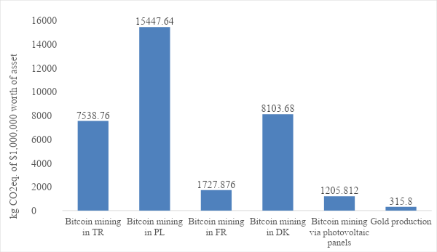

Figure 1. Carbon footprints of Bitcoin mining (different locations) and gold production

According our life cycle model, more than 99% of the total carbon footprint of Bitcoin mining arises from electricity consumption required for the “mining”. Thus, it would be a reasonable approach to assume that the impacts will increase linearly with the amount of Bitcoin mined. In that sense, the critical exchange rate of Bitcoin so that gold and Bitcoin would have equal carbon footprints per $ of value is obtained as $1,100,000 on average (of the mining locations). When the value fluctuations of Bitcoin in the past is analysed, it can be seen that the highest value that it reached is around $60,000. Therefore, it can be concluded that it is very unrealistic for Bitcoin to reach a value where it would have a lower carbon footprint than gold, at least in the near future.

Conclusions
The main conclusion of this study is that Bitcoin mining, at least from a carbon footprint point of view, has much higher environmental impact than gold production. Although the value of Bitcoin has significantly increased in 2021, it seems very unlikely in the short term for it to reach such a value where it would have a lower carbon footprint than gold. The policy implication of these findings is that, governments that would consider introducing Bitcoin as a legitimate means of transaction should also consider introducing a carbon tax for every transaction that involves Bitcoin.
It should be noted that gold production has several other environmental impacts besides carbon footprint. Some of these impacts include (but are not limited to) land transformation as a result of deforestation due to mining activities, human toxicity potential due to the use of cyanide for leaching, or photochemical smog formation due to the transportation of gold via internal combustion engine-powered means of transportation. Therefore, the actual environmental impact of gold is much higher than what is depicted in this study. A more detailed study in the future, in which the overall environmental impact of both assets are calculated by assigning weights to different impacts and then multiplying normalized impact scores by these weights, could give a more accurate idea about the relative impacts of Bitcoin mining and gold production.

References
[1] Köhler, S., Pizzol, M., 2019. “Life Cycle Assessment of Bitcoin Mining”, Environmental Science and Technology 53, 13598-13606.
[2] Stool, C., Claaßen, L., Gallersdörfer, U., 2019. “The Carbon Footprint of Bitcoin”, Joule 3, 1647-1661.
[3] “Bitcoin Energy Consumption Index”, 2021. Retrived from https://digiconomist.net/bitcoin-energy-consumption/ on March 3rd, 2021.
[4] Norgate, T., Haque, N. 2012. “Using life cycle assessment to evaluate some environmental impacts of gold production”, Journal of Cleaner Production 29-30, 53-63.

