Unraveling the Paradox:
The Economics of Using Otherwise Wasted Heat for Chilling

Lori Smith Schell, Ph.D., ERP Kyle S. Hosford, M.S.
Empowered Energy University of California-Irvine
+1 (970) 247-8181 +1 (619) 672-0687
LSchell@EmpoweredEnergy.com kshosford@gmail.com

Overview
High-temperature fuel cells combined with an absorption chiller in a combined cooling, heating, and power (CCHP) system offer the potential to generate ultra-clean, highly-efficient distributed power with virtually zero criteria pollutant emissions. Such systems effectively utilize waste heat from the high-temperature fuel cell to provide cooling from an absorption chiller. In particular, the high quality heat from the fuel cell can be recovered through absorption chilling and thereby (1) displace electricity required for electric chillers, (2) dramatically reduce the emissions of criteria pollutants and greenhouse gases, (3) increase reliability for the onsite customer, and (4) reduce the demand for electricity transmission and distribution upgrades. A limited number of such integrated systems are being made available commercially today, with the potential for significant market penetration in the future. As a result, there is a need to examine the economics of such a system through an integrated technical and economic model that will allow system optimization and, ultimately, a direct comparison of the relative economics of such a system compared to traditional electric chilling and grid-supplied electricity.

Methods
The technical and economic modeling for a number of different high-temperature fuel cell/absorption chiller CCHP scenarios has been completed. The integrated model will be updated with actual system cost and operating data pending installation of an actual system on the University of California-Irvine (UC-Irvine) campus. Figure 1 (below) illustrates the basic layout of the economic modeling.
The economic modeling has been generalized to represent the costs of a generic system that includes a high-temperature fuel cell, an absorption chiller, and some type of thermal energy storage to allow the fuel cell to operate at baseload conditions round the clock to maximize its efficiency. Cost analysis has been focused of the modeling of the initial UC-Irvine CCHP system, with the goal of guiding actual system design optimization based on the specific building load to be satisfied. For analytical purposes, hourly building load profiles are being developed for a number of different building types to test the robustness of the integrated model.

Results
Scenario results provide a comparison of the levelized cost of energy (LCEO) to provide electricity and chilling to satisfy building loads of various types using the electricity and high quality waste heat made available from the high-temperature fuel cell. It is anticipated that future reliability and operating considerations may show that a multi-component system made up of several smaller absorption chillers may be preferable to a single large absorption chiller with the equivalent chilling capacity. The total portfolio LCOE of meeting building loads using different CCHP system configurations will be compared using scenario analysis. Differences in carbon dioxide (CO₂) emissions will be monetized based on market prices observed in California’s recently implemented CO₂ cap-and-trade program. The results will also provide a side-by-side comparison of the cost components contributing to each scenario’s total levelized cost to allow for a ready comparison of the possible trade-offs between different cost components (e.g., between capital costs, operating and maintenance costs, and fuel costs). The costs associated with the various CCHP systems will be compared directly with the costs of satisfying load through traditional electric chillers and grid-supplied electricity.

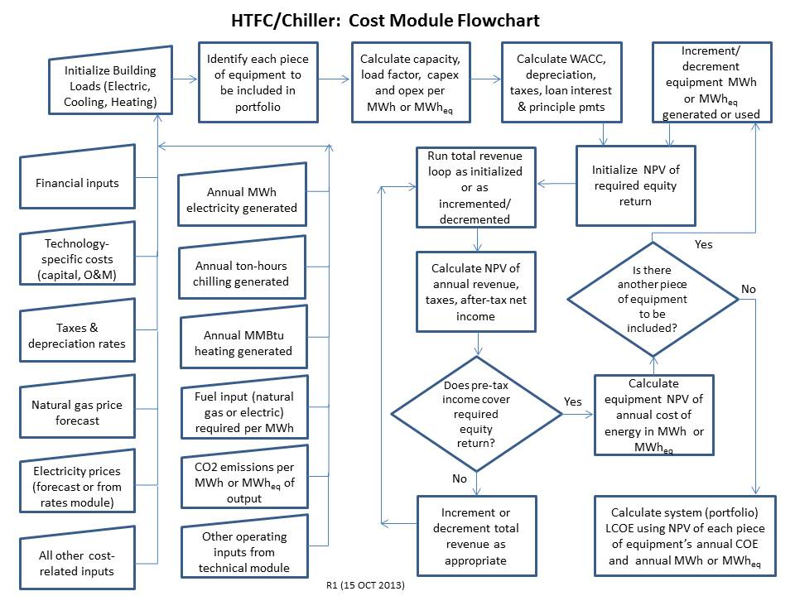
Figure 1: Flow Chart for High-Temperature Fuel Cell/Chiller Economic Model

Conclusions
High-temperature fuel cells combined with an absorption chiller in a combined CCHP system offer the potential to generate ultra-clean, highly-efficient distributed power with virtually zero criteria pollutant emissions. The high quality heat from the fuel cell can be recovered through absorption chilling and thereby (1) displace electricity required for electric chillers, (2) dramatically reduce the emissions of criteria pollutants and greenhouse gases, (3) increase reliability for the onsite customer, and (4) reduce the demand for electricity transmission and distribution upgrades. Increased penetration of such CCHP systems throughout the economy would help reduce the total energy input required to satisfy building demand for cooling, heating, and power.

References

(1) Bollenbacher, Gary, August 1983, “Economic Competitiveness of Fuel Cell Onsite Integrated Energy Systems,” NASA Technical Memorandum.

(2) Deng, J., R.Z. Wang, and G.Y. Han, 2010, “A Review of Thermally Activated Cooling Technologies for Combined Cooling, Heating and Power Systems,” Progress in Energy and Combustion Science 37 (2011) 172-203.
(3) U.S. Environmental Protection Agency, Combined Heat and Power Partnership, August 2007, “The Role of Distributed Generation and Combined Heat and Power (CHP) Systems in Data Centers.”

