Optimal Policy for Plug-In Hybrid Electric Vehicles Adoption

Emrah Ozkaya, PhD Candidate, Purdue University, School of Industrial Engineering, (765) 494-4223, eozkaya@purdue.edu
Andrew Liu, Assistant Professor, Purdue University, School of Industrial Engineering, (765) 494-4763, andrewliu@purdue.edu
Paul V. Preckel, Professor, Purdue University, Department of Agricultural Economics, (765) 494-4240, preckel@purdue.edu
Douglas J. Gotham, Director, State Utility Forecasting Group, (765) 494-0851, gotham@purdue.edu

Overview

Consumers’ decision making behavior when evaluating emerging energy-efficient technologies is a complicated process, often coupled with hidden costs and benefits. Policy makers need to have the right tools that appropriately consider the dynamics of such decision making processes when devising policies for energy-efficient technologies. Energy system models such as MARKAL have been widely used to analyze the impacts of energy efficiency policies but are usually unable to fully capture the complexities related with consumers’ decision making behavior. This study develops an integrated energy system model which builds on the MARKAL framework and merges it with a consumer demand model based on discrete choice analysis in order to capture such complexities. The integrated model is then used for an empirical analysis of the adoption of plug-in hybrid electric vehicles (PHEVs) and the government’s recent PHEV subsidy policy in the United States. We provide optimal policy implications based on our findings.

Methods

The main contribution of this study is the introduction of an integrated energy system model which combines a consumer demand model representing the adoption of PHEVs (based on discrete choice analysis) with a bottom-up energy system model (MARKAL). Figure 1 displays the interaction between the components of the integrated energy system model. MARKAL model feeds electricity and fuel prices (mainly gasoline price) to the PHEV adoption model, which in turn feeds back PHEV adoption rate and subsidy amount in each time period. This iterative mechanism is repeated until convergence is achieved. The convergence metric used in this study is similar to the convergence metric used in EIA’s National Energy Modeling System (NEMS) [1].

Figure 1. Integrated Energy System
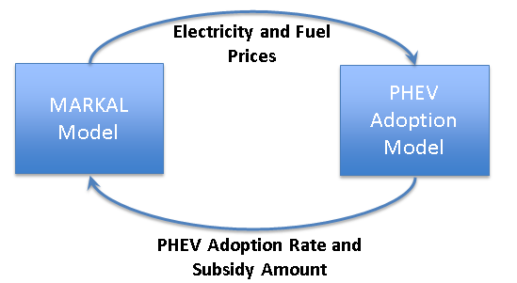

Results

Figure 2 depicts results from the PHEV adoption model which are based on a government target of achieving 20 million PHEVs by 2045. The number of PHEVs demanded increases with government’s subsidy budget, which is not a surprising result but rather a confirmation that the adoption model behaves as anticipated. On the other hand, the graph on the right hand side reveals that the optimal subsidy policy is one where the subsidy amount diminishes gradually over time.

Figure 2. PHEV Adoption Model Results

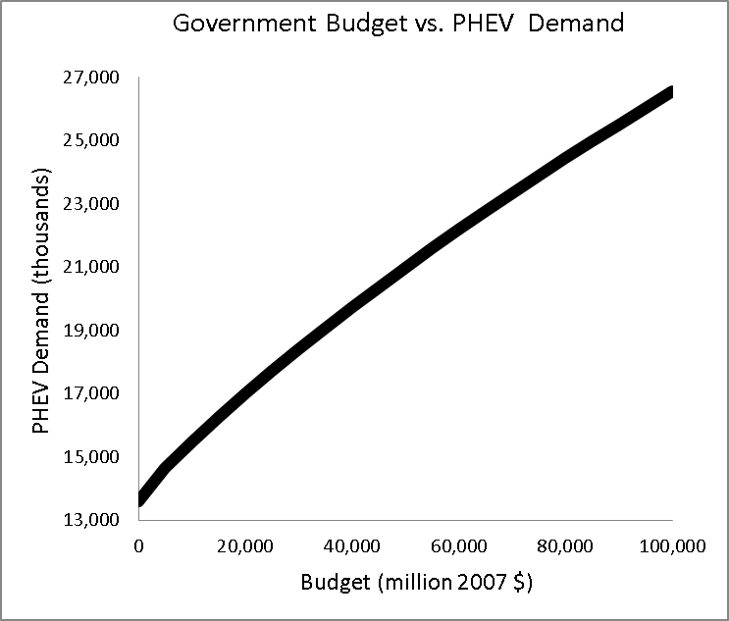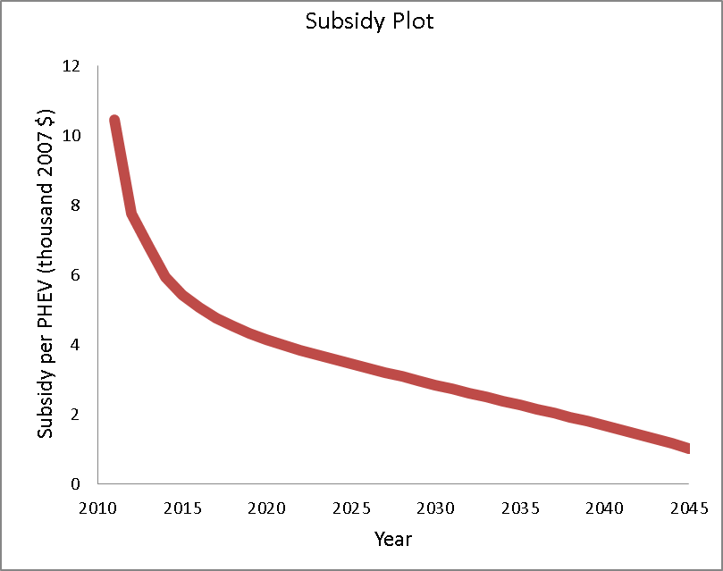

Figure 3 displays the sensitivity of the PHEV adoption model to its input parameters, electricity and gasoline prices. As expected, variation in gasoline price has a much bigger impact on subsidy cost versus variation in electricity price.

Figure 3. PHEV Adoption Model Sensitivity Analysis
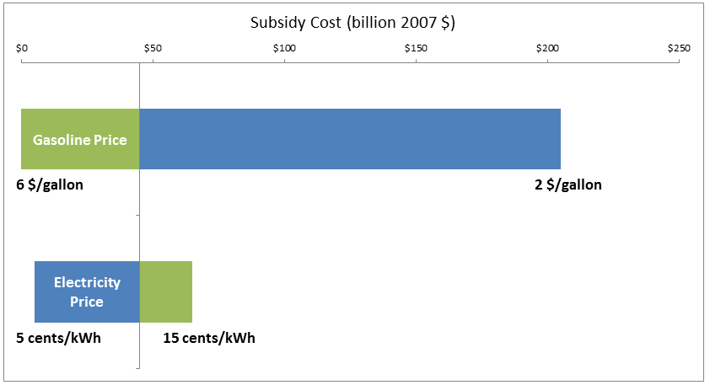

Conclusions
The main conclusion based on our results is that the government should not give out the subsidies all up-front but should instead follow a policy where per-vehicle subsidy is gradually reduced. Electricity and gasoline prices will not be impacted much at the selected PHEV penetration level based on our integrated model results. On the other hand, GHG emissions from the transportation sector are significantly reduced in the 20 million PHEV adoption scenario when compared with the base case where there is no demand for PHEVs.

References
[1] Energy Information Administration, U.S., 2012. Integrating Module of the National Energy Modeling System: Model Documentation. http://www.eia.gov/forecasts/nemsdoc/integrating/pdf/m057(2012).pdf

