THE STABILITY RESERVE IN EU CARBON EMISSION TRADING:
DOES IT DELIVER WHAT IT PROMISES?
Jörn C. Richstein, Delft University of Technology, +31 15 2783095, JC.Richstezin@tudelft.nl
Émile Chappin, Delft University of Technology, +31 15 278 3410, E.J.L.Chappin@tudelft.nl
Laurens J. de Vries, Delft University of Technology, +31 15 278 1137, L.J.deVries@tudelft.nl

Overview
This work investigates the effects that the recently announced and proposed reforms of the European Emission Trading Scheme (EU ETS) may have on the European power sector and on long-term performance of the EU ETS. In recent years the Europe Union’s emission trading system (EU ETS) has experienced very low prices. This has triggered a political discussion about stabilising the EU ETS and improving incentives for investing in CO₂ abatement. As a result of this discussion, the EU parliament accepted a proposal of the EU commission on the “backloading” of EU emission allowances (EUA), where the auctioning of EUAs is postponed to future time periods [1]. Secondly the EU commission recently updated and detailed its climate strategy between 2020 and 2030 [2], which includes a specific proposal to the EU parliament for a “market stability reserve” (MSR). The MSR is a quantity based stabilisation policy, triggered by the amount of EUAs in circulation [3]. Both policy measures together mark a significant change of the EU ETS policy framework.
We study these reforms using a simulation: Evaluation of the reforms is carried out in the long-term agent-based model EMLAb-Generation via an analysis of the dynamic investment pathway of two interlinked electricity markets coupled by an emission trading scheme including banking of EUAs, under the influence of stochastic fuel price development and demand growth. We investigate three policy scenarios: The unchanged EU ETS, the EU ETS including the backloading legislation and an additional market stability reserve.

Methods
The work utilizes the long-term focused agent-based model EMLab Generation [4, 5], to simulate the dynamic effects of CO₂ policy with a common CO₂ emission trading scheme, which includes banking of power producers. Great Britain and Central Western Europe are modelled mirroring their current operational power plant mix. The residual electricity demand is represented as a band of 20 segments with varying length from peak to base-load, approximating the load duration curve as blocks. Interlinked with the electricity market is the CO₂ market including banking. It is implemented by an algorithm that finds a CO₂ price bringing the current electricity market and its emissions in equilibrium with forecast CO₂ emissions, while abiding to the cap and the CO₂ hedging needs of power producers. This is achieved by simultaneously clearing the current electricity market and a forecast electricity market in three years under a joint emission cap and a joint CO₂ price (which is compounded to the future) and letting producers strive to achieve a hedging target (based on future power sales).

The market stability reserve is introduced to the model closely following the formal description in [3]. Before the electricity and CO₂ markets are cleared, the EU ETS cap for the current year is adjusted based on the volume of EUA allowances that were banked two years ago. The target corridor has been linearly scaled to the scope of the model (the electricity sectors of CWE and GB). If the banked allowances in year x-2 are above the upper trigger, 12% of these allowances are deducted from the EU ETS cap in the current year. If the banked allowances in year x-2 are below the lower trigger the MSR releases a fixed amount of EUAs. The emergency price trigger that is based on a tripling of CO₂ prices within 2 years is directly integrated in the market clearing algorithm.

Investment is based on a NPV forecast for different technologies. Investment decisions by generators are made in an iterative process in which the companies sequentially consider investing. A company’s investment decision influences the decisions of the following companies. To investigate the policy reforms for robustness a Monte-Carlo simulation is carried out: Fuel prices, as well as the electricity demand are modelled as mean-reverting stochastic trends, with high, medium and low fuel price. Demand scenarios are modelled as stochastic trends following a triangular distribution.

Results
Figure 1 shows the development of CO₂ prices and banked EUAs over time (the unchanged EU ETS scenario is named PureETS). Compared to the current EU ETS we see backloading to increase prices in the short term. However, its medium and long-term effect are small and both the scenario with and without backloading show a risk of CO₂ price shocks and following high costs to electricity consumers. Backloading mainly shifts prices and volatility to a slightly later point in time.
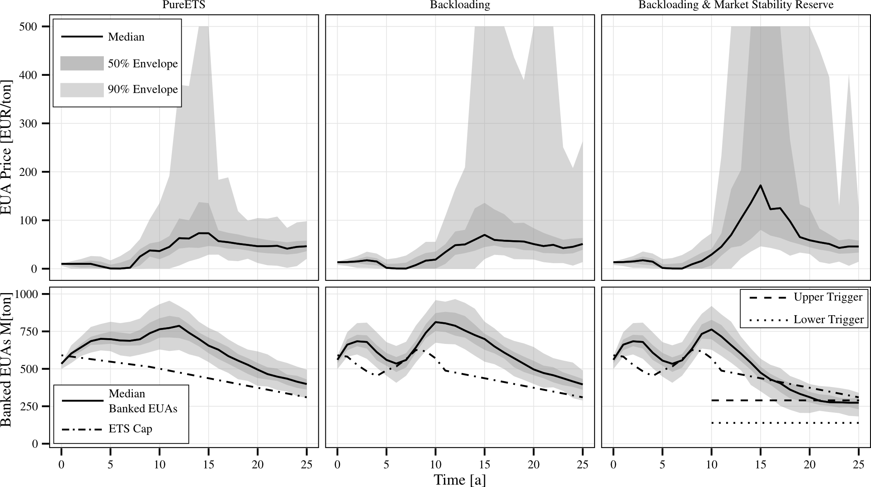
Figure 1: CO₂ price development and banking of carbon emission allowances under proposed EU ETS reforms.
The proposed market stability reserve may indeed not introduce stability to the EU ETS, but rather significantly destabilise it, leading to a marked increase of medium term prices and a period of very high CO₂ price volatility. The cause of this destabilisation is to be found primarily in the wrong parameterisation of the policy: its target corridor is set far below what we assume to be the hedging need of power producers (and other actors in the EU ETS), thus leading to a shortage of carbon emission allowances. Notably, we don’t assume hedging to being exclusively driven by developments within the carbon market, but being induced by future power sales. Thus banking constraints might also affect trading in future electricity markets. Secondly, the price rules that need to be fulfilled for an emergency intervention of the EU are set in such a way that extremely high prices might occur without triggering a response.

Conclusions
We study the effects the recently announced backloading and the newly proposed market stability reserve will have on the functioning of the EU ETS. To do so we use the agent-based model EMLab-Generation to simulate the dynamic pathway of central western europe and Great Britain under a joint carbon market. We find that the backloading proposal might increase prices in the short-term put not does prevent periods of high CO₂ prices and volatility, which also occur under the unchanged EU ETS. The proposed market stability reserve might act counter to its objectives: We found it to markedly increase CO₂ prices and CO₂ price volatility due to a very low target corridor for banking. We recommend to reconsider the introduction of the market stability reserve in its current form. Future research into hedging behaviour is necessary to better estimate impacts such a rule based scheme would have on the carbon and electricity markets.

References
[1] European Commission, 2012a. COM(2012) 416 final: Clarifying provisions on the timing of auctions of green-house gas allowances.
[2] European Commission, 2012b. COM(2014) 15 final: A policy framework for climate and energy in the period from 2020 to 2030.
[3] European Commission, 2014a. COM(2014) 20 final: Concerning the establishment and operation of a market
stability reservefor the union greenhouse gas emission trading scheme and amending directive 2003/87/ec
[4] Richstein, J.C., Chappin, E., de Vries, L., forthcoming. Cross-border electricity market effects due to price caps in an emission trading system: An agent-based approach. Energy Policy URL: http://dx.doi.org/10.1016/j.enpol.2014.03.037
[5] De Vries, L.J., E.J.L. Chappin & J.C. Richstein, EMLab-Generation – An experimentation environment for electricity policy analysis , TU Delft, 2013

