Counting consumption-based energy system emissions: linking an energy system and eeio model for the UK

Dr. Hannah Daly, UCL Energy Institute, Phone +44 2031089158, E-mail: hannah.daly@ucl.ac.uk
Kate Scott, University of Leeds, Phone +44 113 34 32394, E-mail: k.a.scott@leeds.ac.uk

Prof. Neil Strachan, UCL Energy Institute, Phone +44 203 108 5995, E-mail: n.strachan@ucl.ac.uk

Prof. John Barrett, University of Leeds, Phone +44 113 34 32394, E-mail: j.r.barrett@leeds.ac.uk

Overview
Nearly a quarter of global GHG emissions are due to trade that is not captured in current policy, and the difference between production emissions and emissions associated with consumption is growing. In the absence of a global emissions agreement and with different levels of ambition between countries, there is increasing concern for countries with ambitious GHG mitigation targets that emissions are being exported rather than reduced, and territorial reductions are being offset because of carbon leakage. Consumption-based accounting can be a robust and effective means of mitigating the carbon leakage effect, and studies have shown that there is a need to include consumption-based indicators as a complement to production-based accounts. Further, there is growing policy recognition that consumption based accounting is needed to achieve significant carbon reductions on a global level, yet there are few studies which address this issue within energy system analysis and other quantitative policy analysis.

The growing gap between consumption and production emissions motivates two important questions:
- What are the global implications of current energy system pathways based on territorial (production based) emissions accounting?
- How would energy and climate change policy change were emissions counted on the basis of consumption rather than on production?

Climate policy analyses have a strong focus on decarbonisation pathways for energy systems, and bottom-up energy system models have long underpinned these studies. We expand one such existing model to enable us to look at these questions for the first time by taking into account the full lifecycle GHG emissions, including indirect and leaked carbon emissions, associated with energy infrastructure, trading, construction and manufacture, within an energy system model. We differentiate between domestic indirect emissions, which arise from the domestic manufacturing and construction of energy system infrastructure and technologies, and imported emissions, arising from emissions caused abroad for the supply of energy domestically.

The UK is used as a case study for this paper. The UK government has set an ambitious decarbonisation target for 2050, requiring territorial emissions to be reduced by 80% on 1990 levels. The government is however increasingly recognising that emissions savings already achieved are undermined by carbon leakage. The motivations for this study are equally highly relevant to other developed and developing counties who engage in international trade. Moreover, the methodology is applicable depending on data availability.

Methods
The methodology is based on linking two established energy-economic models for the UK: the UK TIMES Model (UKTM), a bottom-up energy system model, and a multi-regional, environmentally extended input-output (MR-EEIO) model.

UKTM is a newly developed energy system model for the UK, as a successor to UK MARKAL. As a partial equilibrium, cost optimization model of the complete UK energy system, it calculates optimal investment for the UK to reach ambitious 2050 climate targets based on alternative fuel and technology pathways. UKTM is based on a strong pedigree of models with a history of significant policy contribution in the UK.

The MR-EEIO model calculates the lifecycle emissions associated with all energy technologies, infrastructure and trade in the UK. Input-output analysis converts monetary flows to physical flows (for example greenhouse gas emissions) between sectors in an economy and uses the composition of purchases for an average economic sector from a country’s National Accounts to estimate the environmental impact along the full supply-chain of a product.

Figure 1 describes the process of including and balancing indirect emissions across the energy system. We project forward scenarios of future international indirect emissions based on assumptions around the UK trade balance in different economic sectors, and the level of decarbonisation of the rest of the world, to estimate the sensitivity of results to alternative futures.

Figure 1: Simplified UKTM energy system with addition (+) and removal (-) of indirect emissions (domestic and international)
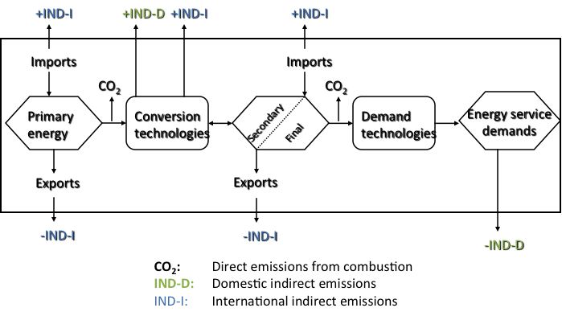

Results
Results show firstly that balancing domestic indirect emissions within the energy system model does not significantly change least-cost energy system pathways, and that uncertainties surrounding new low-carbon technology costs and attributes are likely to dominate the effect of domestic indirect emissions.

Secondly, we find significant carbon leakage from the UK for the supply of energy, via imported electricity and biofuels, and via lifecycle emissions from the manufacture of imported energy technologies. The level of carbon leakage is very sensitive to the rate that energy technologies and fuels are imported versus produced domestically, and the rate at which other regions decarbonise in the future.

Thirdly, we present the least-cost energy system formulation when a consumption-based accounting system is in place for the UK, showing the robustness of current pathways in the face of uncertain future objectives.

Conclusions
The IPCC’s latest Special Report on Renewable Energy Sources and Climate Change Mitigation recognises the important contribution life-cycle analysis can play in informing the evidence base for climate change mitigation policy. A key issue explored in this research is how important lifecycle emissions are for the feasibility of stringent emissions targets. A second key issue is in the relative costs imposed on an OECD country like the UK under fuller emissions accounting. A third key issue is in the robustness of the optimal decarbonisation pathways and results energy mix under full accounting.

References
Strachan N., S. Pye and R. Kannan, (2009) “The Iterative Contribution and Relevance of Modelling to UK Energy Policy”, Energy Policy, 37(3), 850-860.
Barrett J., G. Peters, T. Wiedmann, K. Scott, M. Lenzen, K. Roelich & C. Le Quéré (2013) “Consumption-based GHG emission accounting: a UK case study”, Climate Policy, 13:4, 451-470, DOI: 10.1080/14693062.2013.788858
Minx, J.C., Baiocchi, G., Wiedmann, T. and Barrett, J. (2009), “Understanding Changes in CO2 Emissions from Consumption 1992-2004: A Structural Decomposition Analysis”, Report to the UK Department for Environment, Food and Rural Affairs by Stockholm Environment Institute at the University of York and the University of Durham, DEFRA, London, UK.

