Overview

Shale Gas Development and Housing Values Over a Decade: Evidence from the Barnett Shale

Jeremy Weber, USDA/Economic Research Service, 202-694-5584, jeweber@ers.usda.gov
Wesley Burnett, West Virginia University, Division of Resource Management, 304-293-5639, Wesley.burnett@gmail.wvu.edu
Irene M. Xiarchos, USDA/Office of Energy Policy, 202-690-3592, ixiarchos@oce.usda.gov

The U.S. has become the global leader in natural gas production by drilling in shale formations. Drilling has created jobs and generated public revenues for local and state governments in a time of tight budgets (Weber, 2012; Pless, 2012). Yet, environmental and quality of life concerns have led several states and cities to impose a moratorium on the key technology used to extract natural gas from shale. In 2013, New York, North Carolina, Maryland, and Vermont had a moratorium on hydraulic fracturing (“fracking”) – the method of injecting a mix of water and chemicals underground at high pressure to create fissures in the shale. The support for moratoriums reflects a range of concerns such as the eye-sore of natural gas infrastructure, groundwater polluted by fracking fluids, and the boom-bust nature of energy development. Muehlenbachs, Spiller, and Timmins (2013), for example, found that at least in the short term properties in Pennsylvania dependent on groundwater lost value when an unconventional gas well was located nearby.
We study the medium to long-term effects of shale gas development on zip code level housing values over the 1997 to 2013 period in Texas’ Barnett Shale. In doing so, we connect the natural resource economics literature on the effects of extractive industries to the public economics literature on local public finances and property values. The two literatures intersect in our study: in Texas the value of oil and gas rights enter the property tax base once drilling begins, generating revenue for local schools and governments.
The Barnett Shale has had more wells drilled over a longer time and in a smaller area than any other shale formation in the U.S. Extensive drilling started in the early 2000s in some areas of the Barnett, allowing us to observe the effect of development on housing values over a decade. By 2009 the Barnett Shale had 13,740 wells, about ten times more than in Pennsylvania’s Marcellus Shale – the location of prior studies on shale gas development and housing values (Railroad Commission of Texas, 2014; PA DEP, 2014). The Barnett Shale also conveniently splits the Dallas-Fort Worth area in half, with all of the drilling occurring on the western side and none occurring on the eastern side. The clear demarcation of shale and nonshale areas, all within the Dallas-Fort Worth regional economy, provides spatial variation in drilling determined by geological endowments alone and therefore aids in separating the effect of development from confounding factors.

Methods
We combine matching and regression analysis to compare growth in housing values over time for shale and nonshale zip codes. We delinate shale and nonshale zip codes using the boundary of the Barnett Shale. The comparisons are further refined using socioeconomic characterstics from the 2000 Dicennial Census to match shale zip codes with the most similar nonshale zip codes. For housing values, we use a Zillow’s monthly housing value index, covering the period from 1997 to 2013.

Results
We find that shale zip codes appreciated relative to nonshale zip codes from 2005 to 2008, the period of peak drilling. This switched in the 2009-2013 period when nonshale zip codes appreciated more, though to a lesser degree (see Figure 1 below). Over the entire 1997-2013 period, shale zip codes appreciated 5 to 6 percentage points more than nonshale zip codes. Within shale zip codes, however, an extra well per square kilometer was associated with a 1.6 percentage point decrease in appreciation over the study period.
The greater appreciation in part reflects the incorporation of natural gas rights into the property tax base, which increased local public revenues. In the 2005-2008 period local tax revenue per student increased by $529 more per student in shale areas and operating expenditures increased by $324 per student. The difference widened further in the 2009-2011.The expenditure increase was smaller than the revenue increase, creating a surplus that fed into the fund balance – the district’s assets less liabilities. Better fund balances mean better credit ratings, lower interest rates, and easier access to financing. They also help districts cushion variation in expenditures and generate further revenues through interest income.

Conclusions
Shale zip codes appreciated more than nonshale zip codes from the beginning of large-scale development of the Barnett Shale to the end of 2013 when development had largely ceased. Although development increased housing values as reflected in the Zillow Home Value Index and Census median housing values, it is possible that drilling and hydraulic fracturing in particular created disamenities for some or perhaps most residents. Indeed, within shale zip codes, greater well density was associated with less appreciation. Our findings imply that to the extent that housing values fully capture the economic cost of disamenities from development for the typical housing property the positive economic effects such as improved local public finances more than offset the negative externalities up to 2013.
The link between oil and gas development, local public finances, and property values may be the primarily channel through which development affects property values in the long term and is an area ripe for research since property tax policies vary by state. Furthermore, our study of housing values over a decade of development is still a medium term analysis in certain aspects. In the last period of our analysis shale zip codes appreciated less than nonshale zip codes on average. The expanded tax base will not remain large for many years on account of natural gas rights alone, and the industry may have created public liabilities that become more apparent in time.
References
Muehlenbachs, Spiller, E., and Timmins, C. 2013. The Housing Market Impacts of Shale Gas Development. Resources for the Future Discussion Paper 13-39.
Pennsylvania Department of Environmental Protection (PA DEP). 2014. Oil and Gas Reports – Wells Drilled By County. Available at http://www.portal.state.pa.us/portal/server.pt/community/oil_and_gas_reports/20297.
Pless, J. 2012. Oil and Gas Severance Taxes: States Work to Alleviate Fiscal Pressures Amid the Natural Gas Boom. National Conference of State Legislatures. http://www.ncsl.org/research/energy/oil-and-gas-severance-taxes.aspx (last accessed on 2/25/2014).
Railroad Commission of Texas. 2014. Barnett Shale Information. Available at http://www.rrc.state.tx.us/barnettshale/index.php (accessed 4/8/2014).
Weber, J.G. 2012. The effects of a natural gas boom on employment and income in Colorado, Texas, and Wyoming. Energy Economics, 34(5), 1580-1588.

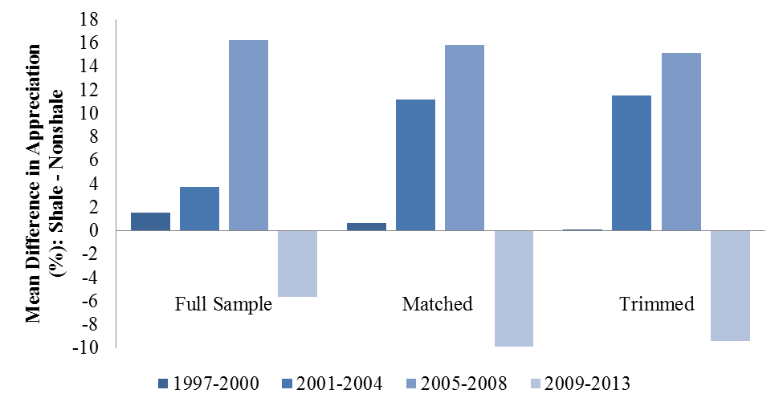

Figure 1. Mean differences in appreciation in zip code level housing values between shale and nonshale zip codes

