Overview
Retail Price Effects of Feed-in Tariff Regulation
E. Trujillo-Baute, University of Barcelona and CES-IEB, + 34 93 4035409, elisatrujillo@ub.edu

One of the targets within the European Union (EU) 2020 energy strategy was raising the share of EU energy consumption produced from renewable resources to 20%. Countries embraced this target promoting the production of electricity from renewable energy sources (RES), and the feed-in tariff (FIT) regulation is the wider spread promotion scheme used to encourage the take-up and development of generation from RES. In most EU countries the costs of resources devoted to promote the production of electricity from RES are borne by final consumers. Recent years’ recession has made Europe’s governments, industry and consumers worry about high energy prices, and some blame is attributed to climate policies in general and to FIT in particular. However, there is no empirical assessment of the actual impact that this scheme has over final consumer (retail) prices.
Two components of the electricity retail price are expected to be influenced by FIT regulation; the incentive to those firms producing electricity from RES and the wholesale price of electricity. On the one hand, from the characteristics of the electricity wholesale price (WP) formation (merit of order) and the low marginal cost of renewable energy generation, the introduction of RES in the energy mix is expected to exert a downward pressure on the WP of electricity. This effect over the WP is represented on the Wholesale Marke graph in Figure below. On the other hand, from the regulatory design of the incentive mechanisms the FIT costs (FITC) are translated to the final electricity consumers. Hence, acting over the electricity retail price in opposite directions (see Retail Market graph in Figure), both components are functions of the proportion of renewable sources in the energy mix. Therefore, to assess the overall effect of RES promotion the research question is on the relative intensity that these two components exert over electricity retail prices.

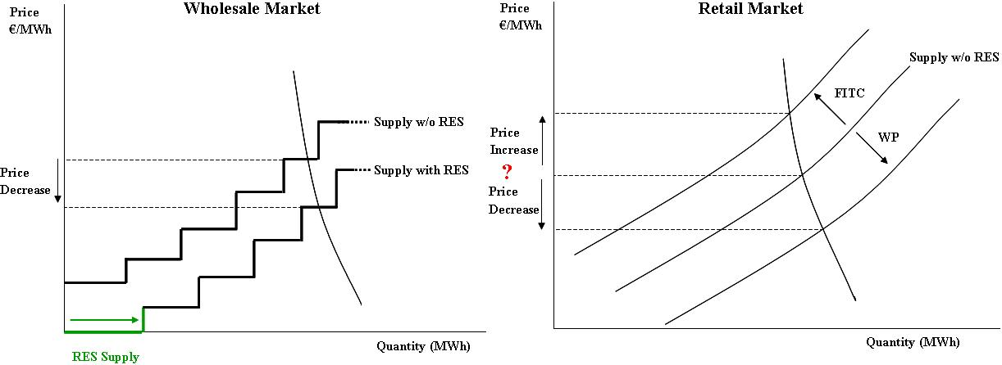

To the best of our knowledge, none of the previous work has assessed empirically the effect from both components on retail price. Gelabert et al. (2011) analysed empirically the effect of RES and COG only on wholesale price, and Burgos-Payán et al. (2013) presents an overview of the policy including both components, but performing only an aggregated cost-benefits analysis. Therefore, this paper aims to contribute to the empirical assessment of effect that the FIT regulation has over electricity retail price by quantifying the relative intensity of the incentives to electricity generation under the FIT scheme and the wholesale price of electricity. More preciscely, in this study we analyzed the effects that feed-in tariff regulation has on Spanish electricity retail prices for industrial consumers.

Methods
The empirical assessment of the effect that the FIT regulation has over electricity retail price (RP) has been developed through the estimation of a RP equation which allows us to quantify the relative intensity of the effects from both the FITC and the WP of electricity. This assessment is performed in a two steps strategy using weekly data. First, we estimate an inverse supply equation Eq.(1) where WP as function of the energy supply mix and the load (equilibrium quantity), and a FITC equation Eq.(2) capturing the effect that the daily electricity production by RES and COG has on the cost per unit of electricity consumption. Second, we introduce the estimates of WP and FITC (along with additional controls) into the RP equation Eq.(3) to evaluate the relative intensity of both components. Especial attention is devoted to technology-specific considerations, as well as short and long run effects.
ΔWP_{t} = β₀ + β₁ ΔWP_{t-1} + β₂ ΔLoad_{t} + β₃ ΔMix_{t} + β₄ Y_{t} + β₅ Q_{t} + β₆ M_{t} +β₇ W_{t}+ ε_{t} (1)
σ2_{t} = δ₀ + δ₁ ε ² _{t−1} (1.1)
ΔFITC_{t} = λ₀ + λ₁ ΔFITC_{t-1} + λ₂ΔMixF_{t} + λ₃Y_{t}+ λ₄Q_{t} + λ₅M_{t} + λ₆W_{t} + λ₇ε_{t-1} + ε_{t} (2)
ΔRP_{t} = α₀ + α₁ΔRP_{t-1} + α₂Δ${\overset{}{\text{WP}}}_{t}$ + α₃Δ${\overset{}{\text{FITC}}}_{t}$ + α₄Y_{t} + α₅Q_{t}+ α₆M_{t} + α₇W_{t} + ε_{t} (3)

Given that the effects from FIT regulation come through the proportion and type of renewable sources in the energy mix, three set of estimations are perform for each equation with different aggregations of the electricity mix. While in the first set a single variable captures the electricity generated under the FIT system (SR), in the second set we distinguish between renewable (RES) and cogeneration (COG) under the FIT system, and in third set the renewable sources are disaggregated in Wind, Solar, Small Hydro, and Other Renewable. In addition to electricity generated under the FIT system, other main technologies of the energy mix are introduced in the WP equation (Combined Cycle, Nuclear, Coal and Hydro).

Results
At an aggregated level, results confirms that an increase of about 9% of the total production under the FIT system leads to a decrease of 2.61% of the WP and an increase of 4.35% of the FIT cost (FITC). Regarding final industrial consumers, the previous mentioned effects over WP and FITC are translated into a 0.042% increase of the average retail price. These results, although illustrative, must be carefully interpreted because do not take into account the effect from different technologies.
One interesting finding from this study is that the effects from one additional GWh of solar production on the WP and on the FITC is stronger than the effects from wind. In the case of the WP this seems to be the confirmation of the differentiated effect from the fact that both technologies make different contributions of electricity to the system during the day, characterized by different demand profiles. Even though solar contribution to the energy mix is relatively small (less than 5% in average), given that it is available during peak hours, the downward pressure that exerts over the WP is stronger than the one from wind with a higher penetration (around 20%) but relatively stronger during off-peak hours. Nevertheless, this would need a further evaluation using hourly data. In the case of FITC the stronger effect from solar it is much more straightforward, it is capturing the extremely high FIT incentive in terms of euro/MWh devoted to this technology.
Regarding the final impact on industrial retail price from previous mentioned result, the effect of one additional GWh solar production is 6.6 higher that the effect coming from wind in the short-run and 7.6 higher in the long-run. When looking at these effects, it is important to highlight that one additional GWh of solar would imply increasing 93.2% its average generation while in the case of wind it would represent only an 18.7%. To place these results into perspective, we compute the effects from a 10% increase of the average production from both technologies on the average retail price. Result indicates that a 10% increase of solar generation leads to an increase in the retail price which it is actually only 1.5 higher that the effect coming from the same increase of wind generation.

Conclusions
It has been recently pointed out by the European Commission that, in an open and competitive retail market the pricing signals should provide a strong link between the retail and wholesale market, and the final consumers would then be able to adapt their economic decisions in line with the supply and demand fundamentals. These conditions are rarely met in today’s retail markets in the EU (EC, 2014). From our analysis we conclude that there is not a strong link between the retail and wholesale market for Spanish industrial consumers. This is possible the consequence of a variety of factors and barriers that are limiting the retail market competition. Moreover, taking into account technology-specific characteristics, results indicates that a 10% increase of solar generation leads to an increase in the industrial retail price 1.5 higher than the effect coming from 10% more wind. This implies that, when comparing FIT regulation effect from solar and wind generation on the industrial retail price, the prevailing the effect from the cost of incentives over the effect from wholesale price it is stronger for solar than for wind.

References
Burgos-Payán, M., Roldán-Fernández, J. M., Trigo-García, Á. L., Bermúdez-Ríos, J. M., & Riquelme-Santos, J. M. (2013). Costs and benefits of the renewable production of electricity in Spain. Energy Policy, 56, 259–270.
Gelabert, L., Labandeira, X., & Linares, P. (2011). An ex-post analysis of the effect of renewables and cogeneration on Spanish electricity prices. Energy Economics, 33(1), S59–S65.

