Overview
IMPACT OF DAY-AHEAD MARKET PRICING RULES ON GENERATION CAPACITY EXPANSION
Ignacio Herrero, Institute for Research in Technology, Comillas Pontifical University,
Madrid, Spain, Phone: +34915422800, <IHerrero@alumnos.upcomillas.es>
Pablo Rodilla, Institute for Research in Technology, Phone: +34915422800, <Pablo.Rodilla@iit.upcomillas.es>
Carlos Batlle, Institute for Research in Technology, also with the MIT Energy Initiative, Cambridge, MA, USA, Phone:+34915406306, <CBatlle@mit.edu>
Pricing rules in wholesale electricity markets are usually classified around two major groups, namely linear (aka non-discriminatory) and non-linear (aka discriminatory). As well known, the major difference lies on the fact that only the first approach does include non-convex costs (start-up and no-load cost of the marginal technology) in the market price perceived by all units. In the non-linear alternative these costs are only recognized to the units not recovering total production costs via marginal market prices, being paid if necessary as “make whole” payments.
According to the classical marginal pricing theories, the resulting market prices are supposed to serve as the key signals around which capacity expansion revolves. Thus, the implementation of one or the other pricing rule may have a different effect on the investment incentives perceived by generation technologies, affecting the long-term efficiency of the whole market scheme.
In this context, the growing deployment of Renewable Energy Sources for Electricity (RES-E) can enhance these potential differences. RES-E penetration increases the cycling operation of conventional thermal plants, raising non-convex costs of these plants (mainly as a consequence of the increase of the wear and tear of the plant, usually reflected in the Long Term Service Agreements, LTSA), see Batlle & Rodilla (2013).
In this paper the objective is two-folded: first we review how long-term investments incentives can be affected by the pricing rule implemented. To do so, we rely on the long-term results obtained with a simulation model which is applied to a real-size thermal system (Herrero et al, 2014). On this basis, we focus on the analysis of the potential effect of RES-E on the previous discussion. That is, on whether a large penetration of RES-E (in particular solar PV) could exacerbate the differences between using one or the other pricing rule. As described next, we approach the generation expansion planning problem by properly considering the effect of the aforementioned thermal cycling costs dynamics and its impact in price formation.

Methods
We base our analysis on a long-term greenfield simulation of a real-size case example. Three different thermal generation technologies (Nuclear, CCGT and OCGT) and their detailed costs and operation constraints (overnight costs, fuel variable costs, start-up costs, minimum stable load, ramps, etc.) are considered in the simulation. The mix to be optimized has to supply the hourly demand of Spain for 2012. The exogenous solar PV production profile has been scaled from the 2012 production profile in Spain.
Our goal is to find the perfectly adapted energy mix that should be installed under different pricing rules. The computation of this perfectly adapted mix is based on the major assumption that, when perfect competition is considered, the market-driven mix corresponds to the one guaranteeing satisfactory remuneration for generators (break-even remuneration) and at the same time maximizing the net social benefit.
The general approach followed consists of analyzing, under the point of view of the previous conditions, a large set of possible generation mixes. This way, the proposed approach is similar to that presented in Shortt et al. (2013); although in our case the focus is on market income, and not on production costs. In order to reduce the space of potential mixes to be considered, we first obtain a starting reference mix by using a traditional expansion planning model. This model aims at minimizing the total operating and capital costs on a future target year, but it considers centralized decisions instead of independent competitive investments. The reference mix is then used to generate around it different combinations of plants of the three thermal technologies mentioned.
For each case in the set of possible generation mixes, a sufficiently detailed unit commitment model (representing start-up costs, minimum stable loads and ramps) is first run, providing the complete economic dispatch and the hourly marginal costs. Once these marginal costs/prices are known, we evaluate on the one hand the necessary side-payments (corresponding to the non-linear pricing rule) and on the other, the extended price (for the case of the linear one) that guarantee that all the scheduled units fully recover their operation costs, including the non-convex costs. For each of the two pricing rules evaluated, the best adapted mix is the one fulfilling the best way possible the two criteria previously enounced. This process is applied to a set of scenarios with an increasing amount of RES-E installed (solar PV) to determine the influence of RES-E penetration in the potential differences between these two pricing schemes.

Results
Figure 1 shows the resulting energy mixes for 3 different levels of solar PV penetration. For each scenario, the bar on the left represents the perfectly adapted mix when short-term prices result from the application of the linear pricing rule and the one on the right the corresponding to the non-linear one. Generally speaking, it can be noted that a linear pricing rule attracts more investment in capital intensive technologies (base-load plants) which allow for a saving in operational costs. In the non-linear case the non-convex costs are not embedded in the market prices perceived by base-load plants, so as evidenced in the analysis developed, the incentive to enter the system for these technologies is weaker.
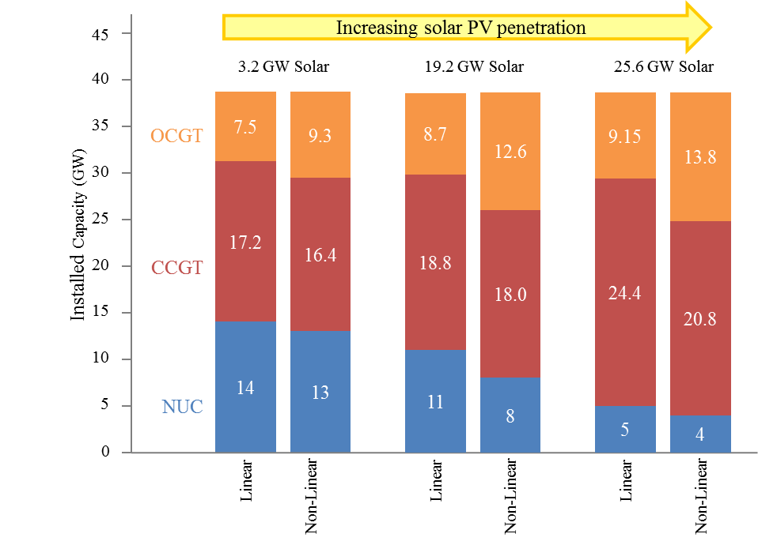
Figure 1

Conclusions
Previous studies have shown that a large penetration of variable energy resources can increase the differences between the remuneration received by base-load plants in different pricing schemes (Veiga, et al., 2013). In this paper we provide evidence on the base of an integrated capacity expansion analysis. We argue that the pricing rule implemented can substantially affect the resulting energy mix and its importance will increase with the introduction of RES-E, making it a key part of energy policy.

References
Batlle, C. & Rodilla, P., 2013. An Enhanced Screening Curves Method for Considering Thermal Cycling Operation Costs in Generation Expansion Planning. Power Systems, IEEE Transactions on, 28(4), pp. 3683-3691.
Gollmer, R., Nowak, M. P., Römisch, W. & Schultz, R., 2000. Unit commitment in power generation - a basic model and some extensions. Annals of Operations Research, 96(1-4), pp. 167-189.
Herrero, I., Rodilla, P., Battle, C., 2014. Intermittent RES-E, spot prices and investment incentives: The role of pricing rules. Working Paper IIT-14-025A. Submitted to Energy Economics.
Pérez-Arriaga, I. & Batlle, C., 2012. Impacts of intermittent renewables on electricity generation system operation. Economics of Energy and Environmental Policy, 1(2).
Shortt, A., Kiviluoma, J. & O'Malley, M., 2013. Accommodating Variability in Generation Planning. Power Systems, IEEE Transactions on, 28(1), pp. 158-169.
Veiga, A., Rodilla, P. & Batlle, C., 2013. Intermittent RES-E, cycling and spot prices: the role of pricing rules. IIT Working Paper. Submitted to Electric Power Systems Research. Available at www.iit.upcomillas.es/batlle.

