Overview
Present-day and future power systems are operated under increasing uncertainty, mainly due to the integration of intermittent renewables. Availability and output of renewable generators can fluctuate rapidly and unexpectedly with changes in weather. As a result, short-term reserve requirements increase with the penetration of renewables in the power system, which in turn leads to an increase in balancing costs [1,6]. In this paper, we will focus on a specific source of uncertainty, namely the error on wind power forecasts, and the impact of this forecast error on the operational costs of electricity generation. These balancing costs have been studied extensively in the literature – for an overview, see [1]. Reported balancing costs are about 1 to 4 €/MWh of wind power produced for wind power penetrations up to 20% of the gross energy demand. Evidence from the Nordic day-ahead market indicates 1.4 – 2.6 €/MWh for a 24% wind penetration. Hirt et al. [7] report balancing costs between 1.7 and 2.5 €/MWh wind energy in Germany during the period 2010-2012. Based on novel simulations methods we calculate such a range for the balancing cost for wind power in the Belgian wind sector. Furthermore, we provide an estimate of how much of these balancing costs can be avoided by employing a best-available reserve sizing and allocation technique, namely stochastic unit commitment [3,4]. A detailed description of the results can be found in [8].

The cost of wind power forecast errors in the Belgian power system

ir. Kenneth Bruninx, KU Leuven Energy Institute, TME Branch, +32 16 372836, kenneth.bruninx@mech.kuleuven.be
dr. ir. Erik Delarue, KU Leuven Energy Institute, TME Branch, +32 16 322521, erik.delarue@mech.kuleuven.be
prof. dr. ir. William D’haeseleer, KU Leuven Energy Institute, TME Branch, +32 16 322510, william.dhaeseleer@mech.kuleuven.be

Methods
In this paper, we employ state-of-the-art deterministic and stochastic unit commitment models to estimate the additional operational costs caused by the uncertainty on wind power forecasts. To characterize this uncertainty, wind power forecast error scenarios are generated using a scenario generation tool [3], which are used as an input of the proposed models. The result of a deterministic unit commitment model, in which the system operator has perfect foresight on the available wind power, will be used as a benchmark. A comparison of the resulting (expected) operational costs from this simulation, in which no uncertainty exists, and from simulations in which the realization of wind power is uncertain, allows assessing the additional balancing costs due to this uncertainty. The upper bound of our balancing cost estimate is given by a deterministic unit commitment model, in which the upward reserve constraints as proposed by Elia NV, the Belgian transmission system operatior, are enforced [5]. The lower bound is formed by the cost estimate that results from a stochastic unit commitment model, as described in [3,4]. In such a state-of-the art model, the reserve calculations are internalized through the consideration of a set of significant scenarios, which allows for more optimal planning of the available flexibility [4].

As we study the Belgian power system, wind power and demand data, as well as the generation system data, are obtained from the Belgian TSO Elia NV. Using 2011-2013 data, the Belgian power system is simulated for a full year. Wind power penetration levels from 5% to 30%, indicating the annual share of electrical energy provided by wind power, are studied. Note that the only source of uncertainty considered in this study is the uncertainty on wind power forecasts. Other sources of uncertainty, such as the demand (forecasts) or other intermittent renewables, as well as forced outages of conventional power plants, are not modelled.

Results
Results (simulation of 1 month) (Fig. 1) indicate that system costs significantly increase due to the uncertainty on wind power forecasts. Compared to the ‘perfect foresight’ case, operational costs increase by at least 1 to 12% or up to 6.7 €/MWh wind generated. In absolute terms, the cost difference increases with the wind power penetration, but in relative terms it remains relatively constant if one excludes the cost of a reduced relability. In other words, on a per MWh wind energy basis, the lower limit on additional balancing costs (excluding load shedding costs) remain constant and between 3.6 to 4€/MWh if (Fig. 1). Comparing the results from the deterministic model with the reserve volumes as proposed by Elia NV and those from the stochastic optimization, one notes the opportunity that lies within adequate sizing and allocation of reserves. The stochastic optimization results in cost savings of 5 to 12% of the total expected operational costs or 6.6 to 26.2 €/MWh generated wind energy. Although the relative benefits of the stochastic method decrease with increasing wind power penetrations, in absolute terms the savings increase, up to 12% of the total operational cost. The difference in operational costs between the deterministic and stochastic optimization models is the result of a better planning of the available flexibility, upward and downward, and the pumped hydro storage unit [4].
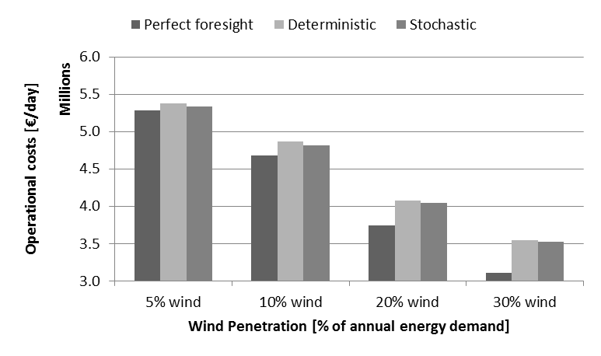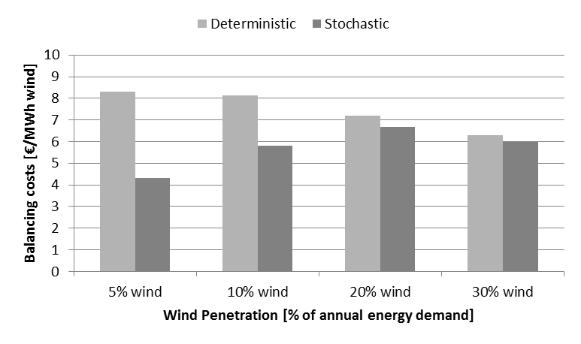
Fig. 1: Increasing wind power penetrations lead to increased balacing costs, which can partially be avoided by stochastic unit commitment. The deterministic model yields balancing costs up to 30€/MWh wind energy (5% wind energy), while the stochastic model yields relatively constant balancing costs between 4.3 and 6.7 €/MWh.

Conclusions
In this paper we studied the balancing costs in the Belgian power system as a function of the wind power penetration. Based on a deterministic and a stochastic unit commitment model, the range of the lower bound on balancing costs for the Belgian power system is estimated to be 4.3 €/MWh (1% wind energy) and 6.7 (20% wind energy). Stochastic unit commitment models could reduce the integration costs of wind power by 5 to 12% of the total expected operational system cost. These results indicate that policies supporting novel wind power forecasting techniques and reserve sizing and allocation methods could lead to a more cost-efficient integration of intermittent renewables in the power system. Future work may entail the inclusion of multiple sources of uncertainty, such as the solar power forecast error and the demand forecast.

References
[1] H. Holttinen, P. Meibom, A. Orths, B. Lange, M. O’Malley, J. O. Tande, A. Estanqueiro, E. Gomez, L. Söder, G. Strbac, J. C. Smith, and F. van Hulle, “Impacts of large amounts of wind power on design and operation of power systems, results of IEA collaboration,” Wind Energy, vol. 14, no. 2, pp. 179–192, Mar. 2011.
[2] K. Bruninx, E. Delarue, and W. D’haeseleer, “The Cost of Wind Power Forecast Errors in the Belgian Power System,” 2nd BAEE Research Workshop, October 2013, Leuven, Belgium.
[3] -, “A modeling framework for the integration of intermittent renewables: stochastic unit commitment,” Working Paper. 2014. Available online: http://www.mech.kuleuven.be/en/tme/research.
[4] -, “A modeling framework for the integration of intermittent renewables : the added value of stochastic unit commitment,” in PSCC14, 2014.
[5] Elia NV, “Evolution of ancillary services needs to balance the Belgian control area towards 2018,” Tech. Report, Brussels, Belgium, 2013.
[6] I. Pérez-Arriaga and C. Batlle, “Impacts of intermittent renewables on electricity generation system operation,” Econ. Energy Environ. Policy, January, pp. 1–13, 2012.
[7] L. Hirth and I. Ziegenhagen, “Integration Costs and the Value of Wind Power,” USAEE Working Paper No. 13-149. 2012. Available online: http://dx.doi.org/10.2139/ssrn.2335386
[8
] K. Bruninx, E. Delarue and W. D’haeseleer, “The cost of Wind Power Forecast Errors in the Belgian power system”, in IAEE 37th Int. Conf., NYC, USA, 2014.

In this paper, we expand the work presented at the 2nd BAEE (Benelux Association for Energy Economics) Research Workshop (October, 2013, Leuven, Belgium) [2].
A unit commitment model mimicks a day-ahead electricity market in which perfect competition exists. Power plants are scheduled and dispatched in order to meet the demand for power at minimum operational costs (fuel costs, emission costs, start-up costs). A full description of the models and data used it this work can be found online [3]. The difference in performance of a stochastic and deterministic unit commitment model is described in [4].
In [5], Elia NV provides an estimate of the additional reserve capacity needed by 2018 to cope with an increasing penetration of intermittent renewables in the Belgian power systems. The provided figures are linearly extrapolated to higher wind power penetrations.

