Overview

On The FUTURE OF electricity SUPPLY: COMPETITIVE markets OR PLANNED ECONOMIES?

Reinhard HAAS, Hans AUER, Michael HARTNER
Energy Economics Group, Vienna University of Technology, 1040 Wien, E-mail: haas@eeg.tuwien.ac.at

In recent years increasing shares of electricity generation from intermittent renewable energy sources (RES-E) like wind and photovoltaics (PV) in Germany have started to change the usual pattern of electricity markets in Western Europe fundamentally. The fact that these “must run” capacities are offered at Zero or even negative costs over a large time per year has led to the situation that mainly natural gas power plants became economically less attractive because of lower fullload hours per year and to a call for “capacity” markets (CM) in addition to the “energy-only” markets. Currently, also the EC is looking for a new or revised electricity market design (Koch (2012)). The core objective of this paper is to discuss the relevance and the effects of CM and the alternatives.

Method

Our method of approach is based on the basic principle that prices equal marginal costs. This principle prevails since the start of liberalization. Because at that time considerable excess capacities existed in Europe the expectation was that prices will (always) reflect short-term marginal costs (STMC). Because of lower fulload hours this principle is now questioned.

Results

The core issue is, how electricity prices will evolve in future if larger amounts of intermittent RES-E are generated. An example is shown in Fig. 1 where a hypothetical scenario with high levels of intermittent RES-E over a week in summer is depicted. The graph shows significant volatilities in electricity market prices with total costs charged for conventional capacities – black solid line – ranging from zero to 14 cents/kWh. In practice, of course, the prices may not just go to zero but also below. Given the price pattern in Fig. 1 we are convinced that it would be attractive for (some but sufficient) power plants operators to stay in the market or even to construct a very efficient new plant! This would lead to a revised energy-only market.
If these temporaily high prices are not accepted CM could be a proper solution. Yet, the first major reason for the call for CM is to retain supply security in the electricity system. The historical (anachronistic) definition of supply security is: At every point-of-time every demand has to be met regardless of the costs! The major reason for this is that in times of regulated monopolies every demand could be met due to significant excess capacities and in the liberalized markets still excess capacities remained.

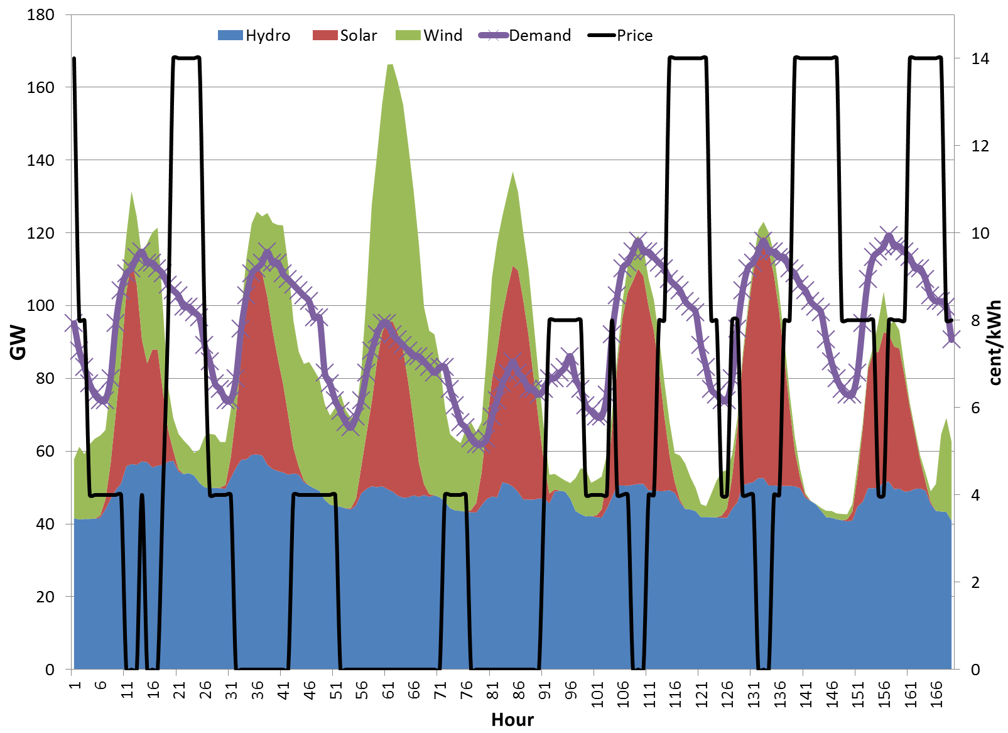 | 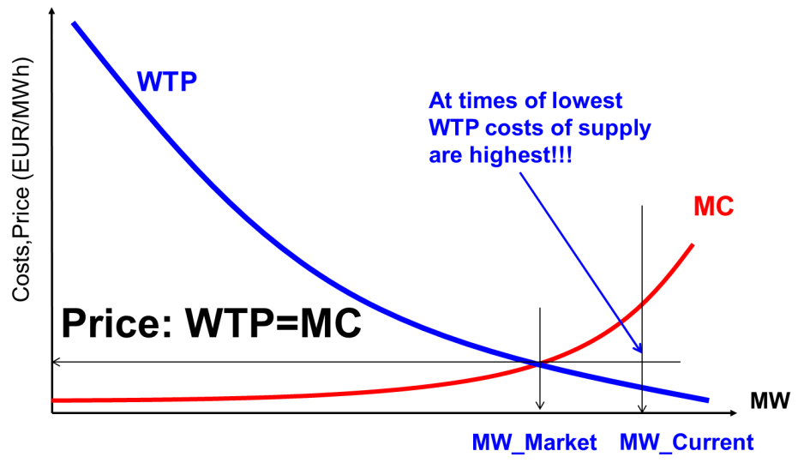
Figure 1. Development of intermittent RES-E over a week in comparison to demand and resulting electricity market prices with total costs charged for conventional capacities | Figure 2. A market-based approach to supply security

The major CM models currently discussed are (see e.g. Cramton et al 2012): (i) a Comprehensive CM model which treats existing and new capacities jointly; (ii) a Focused CM approach which differs between existing and new capacities. In both of these market models – as in the classic EOM – the price should equal the STMC. The major open questions regarding CM are: (i) Which quantity of capacity should get payments and where? (ii) How to split in existing and new capacity? (iii) How to tune with grid extention?; (iv) Who plans? On national or international level?

Based on these open questions an important aspect is the international dimension. In recent years a remarkable convergence of prices has taken place even in Western continental Europe. That is to say that any measure in one country will affect the market structure in others. The discussion in Europe starts with the request for CM on national level. Yet, because the Western European electricity markets is strongly integrated the national planning activities has at least to some extent to consider the international dimension. Transboundary grid extentions and storage availability are some important aspects. This leads after some time undoubtedly to international planning of CM. The next logical step is to think about an international joint concept for financing. And this would lead very soon to central European planning, Fig.3.

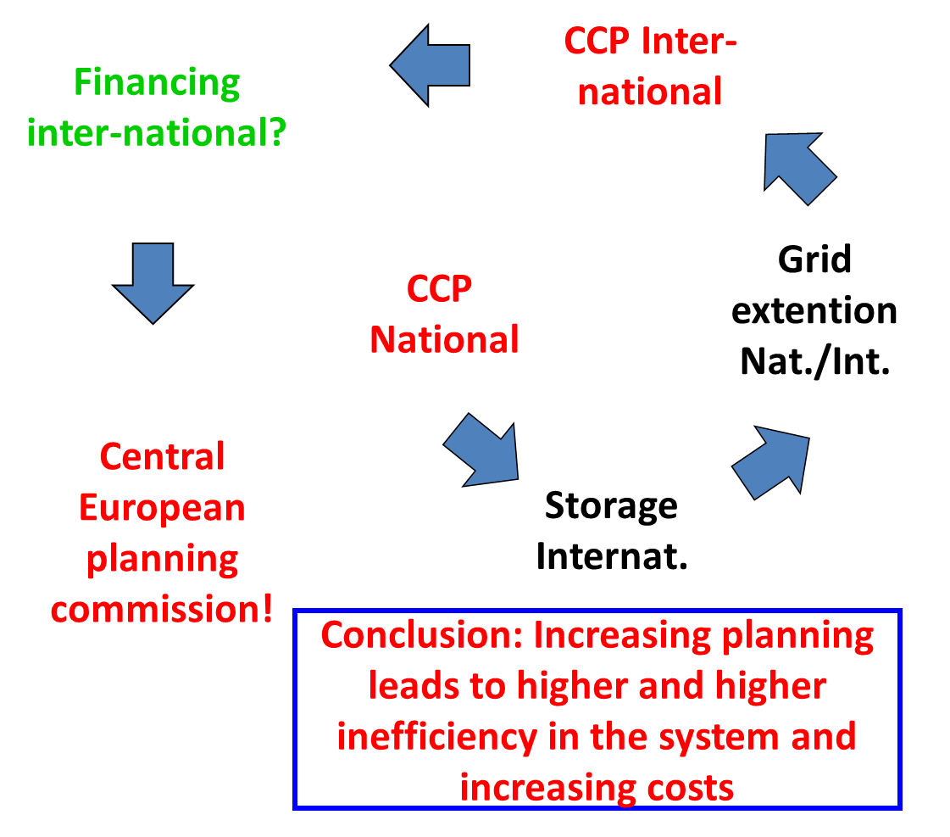 | 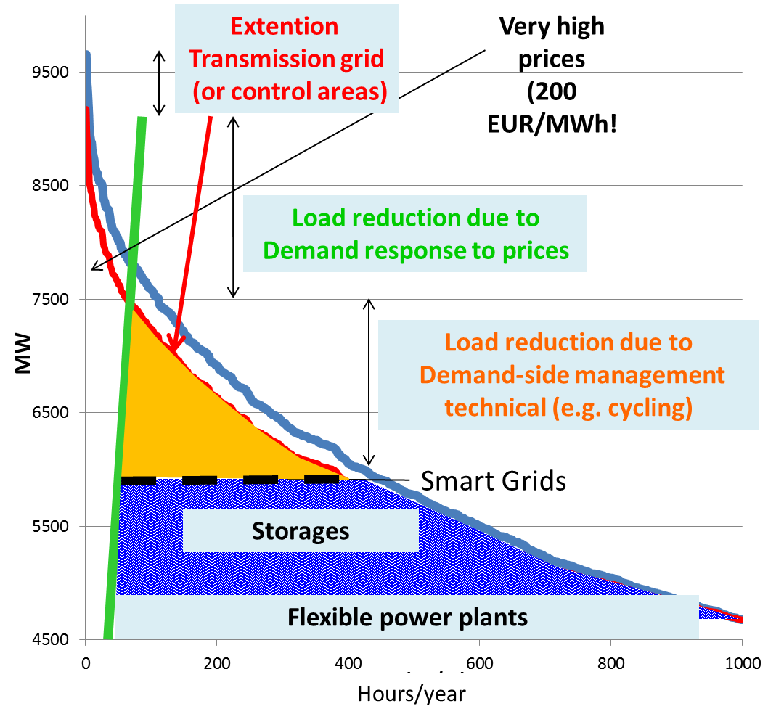
Figure 3. Options for copying with peak residual load in electricity markets | Figure 4. The international planning spiral in the implementation of capacity markets

On contrary to this central planning approach a market-based one would take into account customers WTP and the equilibrium between demand and supply would come about at lower capacities. Note, that where WTP is lowest the MC of providing capacity are highest, see Fig. 2. A market approach will consider also other options on the supply- and demand-side as there are, see Fig. 4:
- DSM (technical): Measures conducted by utilities like cycling, control of demand, e.g. of cooling systems)
- Demand response due to price signals: Response of mainly large customers to price changes
- Transmission grid extention: if the grid is extended there is in principle always more capacity available in the system and the volatility of RES a well as demand evens out;
- Smart grids: They allow variations in frequency (upwards and downwards regulation) and switch of voltage levels and contribute in this context to a load balancing
- Storages: short-term and long-term storages – batteries, hydro storages, or chemical storages like hydrogen or methane – can help to balance significant volatilities of RES generation.
Hence, a major component of the revised EOM-model described above is to include demand-side contracts. In this category fits also the idea of Erdmann (2012) who suggests that the balancing groups should be responsible for providing capacities.

Conclusions

The major conclusion of our analysis is that capacity markets are a step back to a planned economy with – all in all – much higher costs for society. The only “negative” aspect of a market without capacity component will be that – at least in the short run –temporarily higher costs than the short-term marginal costs will occur. However, after some time the market will learn to benefit from these higher costs and also from the very low costs at times when RES are abundant. A reasonable price spread will come about that provides incentives for different market participants. Moreover, in addition to pure power generation capacities other elements like Smart grids, technical and economic DSM, short-term storage options will even out a large part of the residual load profile. Yet, the most important – so far neglected – issue for a real electricity market is the development of the demand-side.

References:
Koch Oliver, Electricity market design, Presentation at IAEE-conference, 18-21 July 2013 Düsseldorf.
Haas R., Lettner G., Auer J., Duic N. "The looming revolution: How Photovoltaics will change electricity markets in Europe fundamentally", Energy 57, 2013, 38-53.
Cramton P., Ockenfels A.: Economics and Design of Capacity markets for the power Sector, Zeitschrift für Energiewirtschaft, 36, 2/2012, 113-134.
Erdmann G., Kapazitätsmechanismus für konventionelle und intermittierende Elektrizität. In: Agora: „Brauchen wir einen Kapazitätsmarkt?“, August 2012.

