PROMOTING THE DIESELIZATION OF THE EUROPEAN PASSENGER CAR FLEET: WAS IT WORTH IT?

Amela Ajanovic, Vienna University of Technology, Phone + 43 1 58801370364, email: ajanovic@eeg.tuwien.ac.at
Reinhard Haas, Vienna University of Technology, Phone + 43 1 58801370303, email: haas@eeg.tuwien.ac.at

Overview
One of the most remarkable developments in passenger car transport in recent years was the rapid gain of market shares of diesel vehicles in many European countries. The share of diesel cars in the total vehicle stock is continuously increasing. In some of the EU countries (Austria, Belgium, Spain and France) share of diesel is already over 50%. This share is even higher in the case of new car registrations. Fig. 1 shows increase in the share of new diesel cars in EU-15 countries in period 1990-2012. In 2012 more than 50% of vehicles sold in the EU-15 were diesel vehicles (ACEA, 2013). In France, Ireland, Luxemburg and Portugal this figure is even significantly higher – over 70%, see Fig. 1. Especially steep increases in diesel penetration in the last few years can be noticed in Greece and Ireland.
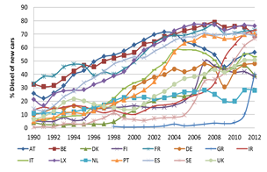 | 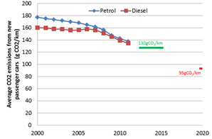
Fig. 1. Increase in the share of diesel of new cars in EU-15 countries 1990-2012 (ACEA 2013) | Fig. 2. Targets and average CO₂ emissions from new passenger cars by fuel in EU countries (EEA –Monitoring 2011)
The major reasons for this development were a better fuel economy – about 20% to 30% compared to gasoline – and lower fuel price (to some extent due to considerable tax benefits) which led to lower service price per vehicle km driven of about 30% for diesel cars comparing to gasoline cars, Schipper et al (2013). Another reason for this penetration was the European efforts to curb rising emissions from transport sector as well as significant technical improvements of diesel vehicles.
The main mitigation strategy for climate change in Europe was based on agreements with the automobile industry with the goal to reduce average CO₂ emissions of new passenger cars. As part of this strategy, Regulation (EC) No 443/2009 set a short-term target of 130 grams of CO₂ per kilometer (g CO₂/km) by 2015, to be phased in from 2012, and a long term target of 95 g CO₂/km by 2020, see Fig. 2.
The core objective of this paper is to analyze whether the promotion of dieselization was, and still is, worth. In the scope of this paper we have analyzed and discussed the impact of the switch to more efficient diesel cars on energy savings on an aggregate level of selected European countries. To do this assessment we have investigated what the effects of the switch to diesel on energy consumption and on CO₂ emissions were. In detail we analyze how diesel has affected the demand for the service mobility (vkm driven) and the average size of cars. Most important in this context are the impacts of prices – especially with respect to lower taxes on diesel – and the effect of better efficiency of diesel cars.

Methods
The method of approach builds on the formal framework and analysis conducted in Ajanovic/Haas (2012). In this paper we extend and deepen the analysis of the impact of switch to diesel on vkm driven and on car size and further-on on energy consumption and CO₂ emissions. In other words, we consider the rebound due to more km driven as well as the rebound to larger cars. We conduct the detailed analysis for the European countries for which reliable data were available for the period 1990 to 2010. In this paper we focus on ten European countries: – FR, AT, IT, SE, DE, DK, PT, UK, NL, ES –over the time period 1990-2010 by means of an econometric analysis. This gives finally price elasticities of service demand and based on a formal framework following the major literature we can derive the rebound effect of the switch to diesel.

Results
Fig. 3 depicts this impact of changes in fuel intensity due to a switch to diesel for EU-10, (base year is 1990) on total energy consumption. The perception is that the overall effect was rather small and a large share of savings has been compensated by the switch to larger cars and driving more. E.g. in 2010 from theoretically calculated savings of 800 PJ only about 235 PJ effective savings remained (Fig. 3). About 365 PJ of savings were compensated by means of more km driven and about 200 PJ were reduced because of larger cars due to the switch to diesel. This led finally to savings of about 14.7 million tons of CO₂ saved per year in 2010.
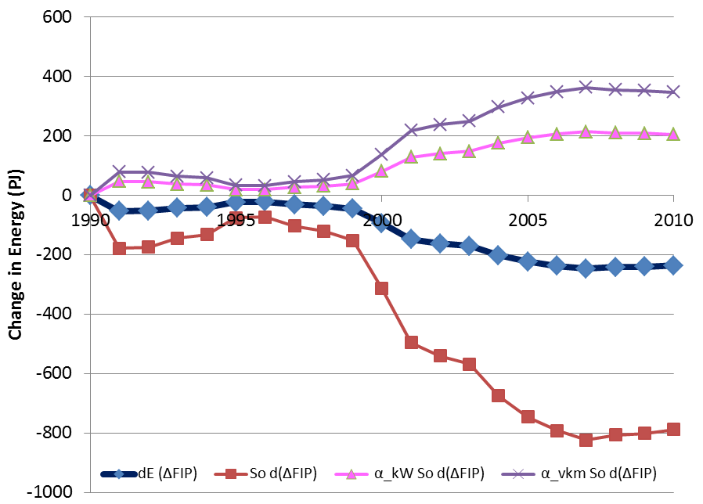 | 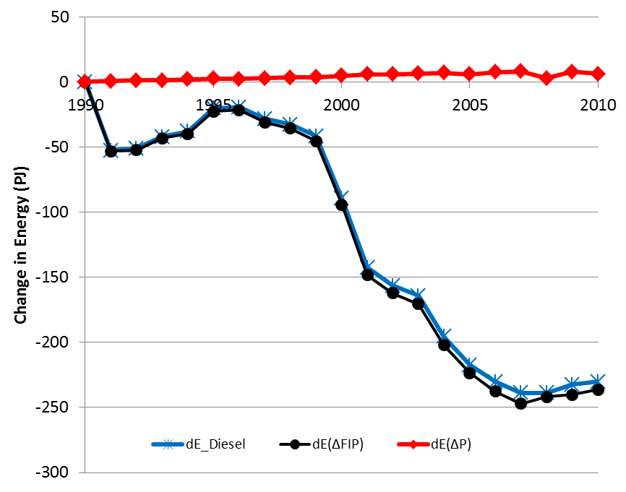
Figure 3. Impact of changes in fuel intensity on total energy consumption due to a switch to diesel in EU-10 | Figure 4. The change of energy consumption due to switch to diesel: share of changes due to fuel intensity and fuel price
Finally we analyze the total changes in energy consumption and CO₂ emission reduction. Total changes consist of the fuel intensity effect and the price effect:
The result is that due to lower diesel prices a slight increase in energy consumption took place so that the overall saving effect is a little bit smaller than the saving effect due to better fuel intensity. These effects are summarized in Fig. 4 where the over-all change of energy consumption due to the switch to diesel is compared to the shares of changes due to fuel intensity and fuel price. Total savings in 2010 amounted to about 230 PJ.

Conclusions
Concerning the impact of the switch to diesel our major perception is that the CO₂ emission reduction effect in the years 2005 to 2010 was about 4%. Note that this effect was due to lower energy consumption of diesel while CO₂ emissions of diesel and gasoline per kWh are virtually the same. It is important to note that about 50% of the theoretical savings due to better efficiency of diesel cars was compensated by the rebound due to more km driven with diesel cars and about 28% of theoretical savings were compensated by the switch to larger diesel cars.
Given this moderate result of about 4% in CO₂ reduction, the high losses in taxes of about 25% and the very high resulting CO₂ reduction costs we conclude that the fuel tax incentives provided in Europe of about 10% to 50 % lower taxes for diesel than for gasoline were not at all justified. Tax exemptions for diesel led to small CO₂ savings at very high costs. So the major consequence for energy policy makers should be to abandon the current tax advantages for diesel cars or to change the excise tax system to a CO₂-based one.

References
Ajanovic A, R. Haas. The role of efficiency improvements vs price effects for modeling passenger car transport demand and energy demand – Lessons from European countries, Energy Policy 2012, 41:36-46
ACEA, 2013. www.acea.be
Schipper L., Fulton L.: Dazzled by diesel? The impact on carbon dioxide emissions of the shift to diesels in Europe through 2009. Energy Policy 54 (2013) 3-10

