CAPTURING RENEWABLE DYNAMICS INFORMATION IN TOP-DOWN ENERGY MODELS: A HYBRID METHOD APPLIED TO OFFSHORE WIND IN CHINA

Da Zhang, Institute of Energy, Environment and Economy, Tsinghua University, Phone +86 134 8866 0769,
E-mail: zhangda.thu@gmail.com
Valerie J. Karplus, Joint Program of the Science and Policy of Global Change, MIT, vkarplus @mit.edu Sebastian Rausch, Centre for Energy Policy and Economics (CEPE), ETH, srausch@ethz.ch

Overview
Top-down modeling approaches are often criticized based on limited ability to represent detailed technological information. We extend a hybrid method for representing heterogeneity in the quality of resource inputs when modeling energy production, focusing on offshore wind electricity as an example. Using a stylized top-down economic model, we compare the supply curve derived from policy simulations in our general equilibrium approach to a static supply curve and show that predictions of electricity supplied differ systematically. We further show how the hybrid model predicts a “wind rush” phenomenon as a carbon price applied across the economy rises, the piecewise shape of the supply curve dictates that large quantities of wind capacity will be deployed upon reaching threshold electricity prices. This effect is typically not captured by traditional top-down models, which typically rely on smooth curve fits for resource representation. Finally, we show how to introduce a piecewise supply curve based on observed wind resource data into a top-down economic model that includes many heterogeneous resource prices and multiple sectors. The results suggest that planning and policy measures are necessary to coordinate the pace of renewables deployment with infrastructure and grid network expansion to avoid congestion and curtailment.

The paper is structured as follows: the introduction briefly reviews methods to incorporate renewables into top-down models and discusses the advantages of extending a hybrid approach recommended by Kiuila and Rutherford (2013) to represent renewable resource availability in energy-economic models. In Section 2, a simple stylized top-down economic model is applied to demonstrate the application of this hybrid approach and its potential policy implications. Section 3 provides a real-world example of how the same method could be extended using data for China’s economy and offshore wind resources. The final section discusses the results and policy implications.

Methods
We construct a simple stylized two-sector general equilibrium models in GAMS to demonstrate a “wind rush” phenomenon. To capture the observed wind profile within a top-down modeling framework, we represent China’s offshore wind supply curve derived from MERRA wind resource dataset with a 0.5° latitude by 0.67° longitude spatial resolution (Zhang et al., 2014). We demonstrate how a many-step linear piecewise supply curve for renewable technology can be directly represented or precisely approximated in a computable general equilibrium model. The top-down model is a two-region, ten-sector global model is similar to the CGE model described in Zhang et al. (2013) except the treatment for simplified trade as we only include two international
regions here.

Results
First, a stylized model shows that top-down modeling approach can predict a different supply level of a certain technology compared to partial equilibrium analysis shown in Figure 1.

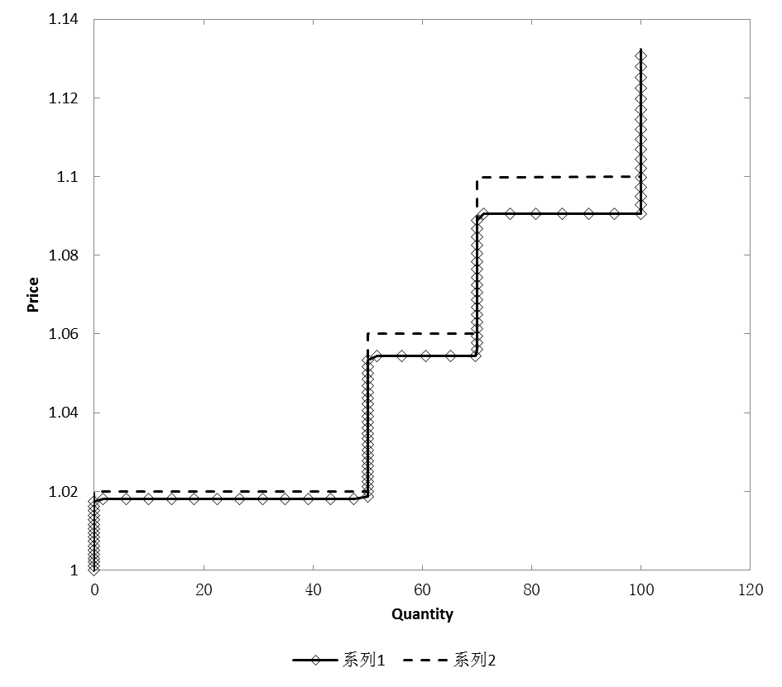
Figure 1 Supply curves for wind in a stylized top-down economic model (diamond-connected line) and in partial equilibrium model (dashed line)

Second, we show jumps of wind installations under carbon policies with increasing stringency in a stylized top-down energy-economic model.

Third, offshore supply curve for China is estimated using MERRA data and approximated by a step-fitting method with given tolerance shown in Figure 2.
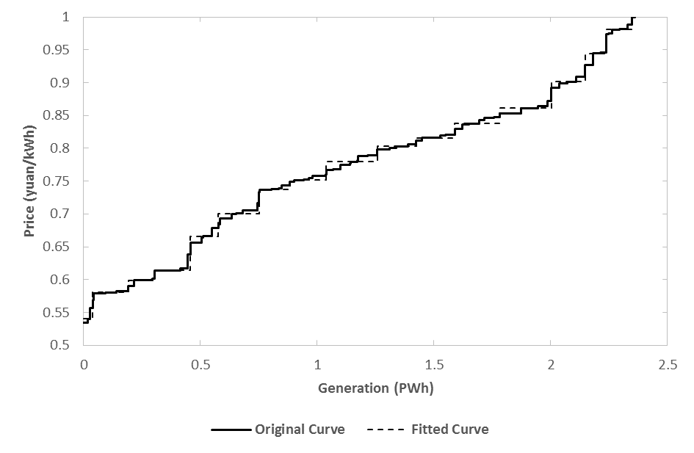
Figure 2 original and fitted offshore wind supply curve for China

Fourth, the deployment of offshore wind in China is estimated using China’s economy data set with the assumption that a carbon tax is levied from 2012 to 2047 to reduce China’s emissions intensity by 17% every five years (comparable to the 12th Five-Year Plan target). We find that offshore wind does not become competitive until around 2030 (when the carbon price reaches about $20/ton (2007 constant price)), and installations will grow fast from about 100 GW around 2040 to about 350 GW around 2050. The results are robust if we use the fitted curve shown in Figure 2 instead of the original curve.

Conclusions
The hybrid method to incorporate renewable technologies with heterogeneous resources into top-down economic model is efficient and flexible. We show that top-down models are needed to capture how the rising economy-wide carbon price interacts with factor endowments and abatement strategies present across various sectors, while sector-specific static supply curve does not fully capture these multi-sector feedbacks to relative energy prices. The cyclical high speed of renewables deployment could lead to localized grid congestion and integration delays if planning and policy do not take into account the potential for a wind rush to occur.

References
Kiuila, O., Rutherford, T.F., 2013. The cost of reducing CO2 emissions: Integrating abatement technologies into economic modeling. Ecological Economics 87, 62–71.

Rausch, S., Mowers, M., 2014. Distributional and efficiency impacts of clean and renewable energy standards for electricity. Resource and Energy Economics 36, 556–585.

Zhang, D., Davidson, M., Gunturu, B., Zhang, X., Karplus, V., 2014. An integrated assessment of China’s wind
energy potential. MIT Joint Program on the Science and Policy of Global Change Report 261.

Zhang, D., Rausch, S., Karplus, V., Xiliang, Z., 2013. Quantifying regional economic impacts of CO2 intensity targets in China. Energy Economics 40, 687–701.

