A Comparison of Air Emissions from Natural Gas Pathways for Road Transportation

Fan Tong, Carnegie Mellon University, 412-576-7174, ftong@andrew.cmu.edu
Paulina Jaramillo, Carnegie Mellon University, 412-268-6655, pjaramil@andrew.cmu.edu
Inês L. Azevedo, Carnegie Mellon University, 412-268-3754, iazevedo@cmu.edu

Overview
Production and reserves of unconventional natural gas (mostly shale gas) have increased over the course of the last few years (EIA, 2013a & 2013b). The use of natural gas in the transportation sector has so far been low (EPA, 2013). Having a domestic low cost abundant fossil fuel has stimulated strong industrial and policy interest in making natural gas an important fuel for road transportation (ACCD, 2012; EIA 2013c; Pirog, 2012). Efforts have been devoted to assess the environmental performance of alternative fuel pathways, either on a range of fuel-vehicle pathways (Wang et al., 2000; NRC, 2010), or with a focus on a specific fuel (Jacobson et al., 2005; Hill et al., 2005; Jaramillo, et al. 2008; Samaras et al. 2008; Huo et al., 2009; Michalek et al., 2011; Nopmongcol et al., 2011; Venkatesh, 2011), or yet with a focus on specific regions (Allaban et al. 2007; Chester et al., 2010; NRC, 2010; Mashayekh et al., 2011). Outdated data, narrowed focus on studied pathways and different assumptions have limited the applications of findings from existing studies. Natural gas-based fuel pathways have seldom been the center of these studies as natural gas supply was thought to be limited until recently.

Methods
We expand the scope of previous studies and evaluate a broad set of natural gas pathways for both light-duty vehicles and heavy-duty vehicles (Figure 1). We estimate life cycle greenhouse gas (GHG) emissions of natural gas-derived fuels and compare them with conventional gasoline and diesel pathways. GHG emissions are estimated for the full life cycle. Vehicle manufacturing is not included in the system boundary, but emissions from battery manufacturing are included. We use Monte-Carlo simulations to explicitly assess the uncertainty in natural gas upstream (using data from Allen et al, 2013; EIA, 2013; EPA, 2013) and fuel production technologies. Sensitivity analysis is performed on the source of electricity used in the life cycle and on the global warming potentials (GWP).
We also estimate the damage reduction benefits from natural gas-derived fuel pathways with regard to reduced tailpipe criteria air pollutants (CAP, including SO_{x}, NO_{x}, CO, PM_{2.5} and VOCs) compared to gasoline passenger vehicles. Tailpipe emissions are estimated using the GREET model (ANL, 2013) with updated parameters. We rely on the AP2 model (Muller, 2011) to estimate the monetary reductions of health and non-climate damages.
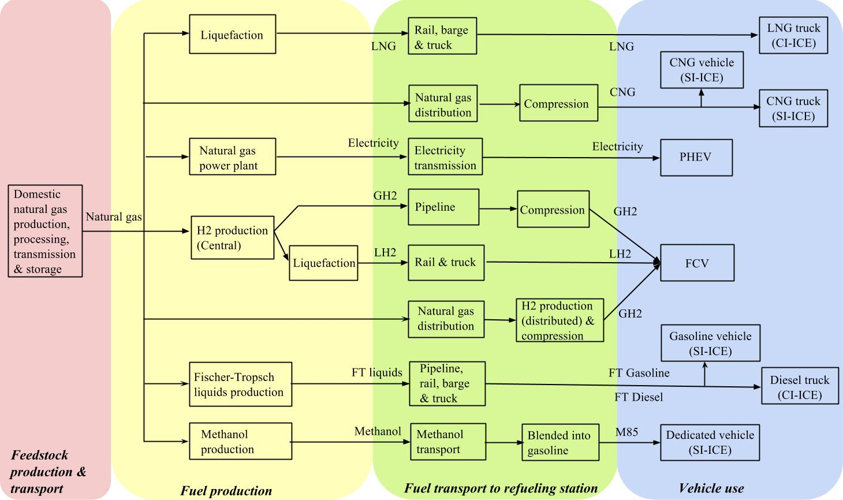
Figure 1: Study system boundary of natural gas pathways. The final two columns indicate whether the pathway is for passenger vehicle, semi-trailer truck or both. Abbrevations: CNG, compressed natural gas; HEV, hybrid electric vehicle; FCV, fuel cell vehicle; PHEV -X, plug-in electric vehicle with an all electric range of X kilometers; LH₂, liquid hydrogen; GH₂, gaseous hydrogen.

Results
We present preliminary results of lifecycle GHG emission comparisons in Figure 2. We find that PHEVs (charged with natural gas-based electricity) and hydrogen-based vehicles are likely to provide reductions of life cycle greenhouse gas emissions compared to conventional vehicles that run on gasoline and diesel. CNG could also reduce emissions, but these reductions are likely to be lower than what could be achieved with hydrogen FCV and PHEVs.
In terms of health and non-climate damages, we find significant geographical variations of reduction benefits for all pathways (CNG and PHEV60 reduction benefits shown in Figure 3). PHEV60 provides large reductions in driving emissions, but urban air pollution benefits for CNG are small and concentrated in few urban areas.
Figure 2 Life cycle GHG emissions of natural gas-derived fuels for LDV. (FTG1 and FTG2 are short for F-T gasoline with and without CCS, respectively; LH2c, GH2c, and GH2d refer to LH2 produced centrally, GH2 produced centrally and GH2 produced at refuelling stations.)
Figure 3 Health and non-climate damage reduction benefits of alternative natural gas-derived pathways compared to conventional gasoline pathway. Each figure represents damage reduction benefits for one pathway. The unit is 2012 cent/km. Colors are used to indicate the scale of reduction benefits.

Conclusions
We find that using natural gas for road transportation doesn’t necessarily provide environmental and health air emission benefits compared to existing petroleum-based pathways. GHG emission potentials and CAP emission reduction benefits are determined by how and where to use natural gas for road transportations. Thus, government and industry should work together to make sure natural gas provides environmental benfits rather than environmental burdens to the society by replacing gasoline in road transportations.

References
Abu-Allaban M, Gillies J, Gertler A, Clayton R, Proffitt D (2007) "Motor vehicle contributions to ambient PM10 and PM2.5 at selected urban areas in the USA. " Environ Monit Assess 132:155–163.
Allegheny Conference on Community Development (ACCD) (2012). "Encouraging Natural Gas Vehicles in Pennsylvania. "
Allen, David T., et al. (2013) "Measurements of methane emissions at natural gas production sites in the United States." Proceedings of the National Academy of Sciences.
Argonne National Laboratory (ANL) (2013). GREET Life Cycle Model. Nov 22, 2013.
Chester, M., A. Horvath, and S. Madanat (2010). "Comparison of Life-Cycle Energy and Emissions Footprints of Passenger Transportation in Metropolitan Regions. " Atmospheric Environment, Vol. 44, No. 8, 2010, pp. 1071–1079.
EIA (2013a). "U.S. Dry Natural Gas Proved Reserves". http://www.eia.gov/dnav/ng/hist/rngr11nus_1a.htm. Accessed on Nov 18, 2013.
EIA (2013b). "U.S. Natural Gas Gross Withdrawals and Production." http://www.eia.gov/dnav/ng/ng_prod_sum_dcu_NUS_m.htm. Accessed on Nov 18, 2013. EPA-420- EPA-420-F-13-033a.
EIA (2013c). Annual Energy Outlook 2013. DOE/EIA-0383(2013).
EPA (2013). U.S. Transportation Sector Greenhouse Gas Emissions: Fast Facts 1990-2011.
Hill, Jason, et al (2009). "Climate change and health costs of air emissions from biofuels and gasoline." Proceedings of the National Academy of Sciences106.6 (2009): 2077-2082.
Huo, Hong, Ye Wu, and Michael Wang (2009). "Total versus urban: Well-to-wheels assessment of criteria pollutant emissions from various vehicle/fuel systems."Atmospheric Environment 43.10 (2009): 1796-1804.
Jacobson, M. Z., W. G. Colella, and D. M. Golden (2005). "Cleaning the air and improving health with hydrogen fuel-cell vehicles." Science 308.5730 (2005): 1901-1905.
Jaramillo, Paulina, W. Michael Griffin, and H. Scott Matthews (2008). "Comparative analysis of the production costs and life-cycle GHG emissions of FT liquid fuels from coal and natural gas." Environmental science & technology 42.20 (2008): 7559-7565.
Mashayekh, Yeganeh, et al (2011). "Costs of automobile air emissions in US metropolitan areas." Transportation Research Record: Journal of the Transportation Research Board 2233.1 (2011): 120-127.
Michalek, Jeremy J., et al (2011). "Valuation of plug-in vehicle life-cycle air emissions and oil displacement benefits." Proceedings of the National Academy of Sciences 108.40 (2011): 16554-16558.
Muller, Nicholas Z (2011). "Linking policy to statistical uncertainty in air pollution damages." The BE Journal of Economic Analysis & Policy 11.1 (2011).
National Research Council (NRC) (2010). "Hidden Cost of Energy. " Washington, DC: The National Academies Press.
Nopmongcol, Uarporn, et al. "Impact of dedicated E85 vehicle use on ozone and particulate matter in the US." Atmospheric Environment 45.39 (2011): 7330-7340.
Pirog, R., Ratner, M. (2012). "Natural Gas in the U.S. Economy: Opportunities for Growth", Congressional Research Service.
Samaras, Constantine, and Kyle Meisterling (2008). "Life cycle assessment of greenhouse gas emissions from plug-in hybrid vehicles: Implications for policy." Environmental Science & Technology 42.9 (2008): 3170-3176.
TIAX (2007). "Full Fuel Cycle Assessment: Well-To-Wheels Energy Inputs, Emissions, And Water Impacts." Prepared for California Energy Comission.
Venkatesh, A., et al. (2011) "Uncertainty in life cycle greenhouse gas emissions from United States natural gas end-uses and its effects on policy." Environmental science & technology 45.19 (2011): 8182-8189.
Wang, M. Q., & Huang, H. S. (1999). "A Full Fuel-Cycle Analysis of Energy and Emissions Impacts of Transportation Fuels Produced from Natural Gas." U.S. Department of Energy, ESD(40), 88.

