VIRTUAL ENERGY: MAKING MONEY ON THE BIAS BETWEEN ISO DAY AHEAD MARKETS AND REAL TIME MARKETS

Mark Lively, Utility Economic Engineers, 301-428-3618, MbeLively@Aol.com

Overview

Most areas of the United States and Canada sit in the footprint of Independent System Operators (ISOs). Most of these ISO operate two energy markets, a Day Ahead (DA) market and a Real Time (RT) market. In many respects the DA can be viewed was a hedge against the RT. Some ISOs allow the concept of virtual energy, a transaction in the DA which is then resolved in the RT. Under very idealistic circumstances, the value of virtual energy is zero, since the DA and RT markets would produce identical results. But we do not live with idealistic circumstances. Almost always there is a difference between DA and RT prices, such that virtual energy has a value. Often the value of virtual energy is very close to zero. Occasionally, virtual energy has a large predictable value that reduces the risk associated with transacting in the DA market with the expectation that the cash out in the RT market will be profitable. Successful participation, that is, making a profit from such participation, in the virtual energy market serves a societal purpose of reducing the gap between the DA and RT markets.

Methods

Most ISOs have very accessible data bases on the prices that have been used on their systems. I obtained hourly basic DA and RT prices for 2012 from PJM, the major ISO for north-eastern USA, running from New Jersey to Illinois. The prices examined were not geographically differentiated. I calculated the hourly value of Virtual Energy by subtracting the DA price for the RT price for corresponding hours. Positive values indicated that the price of electricity increased during the 24 hours between the calculation of the DA price versus when the RT price was calculated. Negative values indicated a decline in the price of electricity. The values of Virtual Energy were analyzed for potential biases that could have been exploited.

Results

The value of Virtual Energy varied in 2012 from a negative $200/MWH (a huge overnight drop in electricity prices) to a positive $331/MWH (a huge overnight increase in electricity prices), as is plotted below.

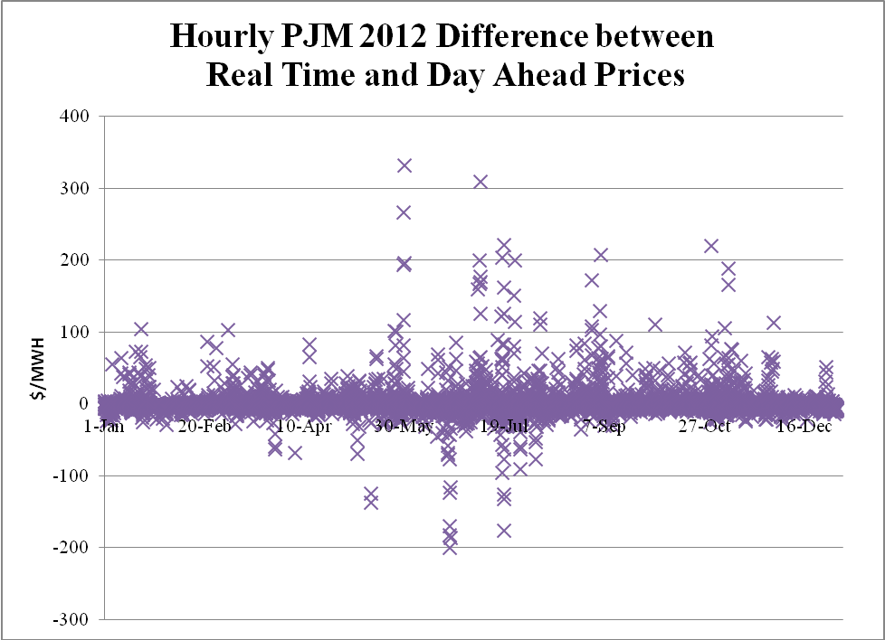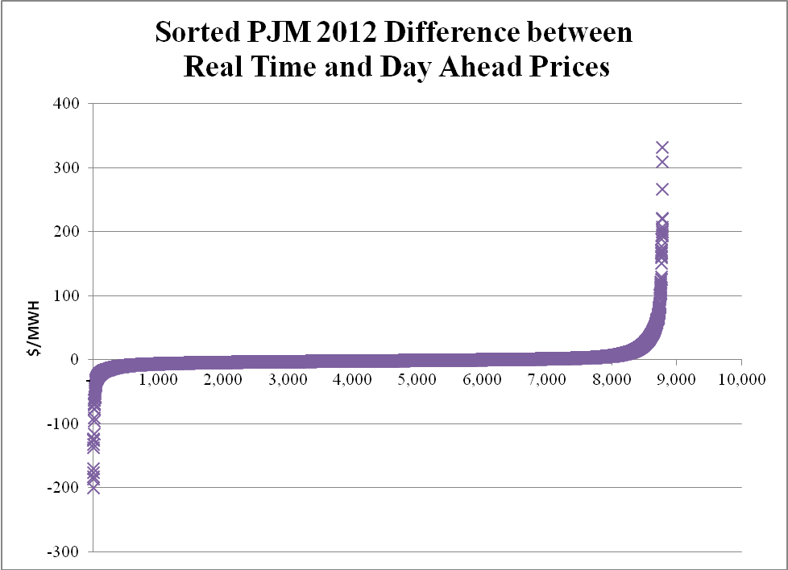

For much of the time, Virtual Energy had little value. For approximately 3/4 of the hours during the year, Virtual Energy had a value between +/- $5.00/MWH. However, for several hours of the year, Virtual Energy had a large positive value. Similarly for several hours of the year, Virtual Energy had a large negative value, which suggests value in selling Virtual Energy instead of buying Virtual Energy. A distinctive daily pattern was identified, such that Virtual Energy had a positive value during many weekday daytime hours and a negative value during many night time hours, as is presented in the following table.

PJM 2012 Average Market Prices
RT Prices minus DA Prices
By Day of Week and By Hour
($/MWH)
Table 1

 | Sun. | Mon. | Tues. | Wed. | Thurs. | Fri. | Sat. | All
1 | $ (0.22) | $ (2.12) | $ (0.79) | $ (0.60) | $ (1.20) | $ (0.16) | $ 1.31 | $ (0.54)
2 | $ 0.06 | $ (3.85) | $ (2.57) | $ (1.29) | $ (2.44) | $ (2.41) | $ 0.38 | $ (1.73)
3 | $ (0.37) | $ (2.20) | $ (2.45) | $ (1.95) | $ (1.52) | $ (1.85) | $ (0.18) | $ (1.50)
4 | $ (3.48) | $ (0.50) | $ (0.80) | $ (0.69) | $ (0.84) | $ (0.03) | $ (0.77) | $ (1.02)
5 | $ (2.96) | $ (1.26) | $ 0.47 | $ (0.78) | $ (1.02) | $ 0.19 | $ (0.42) | $ (0.83)
6 | $ (7.00) | $ 2.50 | $ 9.44 | $ 2.42 | $ 3.21 | $ 3.12 | $ (2.32) | $ 1.63
7 | $ (5.01) | $ (1.11) | $ 0.33 | $ (2.11) | $ 2.41 | $ 3.05 | $ (0.77) | $ (0.46)
8 | $ (1.84) | $ (1.07) | $ 1.47 | $ (0.88) | $ (1.94) | $ 0.10 | $ 0.09 | $ (0.58)
9 | $ (1.40) | $ 3.32 | $ 2.58 | $ (0.84) | $ 0.49 | $ 0.25 | $ 0.70 | $ 0.73
10 | $ (1.29) | $ 6.23 | $ 2.16 | $ 3.41 | $ 1.26 | $ 1.26 | $ 2.14 | $ 2.17
11 | $ (0.90) | $ 2.75 | $ 1.22 | $ 2.54 | $ (0.42) | $ (2.02) | $ 2.20 | $ 0.77
12 | $ (1.41) | $ 2.75 | $ 2.31 | $ 2.99 | $ (2.62) | $ (0.74) | $ 0.65 | $ 0.56
13 | $ 0.09 | $ 0.51 | $ 8.61 | $ 1.98 | $ (1.55) | $ (0.03) | $ (0.01) | $ 1.37
14 | $ 0.14 | $ 2.04 | $ 3.28 | $ (2.09) | $ (3.57) | $ 4.12 | $ (1.03) | $ 0.41
15 | $ 0.78 | $ (2.33) | $ 6.20 | $ (3.21) | $ (1.24) | $ 2.20 | $ (1.29) | $ 0.16
16 | $ 0.14 | $ 1.75 | $ 8.22 | $ (1.20) | $ (2.79) | $ 2.73 | $ (1.12) | $ 1.11
17 | $ (0.05) | $ 7.11 | $ 6.11 | $ 4.15 | $ (4.04) | $ 6.25 | $ (0.68) | $ 2.69
18 | $ (1.27) | $ 3.29 | $ 3.59 | $ 3.39 | $ (3.08) | $ 5.72 | $ (0.42) | $ 1.60
19 | $ 0.16 | $ 6.28 | $ 3.76 | $ 1.12 | $ (2.31) | $ 1.36 | $ (2.27) | $ 1.16
20 | $ (0.08) | $ 9.08 | $ 8.54 | $ 2.11 | $ 0.99 | $ 2.84 | $ (1.30) | $ 3.17
21 | $ (0.73) | $ 3.07 | $ 3.18 | $ 2.51 | $ 0.40 | $ 1.25 | $ (0.95) | $ 1.25
22 | $ (1.53) | $ (1.59) | $ (1.51) | $ (1.65) | $ (2.00) | $ (1.28) | $ (0.91) | $ (1.49)
23 | $ (1.44) | $ (1.33) | $ (1.26) | $ (1.30) | $ (0.81) | $ (0.46) | $ (0.95) | $ (1.08)
24 | $ (0.99) | $ (2.03) | $ (2.01) | $ (1.35) | $ (1.37) | $ (1.02) | $ (0.37) | $ (1.30)
All | $ (1.27) | $ 1.30 | $ 2.50 | $ 0.28 | $ (1.08) | $ 1.02 | $ (0.35) | $ 0.34

Conclusions

The DA and RT markets operated by ISOs provide distinctly different hourly prices, sometimes a positive difference, sometimes a negative difference. These differences provide value for Virtual Energy, the practice of buying electricity in the DA market with the expectation of selling that electricity in the RT market. Sometimes a pattern can be identified in the value of Virtual Energy. A statistically significant patter could allow participants to obtain value by buying and selling Virtual Energy in the DA market. That value to the participant will also provide value to the ISO by reducing the gap between the DA and RT markets.

