THE IMPACT OF PV TILT ANGLE AND AZIMUTH ON THE MARKET VALUE OF PV SYSTEMS AND ELECTRICITY GENERATION COSTS

Michael Hartner, Vienna University of Technology, +43 58801 370379, hartner@eeg.tuwien.ac.at
André Ortner, Vienna University of Technology, +43 58801 370367, ortner@eeg.tuwien.ac.at

Overview

While currently it is common practice to seek for the maximum output of a Photovoltaic (PV) system over the lifetime of the module this might not be the optimal strategy in a situation with a significant share of PV in the electricity production of a region. This is true from a system perspective and from an investor´ s perspective assuming that feed-in tariffs might phase out and the produced electricity has to be sold on the spot market. With decreasing spot prices in times of high solar radiation around noon PV modules pointing towards east or west or steeper setting angle might be more profitable. (see Rowlands 2010) From a system´ s perspective a wider distribution of module-angles can lead to reduced generation costs as a whole. In this paper we estimate the cost saving potential of a wider distribution of angles for the electricity system in Austria and Germany under various PV expansion scenarios.

Methods
In a first step PV-generation profiles are generated using a PV simulation tool which models the position of the sun to account for the effect of various module angels. (see Eicker 2011) The radiation data, which include direct and indirect radiation on a horizontal plane, is provided by satellite data with 15min resolution. This is done for 20 regions in Germany and Austria to account for different solar hours and angle effects due to the latitude of the regions. We generate 200 PV profiles with different combinations of inclination angles and azimuth for each of the regions. The profiles are then fed into a dispatch optimization model which includes the existing power plants of Germany and Austria and the corresponding electricity demand in hourly resolution. The model then implements the optimal mix of installed capacity for each profile in each region. In different scenarios we apply restrictions on the distribution of the installed capacity over the regions. The model output should theoretically reflect the most cost effective mix of the installed angels under the assumed conditions and restrictions. Under the assumption of perfect competition this should also reflect the maximum market value of all PV-systems installed.

Results

Preliminary results show that at present the highest revenue still corresponds with the maximum energetic output if we assume spot market prices. (see figure 1). Even with a substantial increase of PV capacity of additional 40 GW of PV capacity installed the energetic optimum does not deviate from the system optimum. Only with a dramatic increase of +100GW the model output suggest a deviation towards steeper tilt angles and orientation towards east and west. This is shown in figure 2 for a PV-system located in Vienna (48.3°N 16,1°E) and spot prices derived from the model. Of course the results also depend on the installed capacity of storage plants as they tend to smoothen out the price patterns throughout the day. The installed storage capacities also influence the savings in total electricity production costs compared to a scenario in which the installed PV systems are orientated towards an energetic maximum. It also has to be mentioned that start-up costs of conventional plants have not been included yet which could influence the results. This will be studied in further research.

Conclusions

This analyses shows, that at present and probably also in the near future installation angles that are close to the energetic optimum still correspond with the system optimum if only fuel costs of conventional power plants are considered. So at the moment there it there should be no need for political action to change the subsidy design from this point of view. In case of very high PV-penetration levels, where the broader distribution of angles might become a concern elements of direct marketing for PV systems should provide the right incentives. Spot market prices provide information of the energy value of PV production and installers could adjust the installation angles to achieve the highest profits which should also (at least theoretically) correspond to the optimal solution in terms of minimizing total system cost. Fixed feed-in tariffs of course do not provide such flexibility and will always generate the incentive to install the PV-modules at the energetic optimum.

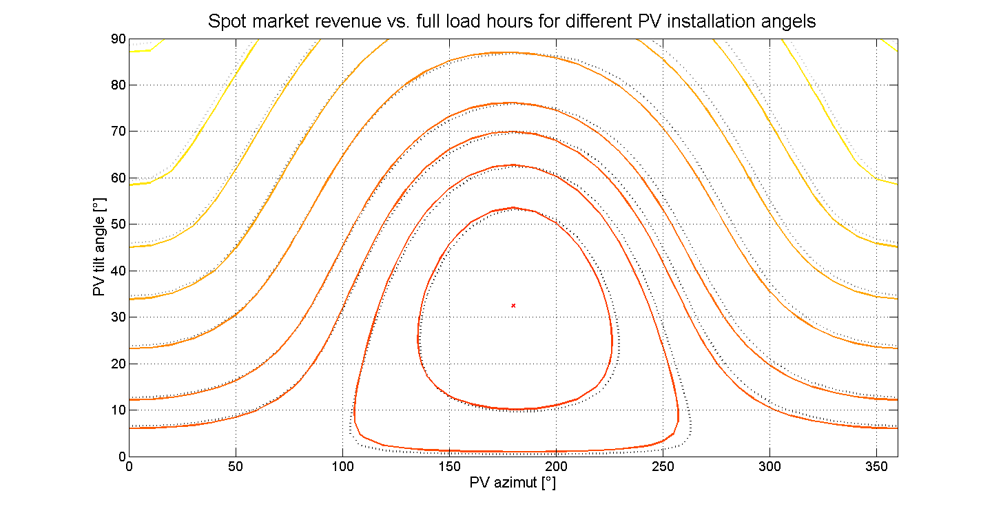
Figure 1: Energetic and system optimum status quo – location: Vienna

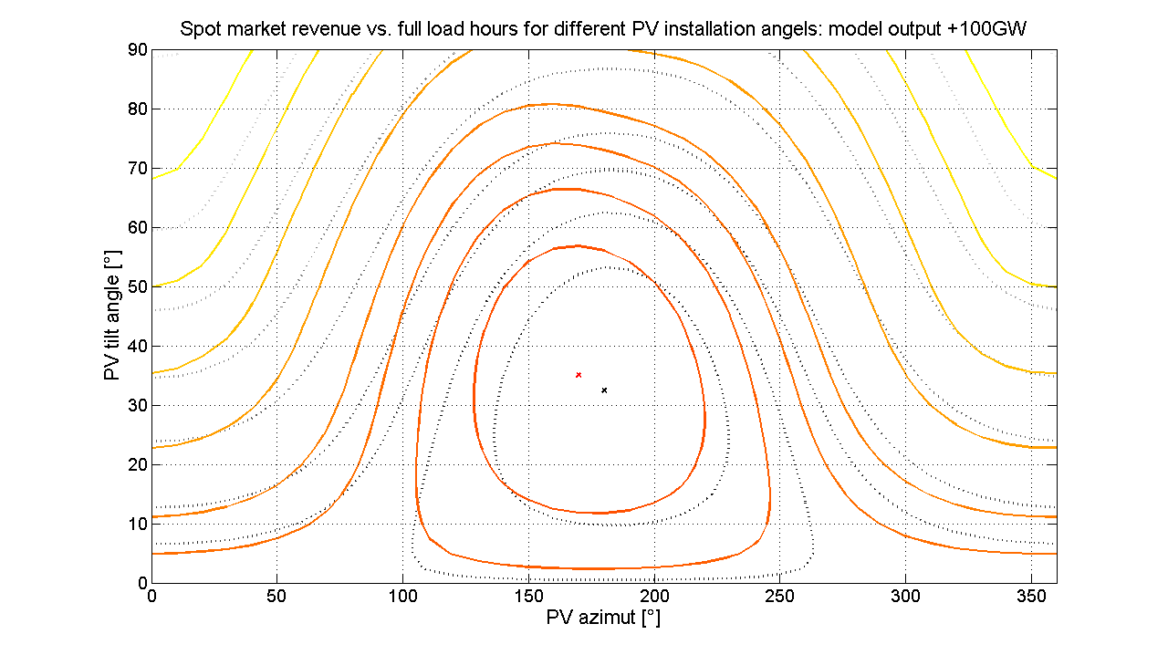
Figure 2: Energetic and system optimum for +100GW – location: Vienna

References
Ian H. Rowlands, Briana Paige Kemery, Ian Beausoleil-Morrison (2010) “Optimal solar-PV tilt angle and azimuth: An Ontario (Canada) case-study”, Energy Policy, 39, 1397-1409.
Ursula Eicker (2011) "Solare Technologien für Gebäude", 2. Auflage, Vieweg+Teubner

