MODELING THE ABILITY OF THERMAL UNITS TO PERFORM LOAD CHANGES IN ENERGY SYSTEMS
[Sonja Babrowski, Karlsruher Institute of Technology (KIT), +49 721 608 44676, Sonja.babrowski@kit.edu]
[Patrick Jochem, Karlsruher Institute of Technology (KIT), +49 721 608 44590, Patrick.Jochem@kit.edu]
[Wolf Fichtner, Karlsruher Institute of Technology (KIT), +49 721 608 44460, Wolf.Fichtner@kit.edu]

Overview

In a power system with an increasing amount of renewable feed-in, the importance of quick load changes by the remaining fossil-fueled thermal generation units grows. A good mapping of the load-changing abilities of those units is therefore important in optimizing energy system modeling. Therefore, we analyze in this paper the differences between three model techniques used in the literature to describe the load-changing behavior of thermal generation units. Accordingly, we apply them within the energy system model PERSEUS-NET-TS (Babrowski et al. 2014). The first way to map these characteristics is as mixed-integer problem through the definition of minimum power (i.e. minimum generation when running), minimum time stopped and minimum time running. The second way is through application of the costs to any positive or negative load change. The third way considers start-up costs for positive load changes below the minimum power. Both the second and the third ways can be modelled as linear problems. Differences in the unit dispatch of coal, lignite, and gas combined-cycle units are analyzed based on the PERSEUS-NET-TS results. The resulting dispatches of each modeling technique are compared to each other as well as to the dispatch that results when restrictions and costs of load changing are totally neglected. The results indicate that especially the implementation of start-up costs has a strong influence on the unit dispatch. The mixed-integer implementation of minimum power and minimum times stopped and running also has a strong influence, but with the disadvantage of a calculation time that is about twice as high as the calculation time of the linear approaches.

Methods
The linear optimizing energy system model PERSEUS-NET-TS is used to evaluate the advantages and draw-backs of the three different approaches to model the load-changing behavior. The model is used to calculate the dispatch plans for the thermal generation plants in the German energy system in 2012. There, the year is represented through the hourly mapping of three days for each season. The model also includes a nodal pricing approach based on a DC calculation of the transmission grid. All German large generation units (> 100 MW) are depicted individually and allocated at their specific grid nodes. Smaller generation units are accumulated for each grid node. The installation of renewable generation units is exogenously given and their feed-in is based on historical courses. The driving force of the model is the exogenously given demand that has to be satisfied at each grid node. This can either be done by electricity generation in the generation units assigned to that grid node or by electricity transfer via the transmission grid. In the PERSEUS-NET-TS model, the load-changing behavior of the existing generation units can be described through the use of one of the following three approaches that have been applied in literature. Firstly, through the mapping of a minimum power and minimum times running and stopped (e.g. used by Dìaz 2008). For the implementation of this approach, binary variables are needed. Subsequently, the optimization becomes mixed-integer linear. Secondly, a linear approach with costs on every load change is implemented (e.g. used by. Eßer-Frey 2012). With this approach, the minimum power is not considered at all. Thirdly, a linear approach where costs are only applied to positive load changes below the minimum power, i.e. some kind of start-up costs (e.g. used by Warland 2008). Above the minimum power, there are no costs applied to further positive or negative load changes. Thus, the generation might rather remain at the minimum power for a few hours than be reduced below it and cause costs when the generation is increased again later. Based on these three approaches, the resulting dispatches of the thermal generation units (lignite, coal, and combined-cycle units) are compared to the dispatch of a model run where no restrictions or costs of the load-changing behavior are considered.

Results
A comparison of the resulting dispatch in 2012 shows that the results based on the approach with start-up costs differ the most to the resulting dispatch when the load-changing behavior is not considered at all (cf. Tab. 1). Costs on all load changes seem to prevent the generation processes from making frequent small changes (cf. the coal dispatch in Fig. 1). When these small changes are above the minimum power they are neither affected by the start-up costs nor by the minimum power or the minimum times.
Tab. 1: Resulting average absolute deviation of the dispatch
Resulting average absolute deviation [GW] | Lignite | Coal | Gas Combined cycle | Total
Minimum power, time stopped & running | 0.05 | 0.46 | 0.36 | 0.88
Costs on all load changes | 0.02 | 0.71 | 0.24 | 0.96
Start-up costs | 0.1 | 0.82 | 0.66 | 1.57

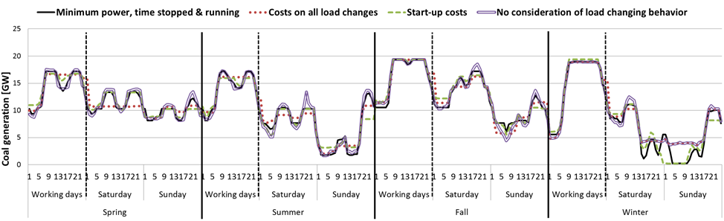
Fig. 1: Resulting generation from coal units in 2012 in Germany

The calculation time for the PERSEUS-NET-TS model based on one of the two linear approaches was only a few minutes (ca. 6 min). The calculation of the model based on a mixed-integer description of the load-changing behavior on the other hand took about twice as long (ca. 13 min).

Conclusions
The description of the load-changing behavior of thermal units though the modelling approach of minimum power, minimum time stopped and minimum time running is well established in the literature. However, it is based on a mixed-integer problem and has a comparably high computing time. In dispatch models which are limited by the computing time, the linear description of the load-changing behavior of thermal units via start-up costs seems favorable. This approach has even a bigger effect on the dispatch of the thermal units than the mixed-integer approach with minimum values. Unfortunately, it is hard to determine which dispatch is the more realistic one as data in the literature about a real plant dispatch is rare and data about cycling costs is often inconsistent. However, as the importance of the flexibility of thermal units increases, the importance to model some kind of load-changing behavior increases as well. As start-up costs and hence the consideration of some kind of minimum power have a strong influence on the dispatch, it seems important to include them. Furthermore, a combination of start-up costs and costs on all load changes might be a favorable way to model the load-changing behavior without the disadvantage of having to use binary variables and the resulting high calculation time. Also, it has to be noted that if, additionally, a linear investment decision for new units is part of the optimization, the description of the load-changing behavior of these new units is not possible with minimum times or start-up costs as no minimum power can be determined without knowledge of the installed capacity. In that case, a description of the load-changing behavior of these new units through costs on all load changes might still be a sufficient approximation and is better than not to consider load- changing behavior at all.

References
Babrowski S., T. Heffels, P. Jochem, W. Fichtner (2014) : “Reducing computing time of energy system models by a myopic approach – A case study based on the PERSEUS-NET model”, Energy Systems, doi: 10.1007/s12667-013-0085-1
Díaz D.J.M. (2008): “Production Cost Models with Regard to Liberalised Electricity Markets”, Dissertation, University of Karlsruhe, Karlsruhe, Germany
Eßer-Frey A. (2012): “Analyzing the Regional Long-term Development of the German Power System Using a Nodal Pricing Approach”, Dissertation, Karlsruhe Institute of Technology (KIT), Karlsruhe, Germany
Warland G., A. Haugstad., E.S. Huse (2008): „Including Thermal Unit Start-up Costs in a Long-term Hydro-thermal Scheduling Model”, Paper of the 16th Power Systems Computation Conference, Glasgow, UK.

