Emissions Due to Plug-in Electric Vehicle Charging in High Wind Systems

Allison Weis, Carnegie Mellon University, +1 412-973-6185, aeweis@andrew.cmu.edu
Roger Lueken, Carnegie Mellon University, +1 240-476-8547, rlueken@andrew.cmu.edu
Paulina Jaramillo, Carnegie Mellon University, +1 412-268-6655, pjaramil@andrew.cmu.edu
Jeremy Michalek, Carnegie Mellon University, Phone +1 412-268-3765, jmichalek@cmu.edu

Overview
Electricity generation together with the transportation sector is responsible for over 70% of U.S. CO₂ emissions. Producing electricity from traditional fossil fuel sources and using gasoline vehicles creates also other emissions that harm human health and the environment, such as NO_{x} and SO₂. Integrating low-emission power options, such as wind and solar power, and transportation options, such electric vehicles, will play a key role in reducing harmful emissions. Electric power systems with substantial wind capacity require additional flexibility to react to rapid changes in wind farm output and mismatches in the timing of increased generation and increased demand. Controlled variable-rate charging of plug-in electric vehicles not only allows for decreased emissions from gasoline but also allows demand to be rapidly modulated. This helps provide the necessary system flexibility for high levels of wind penetration. We find the changes in costs and emissions in the electricity system and transportation system in high wind penetration scenarios given the introduction of electric vehicles and a controlled charging program for electric vehicles. We also investigate how optimal vehicle charging changes if the system is optimized for total social costs by including consideration of the marginal damages of emissions.

Methodology
We construct a mixed integer linear programming model that optimizes power plant dispatch and plug-in electric vehicle charging based on the PJM system. We compare emissions of CO₂, SO₂, NO_{X} and particulate matter for scenarios with no electric vehicles, uncontrolled electric vehicles charging (charging as soon as vehicles are parked at home), and controlled charging of electric vehicles in systems with and without a 20% Renewable Portfolio Standard. We calculate the marginal damages caused by the emissions at power plants and vehicles located in different locations throughout PJM using the Air Pollution Emission Experiments and Policy analysis model. We then re-optimize system operations by minimizing total social costs. Constraints include wind generation satisfying the RPS, generation equaling load, the operational limits of power plants, simplified transmission constraints, and the charging power and energy storage limits of the electric vehicles. Electric vehicle driving patterns are modeled based on the National Household Travel Survey data and electric vehicle penetration is varied in a sensitivity analysis from 1% to 15%. We use hourly load data from PJM in 2006 and modeled 2006 wind data for PJM from the Eastern Wind Integration and Transmission Study.

Results

We find that optimizing the controlled charging of electric vehicles solely based on cost will lead to higher emissions than uncontrolled charging in systems without wind, especially of SO₂, by shifting generation from gas peaking plants to base load coal plants. When significant wind power is available, the added flexibility of controlled charging can help reduce emissions by decreasing wind curtailment and power plant start-ups. We find that this allows CO₂ and NO_{X} emissions due to vehicles to be lower with controlled charging given 20% wind while S0₂ remains nearly constant.

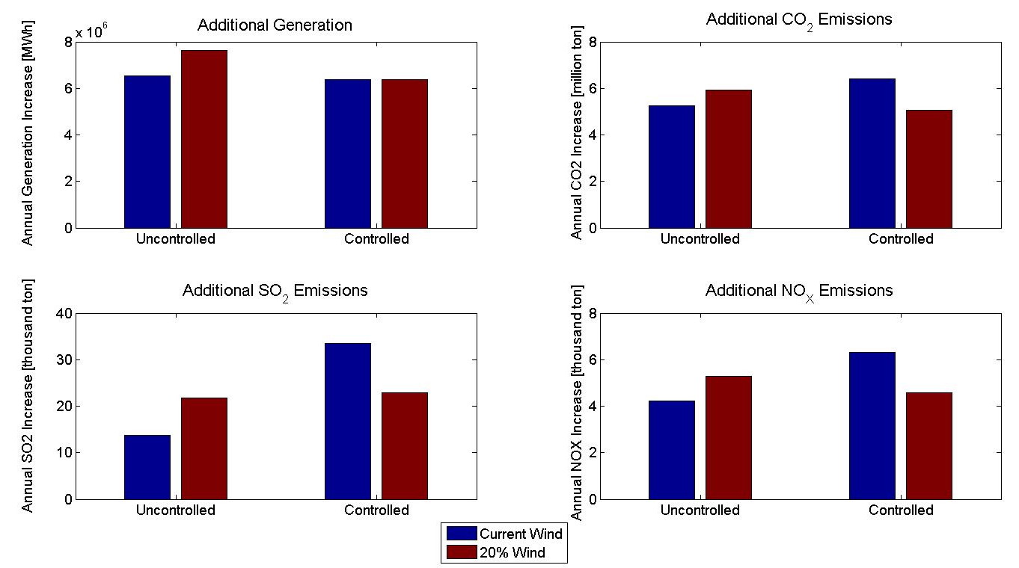

Conclusions
Combining controlled charging of plug-in electric vehicles with wind power can allow for lower emissions in the both the electricity and transportation sectors. However, optimizing grid operations based solely on operational costs will lead to substantially different charging pattern than those chosen based on total social costs. Understanding the emissions due to electric vehicles if the system is optimized for social cost will also show the maximum benefit that electric vehicles can provide over conventional gasoline vehicles and what charging patterns should be incentivized to appropriately balance the cost of generating electricity and its externalities.

