Reforming fossil fuel subsidies in hydrocarbon-rich countries: the case of transport Fuels in Saudi Arabia

Yahya Anouti, 1-720-530-9264, yanouti@mines.edu

Abstract
Historically, fossil fuel consumers in most developing hydrocarbon-rich countries have enjoyed retail prices at a discount from international benchmarks. Governments of these countries consider the subsidy transfer to be a means for sharing the wealth from their resource endowment with social and political benefits. In 2008, OPEC countries are estimated to have provided a total subsidy of $70 billion to their domestic transport fuel markets, equivalent to 2.2 percent of their combined GDP for that year. Since these subsidies create negative economic, environmental, and social distortions, which can only increase over time with a fast growing young and rich population. Both domestic and international pressure has been mounting for the phase out of fuel subsidies. Economic efficiency also argues for their phase out.
Multiple studies have drawn on the negative distortions associated with transport fuel subsidies and called from their removal. However, we are not aware of any available numerical study that measures the economic, environmental and social impacts of reforming these subsidies in hydrocarbon-rich developing countries. Against this background, our paper brings three main contributions. First, we propose a framework for evaluating alternative reform policies. Second, we survey potential reform options and argue for the use of cash transfers. Finally, we take a case study, focused on Saudi Arabia, to illustrate the costs and benefits associated with the phase out of transport fuel subsidies. We develop a general equilibrium model to discuss, in particular, a phase out that is accompanied with a welfare compensating cash transfer. Results show that the Saudi government can increase its consumers’ welfare by one to five percentage points.

Overview
Governments can spend their resource rents via four main channels. They can increase public spending, subsidize selected sectors, reduce various types of taxes, or directly transfer cash to any type of agents (Gelb 1983). Traditionally, governments of developing hydrocarbon-rich countries have subsidized the domestic prices of fuel products as mean of resource-wealth redistribution (IEA 2011). Based on our estimates, OPEC countries provided a total gasoline subsidy of $38 billion in 2008. Across these countries, the share of the subsidy as a percentage of GDP reached up to 2.5% in countries like Libya and Venezuela, where gasoline prices are the lowest in the world.

Fuel subsidies are associated with negative economic, environmental and social distortions. Among the various economic distortions, the subsidy results in suboptimal allocation of fuels to domestic and international markets that reduces potential foreign exchange earnings, increases fiscal pressures, hinders investments in refining capacity, and accelerates the depletion of exhaustable reserves. On another front, the subsidy increases the level of associated negative externalities resulting from the combination of miles traveled and amount of fuels consumed. Among the long list of negative direct externalities, Parry and Small (2004) argue that climate change, local pollutants, congestion and traffic accidents on are on the top of the list. On the social front, Coady et al. (2010) show that gasoline subsidies result in a substantial leakage of benefits to higher income groups instead of going equally to all nationals or to targeted lower income groups. The work shows that direct benefits to the highest groups income quartile are 12 times those accrued by the lowest income quartile in the Middle East, Asia, Pacific and Latin America. The ratio is 32 in Africa, with the world average being 20. Today, the confluence of the associated distortions is increasing the pressure towards reforming transport fuel subsidies.
This paper is structured as follows. Section 2 draws on issues associated with subsidies and motivates the case for reform. Section 3 derives lessons from different reform experiences and presents a conceptual framework for policy analysis. Section 4 develops a general equilibrium model for Saudi Arabia. Section 5 presents numerical analysis and policy implications. A final section offers concluding remarks.

Methods
This paper follows the general equilibrium framework of GTAP. The analysis builds on the algebraic structure presented by Böhringer and Rutherford (2011) and is solved using GAMS-MPSGE software (Rutherford 1999) and the PATH algorithm developed by Ferris et al. (2005). The model operates in a static multi-regional environment where consumers maximize their utility subject to a budget constraint and firms minimize their production costs by combining domestic intermediate goods, imported goods and factors of production. The model assumes perfect competition and constant returns to scale . Using duality theory, the model simultaneously solves for market clearance, zero profits and income balance conditions.
Production is modeled in a three-level nested structure where the first nest separates energy inputs from others. In the second level, energy inputs are separated into different types. As for the other inputs, these are separated into a factor of production block and a material and services block. In the third level, the factor of production block is split into labor, capital and resources. The material an services block in split into the various inputs. These blocks are modeled within an Armington intermediate demand structure. On the consumption front, the representative household generates income from renting out factors of production and spends it on consumption of goods and services. The government, the other agent in the consumption block, generates its revenues from collecting taxes and spends it on the provision of goods and services as well as direct transfers (e.g., import subsidies of oil).

Results
We estimate that the welfare gains to Saudi Arabia from removing gasoline subsidies are around 0.6 percentage points. This can reach over four percentage points under the higher elasticities scenario. Removing diesel subsidies results in welfare gains around 2.5 percentage points. These gains derive from three key effects: (1) the increase in households’ income, (2) substitution away from oil and (3) the increase in domestic supply of oil. The direct cash transfer of subsidy value to consumers increases their disposable budget and thus their welfare level. Given the form of their utility function, consumers will elect to spend less on oil, a pollutant, and more on other goods. The relative increase in oil prices from to the removal of import subsidies will instigate further substitution effects, reducing emissions level. In addition, the increase in the relative price of oil will also drive investments in this sector and increase domestic supply. This will increase the demand for the factors of endowments, thus households’ income.

Figure 1. Percentage change in household’s equivalent variation from removal of gasoline subsidy (left) and diesel subsidy (right).
Figure 2. Sensitivity analysis on change in equivalent variation from removing gasoline and diesel subsidies.
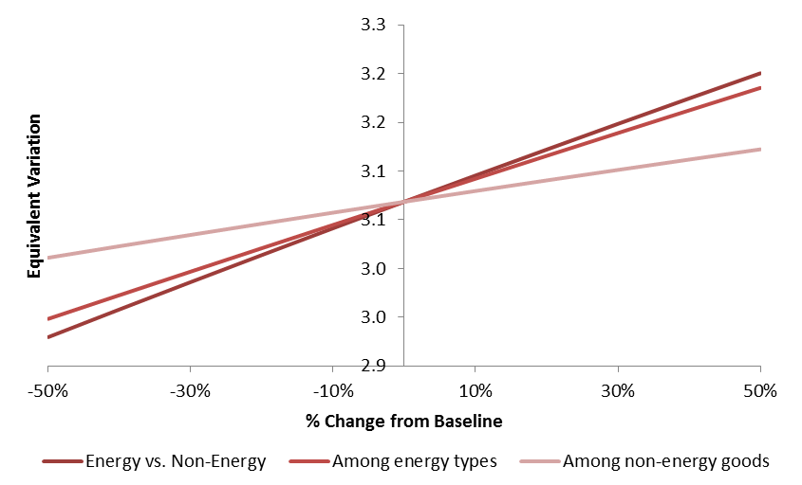

Conclusions
There is ample scope in OPEC countries for reforming fossil fuel prices to better achieve the objectives behind them, be it resource wealth sharing or assistance to the poor. The negative economic, environmental, and social distortions associated with the fuel subsidy are increasing the pressure on governments of hydrocarbon-rich countries to reform subsidies. This paper draws on the inefficiencies associated with fossil fuel subsidies and attempts to assess the size of the “prize” from reforming prices using the case of Saudi Arabia, focusing mainly on recycling revenues through cash transfers. Using a static general equilibrium model, findings reveal the government of Saudi Arabia can achieve the objectives behind fuels subsidies in a more efficient way through transferring cash to consumers. The Saudi government can maintain consumers’ utility at pre-reform level through cash transfers that are lower in value than that of the subsidy cost.

When designing price reform plans, policy makers should take into account distributional effects across different social groups (e.g., income groups, urban versus rural), something we did not consider in this paper. In addition, they policy makers should carefully consider potential substitution effects between means of transport (e.g., private versus public transport) as well as any unintended substitution effects that might occur. All these could be potential extensions to the CGE framework used for this analysis.

References
Biroi, F.; Aieagha, A.V.; and Ferroukhi, R., 1995. The Economic Impact of Subsidy Phase Out in Oil Exporting Developing Countries: a Case Study of Algeria, Iran and Nigeria. Energy Policy, 23 (1995) 209-215.
Coady, D.; Gillingham, R.; Ossowski, R.; Piotrowski, J.; and Shamsudin, T.; Tyson, J.; 2010. Petroleum Product Subsidies: Costly, Inequitable, and Rising. International Monetary Fund, Fiscal Affairs Department, Washington D.C., United States.
Ellis, J 2010. The Effects of Fossil-Fuel Subsidy Reform: A review of modelling and empirical studies. The Global Subsidies Initiative.
Gelb, A; 1985. “The Impact of oil windfalls: comparative statics with an Indonesia-like model”. World Bank.
Granado, J.A.; Coady, D.; and Gillingham, R; 2010. The Unequal Benefits of Fuel Subsidies: A Review of Evidence for Developing Countries. International Monetary Fund, working paper 10/202, Washington D.C., United States.
Henni, A., 2010. Can GCC members unify refined products prices? Arabian Oil and Gas. http://www.arabianoilandgas.com/article-8094-can-gcc-members-unify-refined-products-prices/
International Energy Agency, 2010. World Energy Outlook 2010. International Energy Agency, Paris, France.
Morgan, T. (2007). Energy Subsidies: Their Magnitude, How they Affect Energy Investment and Greenhouse Gas Emissions, and Prospect for Reform. Menecon Consulting.
Parry, I. W. H. and K. A. Small. (2005) “Does Britain or the United States Have the Right Gasoline Tax?” American Economic Review, 95(4), 1276-1289.
United Nations Environment Programme; 2008. Reforming Energy Subsidies. Opportunities to Contribute to the Climate Change Agenda. United Nations publication.

This is measuring the change in equivalent variation.

