Wind Turbine Upgrades in Denmark: Timing Decisions and the Impacts of Government Policies

Jonathan A. Cook, Ph.D Candidate, Department of Agricultural and Resource Economics
University of California - Davis, U.S.A.
Phone: (570) 490-7087, e-mail: jcook@ucdavis.edu

C.-Y. Cynthia Lin, Assistant Professor, Department of Agricultural and Resource Economics
University of California - Davis, U.S.A.
Phone: (530) 752-0824, e-mail: cclin@primal.ucdavis.edu

Overview
Shutting down and/or upgrading existing productive assets are important economic decisions for the owners of those assets and are also the fundamental decisions that underlie the development of new, growing industries. This paper builds a structural dynamic model in which owners make decisions about whether and when to add new turbines to a pre-existing stock, scrap an existing turbine, or replace old turbines with newer versions (i.e., upgrade) during a period of rapid technological improvement and several changes to government wind energy policies. Using an owner-level panel data for Denmark covering 1977-2011, we employ dynamic programming methods to estimate the underlying profit structure for wind producers and evaluate the impact of technological and policy factors on wind industry development. Our structural model explicitly takes into account the dynamics of investment and disinvestment decisions in an optimization framework and produces parameter estimates with direct economic interpretations. Results from the model indicate that the growth and development of the Danish wind industry was primarily driven by government policies as opposed to technological improvements. The parameter estimates can also be used to simulate counterfactual policy scenarios in order to quantify the effectiveness of the Danish feed-in-tariff and replacement certificate programs. The approach in this paper is novel for renewable energy industries and serves as a complement to recent reduced form efforts (Mauritzen 2011).

Methodology
The basis of the data used in the analysis is a publicly available database containing all wind turbines constructed in Denmark after 1977 (DEA 2012). In terms of ownership, the Danish wind industry has been remarkably decentralized throughout its history. Detailed information for 2900 turbine owners exists in the database and the vast majority (~90%) of these owners own two or fewer turbines during the period of study. A panel dataset at the owner level was constructed using ownership information that was obtained from a professional colleague at Energinet.dk. Information regarding relevant policies for wind turbines in Denmark was obtained from the IEA.

The two policies that are most important for the purposes of this paper are a feed-in-tariff for electricity generated by wind turbines and a replacement certificate scheme for incentivizing turbine owners to scrap old turbines and replace them with new ones. Since the late 1970’s, the Danish government has supported wind development by paying wind turbine owners a supplement to the electricity production price (feed-in-tariff). Prior to the liberalization of the power market in 1999, this payment was a fixed amount guaranteed for a significant portion (if not all) of a turbine’s useful life. After liberalization, the payment took the form of a fixed amount that would be paid to owners on top of the electricity price determined in the competitive wholesale market. The amount of these payments has been adjusted over time as more wind power came online, but owners receive the feed-in-tariff that existed when their turbine was installed. Also beginning in 1999, the government created a replacement certificate program to incentivize the upgrading of older, lower capacity turbines to newer, larger turbines. Eligible turbine owners who scrapped their turbines during the program received a certificate that would grant an additional price supplement for a new turbine that was constructed. These scrapping certificates were given out through the end of 2011 and could be sold to other prospective turbine owners.

We analyze the decision to add, scrap or upgrade a wind turbine using a dynamic structural model in which owners maximize a stream of discounted profits generated by selling wind-produced electricity. Payoffs are determined both by the characteristics of the turbine and government policies. The model allows for owners to have up to two turbines at any particular time and the available actions in a given period depend on how many turbines are in operation (see Figure 1). Our model has two “worlds”, such that when an owner has one operating turbine he/she is in the one-turbine world and moves to the two-turbine world if and when a second turbine becomes operational. We model the decisions of owners beginning in the year in which their first wind turbine was built (i.e. we are not modeling the initial investment decision) so that all owners begin in the one-turbine world. Each period (year), an owner decides whether to continue producing with a single turbine, add a new turbine, upgrade to a new turbine, or scrap their existing turbine (exit the market). If the owner decides to add, then they move to the two-turbine world in the following period, where they have a slightly different set of possible actions. In the two-turbine world, owners can either continue producing with two turbines, scrap one of their existing turbines or scrap both of their turbines. Scrapping a turbine and adding a turbine in the same period constitutes an upgrade and if an owner scraps a single turbine in the two-turbine world, they move back to the one-turbine world. We estimate three specifications of the model using dynamic programming methods. The parameter estimates are also used to conduct counterfactual policy simulations.

Figure 1: Model of wind turbine owner behavior
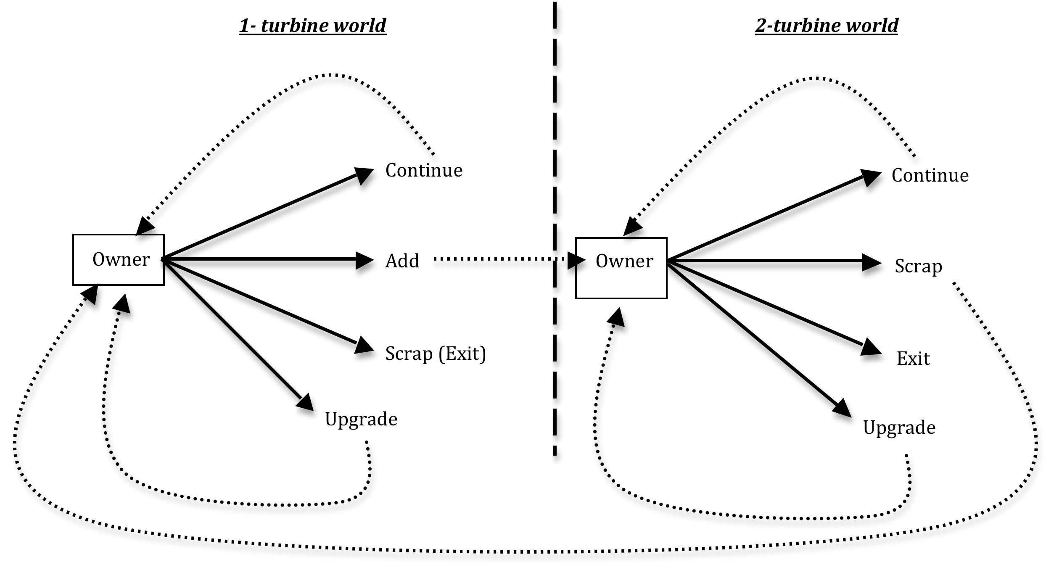

Results
Parameter estimates from the model provide a sense of the relative impacts of different variables on the profits of wind turbine owners and the impacts of the policies put into place by the Danish government. During operation, higher profits are generated by younger turbines with higher capacities that were built during periods of high feed-in-tariffs and low levelized costs. In all specifications the feed-in-tariff is a significant source of revenues that makes up roughly 33-50% of owner revenues. Similarly, replacement certificates comprise a dominant share of the payoffs to scrapping or upgrading existing turbines in all three specifications. Looking across the three specifications, we find that the scrap value of turbines is positive and increases with the capacity of the turbine being scrapped, while adding new turbines or upgrading carries with it a significant cost that is not significantly affected by the capacity of the new turbine. Comparing the magnitudes of the coefficients for adding and upgrading indicates that upgrading is the more costly of the two actions.

Conclusions
This paper developed a dynamic, structural model of wind turbine ownership that was used to estimate a profit structure for wind energy producers in Denmark. Results from the model show that government policies were responsible for about 33-50% of profits earned by operating turbines and also played a significant role in incentivizing turbine owners to scrap or upgrade older turbines. Both the feed-in-tariff and replacement certificate program significantly impacted the timing of investment decisions made by turbine owners and accelerated the development of the wind industry in Denmark.

References
DEA. 2012. “Register of Wind Turbines.” http://www.ens.dk/EN-US/INFO/FACTSANDFIGURES/ENERGY_STATISTICS_AND_INDICATORS/OVERVIEWOFTHEENERGYSECTOR/REGISTEROFWINDTURBINES/Sider/Forside.aspx.
EMD. 1999. “Wind Resource Map.” http://www.emd.dk/Documentation/DK%20Wind%20Resource%20Map/.
Mauritzen, Johannes. 2011. “The Decision to Scrap a Wind Turbine: Opportunity Cost, Timing and Policy.” SSRN eLibrary (September 29). http://papers.ssrn.com/sol3/papers.cfm?abstract_id=1940414.

