Overview

CONTRIBUTION OF TRANSMISSION INTERCONNECTOR EXPANSION TO MITIGATE SURPLUS RES-ELECTRICITY GENERATION IN FUTURE ENERGY SYSTEMS
Karl Anton ZACH, Vienna University of Technology – Energy Economics Group,
Tel.: +43 1 58801 370366, zach@eeg.tuwien.ac.at
Hans AUER, Vienna University of Technology – Energy Economics Group,
Tel.: +43 1 58801 370357, auer@eeg.tuwien.ac.at
This paper provides an overview on the possible contribution of transmission interconnectors expansion between two European electricity market regions (namely Central Western Europe and the Iberian Peninsula) facilitating large-scale expansion of renewable electricity generation (RES-E) and mitigating surplus RES-E generation from variable RES-E technologie (wind, PV, etc.). Initially, the updated modelling tool GreenNet was used to derive a long-term RES-E deployment scenario for all European countries until the year 2050. A methodology for the derivation of the residual load curves of the different European electricity market regions and their possible coverage with existing thermal power plants and (pumped) hydro energy storage (P)HES is presented. Furthermore, the contribution of transmission interconnectors for bringing together variable (excess) RES-E generation and (P)HES / electricity demand between the European electricity market regions Central Western Europe (CWE) and the Iberian Peninsula is analysed. For this, the two developed residual load curves of the regions will be matched for the years 2030 and 2050. In general, it can be observed that variable RES-E generation exceeds the future regional electricity demand for some time in the future and that the existing and new (P)HES and additional flexible thermal power plant units are strongly needed in almost all of the European electricity market regions to (partly) cover the future electricity generation gap.

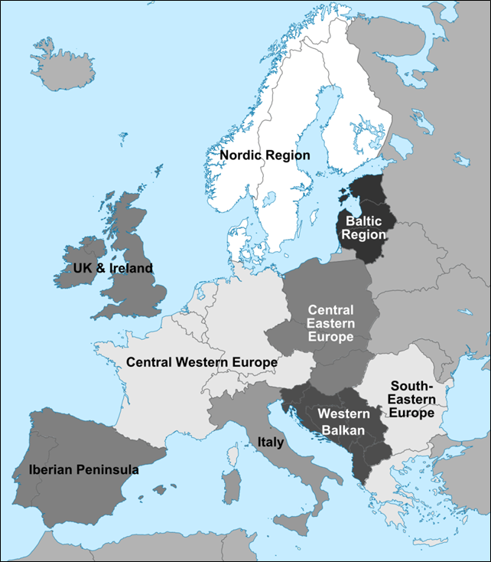
Methodology
For the analyses, a future high RES-E deployment scenario in European countries for the years 2030 and 2050 was generated with an updated version of the GreenNet RES-Electricity deployment simulation tool. GreenNet provides future scenarios on annual RES-E capacities installations and electricity generation per country under a variety of different possible policy settings and constraints. Taking into account the physical constraints in the European (cross-border) transmission grid in the analysis, European countries were clustered into nine different electricity market regions according to the different wholesale electricity market places / prices (as a consequence of physical constraints in the transmission grid). This clustering coincides with relevant EC documents and (e.g. EC infrastructure package) and the ENTSO-E’s “Ten Year Network Development Plan (TYNDP)” and is shown in Figure 1. Out of this nine regions, the Central Western Europe (CWE) region and the Iberian Peninsula were analysed in more detail.

Figure 1: Clustering of countries to nine different European electricity market regions
For the derivation of the load duration curves and residual load curves in the different European electricity market regions for the years 2030 and 2050, the following input data were used:
- Electricity demand data on hourly basis and on country level was taken from ENTSO-E for the year 2011 and linearly upscaled. With this data the regional load duration curves were established for the years 2030 and 2050.
- Hourly CSP, PV and wind electricity generation: To establish an hourly CSP, PV and wind electricity generation dataset for each electricity market region, real hourly CSP, PV and wind generation data was used from selected countries from the year 2011 and up-scaled accordingly: the Spanish data set from the Spanish TSO Red Electrica for the Iberian Peninsula and data sets from the the German and Austrian TSOs for the CWE region.
- Hourly electricity generation of other renewables: Other RES-Electricity technologies (e.g. biomass, biogas, geothermal, etc.) were approximated as constant generation bands throughout the year.
- Hourly run-of-river hydro electricity generation: The hourly run-of-river (RoR) hydro electricity generation for the Iberian Peninsula was established again by up-scaling of the real RoR hydro generation data set of the Spanish TSO Red Electrica of the year 2011. Since no real data sets were available for Germany or Austria, average daily water-level values of the Rhine and Danube river were taken to establish hourly RoR electricity generation data for the CWE region.
An example for the established sets of regional residual load curves is shown in Figure 2, where the load duration and residual load curve for the CWE region in the year 2030 is given. The residual load curves (green line in Figure 2) were generated by subtracting hourly PV (yellow area), wind (purple area), other RES-Electricity (green area) and run-of-river hydro (blue area) electricity generation from the load duration curve (black line). The existing thermal power plant-portfolio within the different European electricity market regions was also considered. Doing this, the age structure and the phase-out of the existing thermal power plant-portfolio were generated from the PLATTS database for the different electricity market regions. Installations of new thermal power plant capacities up to the year 2015 are already considered within the database. After deriving the age structure of the thermal power plant-portfolio in the different regions, the established residual load curves for the years 2030 and 2050 were “filled-up” with the still existing thermal power plant capacities (cf. Figure 3). The thermal power plant capacities are drawn as constant bands, starting with the base-load and least-costly power plants (i.e. nuclear, lignite and coal) followed by gas and oil power plant capacities. Additionally, existing installed capacities of PHES systems in the respective region are depicted as constant bands indicated downward from the top of the residual load curves in order to show their potential for providing peak-load power.
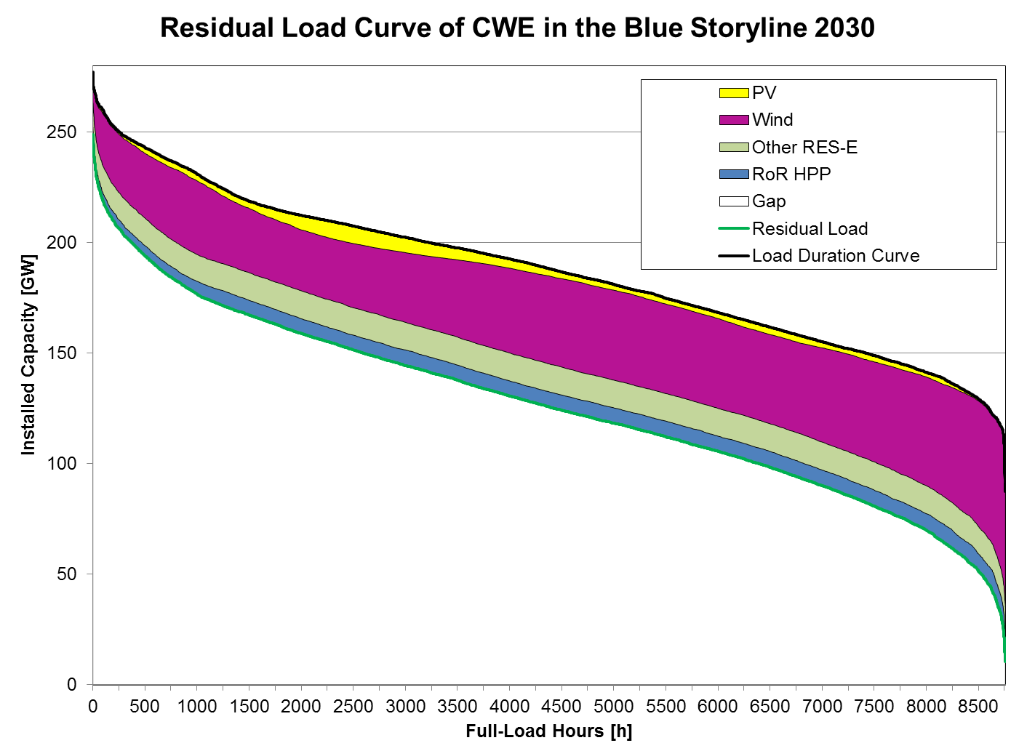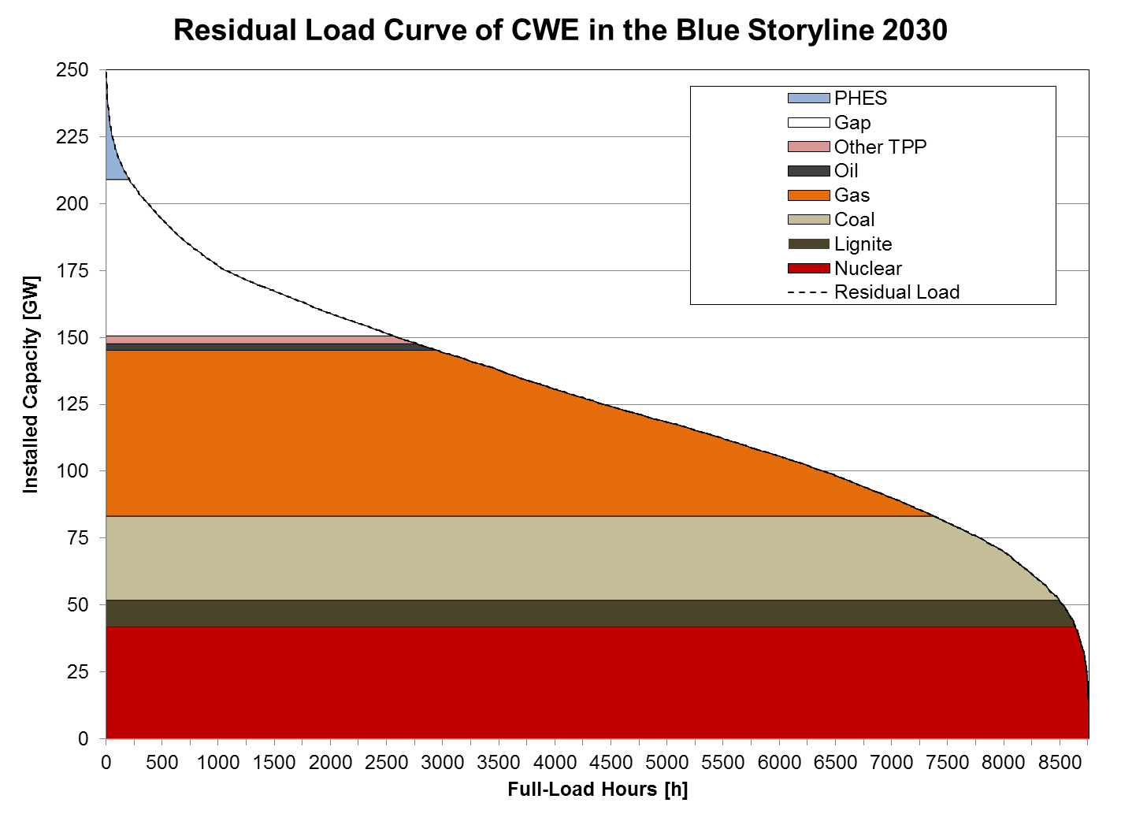Figure 2 (left) & 3 (right): Load duration and residual load curve for the CWE region in the year 2030 & (right) Coverage of the 2030 residual load of the CWE region with existing thermal power plants and PHES

Results & Conclusions
Current results show, that due to age-related phase-out of thermal power plants in the future additional new power plant capacities are needed in the CWE regions already up to the year 2030. The gaps of electricity generation capacity can be either filled up with new PHES systems (as far as additional potential is available in the region), new thermal power plants or imports from neighbouring regions. The Iberian Peninsula has sufficient flexible generation capacity (gas power plants and PHES systems) available in the system to cover the residual load also in the long-term (due to large investments in gas-fired power plants in the last ten years). Furthermore, in the developed scenario RES-E feed-in exceeds electricity demand more than half the time of the year 2050 in the Iberian Peninsula. This excess RES-E generation can be used for (large-scale) electricity storage and / or for exports to the neighbouring CWE region. The (currently limited) export capability and contribution of future transmission interconnector upgrades of the Iberian Peninsula to the CWE region to export this excess RES-E geneneration has to be analysed in a subsequent step.

