Overview

MODELING THE FUTURE COSTS OF CARBON CAPTURE USING EXPERTS’ ELICITED PROBABILITIES UNDER POLICY SCENARIOS
[Gregory F. Nemet, La Follette School of Public Affairs, University of Wisconsin-Madison, 608-265-3469, nemet@wisc.edu]
[Erin Baker, Dept. of Mechanical and Industrial Engineering, University of Massachusetts-Amherst, edbaker@ecs.umass.edu]
[Karen E. Jenni, Insight Decisions, kjenni@insightdecisions.com]
Carbon capture and storage (CCS) is potentially one of the most important energy technologies to address climate change. It frequent accounts for more than 10% of future emissions reductions in modeling exercises . However, CCS is only likely to play such a large role in climate change mitigation if its costs are near or below the marginal cost of abatement. Even though future technological change is highly uncertain, we are not completely ignorant; recent research has developed tools and produced data that, in combination, provide the basis for probabilistic estimates of future improvements in technology .

Methodology
We address this uncertainty in technological change in two ways. First, we use expert elicitations of energy penalties to model the future costs of 7 types of carbon capture technology applied to coal power plants . Second, we conduct extensive sensitivity analysis to assess the various parameters on additional levelized electricity costs ($/tCO2) in 2025. Using data from a variety of sources, e.g. , we explicitly characterize uncertainty in eight parameters including: energy penalties, capital costs, O&M, discount rates, as well as CO2 transport and storage costs. Although the expert elicitation of energy penalties under various policy conditions spans a considerable range, we find that costs are more sensitive to assumptions about overnight capital costs and discounting. Assuming that several, but not all, of these sources of uncertainty are independent across technologies, we run Monte Carlo simulations to specify a distribution of the minimum costs of capture across these 7 capture technologies.
Experts assessed 3 distinct policy scenarios:
Scenario 1 (S1): No further US government funded research and development (R&D) in CCS (i.e. zero public investment in future years); current worldwide carbon policies are unchanged
Scenario 2 (S2): No further US government funded R&D in CCS, worldwide carbon policy equivalent to $100/t CO2 starting in 2015 and continuing indefinitely
Scenario 3 (S3): “High” US government investment in R&D (an annual investment level about five times the 2005 investment was defined for each technology) from 2015 through 2025; current worldwide carbon policies unchanged
We calculate costs for 7 distinct types of carbon capture technology

1.Absorption (solvents)
2.Adsorption (solids and MOFs)
3.Membranes (including ionic liquids)
4.Other PC (enzymes and cryogenics)
5.Pre-combustion capture (with IGCC)
6.Oxyfuel (pure oxygen, not air)
7.Chemical looping combustion (metal)

Results
We find that for 73% of 100,000 samples, the minimum costs of capture are determined by one of three technologies. However, even the least likely of the seven technologies sets the minimum cost of capture in 3% of samples. Despite these concentrated outcomes, we see benefits to technology portfolio diversification in that a full portfolio of technologies increases the likelihood of achieving a $60/tCO2 cost target by about 100% versus focusing on a single capture technology.

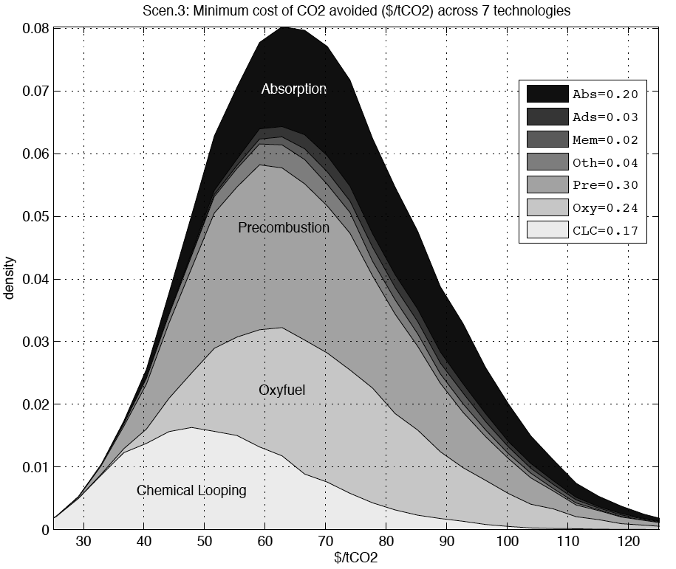
An initial result is the limited importance of R&D on climate change mitigation costs ($/tCO2) for CCS. Its rather small impact is due to the modest difference in elicited energy penalty across scenarios and factors other than energy penalty accounting for a larger portion of costs.
We see benefits to portfolio diversification in that a full portfolio of technologies increases the likelihood of achieving a $60/tCO2 cost target by about 100% versus focusing on a single carbon capture technology.

Conclusions
Our sensitivity analysis showed that the uncertainty in levelized cost of capital is the dominant source of uncertainty in the future costs of CCS. This factor itself consists of overnight capital cost and discount rate.
Expectations about overnight capital costs are subject to a very large range of views, from $600-2500/kW. Reducing uncertainty in these ranges would decrease uncertainties about the overall cost of capture. A key open question in understanding future CCS costs is whether the factors affecting capital costs are primarily exogenous—having to do with exchange rates, labor costs, and material costs for example—or whether they can be targeted with purposive investment, such as with R&D, scaling up, or learning by doing.
A second parameter affecting capital costs is the rate used to amortize the overnight capital costs. Our base value of 14% is similar to those used in other CCS studies. It is perhaps representative of a corporate hurdle rate, in which the decision to invest in a CCS plant competes with other investment opportunities with expected returns at that rate. Our low discount rate, 3% represents a social discount rate that takes into account a different but overlapping set of considerations, such as the returns on other government programs and consideration of future generations. The choice of whether to use a social or private rate depends on the perspective we take: that of a policymaker accounting for citizen preferences or that of a company deciding how to allocate resources among capital investments. In the case of climate change and public policies to address it, we are probably most interested in the social discount rate, since we will ultimately be comparing mitigation costs to the social cost of carbon, which would never be assigned a corporate discount rate. Still, firms’ decisions are crucial as we assume that they, not the government, will ultimately decide whether or not to build large numbers of CCS plants. Their opportunity cost is the returns on alternative investments, represented by a corporate discount rate. Using a social discount rate will underestimate the costs they face and thus bias estimates of adoption upward. Ultimately we face a situation in which mitigation costs are discounted at a high private rate while benefits are discounted at a lower social rate.
Consistent with the above, we find that energy penalty is an important factor in determining overall costs, but its role is not a dominant one. Moreover, the difference in energy penalty between R&D scenario 3 as compared to scenario 1, as elicited from the experts, leads to modestly, but consistently, lower cost of capture across all technologies. To directly inform decisions about how much to diversify, the costs of expanding the portfolio need also be taken into account, as would the benefits, e.g. in terms of reduced climate damages or abatement costs. Our subsequent work will address these costs and benefits of R&D using integrated assessment modeling.

References
Bennaceur, K. and D. Gielen (2010). "Energy technology modelling of major carbon abatement options." International Journal of Greenhouse Gas Control 4(2): 309-315.
Finkenrath, M. (2012). "Carbon Dioxide Capture from Power Generation – Status of Cost and Performance." Chemical Engineering & Technology 35(3): 482-488.
Jenni, K. E., E. D. Baker, et al. (2013). "Expert elicitations of energy penalties for carbon capture technologies." International Journal of Greenhouse Gas Control 12: 136-145.
Nemet, G. F. and E. Baker (2009). "Demand Subsidies Versus R&D: Comparing the Uncertain Impacts of Policy on a Pre-commercial Low-carbon Energy Technology." The Energy Journal 30(4): 49-80.
Rao, A. B. and E. S. Rubin (2006). "Identifying cost-effective CO2 control levels for amine-based CO2 capture systems." Industrial & Engineering Chemistry Research 45(8): 2421-2429.

