Overview
Analysis of Alaska Transportation Sector to Assess Energy Use and Impacts of Price Shocks and Climate Change Legislation
Ginny Fay, Assistant Professor of Economics, Institute of Social and Economic Research, University of Alaska Anchorage*,
907-786-5402, vfay@ alaska.edu,
Tobias Schwörer*, 907-786 5404, tschwoerer@alaska.edu;
Mouhcine Guettabi*, 907-786-5496, mguettabi@alaska.edu;
Jeffrey Armagost*, 907-786- 6727, jaarmagost@alaska.edu
This project analyzed energy use by Alaska’s transportation sectors to assess the impact of sudden fuel price changes or carbon emissions taxes. Inexpensive fossil fuels helped nurture Alaska’s early economic growth. Over time, key Alaska industries such as fishing, mining, tourism, and transportation, as well as activities such as subsistence gathering, have grown to depend directly on liquid fossil fuels. Compared with other states, Alaska is unique in its energy use. In 2010, for example, per capita energy consumption in Alaska was triple the national average. High energy use makes the Alaska economy more vulnerable to energy price volatilities and shocks. For state policy makers and industry, such vulnerability necessitates a better understanding of how energy prices and legislation affect transportation patterns and efficiency.
The relationship of transportation to greenhouse gas (GHG) emissions is also important in the context of ongoing social and political discussion of climate change. Transportation is a major contributor to the GHG emissions (primarily carbon dioxide, CO₂) associated with increased global temperatures; almost 30% of U.S. GHG emissions come from transportation. Additionally, transportation assets and operations worth billions of dollars are vulnerable to the impacts of climate change. Freight GHG is growing at a rate three times that of passenger GHG.

Methodology

We conducted three primary types of analysis: 1) Development of broad energy use statistics for each transportation sector. We estimate the energy and fuel used by the air, water, trucking and rail transportation sectors. We compared their fuel intensity to move passengers and freight by estimating their passenger-miles per gallon of fuel, ton-miles per gallon of fuel, fuel costs per passenger-mile and per ton mile, and CO2 emissions per ton-mile and passenger-mile. 2) Economic input-output analysis, to estimate the employment and output of air, rail, truck, and water transportation sectors in the Alaska economy. 3) Adjustment of input-output modeling assumptions to reflect sudden fuel price changes and/or emissions taxes to estimate the potential impact of these changes on industry output, employment, and Alaska households.

Results
We estimated that rail is the most efficient for moving freight per gallon of fuel followed by barges, marine ships, trucks and ferries, respectively. In terms of passenger-miles per gallon of fuel, we found again that rail is the most fuel efficient followed by air and ferry. Fuel costs per ton-mile and passenger-mile followed the same pattern of efficiency as well as CO2 emission intensity.

Figure 1. Comparison of fuel use and costs per ton mile for
Alaska transportation, 2007-2010, 2011$
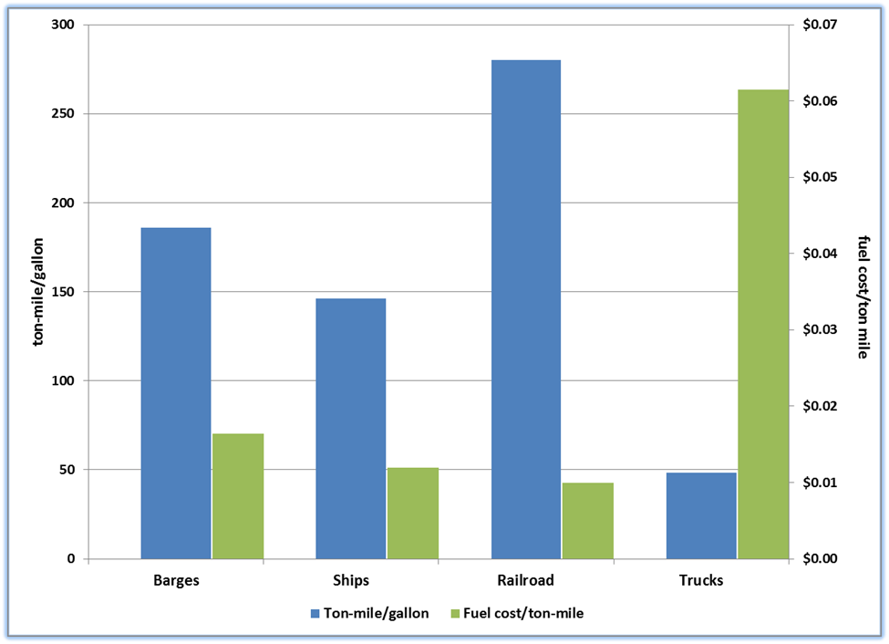
Figure 2. Comparison of fuel use and costs per passenger mile for
Rail and air, 2007-2010, 2011$
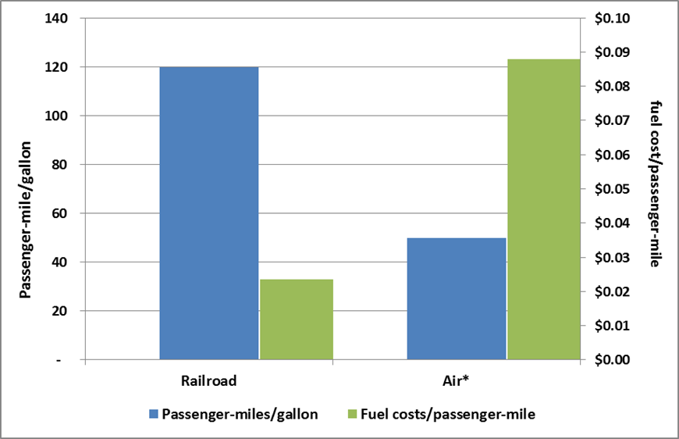

*U.S. average for comparison purposes only.
Sources: U.S. DOT, BTS; U.S, DOE, EIA; U.S. Army Corps of Engineers, Waterborne Statistics; AMHS; AKRR; IFA; Ingram, 2008; company proprietary information; author calculations.

Analysis of the Alaska economy found that the industries that are most dependent on transportation services and refined petroleum in their production are:
- Seafood product preparation and packaging
- Support activities for oil and gas operations
- Transport by truck
- Drilling oil and gas wells
- Construction of new nonresidential commercial and health care structures
- Construction of new residential single-/multi-family housing
- Electric power generation, transmission, distribution
- Mining gold, silver, and other metal ore
- Food services and drinking places
- Other state and local government enterprises
As a result, these industries are the most impacted by increases in fuel prices or other impacts that raise the cost of transportation services and refined petroleum as an input in their production. Most of these are core industries in the Alaska economy.

The Alaska industries that would be most affected by carbon emissions legislation are:
- Petroleum refineries
- Natural gas distribution
- State and local government electric use
- Asphalt paving mixture and block manufacturing
- State and local government passenger
- Other basic chemical manufacturing
- Transport by pipeline
- Plastics material and resin manufacturing
- Commercial fishing
- Transport by air

Conclusions
These are also the industries where increased efficiencies and reduced dependence on fossil fuels change could have the most payback in terms avoidance of potential emission tax impacts.

Alaska household at all income levels are also vulnerable to increases in the price of transportation services as a result of fuel price increases or carbon emission legislation. If Alaska households continued to purchase transportation services after fuel price increases similar to those that occurred between 2008 and 2010, these services would cost an additional $26.8 million; an estimated 73% of these cost increases would be paid by households earning over $50,000 annually. In all likelihood, however, households would reduce their expenditures on transportation services. Water and truck transportation services declined the most in our simulation, probably because the majority of routine purchases of goods by Alaska households are transported by water and truck.

In addition to the higher cost of transportation services resulting from increases in fuel prices, Alaska households’ direct purchases of refined petroleum products would cost an additional $124.1 million if households continued to purchase at the same level after the fuel price increases experienced between 2008 and 2010 as they did before the price increases. Our economic impact simulation did not include utilities so price increases for space heating and electricity are not included in these estimates. Similar to transportation services price increases, an estimated 70% of the refined petroleum price increases would be absorbed by households with incomes of $50,000 or higher.

A recent National Cooperative Freight Research Program (NHCRP) report, found that there is a lack of freight cost data for the various modes of freight transportation, and that no single source can provide the key cost data for any mode. Our data collection efforts and analyses were hampered by this data issue.

