[Strategic capacity investments in an imperfectly competitive world natural gas market]
[Burcu Cigerli, Rice University, 7133209432, cigerli@rice.edu]

Abstract
In this paper we look for strategic capacity investments in an imperfectly competitive model of the world gas market where buyers and sellers are connected by a trading network. We assume a two period model with no uncertainty and show that there is a unique Nash equilibrium and the open-loop Cournot-Nash equilibrium and closed-loop Cournot-Nash equilibrium investments coincide. Producer invests in supply capacity and/or displaces its resources from other markets to increase its supply to a market and its strategic supply capacity investment decision is sensitive to its cost. We apply this model to world natural gas trade network developed by using the major trade flows in BP's Statistical Review of World Energy, 2010. Later, we change model parameters exogenously to analyze various policy scenarios. We do not see the network effects as we see in our first paper, this is because producers respond to changes in market conditions by investing in their supply capacities instead of displacing their resources. We also find that producers would be better off if they cooperate and do not expand their supply capacities when natural gas demand importing regions increase.

Overview
Capacity expansion models in oligopolistic markets are centered around electricity markets, this is because perfect competition is a strong assumption when it comes to restructured electricity markets. Even though there are several studies that look at the operations of oligopolistic electricity markets, the literature on strategic investments in these markets is relatively new. Market models which deal with both investments and operations in an oligopolistic electricity market starts with Murphy and Smeers (2005). Murphy and Smeers (2005) consider three models of investment in generation capacity in restructured electricity systems. The first model assumes perfect competition, the second model extends the Cournot model to include investments in new generation capacities where capacity is simultaneously built and sold in long-term contracts (open-loop Nash equilibrium) and the third model separates the investment and sales decision with investment in the first stage and sales in the second stage (closed-loop Nash equilibrium). Unlike what we want to do in this paper, Murphy and Smeers (2005) consider a simple electricity system where all demand and supply is concentrated at a single node and there are two generators behaving strategically. Majority of the studies after Murphy and Smeers (2005) consider strategic investment problem in a duopolistic market. For instance, Ehrenmann and Smeers (2006) develops a two stage capacity expansion game under the assumption of duopoly. Their model is similar to Murphy and Smeers (2005), but unlike Murphy and Smeers (2005), Ehrenmann and Smeers (2006) assume no uncertainty. Genc and Zacoor (2010) extends Murphy and Smeers (2005) two stage model by allowing for a dynamic duopoly Cournot game with capacity investment under demand uncertainty. They characterize open-loop and closed-loop Nash equilibria of this game. On the other hand, Ventosa et al. (2002) extend capacity expansion from a duopolistic electricity market to an oligopolistic electricity market but in a single demand node. They present two approaches, in the first approach firms choose their output and generating capacity under the assumption of Cournot competition and in the second approach the leader firm chooses its capacity in the first stage, as in the Stackelberg game, then in a second stage all the firms compete in quantity and capacity as in the Cournot game. Our model adds to strategic capacity investment literature by allowing for Cournot competition in a networked market with multiple demand nodes and multiple suppliers. However our model is constrained with the assumption of fixed network graph. A future extension of this paper would look for an equilibrium in a dynamic network graph with demand uncertainties over multiple periods.

We modify Cigerli (2012) which develops a bipartite network model for m markets and n firms with fixed supply capacities in Cournot competition and analyzes how the structure of the network that connects suppliers with consumers affects the market outcome. Unlike our first paper, we assume that each producer invests in its supply capacity and solve for its equilibrium. We show that our game can be represented as a potential game and open-loop Cournot-Nash equilibrium and closed-loop Cournot-Nash equilibrium of this potential game coincide. We apply this model to world natural gas network formed by using BP's Statistical Review of World Energy, 2010. We then consider various changes to the basic model in a number of scenarios to look for strategic investment decisions.

Methodology

Taking account of strategic interaction between suppliers adds to the complexity of our model. To simplify, we therefore aggregate producers and consumers into a small number of regions. The schematic representation of world natural gas trade network is
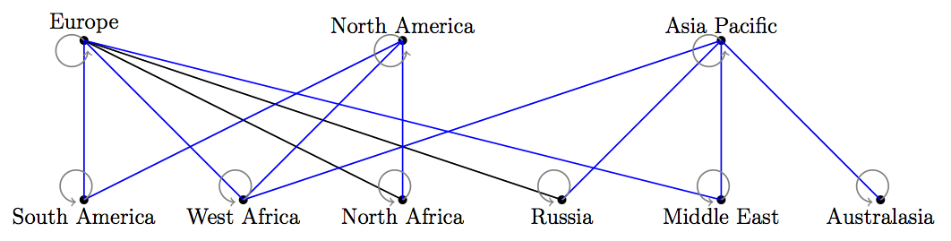

Results
We looked at five different scenarios and I am going to present the results of our third scenario which considers the increase in natural gas demand in Asia Pacific. According to the IEA's 2010 World Energy Outlook, China's demand grows faster than any other region, at an average of almost 6 percent per year 2008-2035. The IEA report projects that from 2008 to 2015 Asia's demand will grow from 341 Bcm to 497 Bcm a year.
The expected demand increase in Asia Pacific is incorporated in our model by increasing the choke price in Asia Pacific by 5 percent. All producers that are connected Asia Pacific increase their supply to it by expanding their supply capacities. Hence, the equilibrium production in Asia Pacific, West Africa, Russia, Middle East and Australasia increase.
West Africa expands its supply capacity by 5.32 Bcm which corresponds to 17.4 percent of its supply capacity in the reference case. On the other hand, Russia increases its supply capacity by 5.22 Bcm which is around 0.77 percent of its supply capacity in 2009.
With the increase in Asia Pacific's demand, equilibrium supply to Asia Pacific increases from 394.34 Bcm to 421.07 Bcm and the equilibrium price increases from 320 million USD per Bcm to 326 million USD per Bcm. Neither the consumption nor the equilibrium price changes in other regions.
Conclusions
In this paper, we solved for the equilibrium strategic capacity investments and trade flows in a network model of the world natural gas market consists of consumer, producers (of which are represented as strategic Cournot players) and links connecting them. We assumed a two period model with no uncertainty and showed that this game has unique Nash equilibrium. We also showed that the open-loop Cournot-Nash equilibrium and closed-loop Cournot-Nash equilibrium investments of this game coincide. Our paper contributes to the literature in strategic capacity investments by allowing for Cournot competition in a networked market with multiple demand nodes and multiple suppliers. A future extension of our model would relax the assumption of fixed network graph and solve for the dynamic model. In this paper, we assume that the strategic capacity investments are continuous however in reality due to investment economics of scale they are lumpy. A good extension of this paper would follow Hartley and Kyle (1989) where demand grows smoothly over time and the investment is the only cost which has a fixed size. They show that there is an efficient investment path which is a function of investment sequence and investment times.

Among others, Wei and Smeers (1999), Daxhelet and Smeers (2001)
According to Fudenberg and Levine (1988), in the open-loop, players cannot observe the play of their opponents; in the closed-loop equilibrium, all past play is common knowledge at the beginning of each stage. Similar to their definition, in this paper in the open-loop producers do not know their competitiors' decisions in supply capacity investments and in the closed-loop equilibrium producers know about the past plays of their competitiors, i.e, supply capacity investments.

