TECHNICAL AND COST IMPACTS OF INTEGRATING RENEWABLES: a CASE STUDY FOR CALIFORNIA

Lori Smith Schell, Empowered Energy, Phone: +1 970 247 8181, E-mail: LSchell@EmpoweredEnergy.com Joshua D. Eichman, University of California-Irvine, Phone: +1 949 824 5326, E-mail: jde@apep.uci.edu

Fabian Mueller, University of California-Irvine, Phone: +1 949 824 6602, E-mail: fm@apep.uci.edu

Overview
California has a legislative mandate to obtain 33% of all electricity sales from renewable energy sources by 2030. The Renewable Energy-based Secure Communities (“RESCO”) project has been undertaken to examine the technical and economic impacts of integrating increasing levels of renewables into the California electricity grid, with the goal of enhancing the energy security of communities and regions through increased reliance on renewable energy. The analysis is based on an integrated computer program that contains a number of different modules that enable the calculation of the levelized cost of electricity (“LCOE”) for varying electricity generatiuon portfolios, based on scenarios in which the amounts of renewable energy change over tiem. This in turn impact the required amount of dispatchable generation.

The presentation is organised as follows: The introduction will lay out the legislative requirements that must be met in California and provide a high level summary of the various modules that make up the integrated computer model. The second section will provide a brief overview of the various renewable energy penetration scenarios that were examined. The third section will address preliminary results of the various renewable energy penetration scenarios in terms of technical and cost impacts and the interaction between the two. The last section will describe our ongoing efforts and how the results will be incorporated into a community roadmap that we hope will serve as a template for other regions.

Methods
The integrated computer model is written in the MATLAB computer language and structured as indicated in the graph below. The integrated computer model contains four major modules: (1) Dispatchable load; (2) renewable generation; (3) balance generation; and, (4) cost of generation. The electricity load to be satisfied is based on historical California load. Existing legacy generating capacity as of 2005 is included in the model to examine the technical (and consequent cost) impact on existing generation as the level of renewable generation is increased. The model is calibrated by generating technology to historical generating data from the Federal Energy Regulatory Commission and the California Independent System Operator.
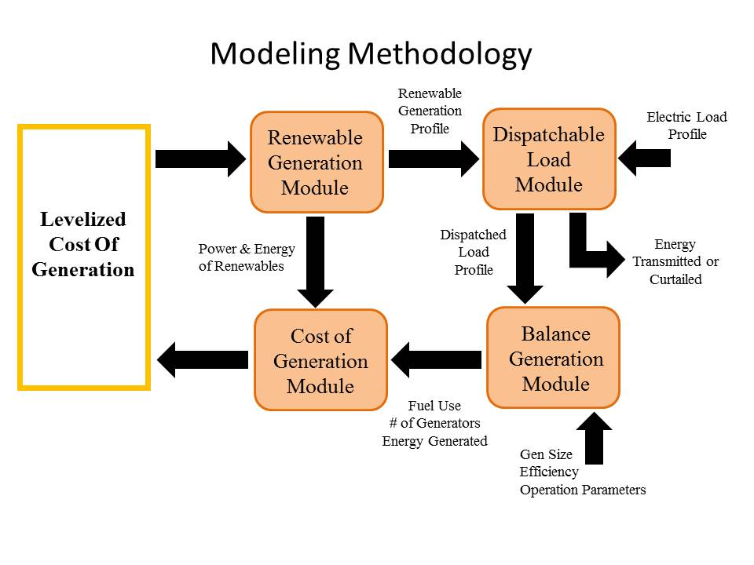

Results
Results will be presented for a number of different scenarios, based on a comparison with the zero new renewables case. Results will be presented largely as graphs that demonstrate how load is satisfied as different levels of renewables generation is brought online. As an example, it has been found that the LCOE of load-following and (particularly) peaking dispatchable generation is highly impacted by changes in capacity factors that result from the up-and-down levels of generation required to balance intermittent renewable generation.

Conclusions
Increased levels of renewable generation on the electric grid increases the amount of dispatchable generation that must be available to balance the intermittency of renewable resources. As significant, however, it that the available dispatchable generation must also operate more often at less efficient generation levels with a greater number of starts and stops, increasing the amount of fuel required and the level of operating and maintenace costs.

References

Klein, Joel, 2010, Cost of Generation Model User’s Guide Version 2, California Energy Commission, CEC-200-2010-002.

O’Donnell, Charles, Pete Baumstark, Valerie Nibler, Karin Corfee, and Kevin Sullivan (KEMA), 2009, Renewable Energy Cost of Generation Update, PIER Interim Project Report, California Energy Commission, CEC‐500‐2009‐084.

