THE MERIT ORDER EFFECT OF WIND GENERATION IN THE IRISH ELECTRICITY MARKET

Amy O’Mahoney, Trinity College Dublin, Phone +353 1 896 3744, E-mail: omahonea@tcd.ie
Eleanor Denny, Trinity College Dublin, Phone +353 1 896 1522, E-mail: dennye@tcd.ie

Overview
As energy consumption has risen steadily over the past century, so too have emissions, contributing in climate change. This, alongside dwindling fossil fuel resources has resulted in increasing global interest in renewable generation, which allows for lower carbon emissions from electricity generation and contributes to policy targets such as the Kyoto Protocol (1992), US cap and trade programs such as the Clean Air Act (2008) and the Regional Greenhouse Gas Initiative (2007) and the EU emissions trading scheme (European Commission 2009).
Of the renewable technologies currently available for electricity generation, wind is one of the most developed and as a result is gaining significant market shares internationally. This has resulted in greater focus on the impact of wind on the electricity system, as until quite recently no system had faced the challenges associated with high penetrations of wind – namely the need for greater flexibility and reserve due to the increase in volatility (NREL 2011; NERC 2008)
Wind generation affects the intersection of the merit order with the demand curve; as can be seen in Figure 1 it essentially shifts the demand curve to the left as it can be considered as the demand for electricity less the amount of wind generated, resulting in the demand for conventional supply. Wind can be considered as negative demand due to its zero marginal cost. This is because once the supply curve is defined and it is compared to demand, the System Marginal Price is set to the bid price of the most expensive plant required to meet demand (Devitt et al. 2008). This is known as the Merit Order Effect (MOE), which arises from the fact that, all else equal, adding wind power to the system should replace higher marginal cost plant on the system, and this in turn is likely to lower wholesale electricity prices (Indecon 2008; Felder 2011).
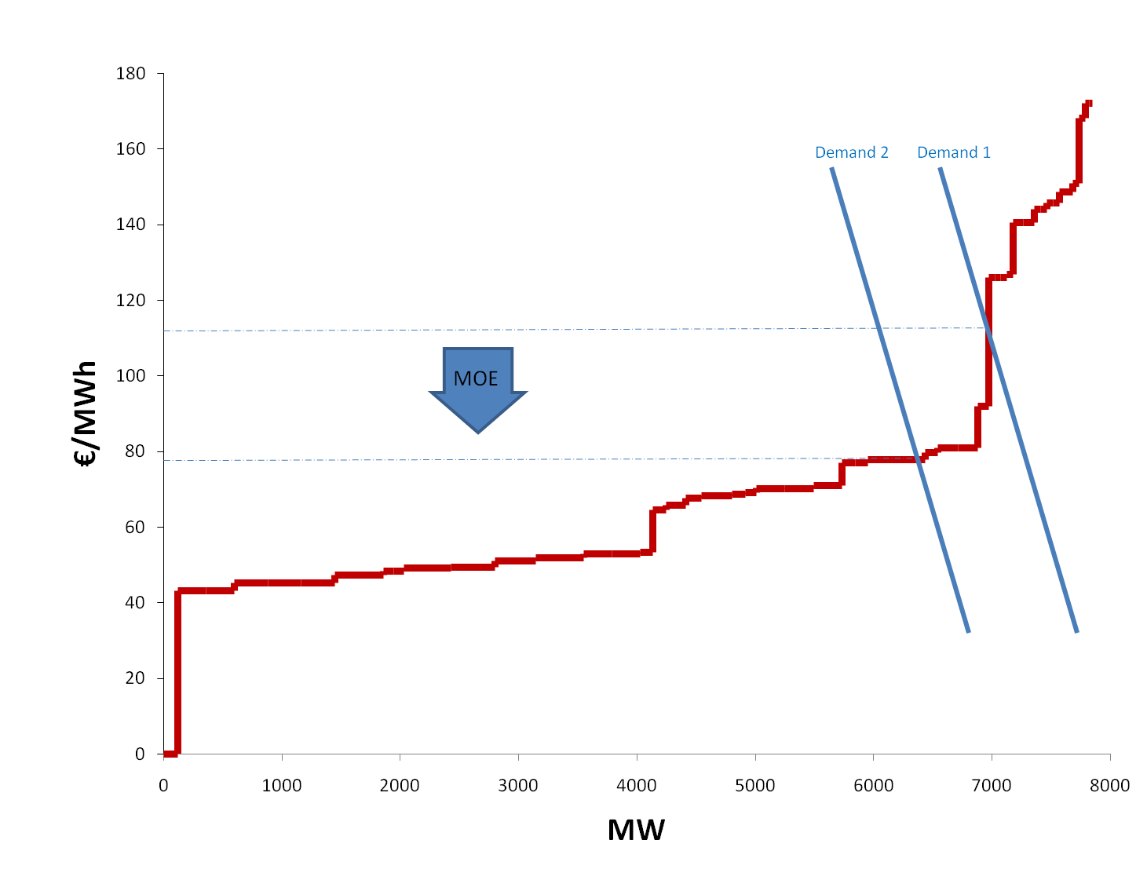
Figure 1 Merit Order Effect

Methods
The All Island Grid Study (2008) found that “at higher proportions of renewable capacity installed, less conventional capacity is required to run and thus the operational cost decreases”. This is in line with various studies to date, which have shown that increased wind power in the generation mix will in fact lead to reductions in the Spot Market Price (Moesgaard and Morthorst 2008; Pöyry 2010; Sensfuß et al. 2008). However these have largely involved simulated wind production and prices as opposed to historical data. Results from Moesgaard and Morthorst (2008) show that wind power benefits the consumer through economic as well as environmental benefits, and that the price reducing effect could be higher than the studies estimate, while Sensfuß et al. (2008) point out that the cost for renewable support paid by consumers is not as high as is generally expected when the MOE is taken into account.
This paper aims to identify the MOE of wind on the Irish system in 2009 through the use of inverse supply multiple regression analysis, as shown in Equation 1.

Once the average hourly effect has been calculated, we can estimate the cost of electricity over the course of the year had no wind been available. Wind generation typically receives a subsidy in order to compensate it for its positive external benefits, which include the reduction in fossil fuel consumption for electricity generation, environmental benefits and the meeting of national and international policy targets.

Results
In this study we generate an inverse supply time series multiple regression model. Controls are included for each hour of the day; day of the week; month and public holidays, as all of these have an effect on the demand for electricity; the availability of wind for generation; and the scheduled maintenance of conventional plant which has an effect on the fuel mix.
The results show that the value of wind to the market dispatch has resulted in savings of €141 million in 2009. Total costs to the market would have been in the region of 12% higher over the course of the year had no wind output been available. As expected, the greatest saving to the market coincides with both peak demand and prices, as wind generation at 7pm represents the greatest saving along the merit curve. The value of wind is directly related to the units which it displaces, which is why the value of -0.0189 seen at 7pm is more than double the coefficient seen at 7am (-0.0046). Ireland’s highest daily levels of wind coincide with peak demand, resulting in a significant saving; countries that experience highest wind levels during the night, or periods of low demand may not see the same level of cost savings.
Using the SEAI (2009) average emissions for the Irish electricity market, we can estimate the carbon savings arising from the displaced fossil fuel generation. This value of 0.582 kg/MWh CO₂ is multiplied by the wind output at each hour and the daily carbon price for the same time period lagged by 24 hours, as shown in equation 3. This aggregates to a saving of €29.3 million over the course of 2009. This saving is assumed to be accounted for in our regression model. EPA (2009) values of SO₂ and NO_{x} for electricity generation are used to assess the savings of this emissions arising from wind generation. These are estimated at €0.5 million and €7.9 million respectively.

Conclusions

This paper estimates the historic cost savings arising from wind generation in the Irish electricity market using a time series OLS regression model in 2009. This allows us to calculate the extent of the value of wind on an hourly basis over the period analysed. Once the average hourly effect is calculated, we aggregate the total and find that the value of wind to the market dispatch has resulted in savings are of €141 million to the market dispatch. We find that the total costs to the market would have been in the region of 12% higher over the course of the year had no wind output been available. These savings are significantly greater than the subsidy received for wind-generated electricity over this time period, and as a result it can be seen that the positive externalities derived from wind generated electricity outweigh the cost of the subsidy; particularly when one considers the CO₂ saving to the market and accepts that all forms of generation impose integration costs to electricity systems.

References
CAA (2008). Clean Air Act as of 2008. U.S. Government Printing Office.
DCENR (2008). All Island Renewable Grid Study - Workstream 2B, “Wind Variability Management Studies”
Devitt, C., Diffney, S., Fitz Gerald, J., Lyons, S., & Valeri, L. M. (2008). The Likely Economic Impact of Increasing Investment in Wind on the Island of Ireland. ESRI.
European Commission (2009). EU action against climate change: The EU Emissions Trading Scheme
Felder, F. A. (2011). Examining Electricity Price Suppression Due to Renewable Resources and Other Grid Investments. The Electricity Journal (Vol. In Press, Corrected Proof).
Indecon (2008). Economic Appraisal of the Potential for Offshore Wind Energy Generation in Ireland
Kyoto Protocol (1992). United Nations Framework Convention on Climate Change. http://unfccc.int/resource/docs/convkp/kpeng.html. Accessed 30th March 2011.
Moesgaard, R., & Morthorst, P. E. (2008). The effect of wind power on spot market prices. EWEC. Brussels.
NERC (2008). Accommodating High Levels of Variable Generation.
NREL (2011). EASTERN WIND INTEGRATION AND TRANSMISSION STUDY.
Pöyry (2010). Wind Energy and Electricity Prices - Exploring the ‘merit order effect’.
Regional Greenhouse Gas Initiative (2007). RGGI Program Overview.
Schneider, M., Froggatt, A., & Thomas, S. (2011). The World Nuclear Industry Status Report 2010–2011 - Nuclear Power in a Post-Fukushima World. Worldwatch Institute.
Sensfuß, F., Ragwitz, M., & Genoese, M. (2008). The merit-order effect: A detailed analysis of the price effect of renewable electricity generation on spot market prices in Germany. Energy Policy, 36(8), 3086-3094, doi:DOI: 10.1016/j.enpol.2008.03.035.

