Overview

A research on predicting amount of energy consumption and carbon emissions of the urban and rural population in chinA

[Mi Hong, Zhejiang University, P.R.C, Phone+8613328771835, (86)571- 88208518, E-mail: spsswork@163.com]
[Ma Pengyuan, Xiamen University, P.R.C, Phone+8615960279339, Email: mpy0618@163.com]
[Zhou wei, Zhejiang University, P.R.C, Phone+8615657123952, E-mail: ttomcc@126.com]

Carbon emissions and global climate changes are significant problems that affect the human society sustainable development. It presents closely relationship between energy consumption and carbon emissions, especially since the industrial revolution, carbon emissions in the energy field had being a major source of man-made emissions. In China, industrialization and urbanization are two developing trends in future, which are directly related to our future energy consumption and carbon emissions. With the development of the industrialization, the energy consumption per unit of GDP gradually declines, and the total amount of energy consumption will appear slowly down. The enhancement of energy consumption of per capita life, leading to the total amount increasing of life energy consumption, which is due to urbanization, will be an important factor which affects our country's energy consumption trend. Therefore, when we pay attention to the industrialization, we also ought to attach great importance to the urbanization and energy consumption changes caused by it. A predicting research on China's prospects of energy consumption in future is necessary and practical for the realization, from a perspective of life energy consumption in the process of urbanization.

This paper takes a forecasting analysis on the energy consumption and carbon emissions of the urban population of 2011-2030 in China, which uses terminal energy consumption data of China's Energy Statistics Yearbook, with the help of the trend prediction model of the improved population flow. Through measuring the scale of Chinese population migration, amount of energy consumption and carbon emissions, analyzing the developing trend of the urban and rural population’s carbon emissions. It is helpful for us to master Chinese carbon emissions status and developing trend, and the governmence can also easily formulate the policy of slowing its carbon emissions which may be scientific, reasonable and complies with the situation of our country.

Methods

Keyfitz model is used to analyse urbanization in China. The assumption of constant rates of natural increasing and net migration is not fit for actual status of population. So this paper put forward variable rates of natural increasing and net migration to improve the coupling equations. Most of migration is caused by socioeconomic factor. So the incoming gap between urban and rural areas must be considered , and the gravity model can be modified as:
$M_{\text{ru}}=K\frac{P_{r}W_{u}D}{P_{u}W_{r}}$ (1)
where $M_{\text{ru}}$stands for migration size from rural to urban areas, $K$is constant coefficient, $W_{r}$ and $W_{u}$ are income in the rural and urban areas respectively in China, $P_{r}$ and $P_{u}$ are rural population and urban population, $D$ is spacial distance between population gravity center and economic gravity center of China.

A population flow trend prediction model is built on the modified population migration gravity model, and the constant coefficient $K$is improved into variable coefficient. The migration improved gravity model of urban and rural population is:
$M_{\text{ru}}(t)=K(t)\frac{P_{r}(t)W_{u}(t)D(t)}{P_{u}(t)W_{r}(t)}$ (2)

If setting $F(t)=\frac{M_{\text{ru}}(t)P_{u}(t)W_{r}(t)}{P_{r}(t)W_{u}(t)}$， and just take the derivative type (2)，which is $∂K(t)=−\frac{F(t)}{D^{2}(t)}∂D(t)$ (3)

This model revealed the changing relationship between the attractors of migration $∂K/∂D$ and the “population-economy gravity center” distance$D(t)$. (Fig.1) It is suitable to the research of the high frequency simulation of floating population dynamic development and population-carrying capacity, and also offers support to the urban and rural population migrating of regulatory mechanisms, policy research and models of urbanization development.

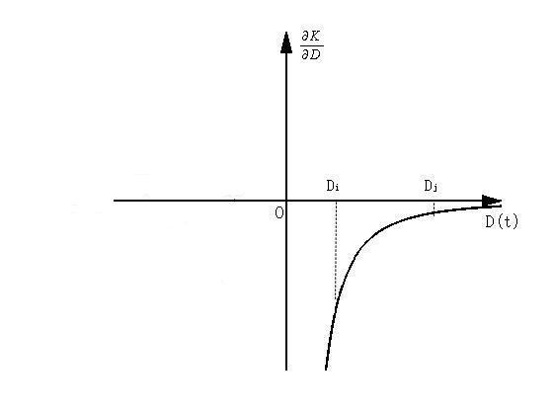
Fig.1 The theory diagram of population flow trend prediction model

Results

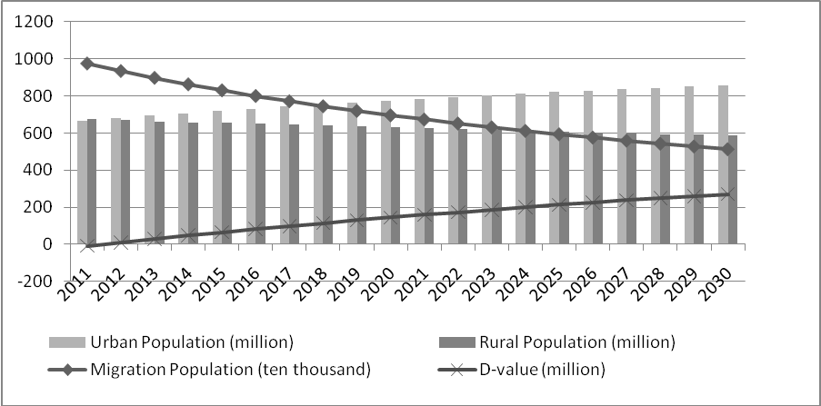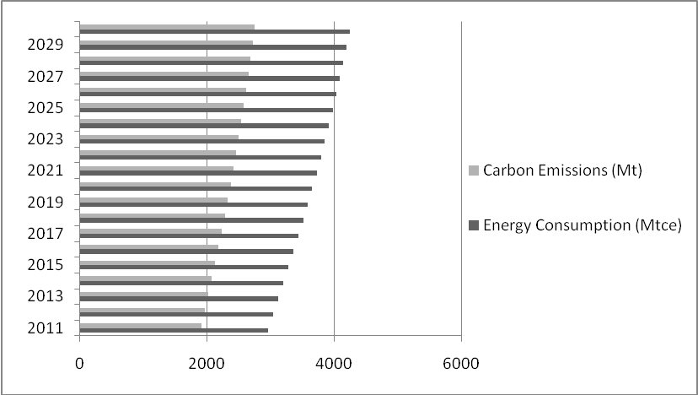
Fig.2 Migration population and Energy consumption in China during 2011-2030

In the background of remaining lower natural population growth and effectively controlling population growth, the structure of urban-rural population has more significant influence on carbon emissions, and the rate of population urbanization increasing directly leads to carbon emissions increasing. The paper predicts that the number of migration population in China will be about 6.67 million, and the urbanization rate will be 61.8% in 2030. Meanwhile, the gross of energy consumption will be changing in the range of 4.24 to 4.53 billion tons standard coal and carbon emissions caused by energy consumption will reach 2.94 billion tons.

Conclusions

According to the forecast analysis that three developing scenes of population urbanization in China and energy consumption, fossil fuel consumption may continue to grow and carbon emissions will also continue to increase, even the proportion and the use ratio of nuclear, wind, solar, hydro etc low carbon energy increasing gradually with the enlargment of population migration from rural to urban and the increasing energy consumption. It will be a long process for China to improve energy structure and ascend utilization efficiency, which will affect China's carbon emissions tendency. In future, when we change the style of economic growing model, develop green low carbon, and strengthen the construction of ecological environment, we should also guide residents to consume reasonably, promote green clean energy actively, and decrease the consumption of life energy and carbon emissions.

In short, China's energy consumption will still increase largely in future, and the pressure of reducing emissions is also augmented correspondingly. Therefore, we should pay much more attention to energy consumption and the increasing of carbon emissions that are caused by urbanization and people's living standards improving.

References

[1] Jones, D. W. (1991). How urbanization affects energy use in developing countries. Energy Policy 19, 621-630.
[2] Keyfitz N. Do cities grow by natural increase or by migration? Geographical Analysis, 1980;12(2):142-156.
[3] F. Urban, R.M.J. Benders, H.C. Moll. Modelling energy systems for developing countries，Energy Policy 35 (2007): 3473–3482.
[4] Zhanglei, Huangyuanxi. Energy Consumption for China s Modern Urbanization [J]. China Population Resources and Environment, 2010,20(1):25-30.
[5] The National Bureau of Statistics, China Statistical Yearbook 1997-2009.

