Overview

Grid-Level Applications for Energy Storage: Informing Future Development
Eric Hittinger, Carnegie Mellon University, Phone: +1 703-899-6861, E-mail: ehitting@andrew.cmu.edu
J. F. Whitacre, Carnegie Mellon University, Phone: +1 412-268-5548, E-mail: whitacre@andrew.cmu.edu
Jay Apt, Carnegie Mellon University, Phone: +1 412-268-3003, E-mail: apt@cmu.edu

In recent years, there has been great interest in grid-level applications for energy storage technologies, due to both increased demand for particular energy services and improved energy storage options. While energy storage technologies have existed for decades, grid-level storage is still an immature industry and is experiencing relatively rapid improvements in the performance and costs of a variety of technologies. In this innovation cycle, it is difficult to determine which energy storage properties are most valuable; for example, while decreased capital cost, increased power capability, and increased efficiency would all improve the value of an energy storage technology, it is not clear which of these is most important and what the elasticity of substitution between them might be. This study uses engineering-economic models of several energy storage technologies and examines their cost-effectiveness for different realistic applications. By performing an extended sensitivity analysis on the storage properties for each combination of application and storage type, we determine which properties are the most limiting and therefore the most valuable to improve, and calculate the elasticity of substitution between storage properties. These results can inform all entities involved in the improvement of energy storage, including manufacturers, research funding entities, and organizations that set technology targets.

Methods
We realistically model four different energy storage technologies (Lithium Ion batteries, Sodium Sulfur batteries, flywheels, and supercapacitors) and four applications (frequency regulation, peaks shaving, and wind smoothing with and without a load-following signal). A time-series engineering-economic model is used to calculate the cost of providing each service for each storage technology. By improving a single energy storage property and rerunning the model, we can determine the effect that this change has on the profitability of an energy service. By performing this operation across different storage properties, we are able to calculate the elasticity of substitution between storage properties and determine which properties most affect the bottom-line cost of energy services.

Results
We determine the sensitivity of cost of an energy service to various performance and cost parameters for each energy storage technology. Because each technology/application combination is different, the results vary according to the application type (power-limited or energy-limited). In general, capital cost and power/energy limitations are the parameters that have the greatest impact on the profitability of the storage applications. An example of the output (for Sodium Sulfur batteries) is shown in the figure below.

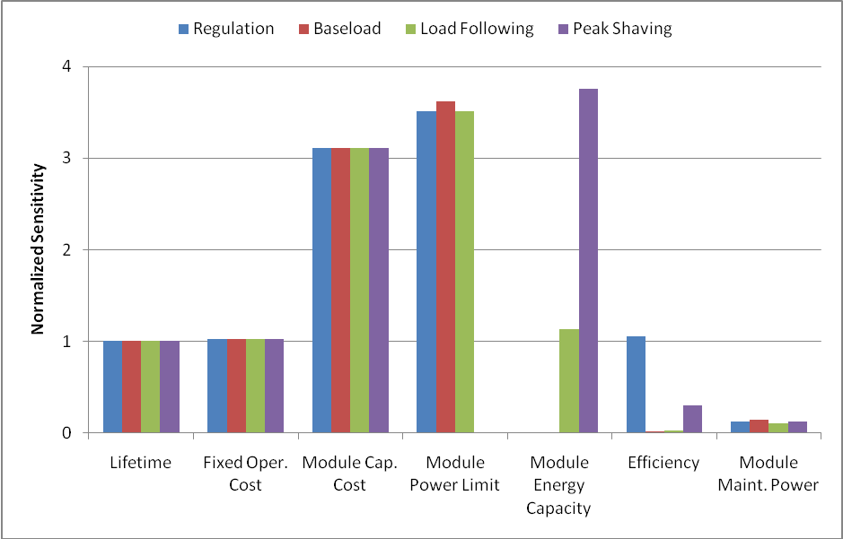
Figure 1: Sensitivity of the cost of energy service to Sodium Sulfur battery properties, across four applications. The properties with higher sensitivity have a greater impact on profitability of the energy service.

Conclusions
We determine the energy storage properties that are most limiting to profitability for different storage technology/application combinations. We find that capital cost of storage is consistently important, and power/energy limitations are also critical depending upon the type of application. But while there are some strong trends, by carefully modeling both storage technologies and applications we show that each combination is different and blanket statements are not always appropriate. And while significant research funding has recently been put towards improving performance of energy storage, decreasing the capital cost through manufacturing process improvements may be far more valuable. These results suggest that entities seeking to improve energy storage technologies should carefully consider how this would affect the adoption of the technology, since different improvements have greatly different effects on the profitablity of energy storage.

