Overview

[an imperfectly competitive model of the world natural gas market]

[Burcu Cigerli, Rice University, 7133209432]

Using Ilkilic (2010) we model Cournot competition in the world natural gas market and analyze how the structure of the trading network that connects producers with consumers affects the market outcome. In particular, we analyze any change in the network structure would change the market outcome. To our knowledge, this paper is the first one to consider natural gas trade in a network structure under an imperfect competition assumption.

Until recently, high transportation costs meant that natural gas was not extensively traded between continents. The infeasibility or the expense of building pipelines over long distances on the ocean floor and the high cost of LNG shipment lead to differences in natural gas prices between regions. However, falling costs of liquified natural gas (LNG) and growing diversity in supply sources and demand sinks have enabled natural gas to evolve into a global commodity. Although the establishment of a single (or a reference) price for natural gas is difficult to achieve due to the high cost of transport and long term take-or-pay contracts, there is some convergence in regional prices.

This paper develops a model of global natural gas trade under the assumption of imperfect competition. Rather than having a market of atomistic buyers and sellers we have a network structure where buyers and sellers are connected via biletaral trading relationships. In other words, a buyer and a seller must have a relationship, or "link" to trade. For instance, the pipeline from Russia to Europe is a link and its existence gives Russia an advantage relative to alternative potential suppliers. According to BP's Statistical Review of 1997, 84 percent of natural gas imported to Europe was carried by pipeline. Even though there has been a significant decline in LNG transportation cost, Russia is still the number one supplier of European natural gas with a share of 78 percent in 2009. The feasible trades of natural gas in our model depend on LNG transportation cost and the availability of pipeline connections.

The market power of producers of natural gas depends on their production capacity, their access to markets and their actual or potential competitors. At the end of 2009, Russia, Iran and Qatar held 53 percent of global natural gas reserves of around 98.86 tcm and Russia had the cheapest access to the European market. The Middle East could, however, become a significant competitor for Russia in Europe. In this paper, we analyze the effects of Russia and the Middle East becoming more competitive as a result of building a pipeline from the Middle East to Europe. We then examine the effects of a possible Russia Middle East merger on the natural gas prices.

Methods

We develop a bipartite network model for three markets and six firms in Cournot competition. We show that there exists a vector of Cournot equilibrium flows from each firm to each market with which it is connected. Ilkilic (2010) assumes that firms have convex quadratic costs and markets have linear inverse demand functions, but there is no transportation cost on each link. Hence, we add a linear transportation cost to each link to capture the cost of carrying natural gas on that link. This cost parameter varies by the distance between market and firm and also with type of transportation: pipeline versus LNG.

We draw a bipartite graph of world natural gas trades based on the BP Statistical Review’s (2009) natural gas major trade connections.

The global natural gas network is:
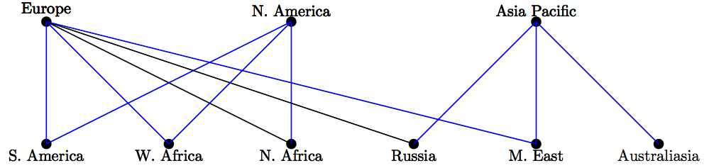

There are three markets (or importers) which are ordered as Europe, North America and Asia Pacific and six suppliers (or exporters) which are ordered as South America, West Africa, North Africa, Russia, Middle East and Australiasia. Each supplier exports natural gas to each market it is connected to. For instance, South America supplies gas to North America but not to Asia Pacific.

We solve for Cournot equilibrum flow quantities and prices.

Conclusions
Our study answers recently debated questions in the literature. The first question we look at is the effect of a pipeline link (the development of Nabucco) between the Middle East and Europe which would lower transportation costs. The pro-competitive effects of such a development could be reduced by a “merger” (or cartel) between Russia and the Middle East. This is the second issue we examined. Another hotly debated issue is the effect of developments in unconventional gas production in North America on regional natural gas prices. Finally, we will also consider the effect of increased LNG imports into Japan in the aftermath of Fukushima crisis.
Calibration and estimation results are yet to be developed.

References
BP Statistical Review (2009).
Ilkilic, Rahmi (2010). Cournot Competition on a Network of Markets and Firms. Maastricht University, Maastricht, Netherlands, working paper.

The main exceptions include liquified natural gas trade from Indonesia to Japan , Algeria to Europe, and Russian pipeline exports to Western Europe.
For more details see The Global Liquefied Natural Gas Market: Status and Outlook, 2003.
These markets are Europe, North America and Asia Pacific.
These firms are South America, West Africa, North Africa, Russia, Middle East and Australasia.

