Overview

ECONOMIC UNCERTAINTY IN SUBSURFACE CO₂ STORAGE: GEOLOGICAL INJECTION LIMITS AND CONSEQUENCES FOR CARBON MANAGEMENT COSTS

Peter H. Kobos, Sandia National Laboratories, (505) 845-7086, phkobos@sandia.gov
Jesse D. Roach, Sandia National Laboratories
Jason E. Heath, Sandia National Laboratories
Thomas A. Dewers, Sandia National Laboratories
Sean A. McKenna, Sandia National Laboratories
Geoff T. Klise, Sandia National Laboratories
Jim L. Krumhansl, Sandia National Laboratories
David J. Borns, Sandia National Laboratories
Karen A. Gutierrez, Sandia National Laboratories
Andrea McNemar, National Energy Technology Laboratory
Storing large volumes of carbon dioxide (CO₂) in saline formations is a potential option to mitigate CO₂ emissions from power generating stations from entering the atmosphere. Inherent to this storage resource is substantial economic and operational uncertainty throughout the CO₂ emissions capture, transportation, injection, and storage supply chain. A critical component of the physical viability of CO₂ storage is the ability of a formation to accommodate and store vast quantities of CO₂. Much has been written on the uncertainties associated with building a CO₂ capture system and the potential storage volumes available in saline formations. However, useful storage is contingent on the ability to physically inject CO₂ into the geological strata with appropriate injection rates to meet storage goals. Geological heterogeneity can dictate how quickly and sustainably any given project can inject and store CO₂ under site-specific conditions. Without suitable subsurface permeability, injecting CO₂ in a formation may not be physically and economically viable for large quantities of CO₂ involved with, for example, an 1800 MW subcritical power plant with 90% capture (over 10 million metric tonnes of CO₂/yr).
The purposes of this paper are to: 1) demonstrate the dependency of well injection rates and associated costs on formation permeability; and 2) determine the ranges in permeability values and other geologic parameters that would physically limit the feasibility of CO₂ injection at a storage site. We present several scenarios of CO₂ injection into varying permeability formations that are chosen as representative of the geological strata throughout the United States that are under consideration for CO₂ storage.

Methods
The Water, Energy and Carbon Sequestration simulation model (WECSsim) links well injection costs to reservoir properties by incorporating subsurface analysis, which evaluates injection flow rates. Flow rates in turn determine the total number of wells needed to accommodate the CO₂ captured at the power plant. The total number of wells is used for calculating injection-related costs of CO₂ capture and storage. Properties for several formations within the U.S. were initially to be populated within WECSsim with data from NatCarb 2008 (National Energy Technology Laboratory, 2008). However, NatCarb 2008 lacks some site-specific data. Thus, we have defined four rock types. All 325 NatCarb “polygons” or formations have been assigned to the four rock types or some combination of the rock types. WECSsim can call any NatCarb polygons, and by its association with a rock type (or combination of rock types), perform the injection rate calculations.

Results
WECSsim takes user input on target CO₂ capture levels at a given power plant and then calculates the costs that would be associated with storing the captured CO₂ in each of 325 NatCarb 2008-based geologic polygons. Here we explore the impact of permeability (as driven by rock type) by fixing all other WECSsim variables. We model a 11 million metric tonne per year CO₂ source that overlies any of the formation geologies associated with the 325 NatCarb 2008-based polygons. The distance from the power plant to all polygons is set to zero, the footprint area of all polygons is set to 1000 square miles, the sequestration depth to 5000 feet, the thickness of all polygons to 500 feet, the background temperature and pressure of all polygons to 100°C and 150 atmospheres respectively, the porosity of all polygons to 15%, and a sweep efficiency of 2% is used for all polygons. There is a nonlinear relationship between the geometric mean permeability of the suite of injection wells utilized and the injection costs (Fig 1a). Injection costs range over an order of magnitude from as little as $0.54 to as much as $12 per tonne (2010 $US). This range represents substantial, geologically-based uncertainty, even within the context of overall CCS costs of $45 to $56 per tonne CO₂ stored. Injection of CO₂ into approximately half of the formations will cost less than $4 per tonne of CO₂, with the high permeability clean sandstone being the least costly option (Fig. 1b).
Sandia National Laboratories is a multi-program laboratory managed and operated by Sandia Corporation, a wholly owned subsidiary of Lockheed Martin Corporation, for the U.S. Department of Energy's National Nuclear Security Administration under
contract DE-AC04-94AL85000. Working Results. SAND2011-5974A.
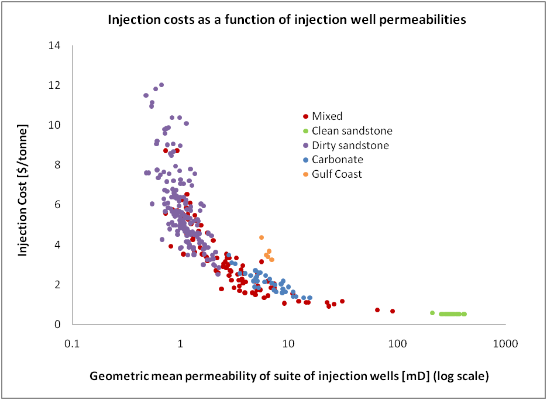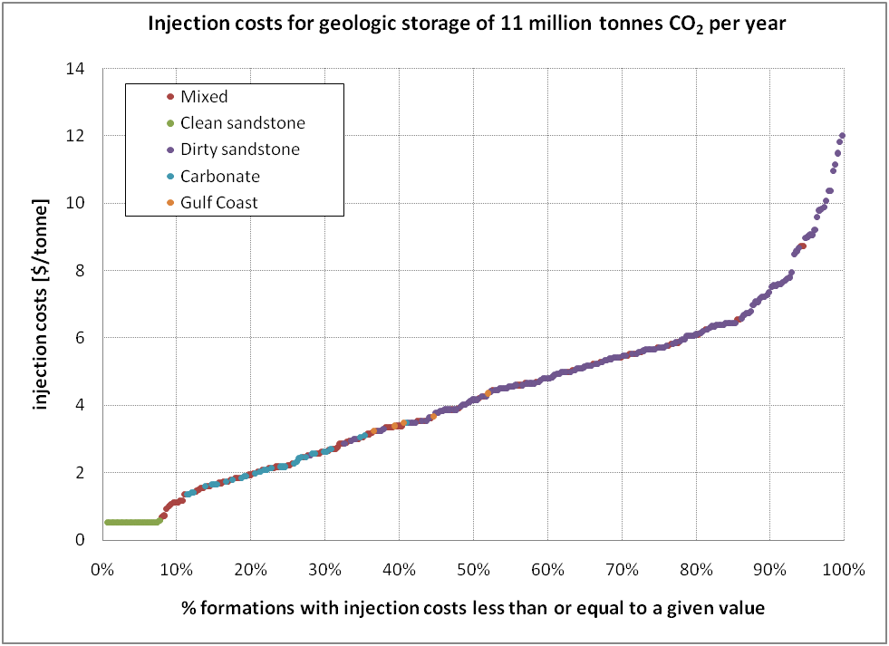Figure 1. a) Relationship between the geometric mean permeability of injection wells used in each of 325 polygons targeted for sequestration. b) One realization of injection costs estimated for permeabilities associated with each of the 325 NatCarb 2008 based polygons arranged in ascending order.
a)
b)

Conclusions
These results have broad implications on both the number and spacing of CO₂ injection wells that may be required to store emissions from a stationary source. Low injectivity will result in both additional injection wells, and dense well spacing in a well field. Site characterization of permeability thus becomes extremely important in initial selection of potential geologic targets for CO₂ storage. Order of magnitude ranges in permeability may be likely for some geological environments (e.g., fluvial depositional systems), and the occurrence of low permeability zones can render a particular injection well relatively ineffective. If permeability is overestimated in original site characterization, many more wells may be required to inject and store a given amount of CO₂, potentially affecting the economic viability of a given target formation substantially.
References
National Energy Technology Laboratory, 2008, Carbon Sequestration Atlas of the United States and Canada – 2nd Edition, National Energy Technology Laboratory. Report available at: http://www.netl.doe.gov/technologies/carbon_seq/refshelf/atlasII/index.html

